# Selenium Features Note

## What is Selenium?

Selenium is an open-source web automation testing framework suite used to automate web applications across different browsers using various programming languages like Java, Python, and C#. It is mainly used for UI automation testing.

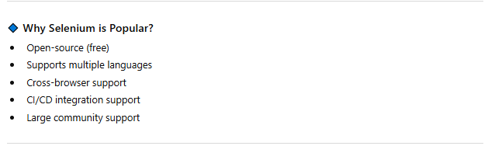

## Component

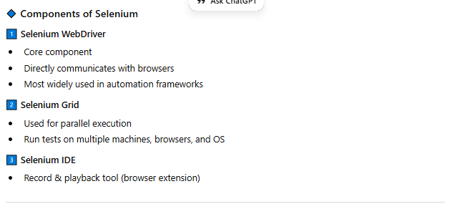

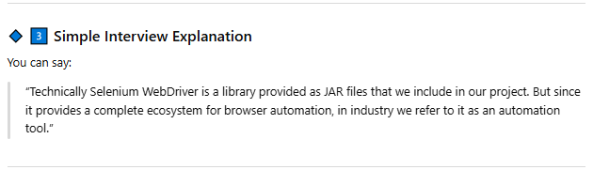

## New in Selenium version 4.40

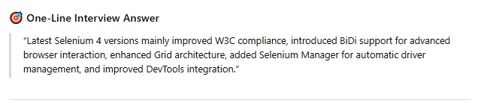

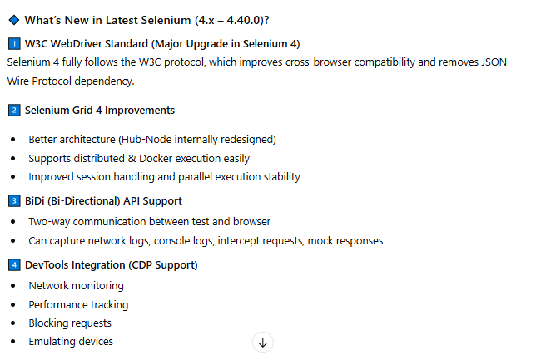

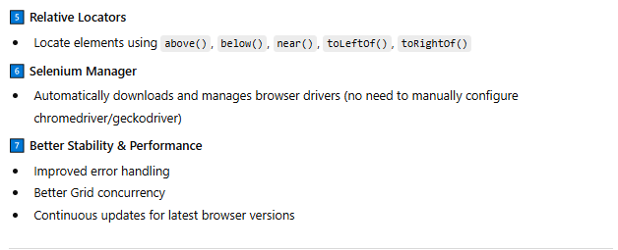

## Web Driver

In Selenium WebDriver, the test script sends commands to the WebDriver API, which converts them into W3C protocol and passes them to the browser driver like ChromeDriver. The driver directly communicates with the browser to perform actions. Since it doesn’t use a server or JavaScript injection like Selenium RC, it is faster and more reliable.

Selenium WebDriver sends commands from the test script to the browser driver using the W3C protocol, which directly controls the browser without a server, making it faster and more reliable.

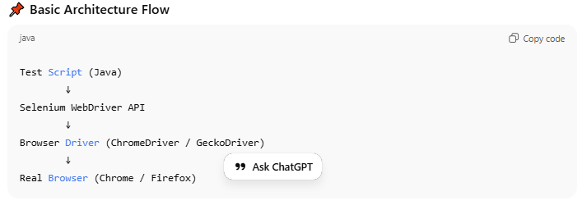

## Note -

Code Formatting – Ctrl+Shift+F

Class name should be starting from capital letter

Variavle name should be starting from small letter

Debug – Rclick on line and set toggal breakpoint

**Interface:** A Java interface defines a set of abstract methods but does not implement them. A class that implements the interface agrees to implement all of the methods defined in the interface.

Webdriver is the Interface

All Known Implementing Classes:

[AndroidDriver](http://selenium.googlecode.com/svn/trunk/docs/api/java/org/openqa/selenium/android/AndroidDriver.html), [AndroidWebDriver](http://selenium.googlecode.com/svn/trunk/docs/api/java/org/openqa/selenium/android/library/AndroidWebDriver.html), [ChromeDriver](http://selenium.googlecode.com/svn/trunk/docs/api/java/org/openqa/selenium/chrome/ChromeDriver.html), [EventFiringWebDriver](http://selenium.googlecode.com/svn/trunk/docs/api/java/org/openqa/selenium/support/events/EventFiringWebDriver.html), [FirefoxDriver](http://selenium.googlecode.com/svn/trunk/docs/api/java/org/openqa/selenium/firefox/FirefoxDriver.html), [HtmlUnitDriver](http://selenium.googlecode.com/svn/trunk/docs/api/java/org/openqa/selenium/htmlunit/HtmlUnitDriver.html), [InternetExplorerDriver](http://selenium.googlecode.com/svn/trunk/docs/api/java/org/openqa/selenium/ie/InternetExplorerDriver.html),[IPhoneDriver](http://selenium.googlecode.com/svn/trunk/docs/api/java/org/openqa/selenium/iphone/IPhoneDriver.html), [IPhoneSimulatorDriver](http://selenium.googlecode.com/svn/trunk/docs/api/java/org/openqa/selenium/iphone/IPhoneSimulatorDriver.html), [RemoteWebDriver](http://selenium.googlecode.com/svn/trunk/docs/api/java/org/openqa/selenium/remote/RemoteWebDriver.html), [SafariDriver](http://selenium.googlecode.com/svn/trunk/docs/api/java/org/openqa/selenium/safari/SafariDriver.html)

Steps for creating class object with reference to interface

* Choose the Browse on which you want to perform Automation and Select the respective class to implement Webdriver

Ex: [FirefoxDriver](http://selenium.googlecode.com/svn/trunk/docs/api/java/org/openqa/selenium/firefox/FirefoxDriver.html)()

* Create an object for the Class and assign name to it

Selenium=New [FirefoxDriver](http://selenium.googlecode.com/svn/trunk/docs/api/java/org/openqa/selenium/firefox/FirefoxDriver.html)();

* Then make Class object reference to the Webdriver Interface which you want to implement

Webdriver Selenium=New [FirefoxDriver](http://selenium.googlecode.com/svn/trunk/docs/api/java/org/openqa/selenium/firefox/FirefoxDriver.html)();

## Browser Launch

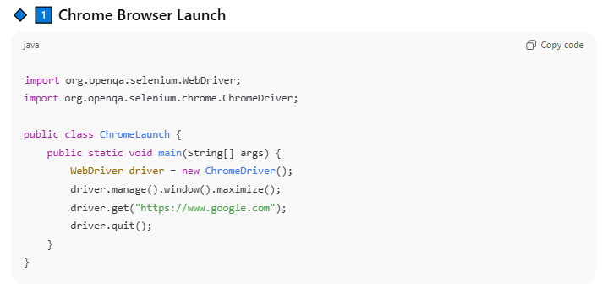

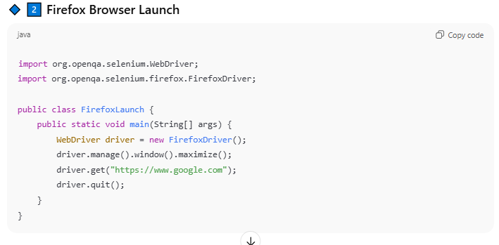

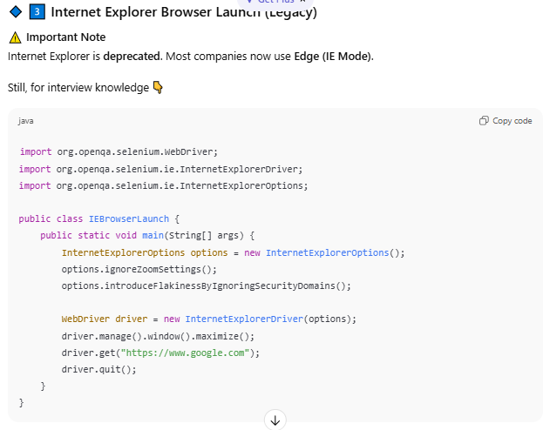

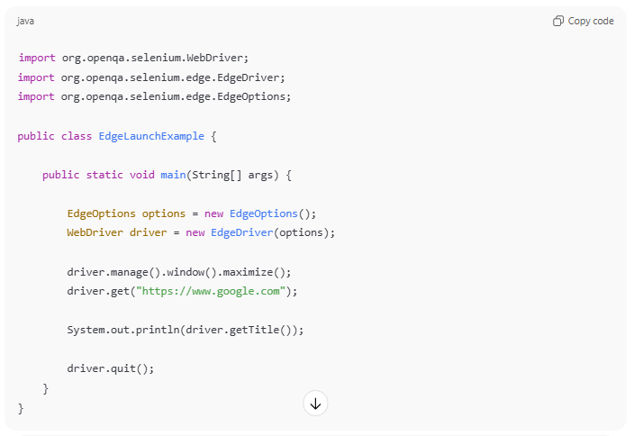

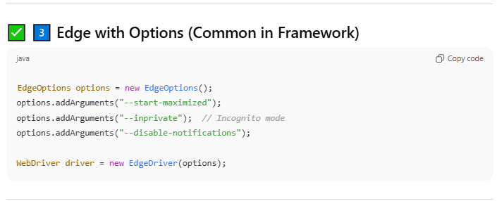

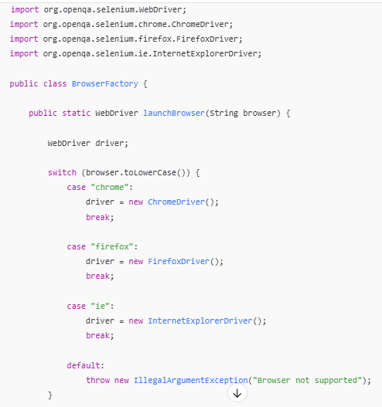

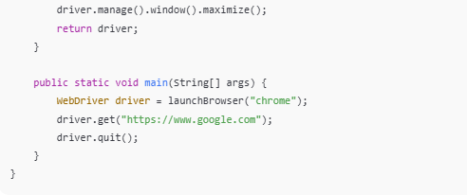

Trick –

* OOS – org.openqa.selenium
* Driver MWM – manage().window().maximize()

# web driver – commands & methods

## Browser Control

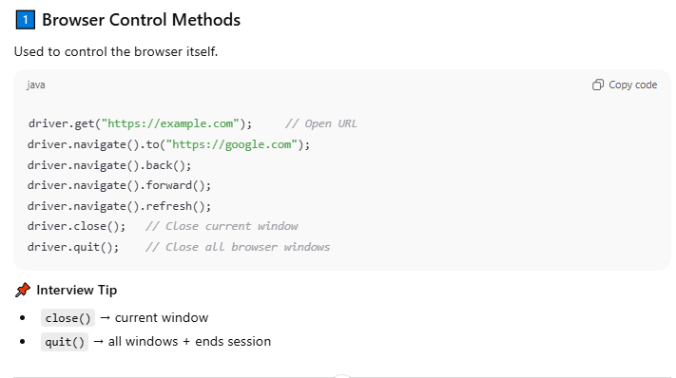

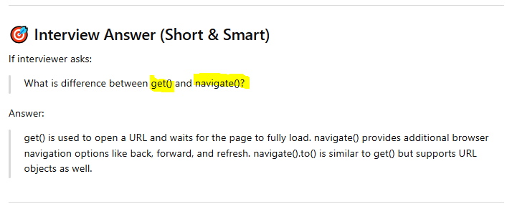

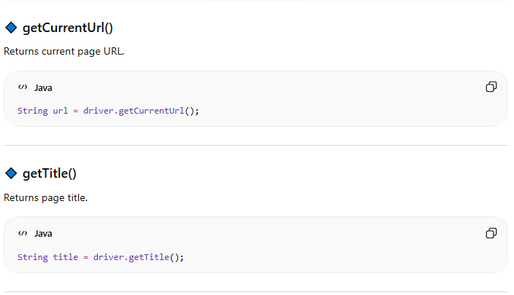

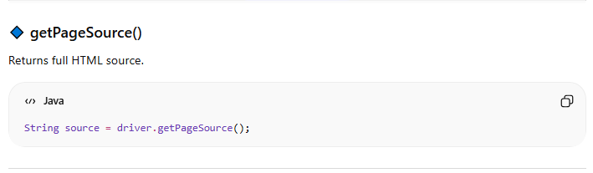

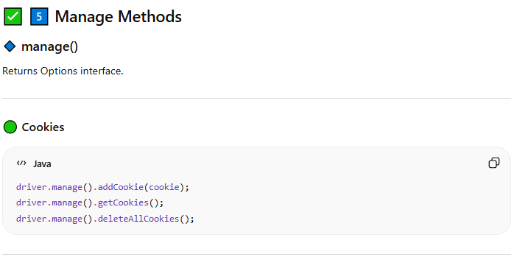

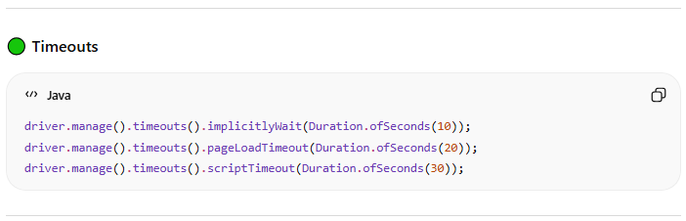

## Window & Frame Methods

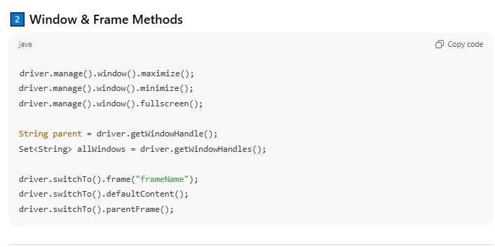

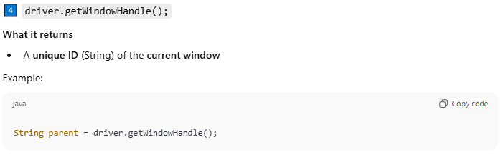

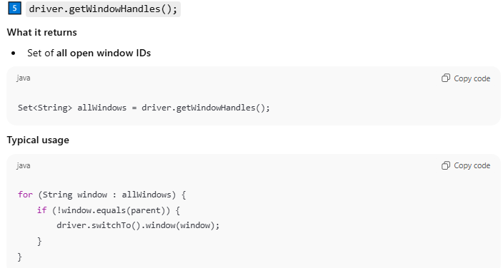

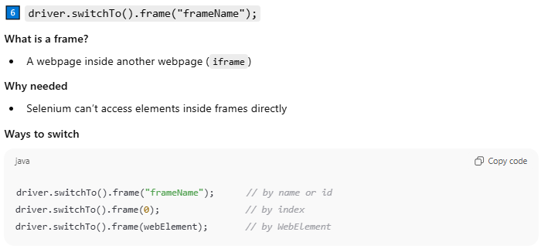

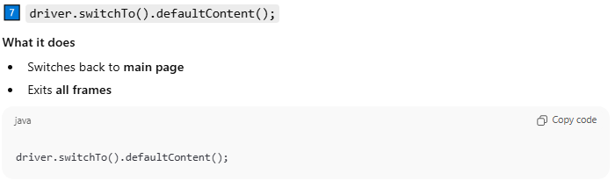

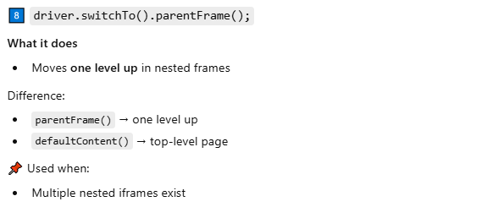

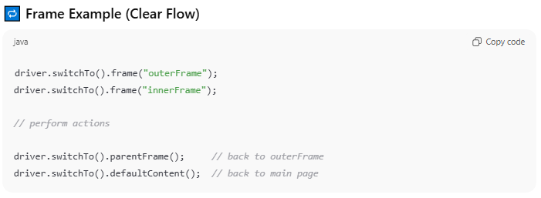

## Open new window tab

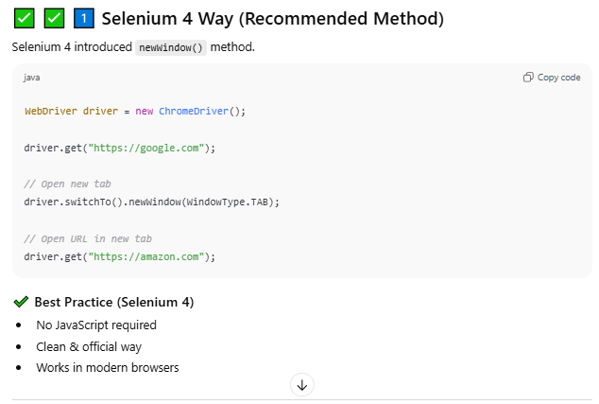

## Find Element Methods

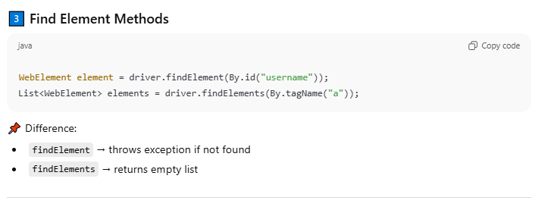

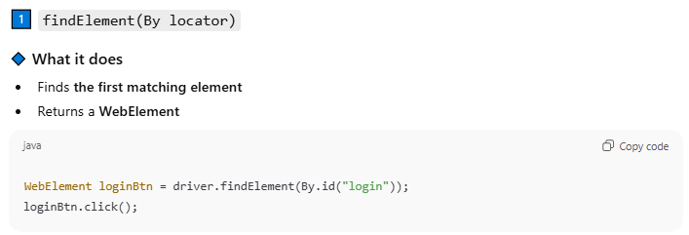

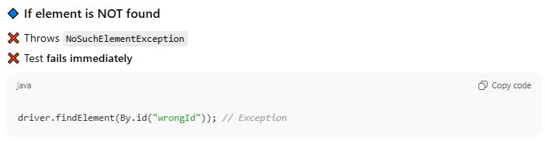

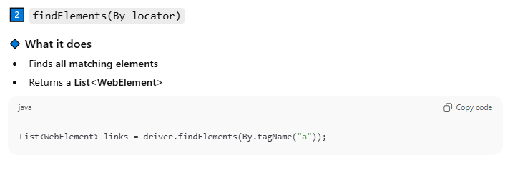

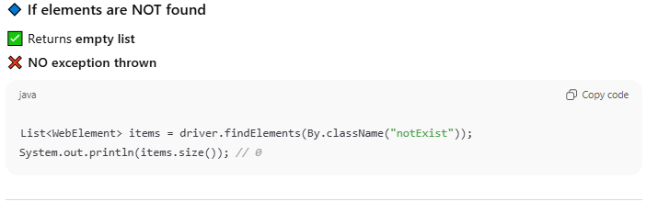

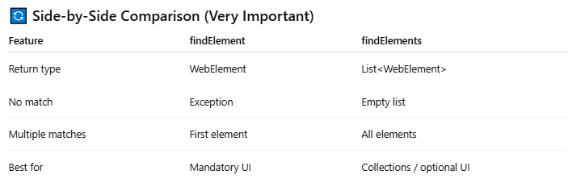

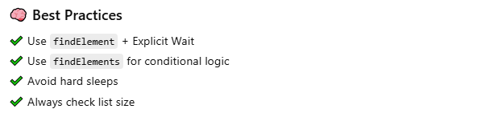

## WebElement Action Methods

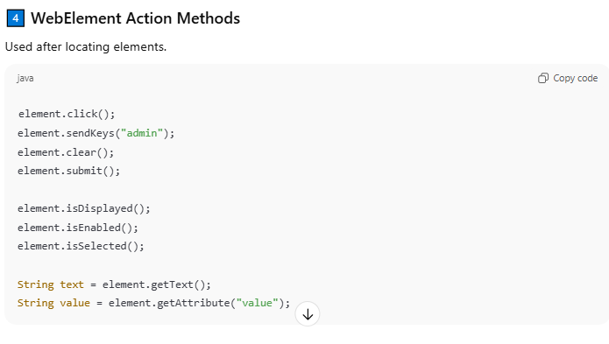

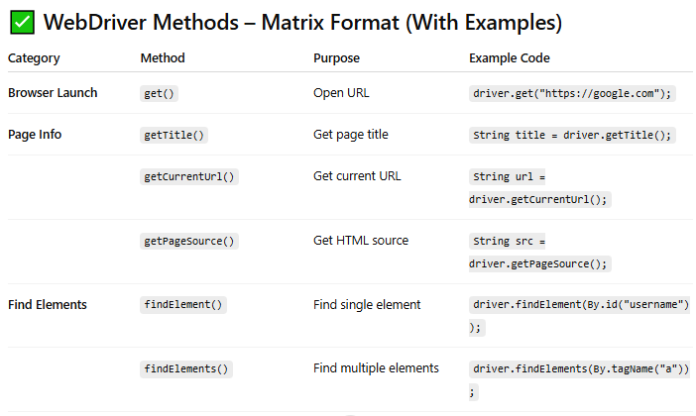

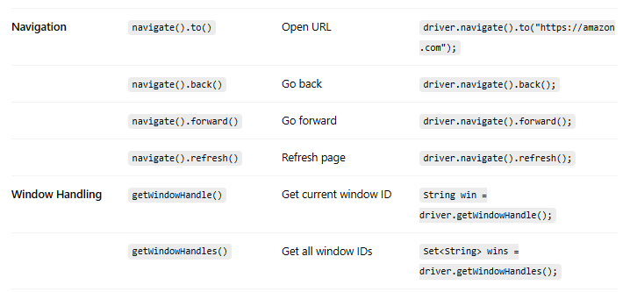

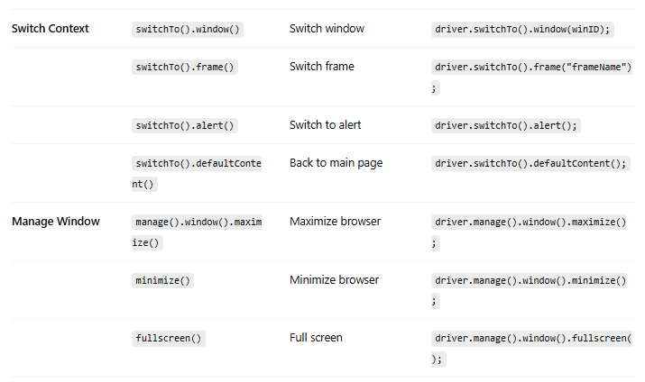

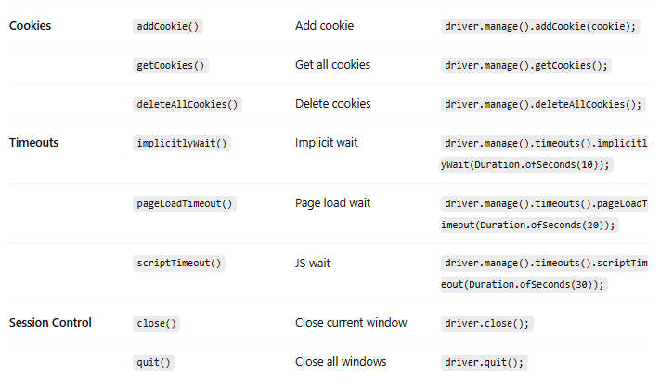

# Window Handling

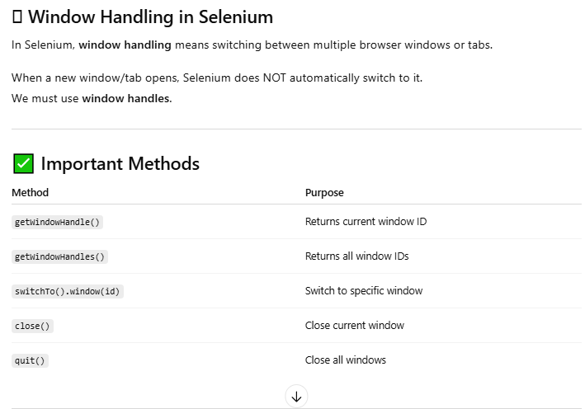

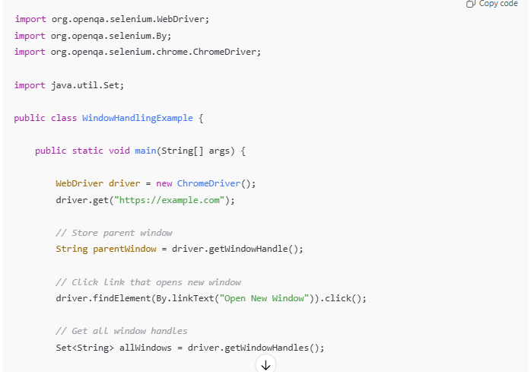

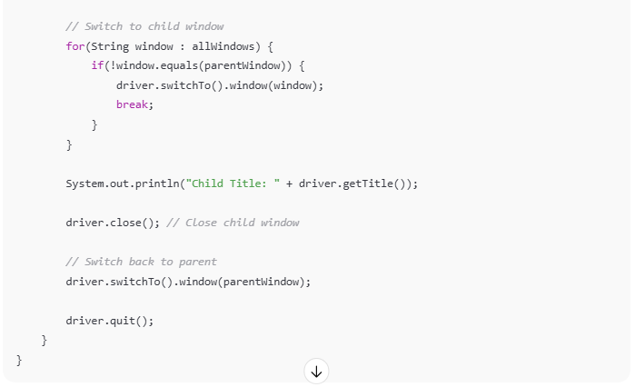

# Frame

A frame is an embedded HTML page inside another page. Selenium cannot directly access elements inside a frame. We must switch using switchTo().frame() and return using defaultContent().

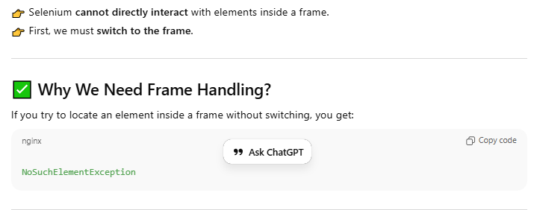

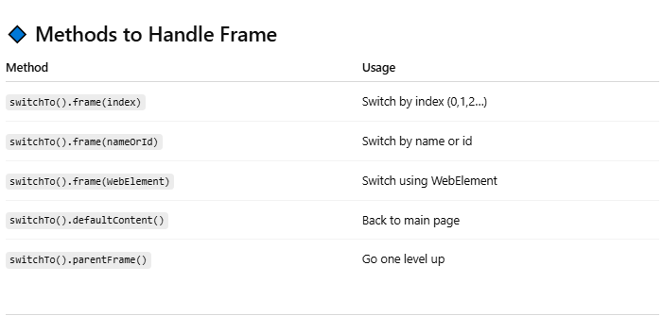

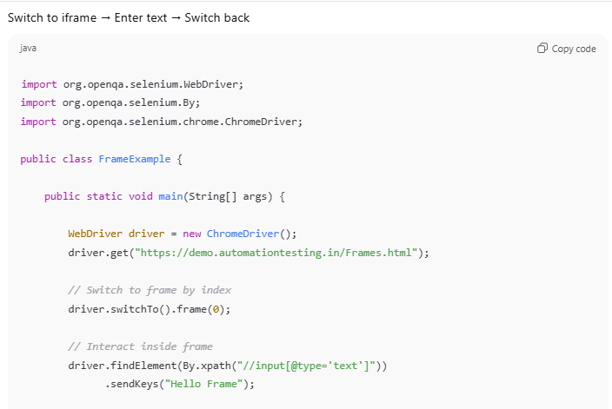

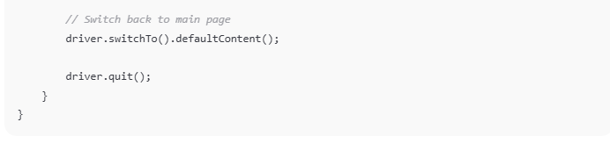

# Synchronization

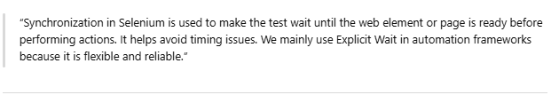

## Wait Methods

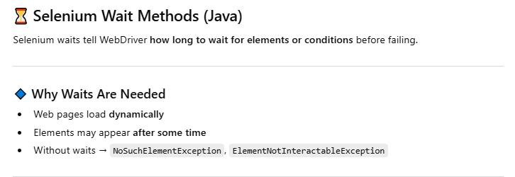

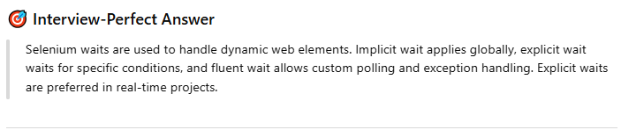

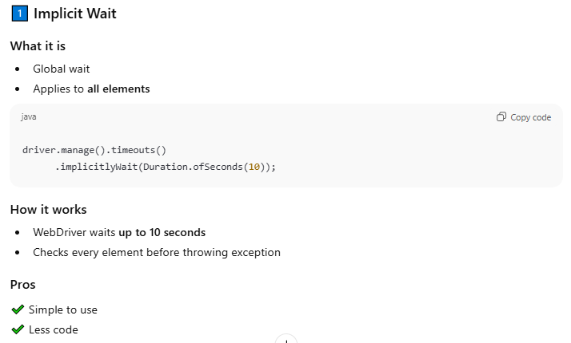

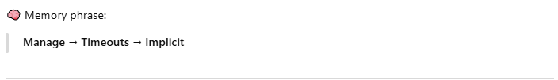

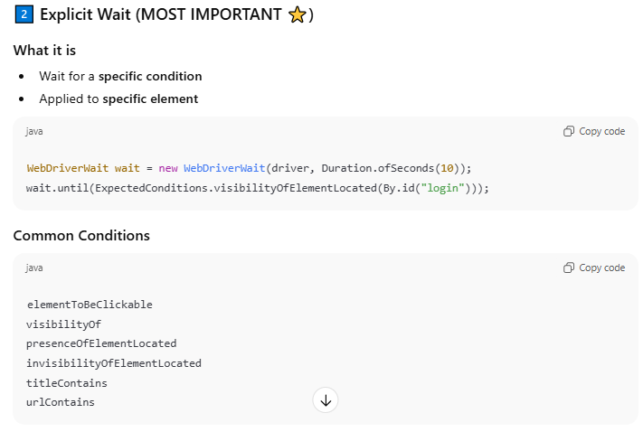

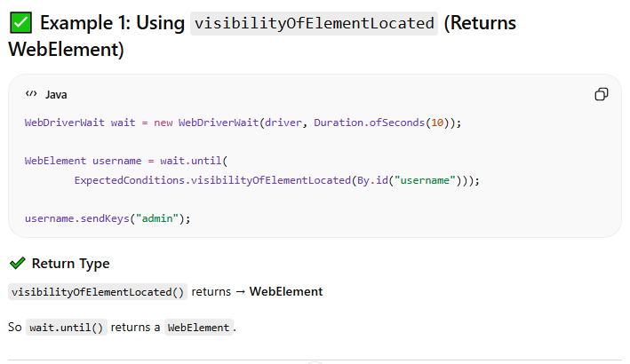

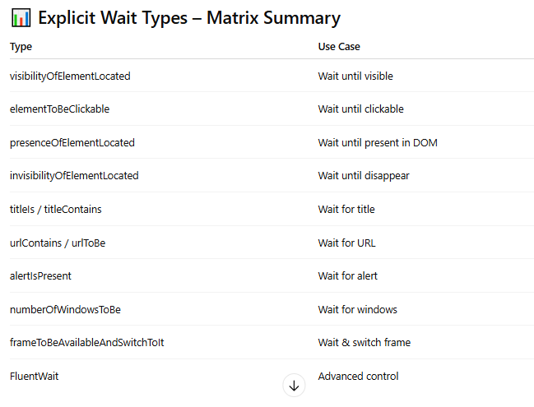

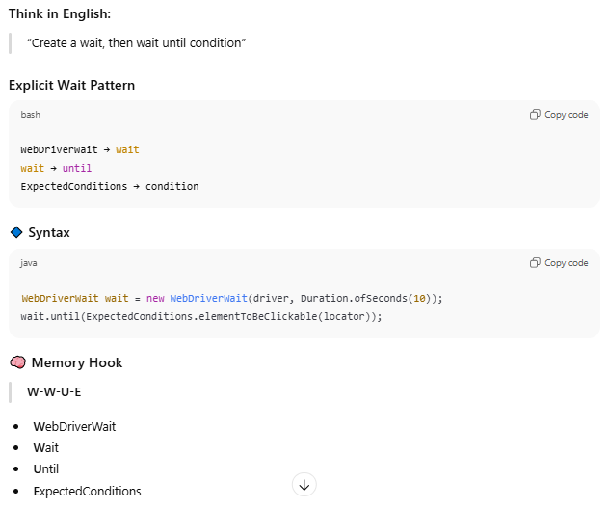

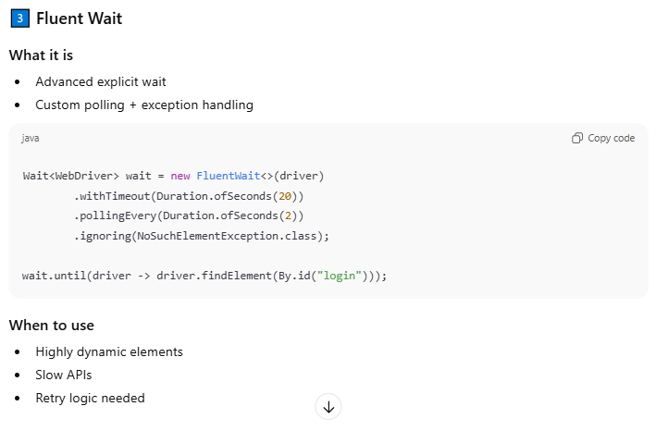

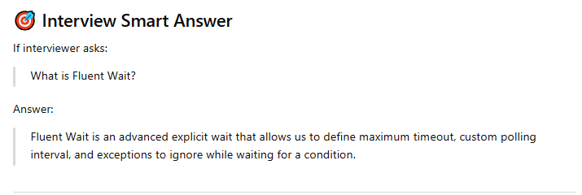

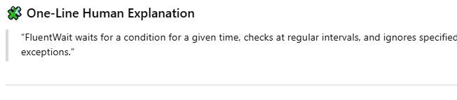

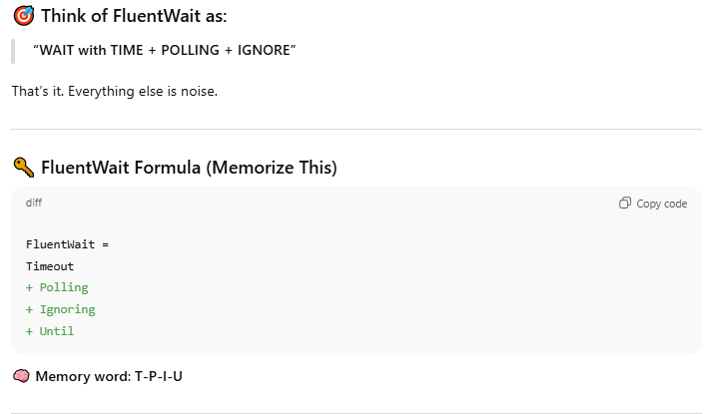

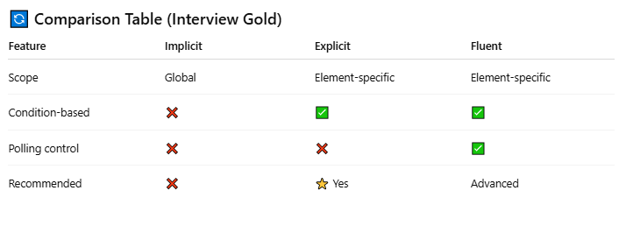

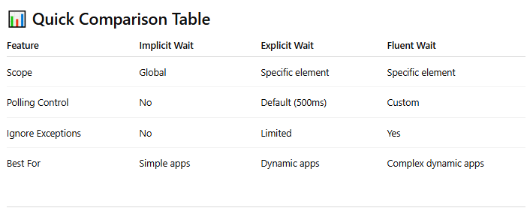

# Alert

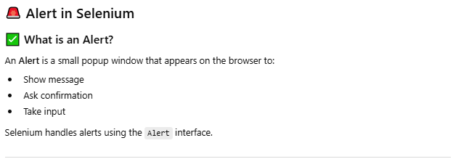

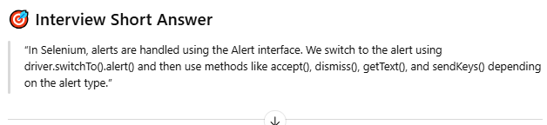

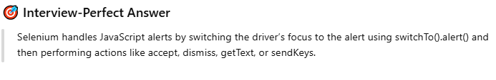

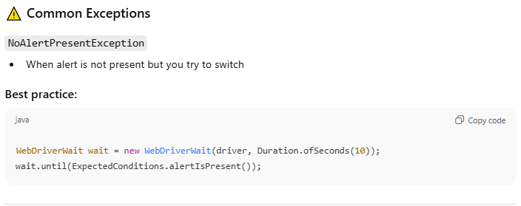

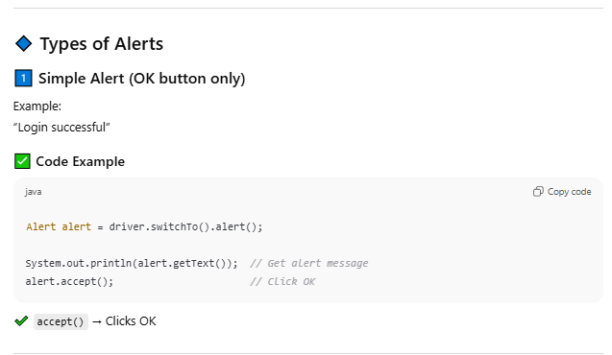

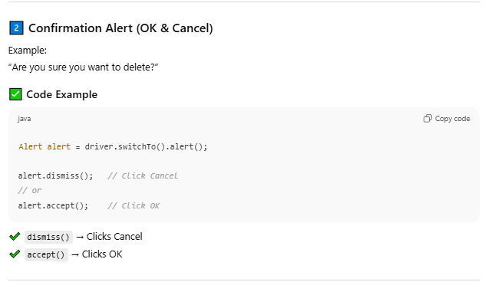

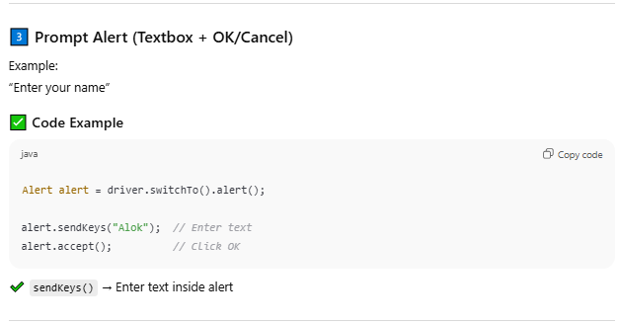

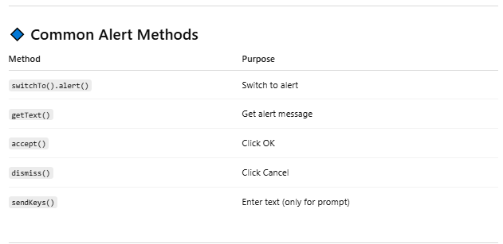

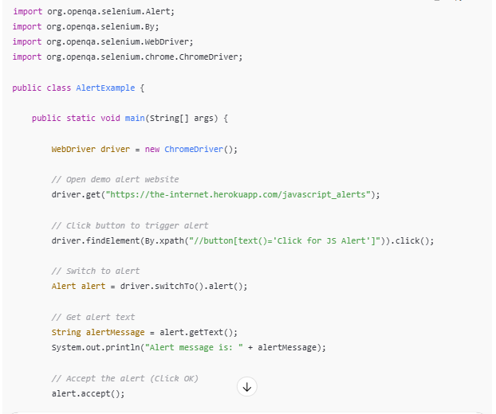

# DropDown

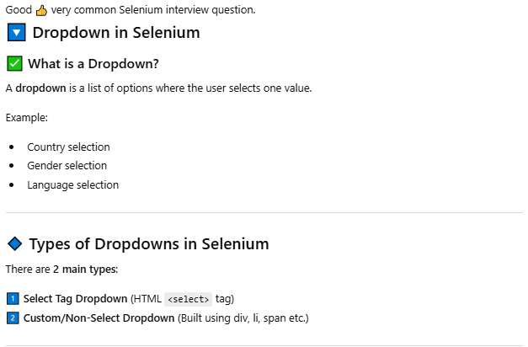

### Select Tag

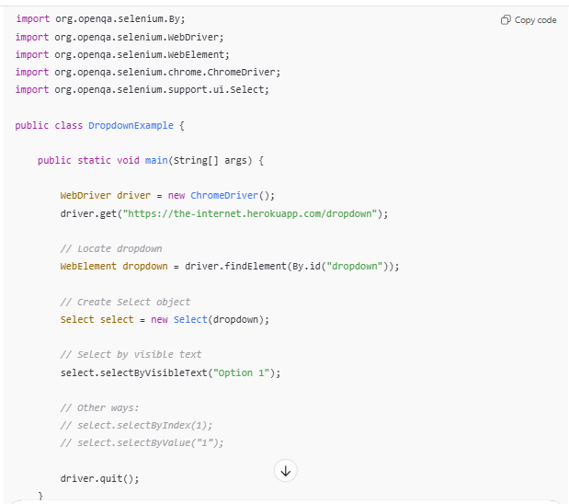

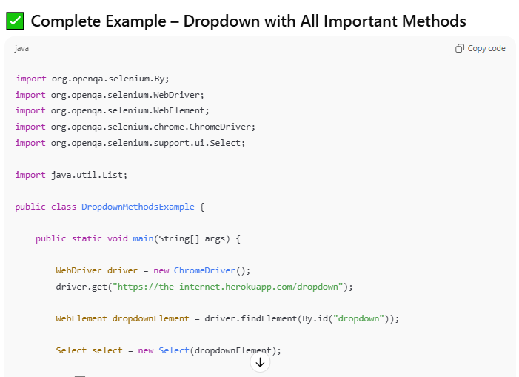

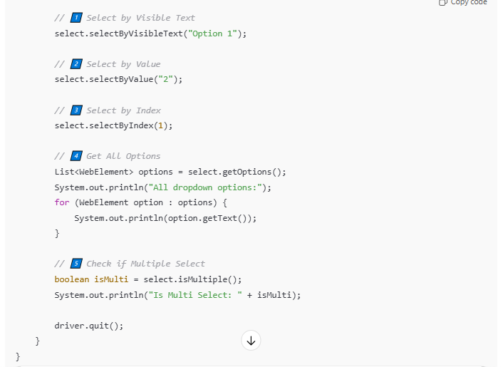

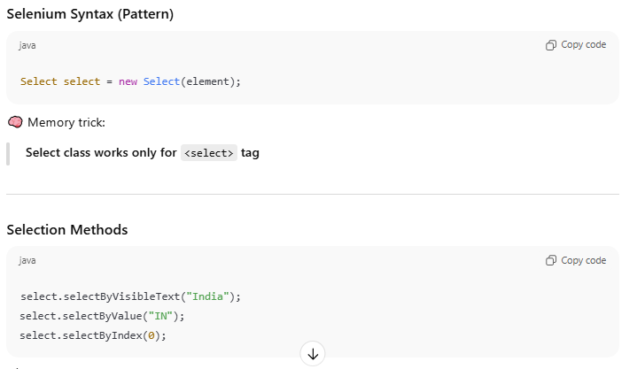

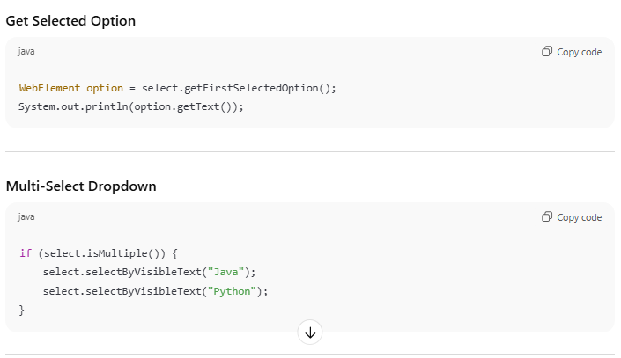

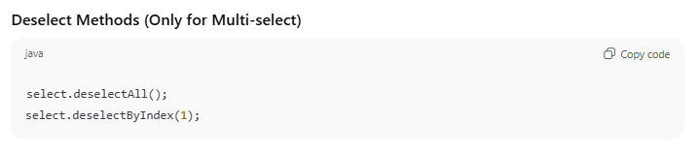

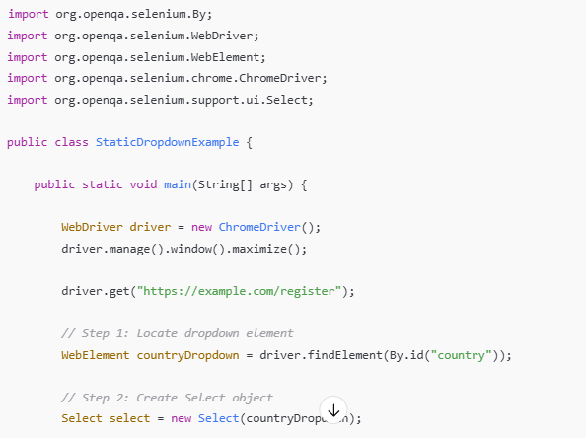

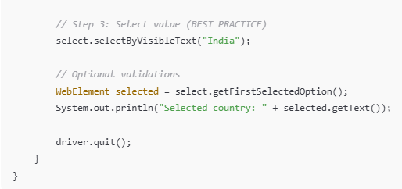

**Multi Select**

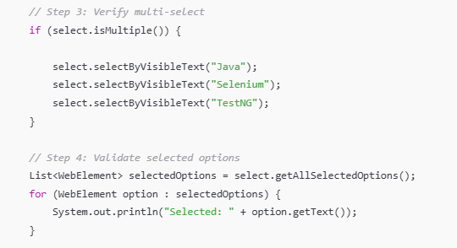

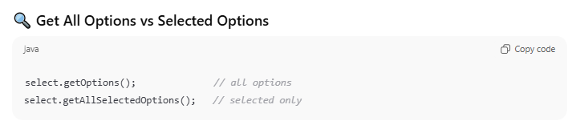

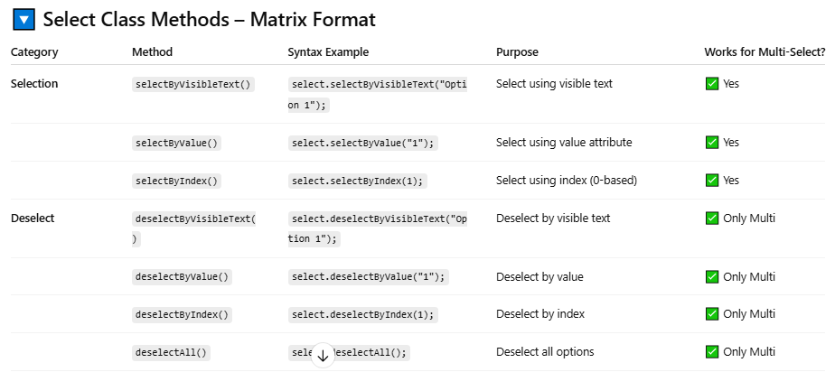

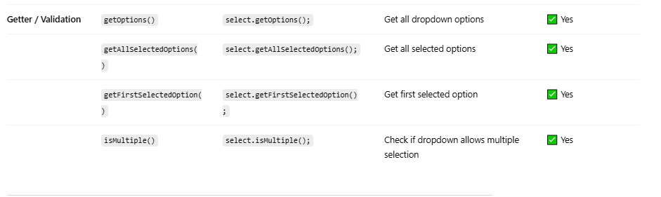

**Methods –**

* **selectByVisibleText(“Text”)**
* **selectByValue(“Dropdown”)**
* **selectByIndex(0)**
* **deselectByVisibleText(“Text”)**
* **deselectByValue(“Dropdown”)**
* **deselectByIndex(0)**
* **select.isMultiple()**
* **getOptions**
* **getFisrtSelectedOption**
* **getAllSelectedOptions**
* **deselectAll**

### Custome – Non Select

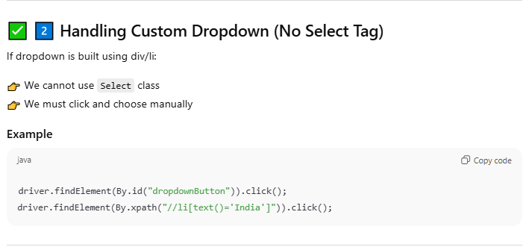

# Mouse Event

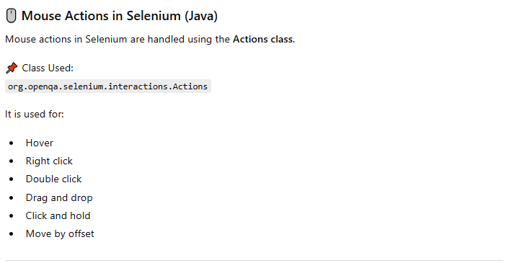

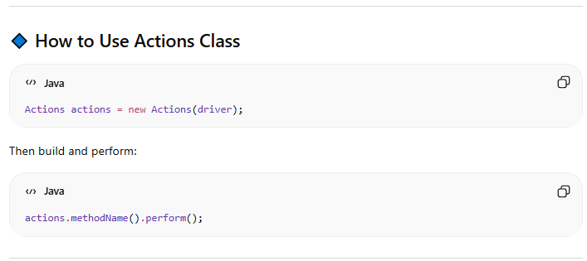



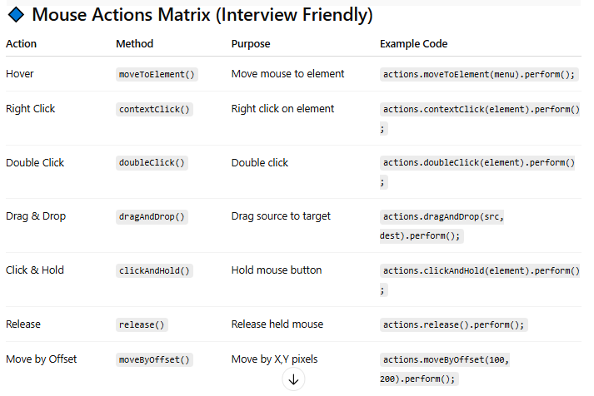

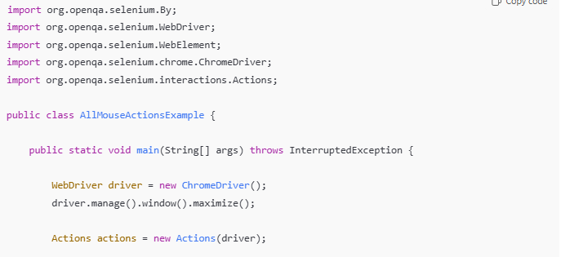

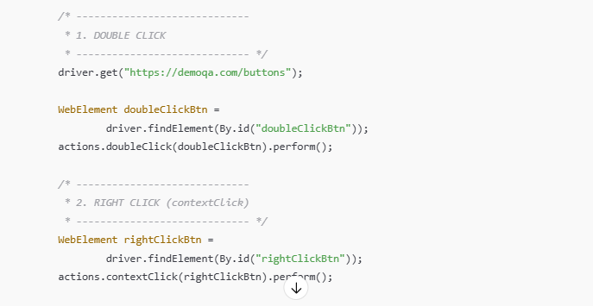

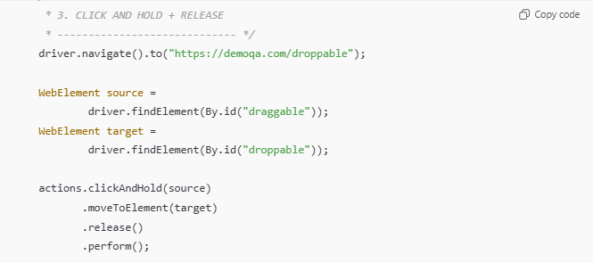

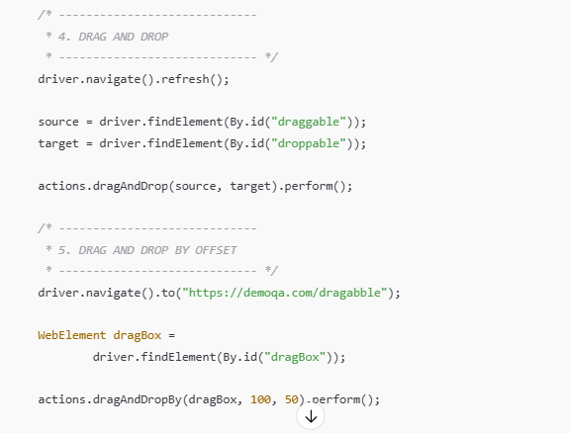

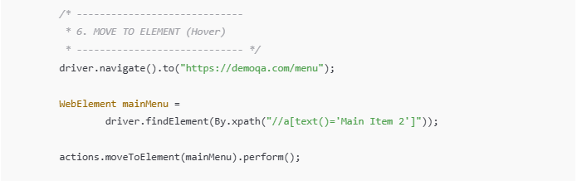

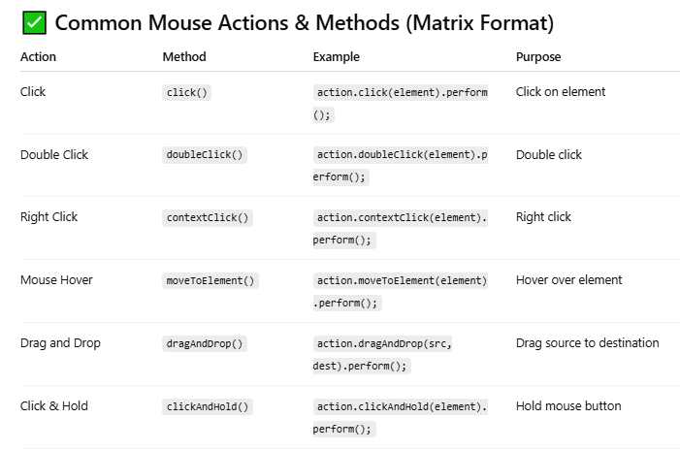

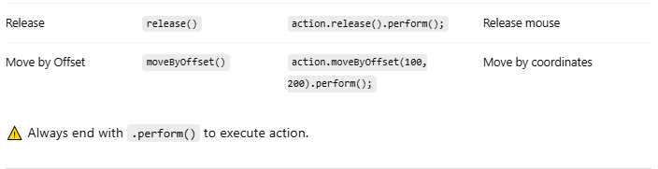

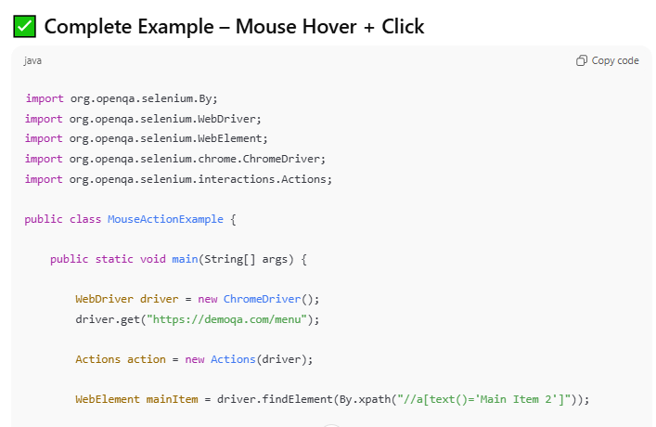

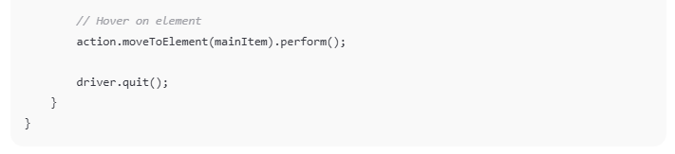

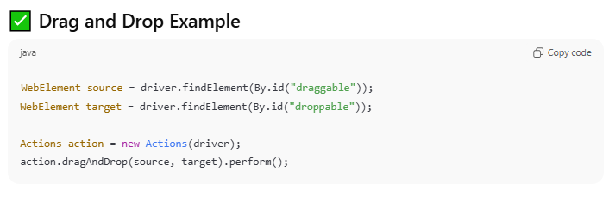

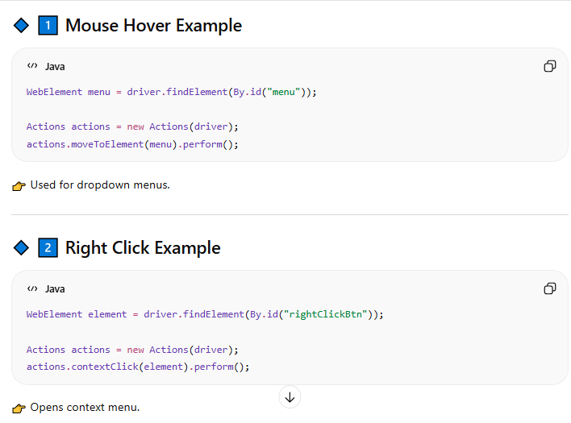

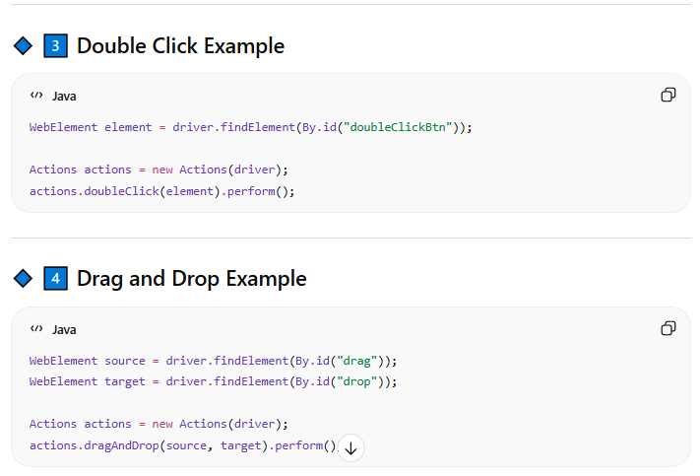

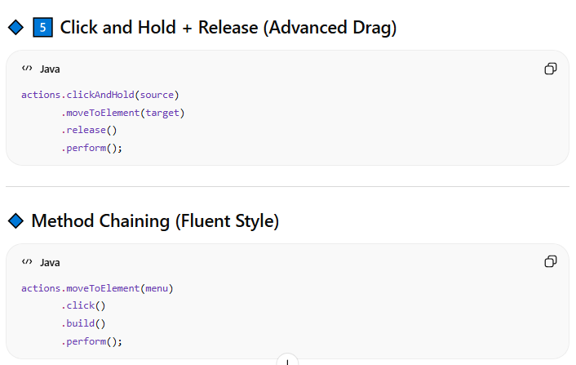

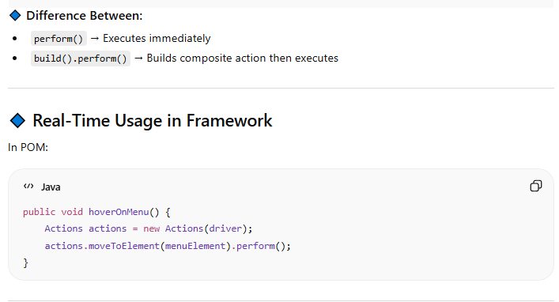

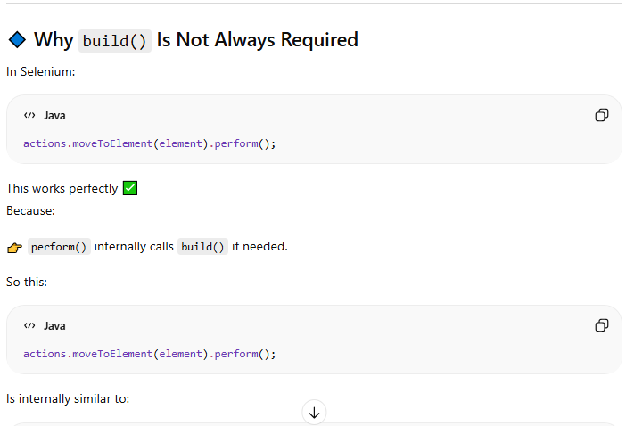

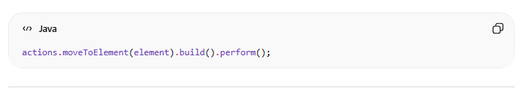

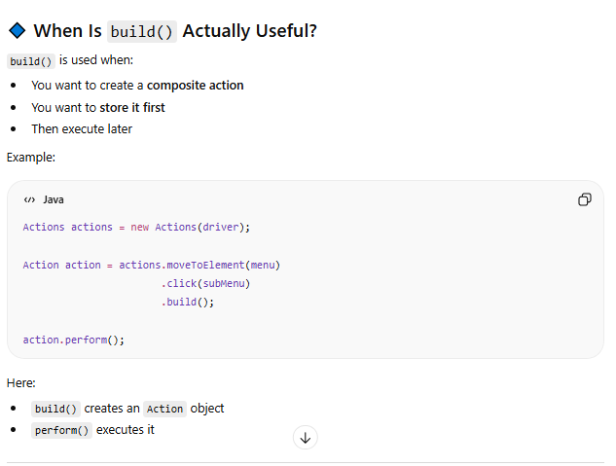

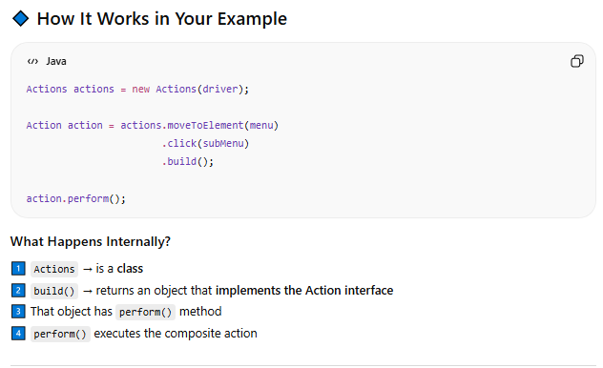

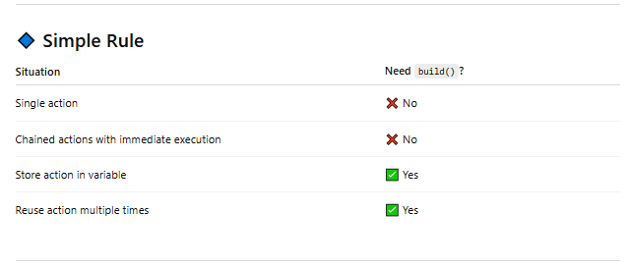

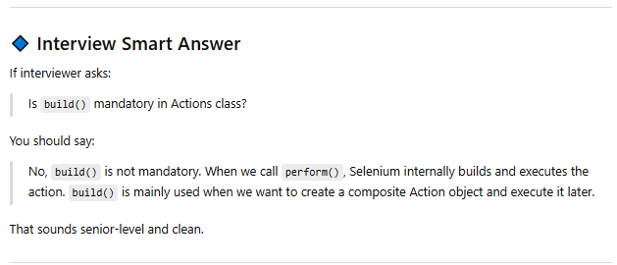

# Keyboard

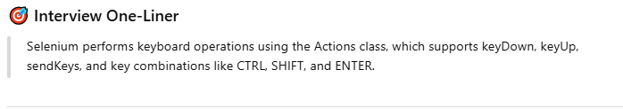

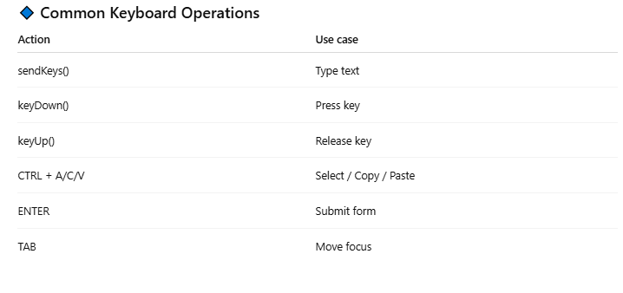

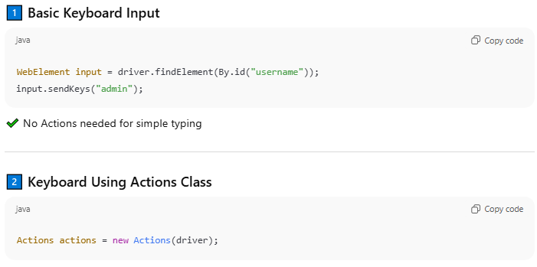

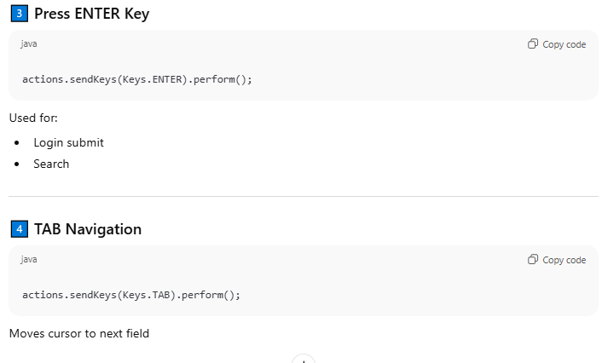

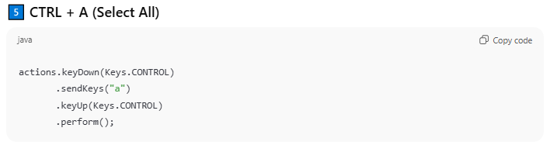

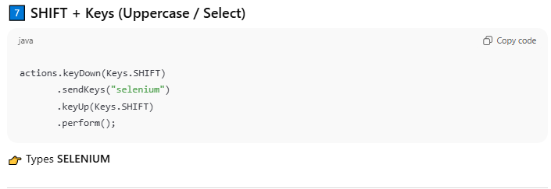

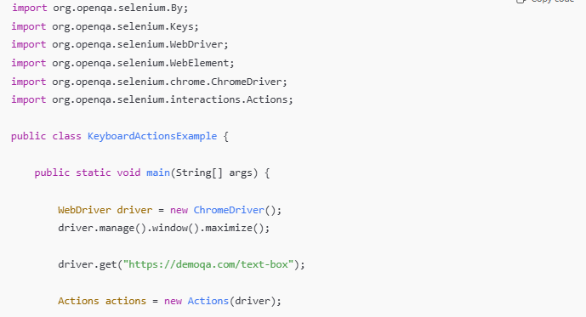

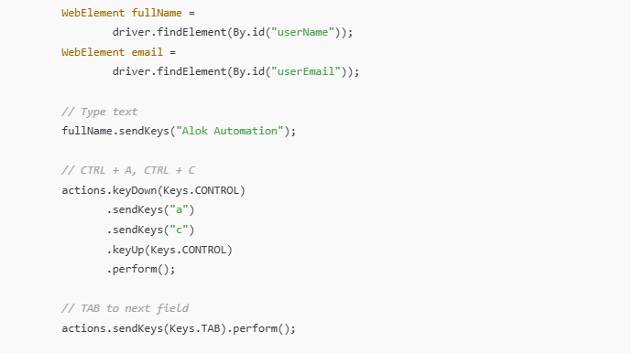

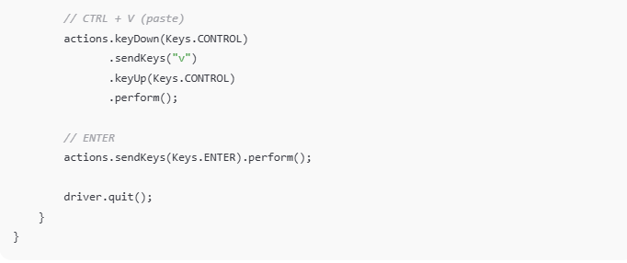

# Screenshots

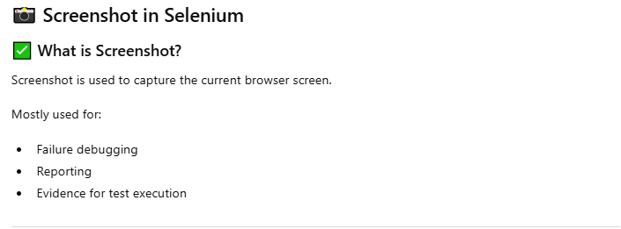

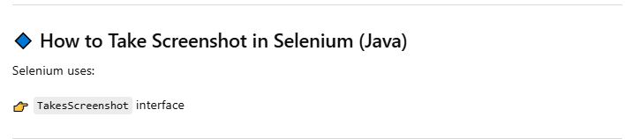

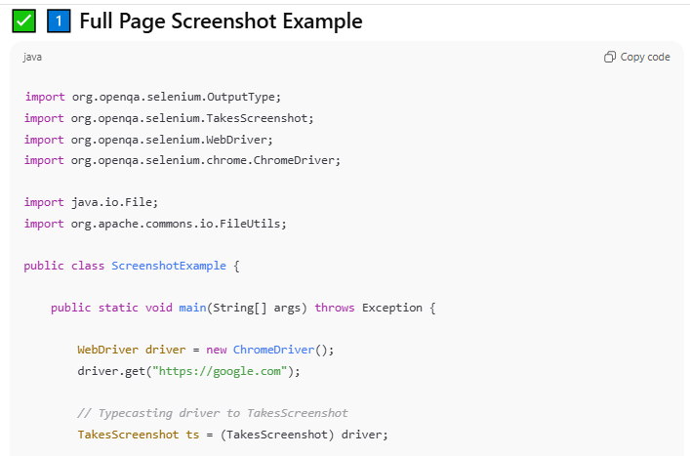

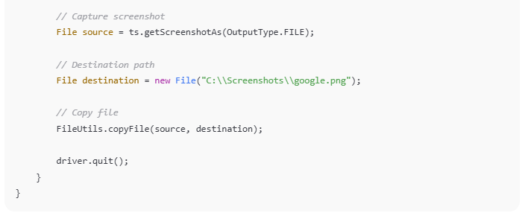

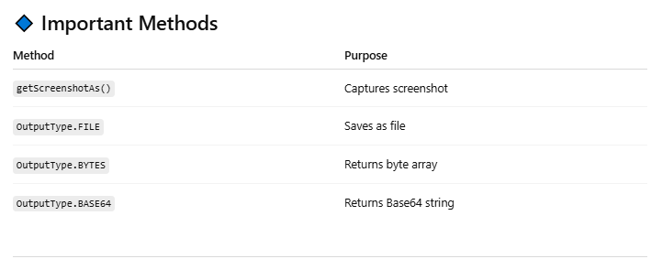

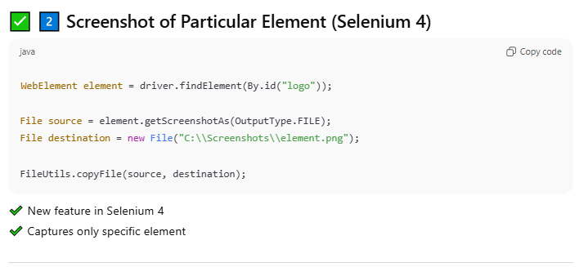

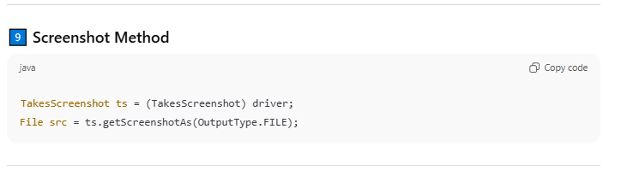

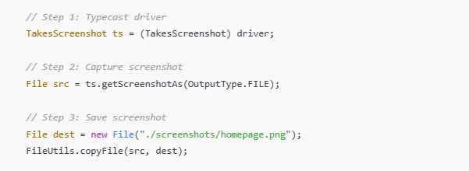

Logo capture

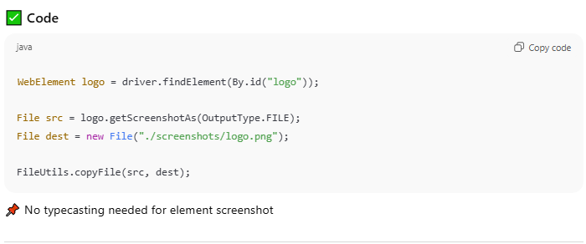

# JavaScript Executor

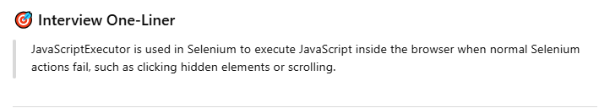

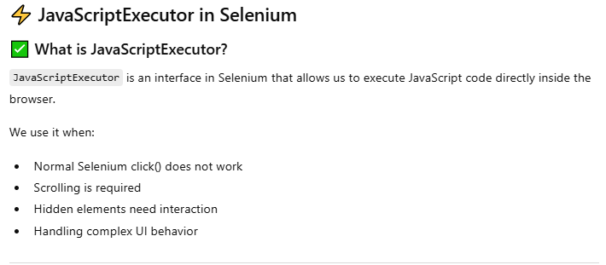

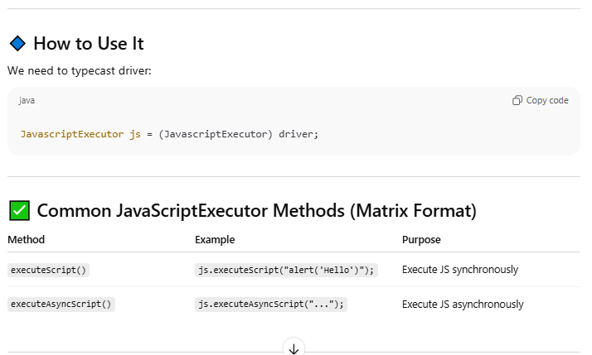

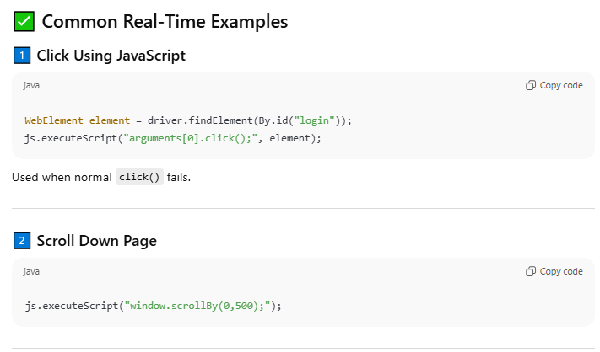

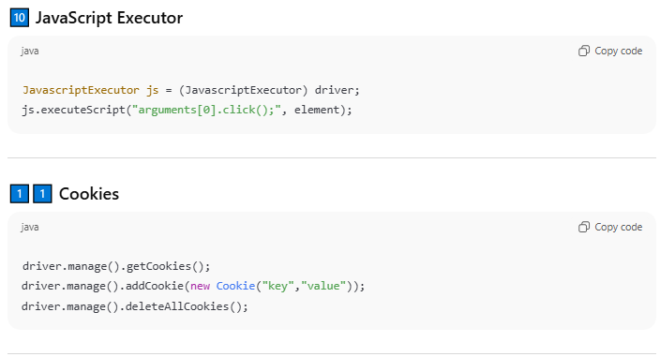

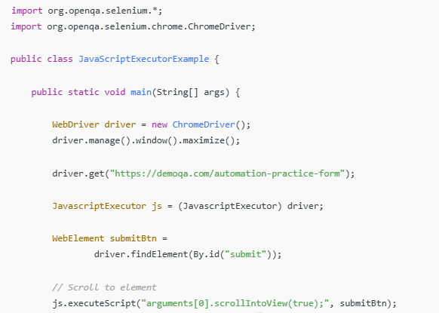

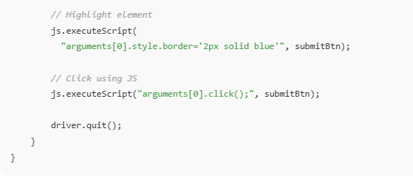

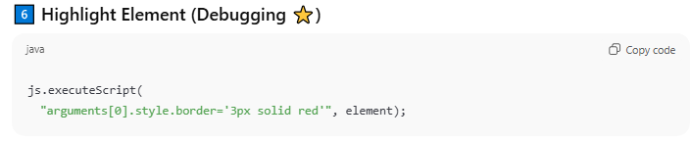

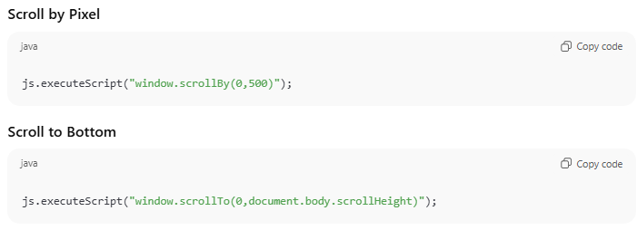

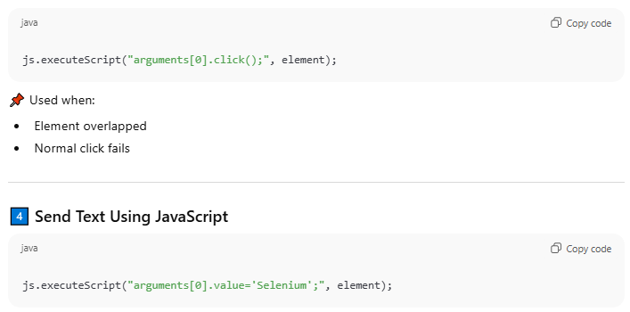

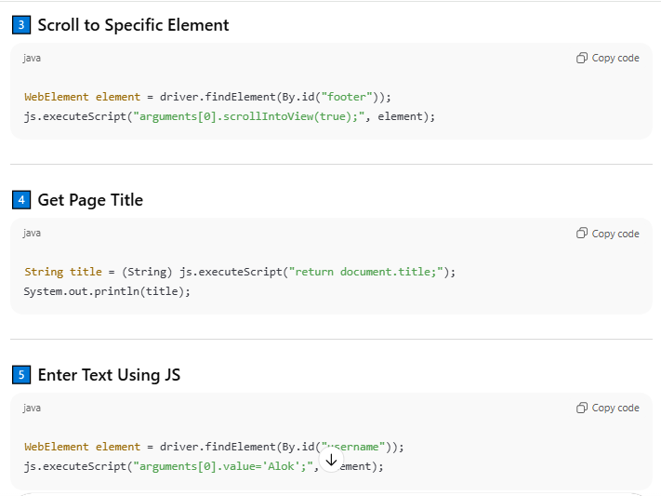

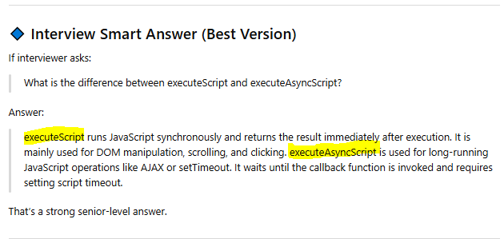

**Most Common Used –**

1. Scroll to Page
2. Scroll to Element
3. Enter text input
4. Click hidden element
5. Highlight Element debug

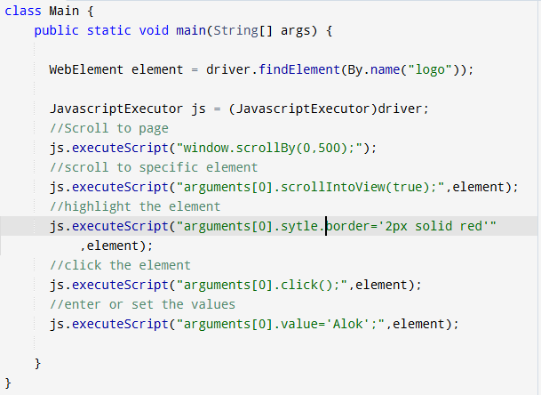

# Locator identifiers

## Regular

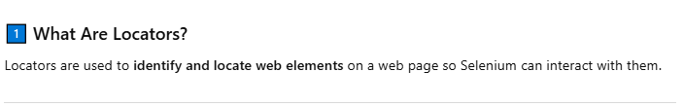

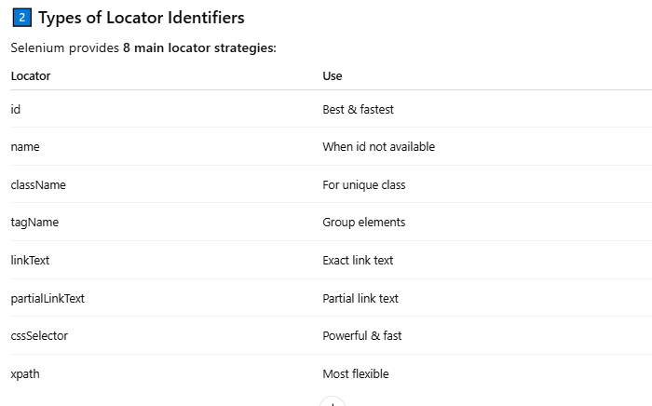

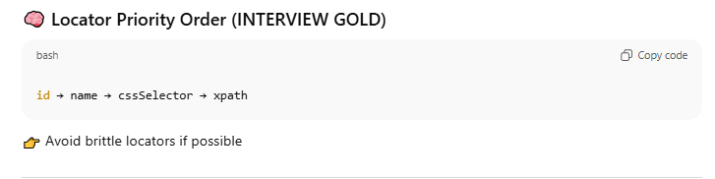

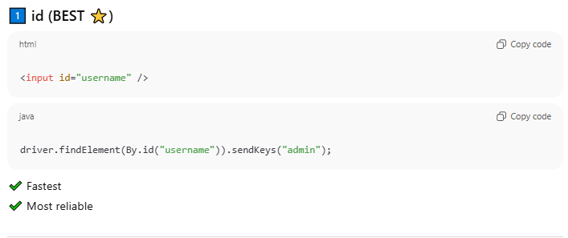

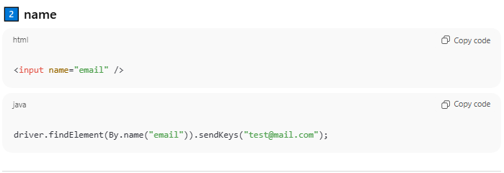

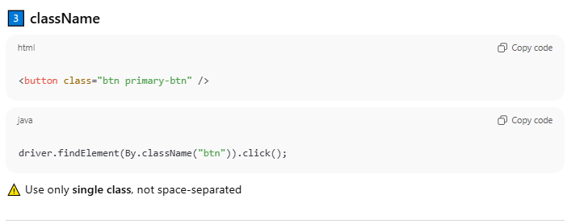

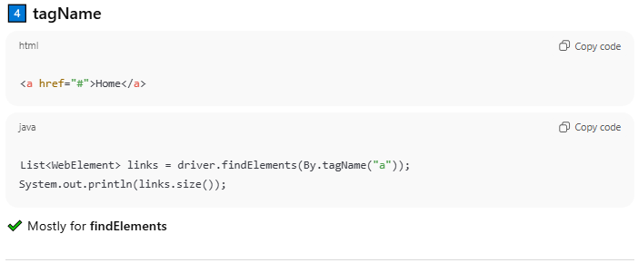

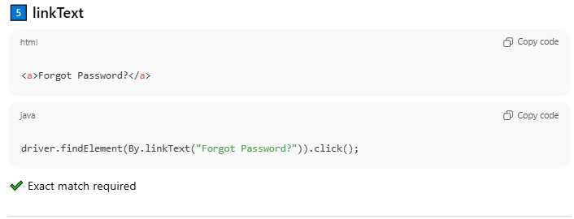

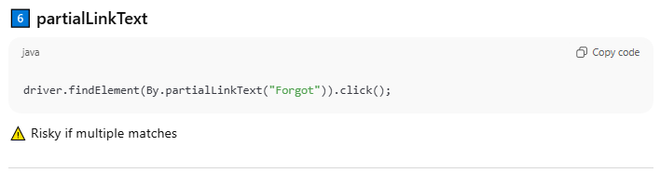

## CSS

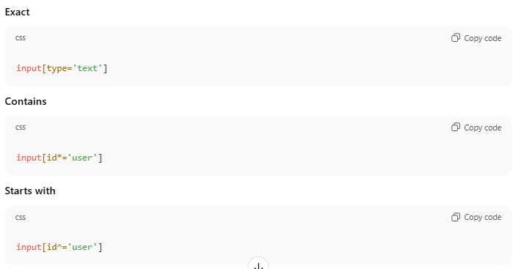

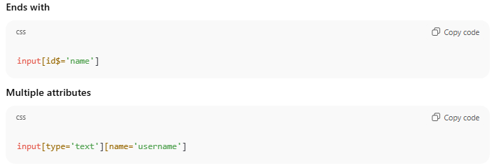

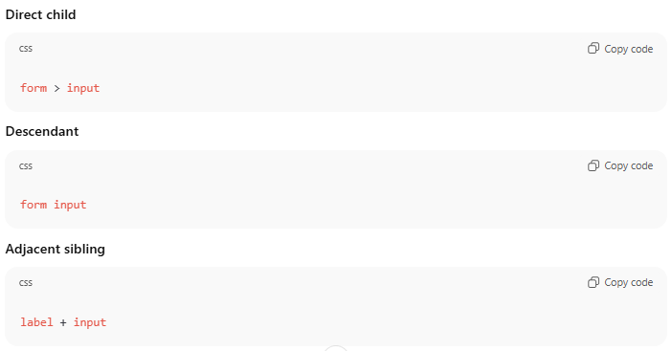

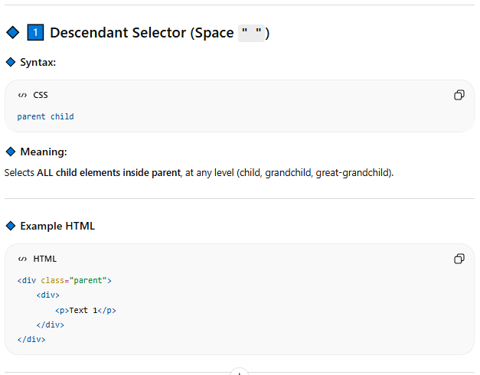

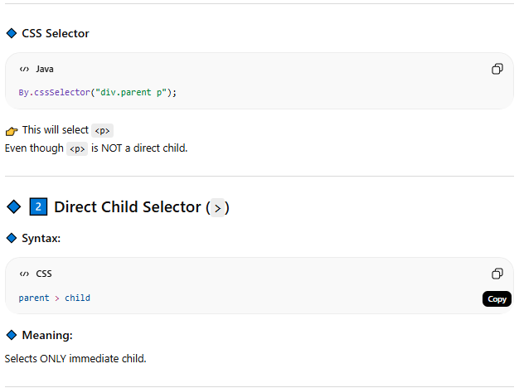

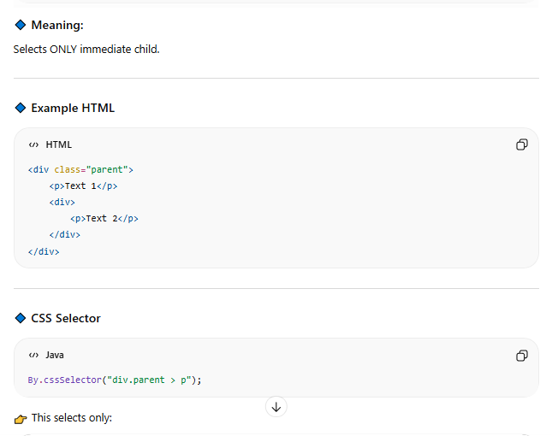

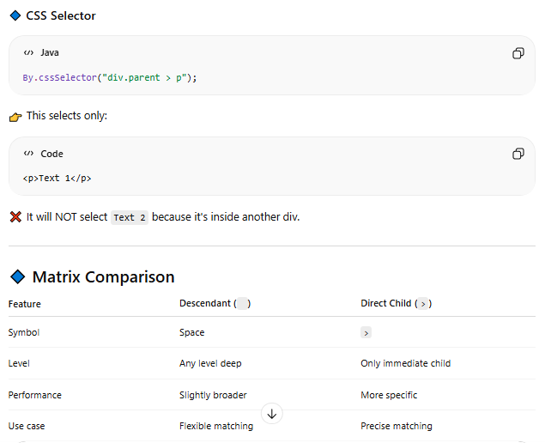

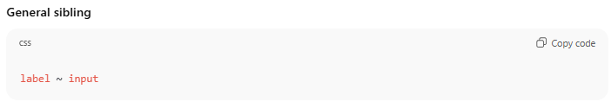

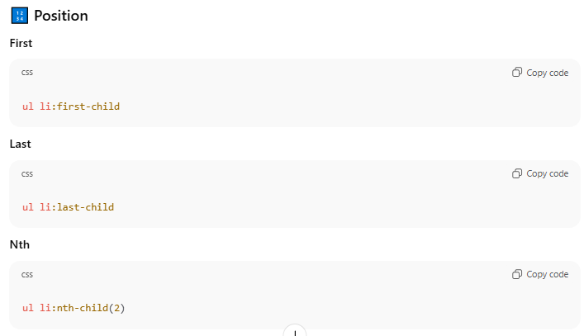

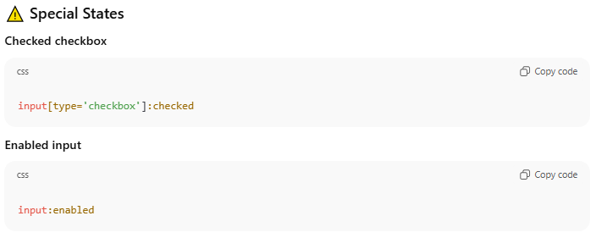

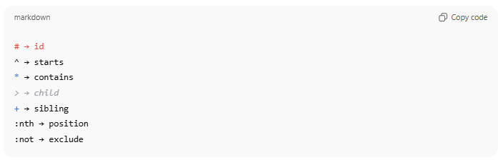

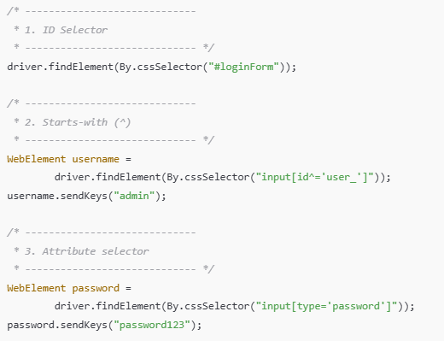

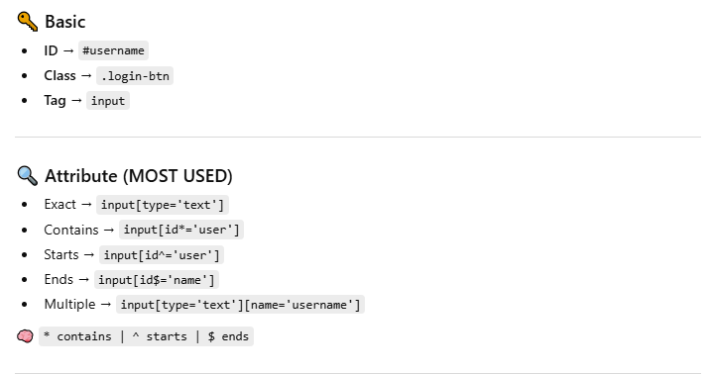

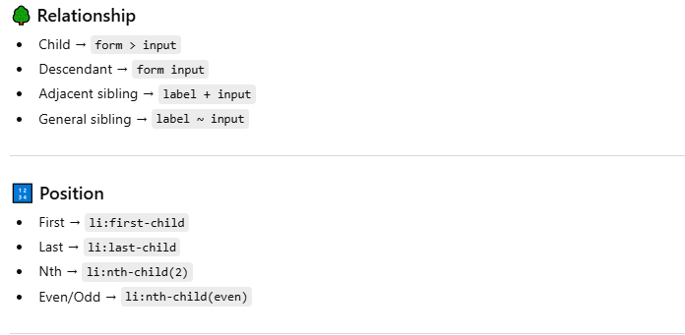

cssSelector -

----------------------

* id = #bookmark-btn
* class = .bookmark-btn
* tag = input
* tag Exact match = input[name='username']
* tag + class = div.w3-responsive
* contains = input[name*='user']
* startWith = input[name^='user']
* endWith = input[name$='name']
* multiple attribute = input[name$='name'][placeholder='Username']
* Direct child = table[class^='ws']>tbody [one level down]
* Descendant = table[class^='ws'] tbody [All down level], table[class^='ws'] tr
* Adjacent sibling = tbody tr+tr
* First position = tbody>tr>th:first-child
* Last Child = tbody>tr>th:first-child
* nth position = tbody>tr>th:nth-child(3)
* tbody>tr>th:nth-child(even),tbody>tr>th:nth-child(odd)
* driver.findElement(By.cssSelector("tbody>tr>th:first-child")).click()

## Xpath

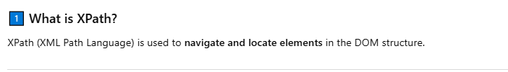

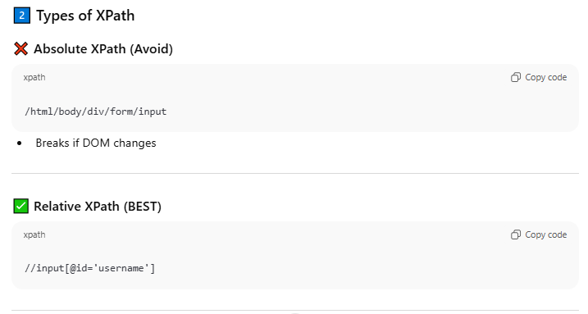

Absolute XPath starts from the **root of the DOM (/html)** and goes through **every node** till the element.

Relative XPath starts from **anywhere in the DOM** using //.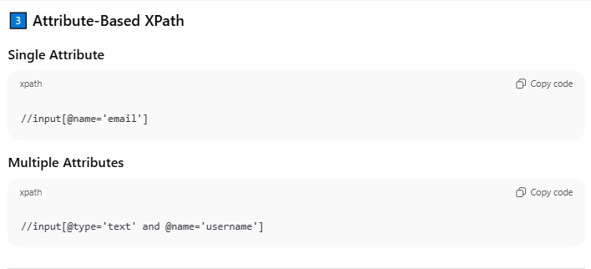

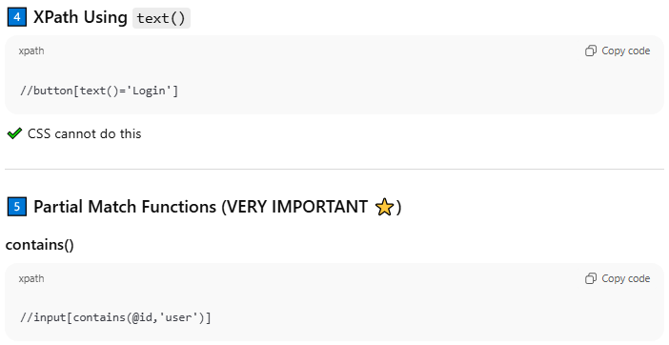

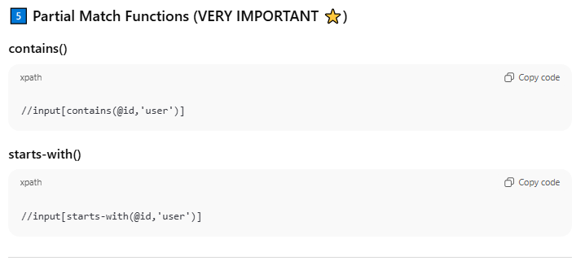

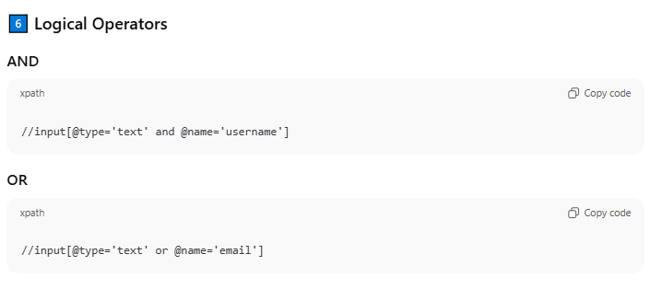

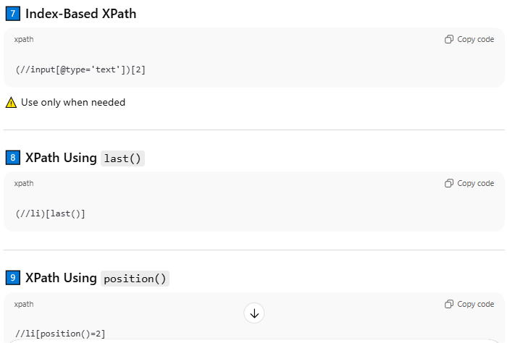

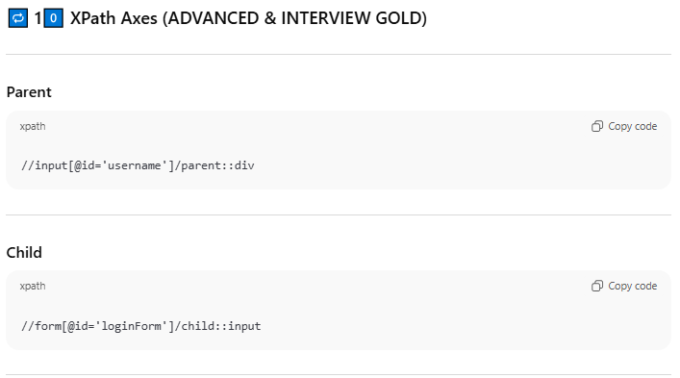

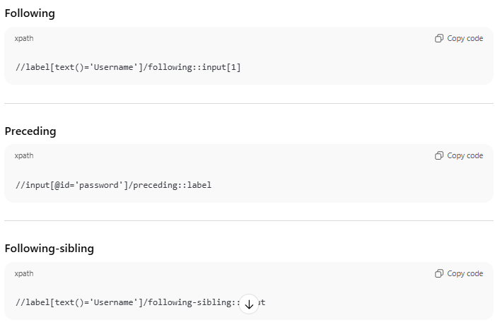

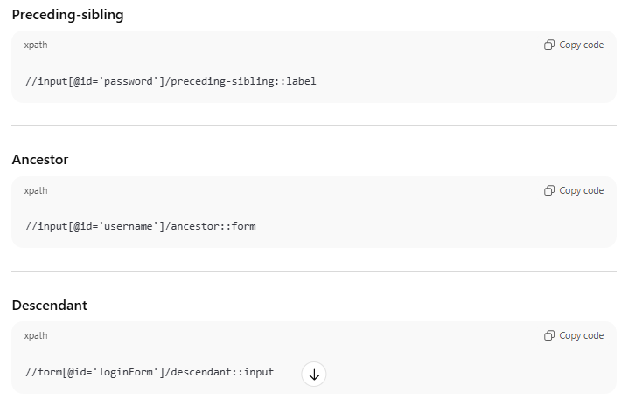

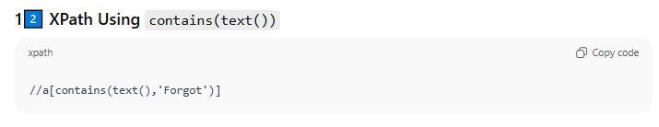

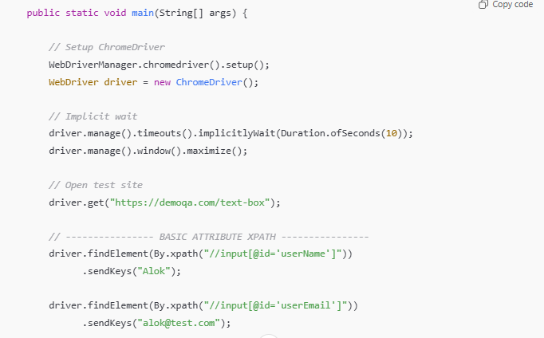

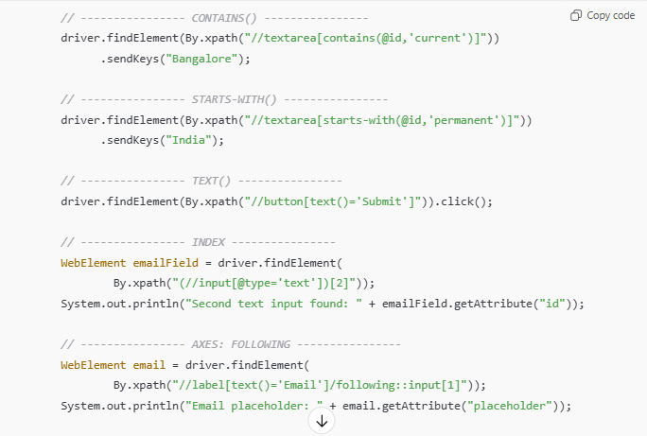

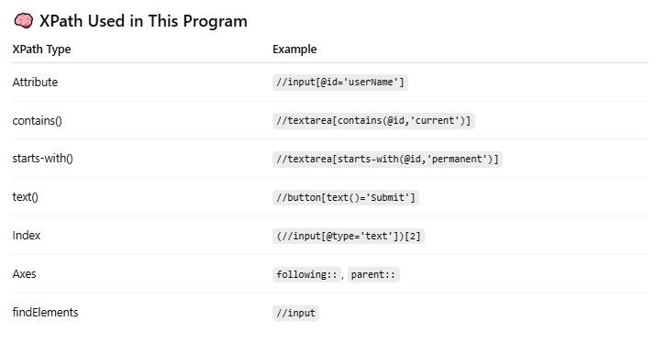

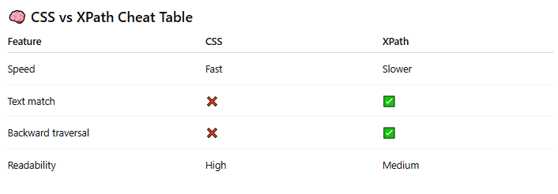

* text = //label[text()='Username']
* contains = //input[contains(@name,'user')]
* starts-with = //input[starts-with(@name,'user')]
* ends-with = NA
* AND = //input[@name='username' and @placeholder='Username']
* OR = //input[@name='username' or @placeholder='Username']
* Index-Based-Xpath = (//form/div[@class='quizoption'])[2]
* Index-Based-Xpath last() = (//form/div[@class='quizoption'])[last()]
* Index-Based-Xpath position() = (//form/div[@class='quizoption'])[position()=3]
* parent = //input[@name='username']/parent::div 'immediate parent
* child = //tbody/child::tr[1]
* following = //tbody/tr[1]/following::tr[2]
* preceding = //tbody/tr[6]/preceding::tr[5]
* following-sibling = //tbody/tr[1]/following-sibling::tr[2]
* preceding-sibling = //tbody/tr[1]/following-sibling::tr[2]

# FindElement vs FindElements

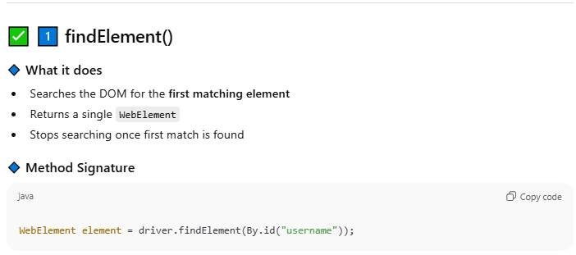

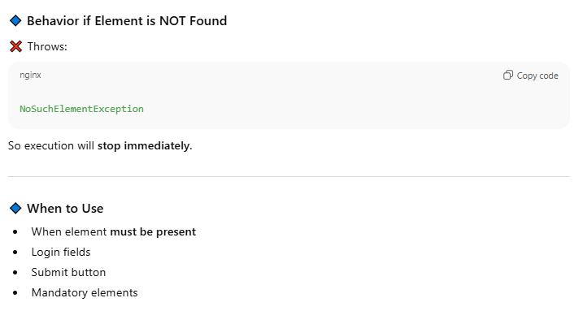

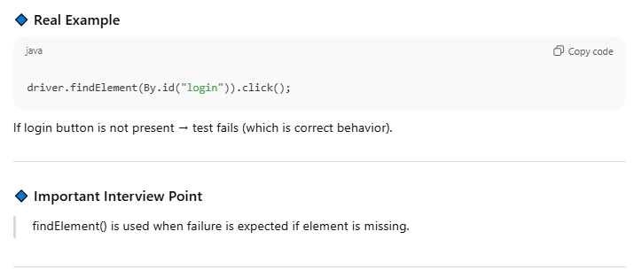

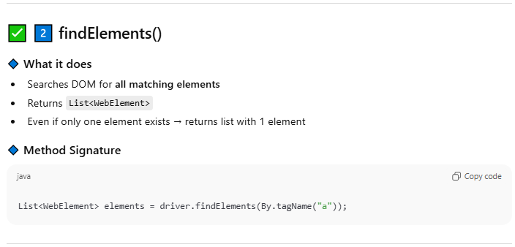

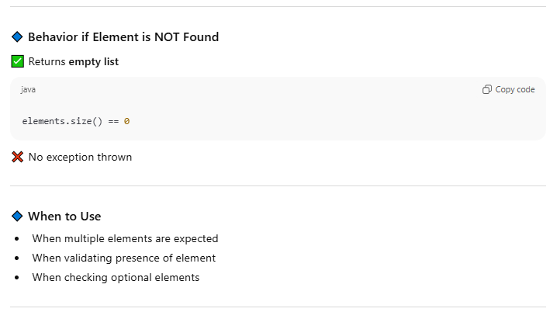

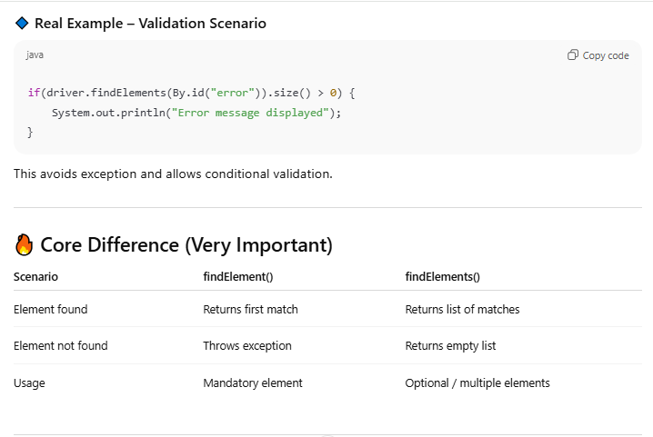

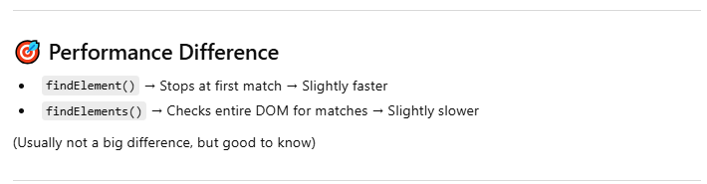

|  |  |
| --- | --- |
| **Find Element** | **Find Elements** |
| Returns the first most web element if there are multiple web elements found with the same locator | Returns a list of web elements |
| Throws exception NoSuchElementException if there are no elements matching the locator strategy | Returns an empty list if there are no web elements matching the locator strategy |
| It will only find one web element | It will find a collection of elements whose match the locator strategy. |
| Not Applicable | Each Web element is indexed with a number starting from 0 just like an array |

# Radio Button & Checkbox

## Radio button

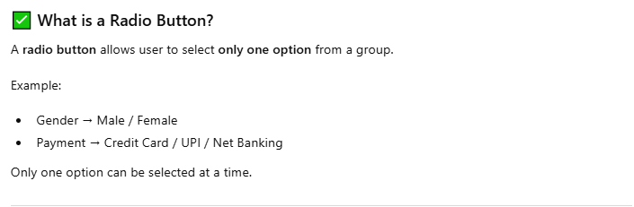

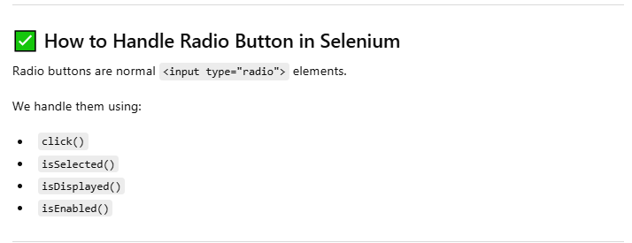

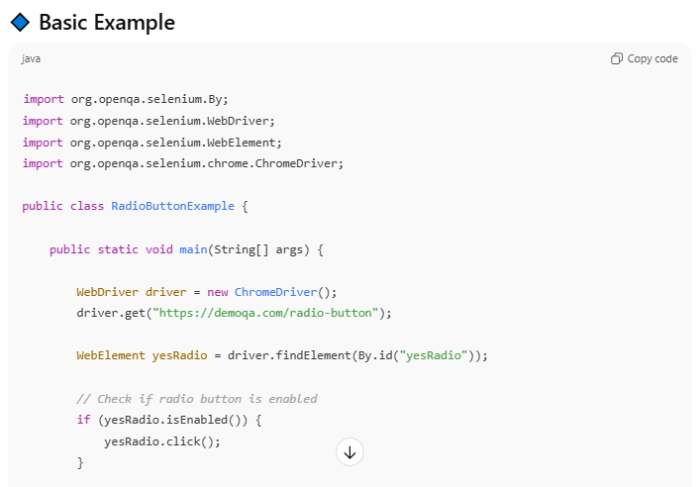

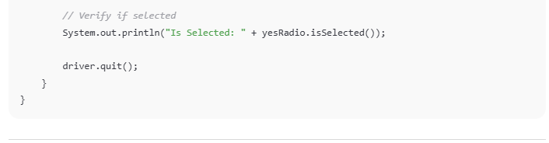

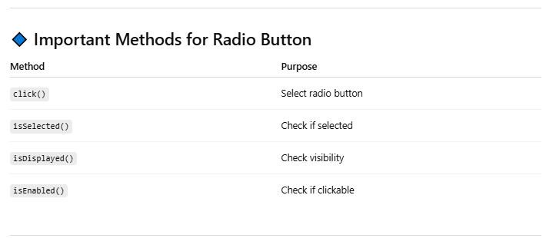

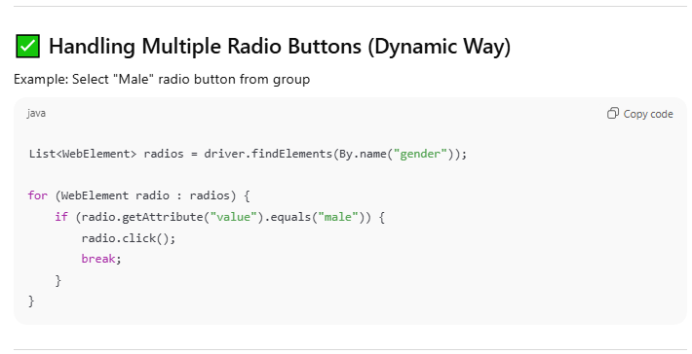

## Check box

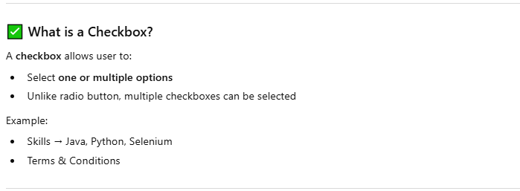

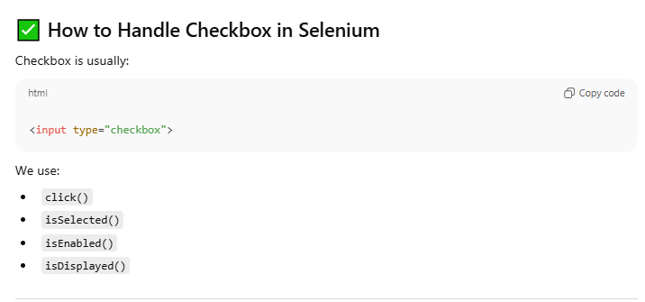

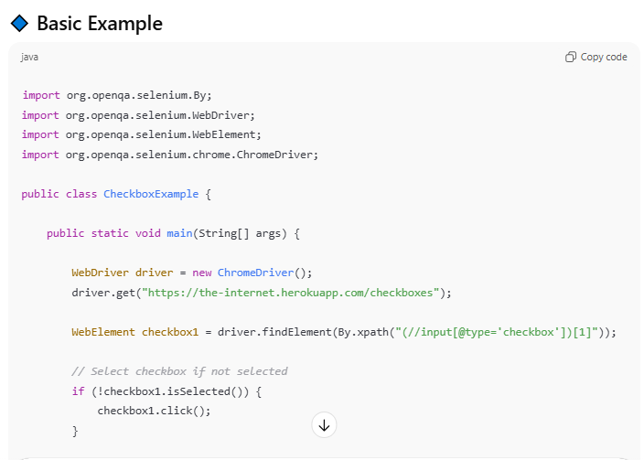

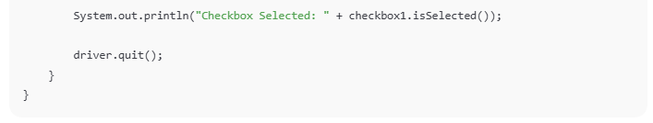

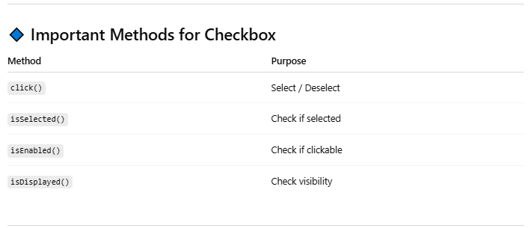

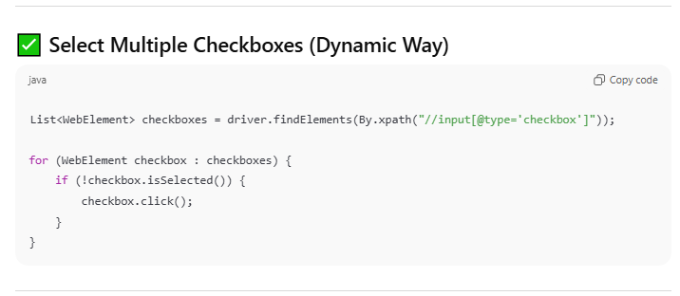

# WebTable Grid

There are two types of HTML tables published on the web-

1. Static tables: Data is static i.e. Number of rows and columns are fixed.
2. Dynamic tables: Data is dynamic i.e. Number of rows and columns are NOT fixed.

Web tables are basically a group of elements that are logically stored in a row and column format. It is used to organize similar information on a web page.

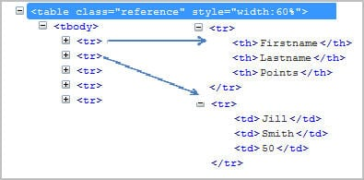

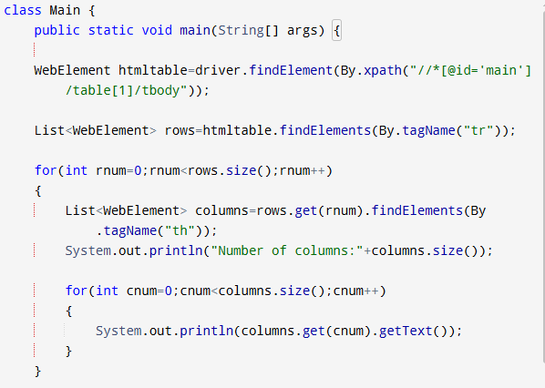

1.’table’ tag defines HTML table.  
2.’tbody’ tag defines a container for rows and columns.  
3.’tr’ defines rows in an HTML table.  
4.’td’/’th’ define the column of an HTML table.

The first approach is best suitable for the table which doesn’t change its dimensions and always remains the same. Above approach will not be a perfect solution for dynamically changing web tables.

**Let’s take above HTML table as an example:**

WebElement htmltable=driver.findElement(By.xpath("//*[@id='main']/table[1]/tbody"));

List<WebElement> rows=htmltable.findElements(By.tagName("tr"));

**for**(**int** rnum=0;rnum<rows.size();rnum++)

{

List<WebElement> columns=rows.get(rnum).findElements(By.tagName("th"));

System.out.println("Number of columns:"+columns.size());

**for**(**int** cnum=0;cnum<columns.size();cnum++)

{

System.out.println(columns.get(cnum).getText());

}

}

**Step 1**: First get the entire HTML table and store this in a variable ‘htmltable’ of type web element.

**Step 2**: Get all the rows with tag name ‘tr’ and store all the elements in a list of web elements. Now all the elements with tag ‘tr’ are stored in ‘rows’ list.

**Step 3**: Loop through each row and get the list of elements with tag ‘th’. ‘rows.get(0)’ will give first row and ‘findElements(By.tagName(“th”))’ will give list of columns for the row.

**Step 4**: Iterate using ‘columns.getsize()’ and get the details of each cell.

**Note**: Above approach will be best suitable if the table dimensions changes dynamically.

**Using Attributes as Predicates**

If the element is written deep within the HTML code such that the number to use for the predicate is very difficult to determine, we can use that element's unique attribute instead.

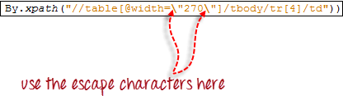

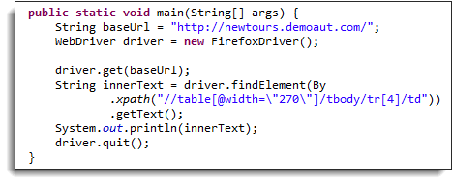

**Fetch number of rows and columns from Dynamic WebTable**

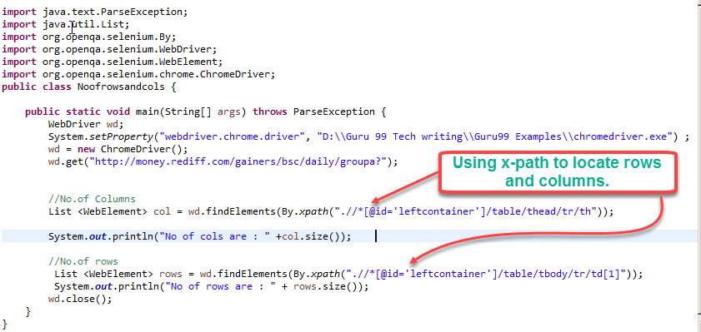

**Get Maximum of all the Values in a Column of Dynamic Table**

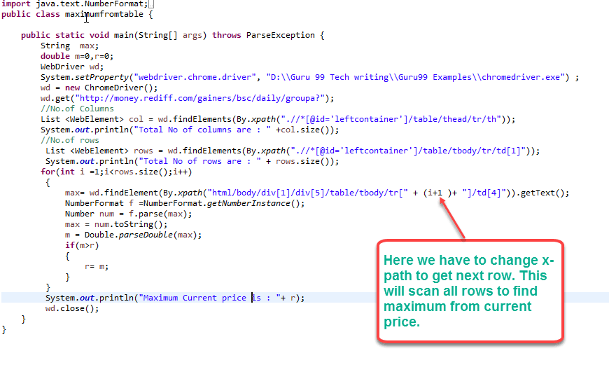

**Example: Get all the values of a Dynamic Table**

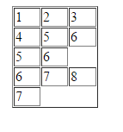

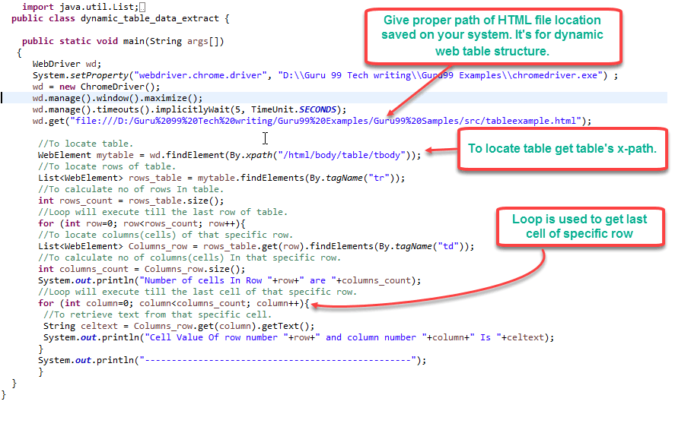

# SSL Certificate

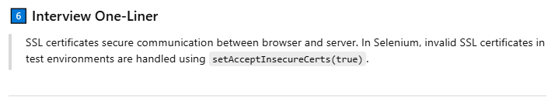

**SAIC** – setAcceptInsecureCerts(true)

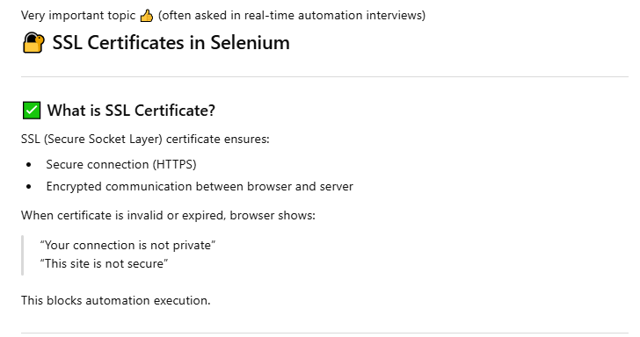

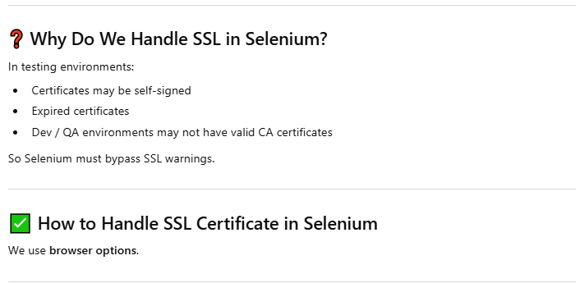

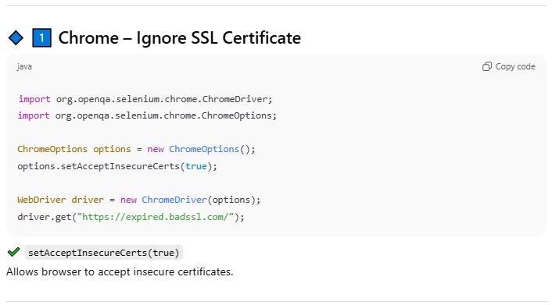

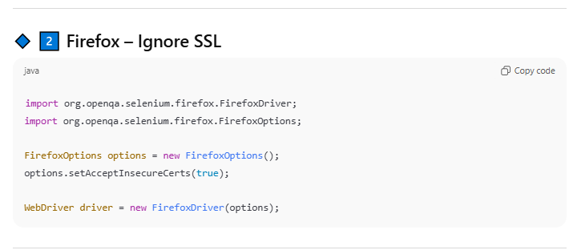

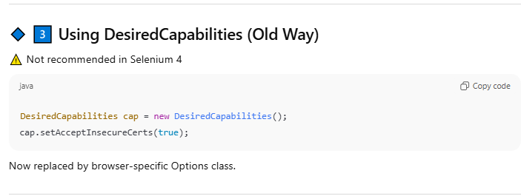

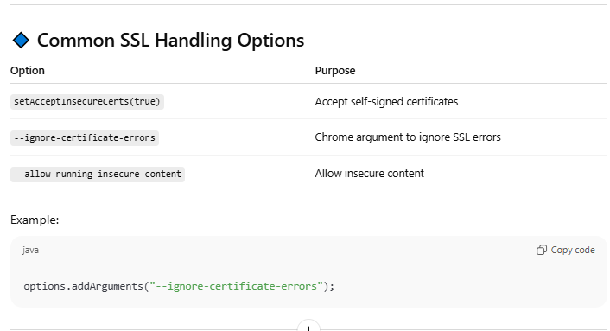

# Database connection - CDSR

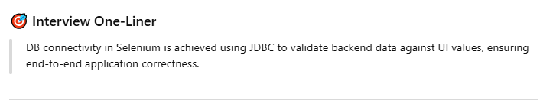

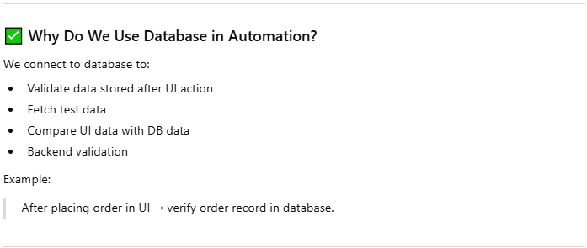

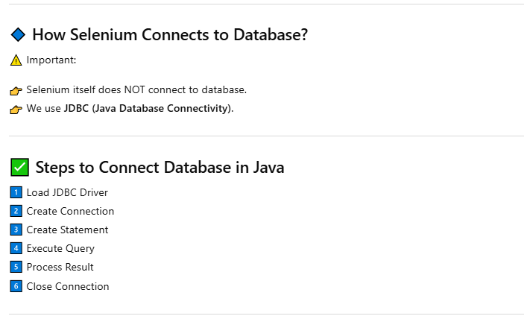

**Below is OPTIONAL in Some Case**

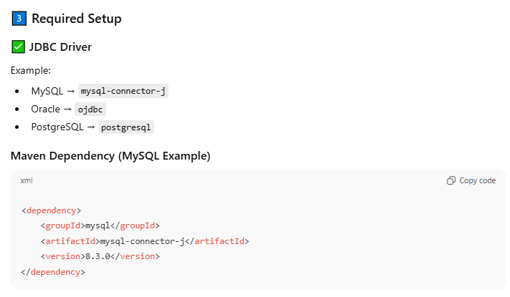

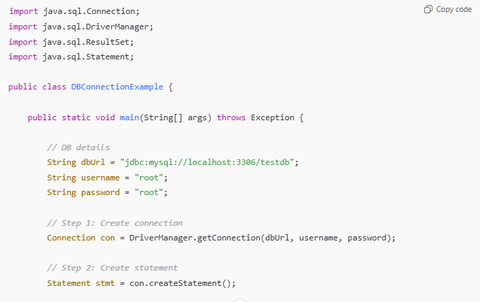

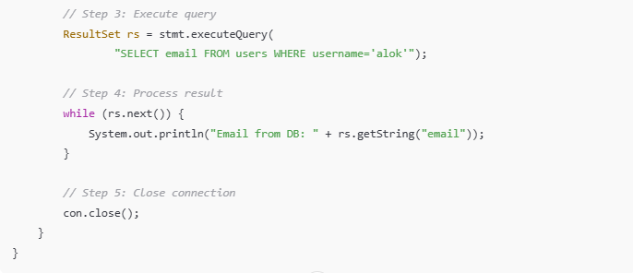

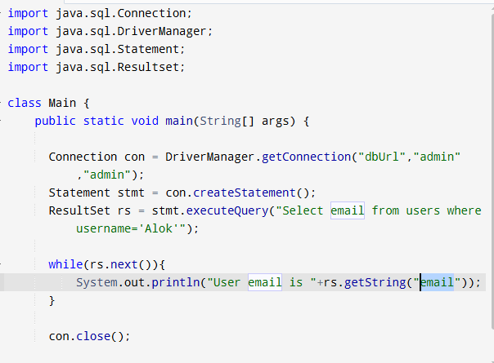

# Calandar Generic

**import** java.util.List;

**import** org.openqa.selenium.By;

**import** org.openqa.selenium.WebElement;

**import** org.openqa.selenium.chrome.ChromeDriver;

**public** **class** calendar {

**public** **static** **void** main(String[] args) {

// **TODO** Auto-generated method stub

System.*setProperty*("webdriver.chrome.driver", "C://work//chromedriver.exe");

ChromeDriver driver=**new** ChromeDriver();

driver.get("https://www.path2usa.com/travel-companions");

//April 23

driver.findElementByXPath(".//*[@id='travel_date']").click();

**while**(!driver.findElement(By.*cssSelector*("[class='datepicker-days'][class='datepicker-switch']")).getText().contains("May"))

{

driver.findElement(By.*cssSelector*("[class='datepicker-days']

th[class='next']")).click();

}

List<WebElement> dates= driver.findElements(By.*className*("day"));

//Grab common attribute//Put into list and iterate

**int** count=driver.findElements(By.*className*("day")).size();

**for**(**int** i=0;i<count;i++)

{

String text=driver.findElements(By.*className*("day")).get(i).getText();

**if**(text.equalsIgnoreCase("21"))

{

driver.findElements(By.*className*("day")).get(i).click();

**break**;

}

}

}

}

# Grid Cross Browser/Platform Testing

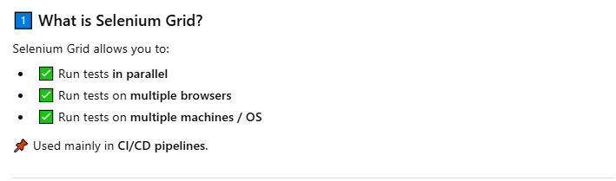



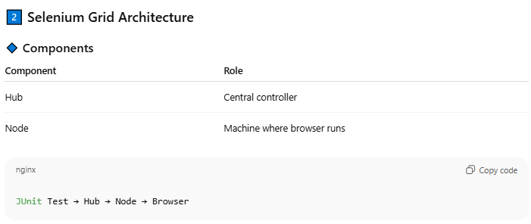

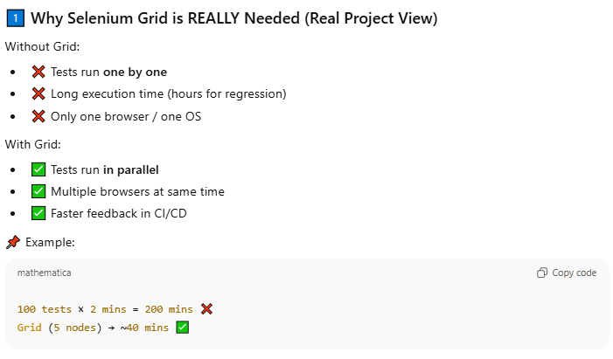

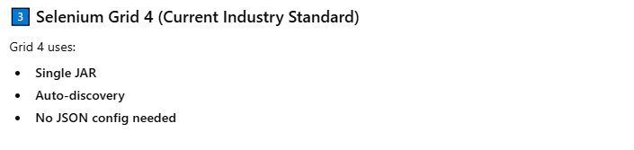

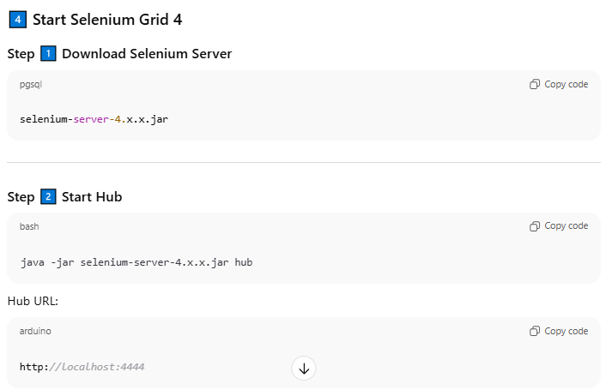

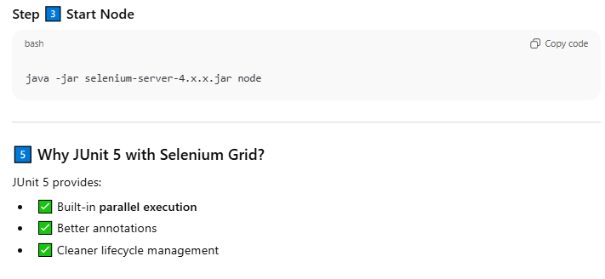

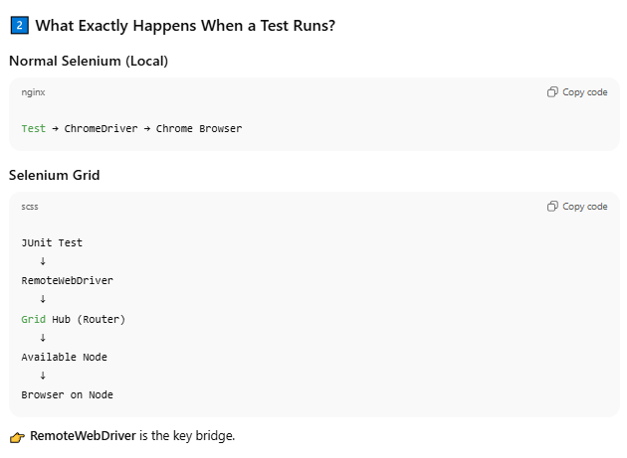

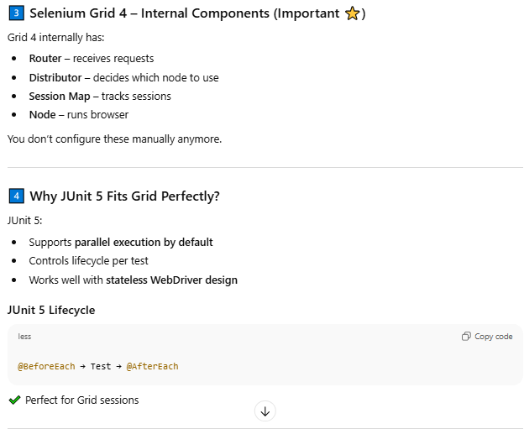

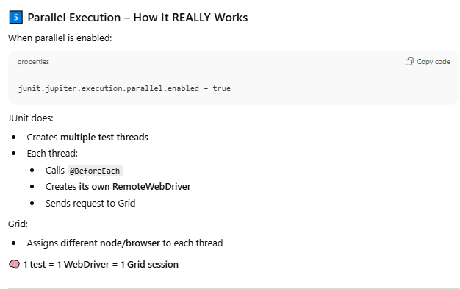

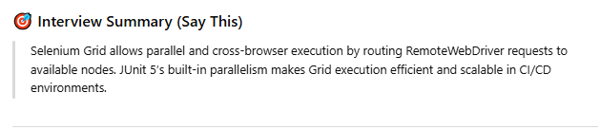

## Grid Real Time Scenario

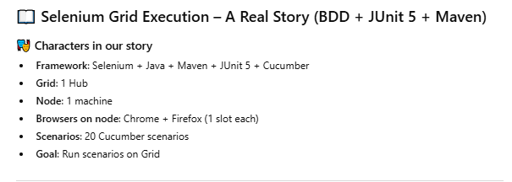

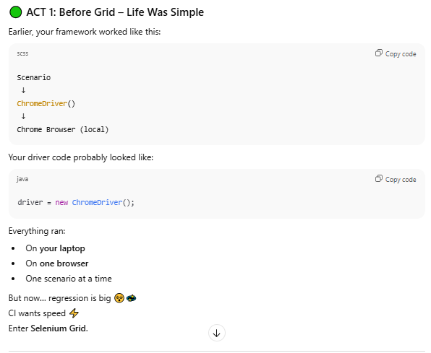

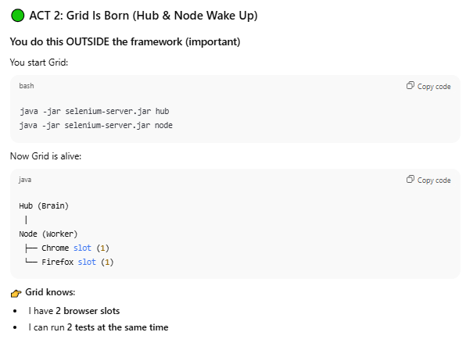

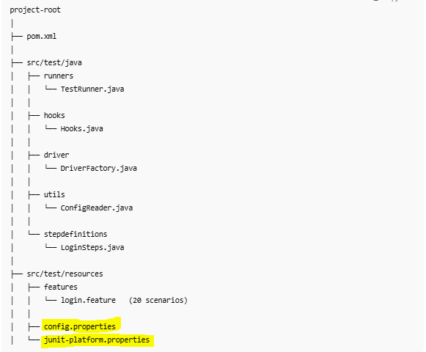

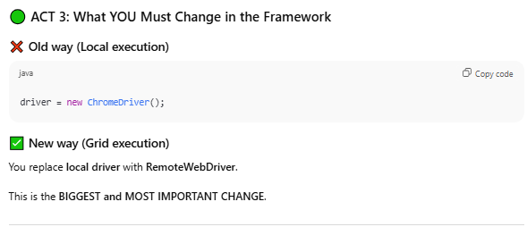

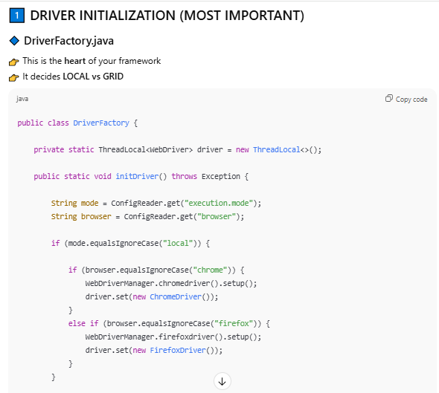

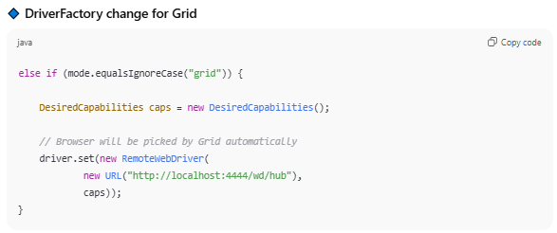

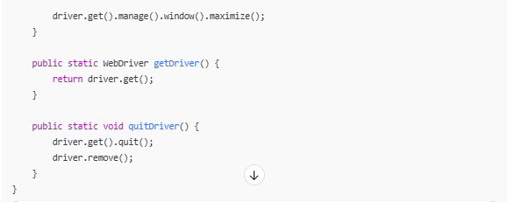

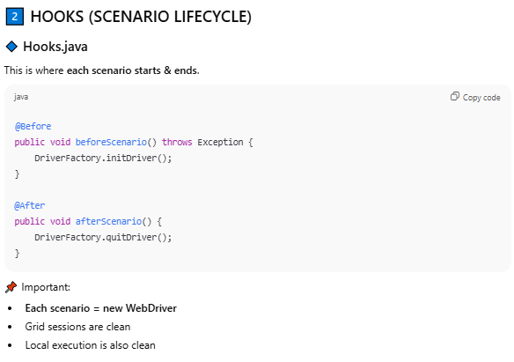

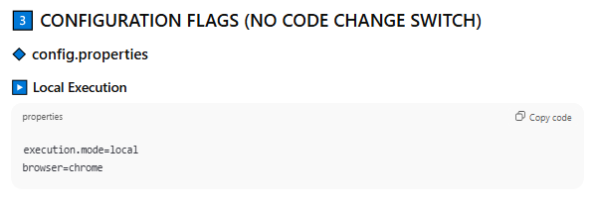

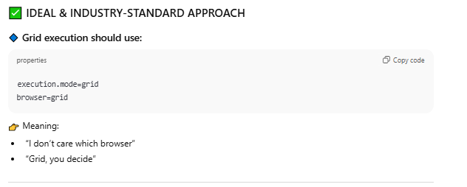

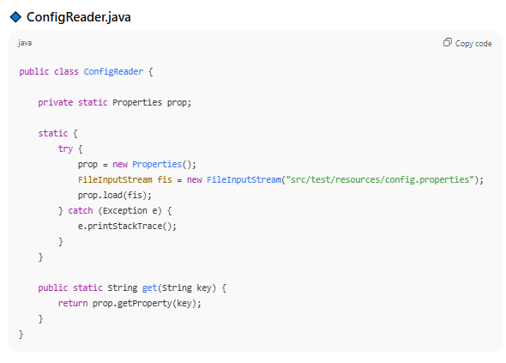

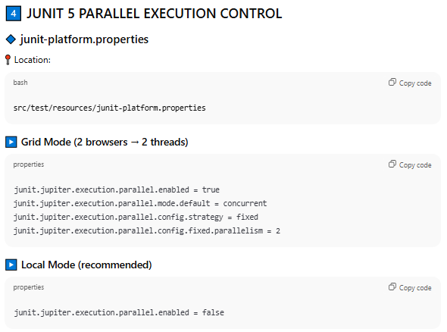

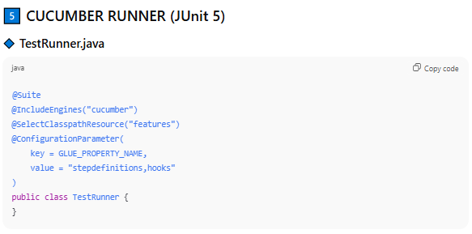

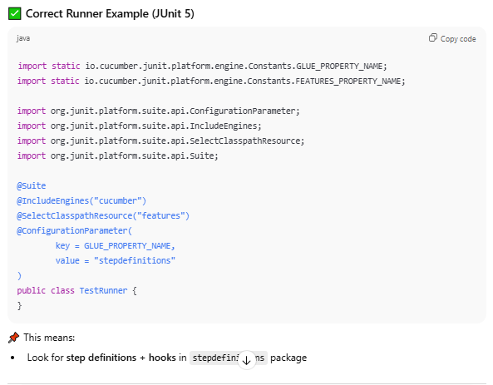

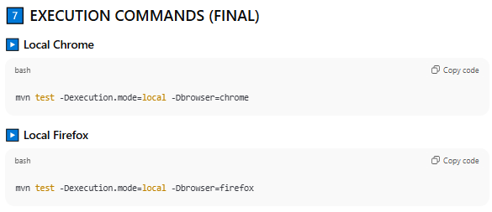

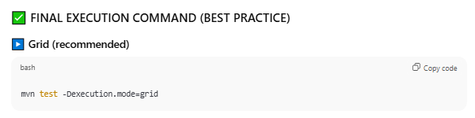

It could be like below as well if you want to run specific browser –

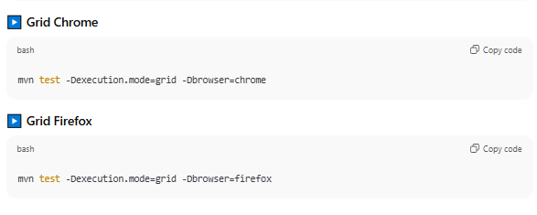

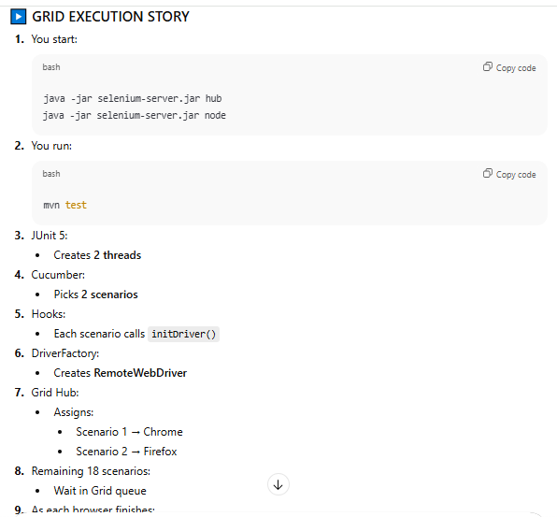

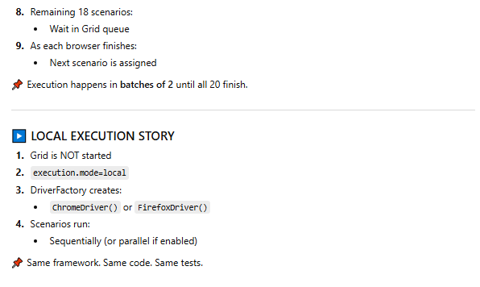

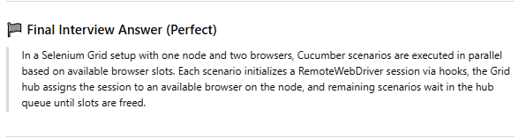

|  |  |
| --- | --- |
| **WEBDRIVER** | **SELENIUM REMOTEWEBDRIVER/LANGUAGES** |
| WebDriver is an interface that can be imported from org.openqa.selenium.* package. | Remote WebDriver is a class that implements the WebDriver interface. |
| WebDriver is an object representing the browser, which can be used to control different browsers. | Remote WebDriver is an object that can control the browser in the grid by configuring the node and the hub. |
| get(),close(),quit() etc. are the methods provided by the WebDriver. | Remote WebDriver provides specific methods like getSessionId(), setSessionId(), startSession() etc. |
| WebDriver can be used to execute the tests in a local machine. | Remote WebDriver can carry out test execution in remote machines on various browsers and multiple environments. |

## Driver Creation

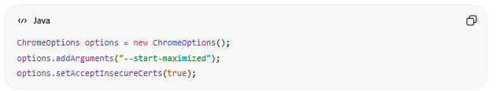

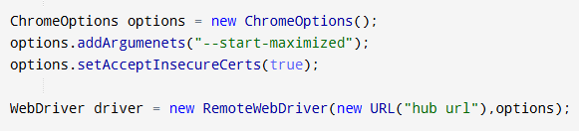

## Grid – Hub Facts

# File Upload - AutoIT (Handle Authentication Popup)

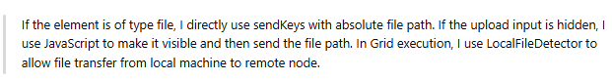

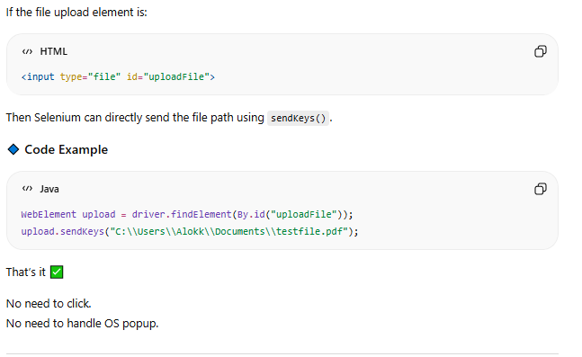

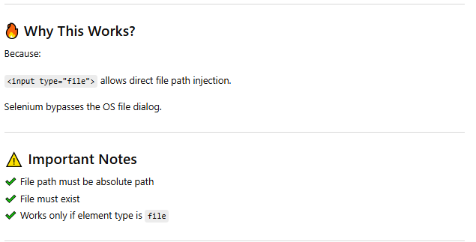

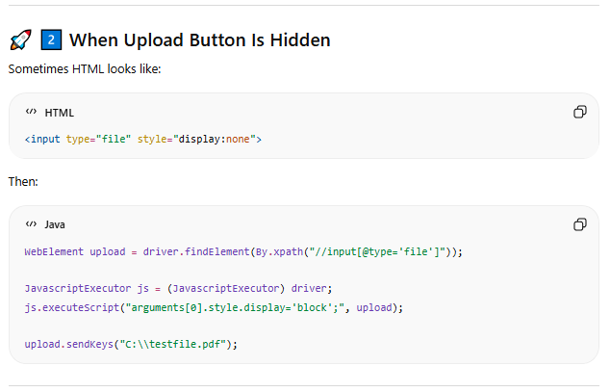

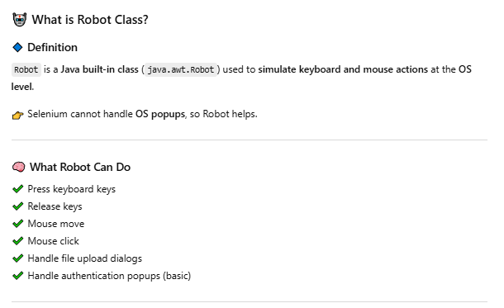

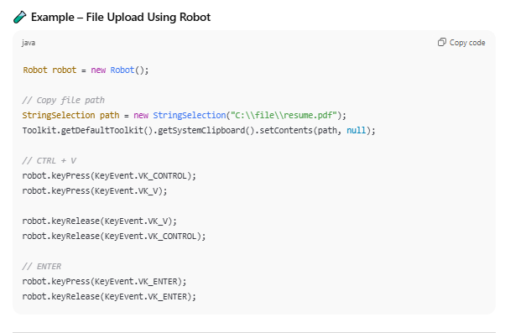

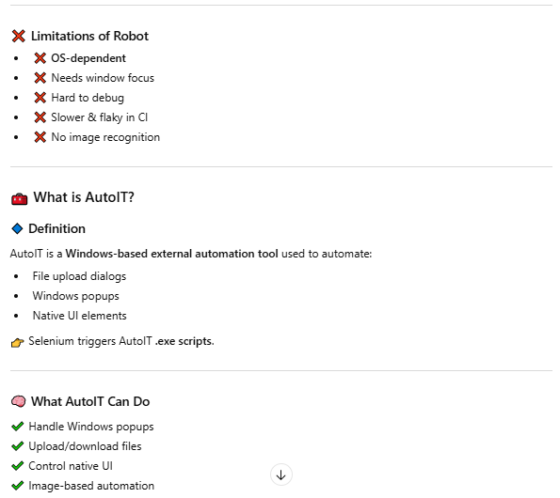

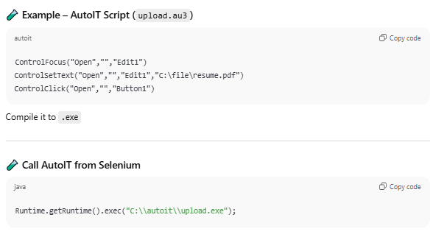

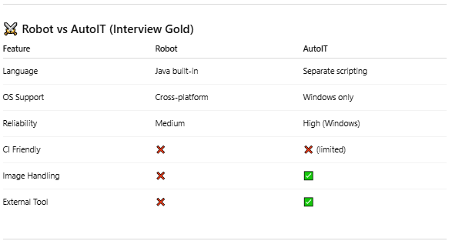

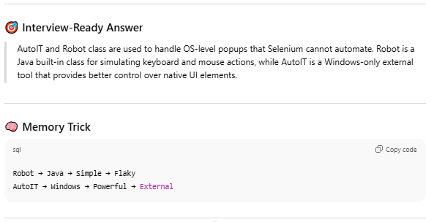

# Junit 5

Junit 5 is the modern modular testing framework consisting the feature like Junit platform(Test launcher, supports multiple engine ) and Jupiter (New programming language, new annotation) providing better extensibility, parallel execution and tightly integration with tools like selenium and cucumber.

### Architecture

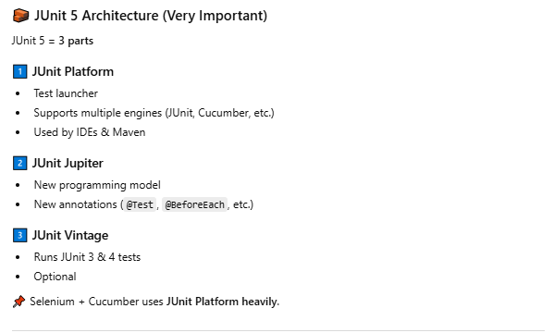

### Runner File

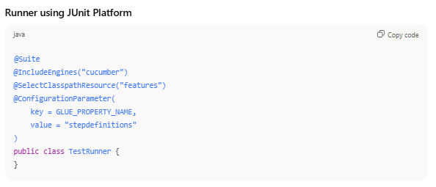

### Parallel Execution

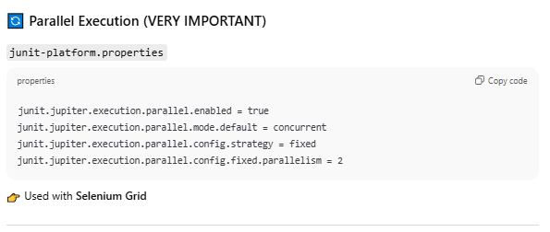

### Maven Dependency

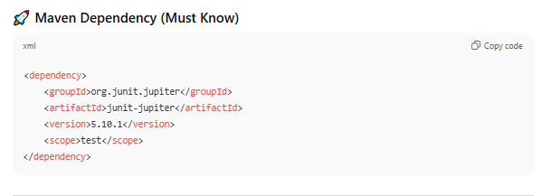

### Veriosn Comparision

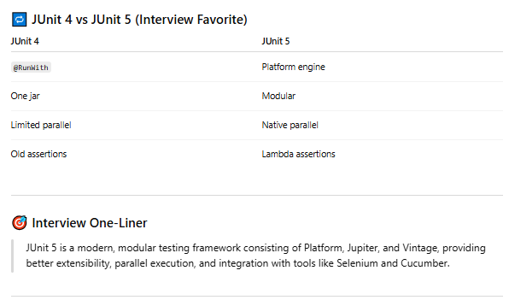

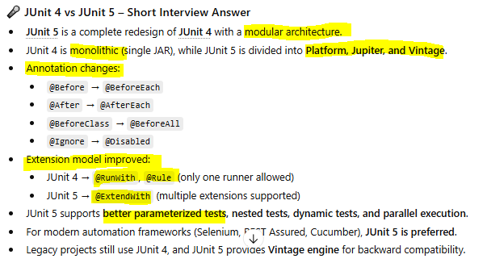

### Annotation

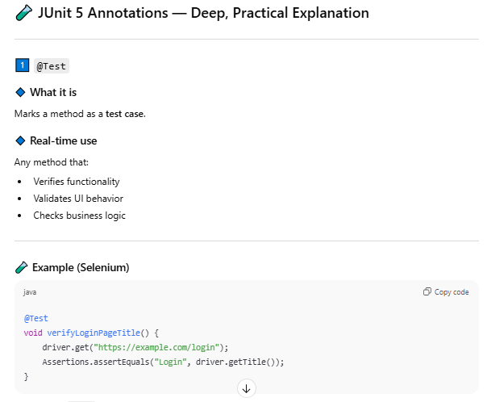

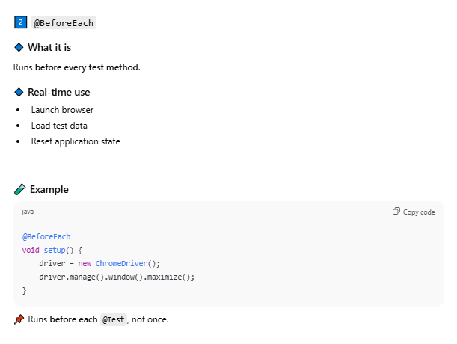

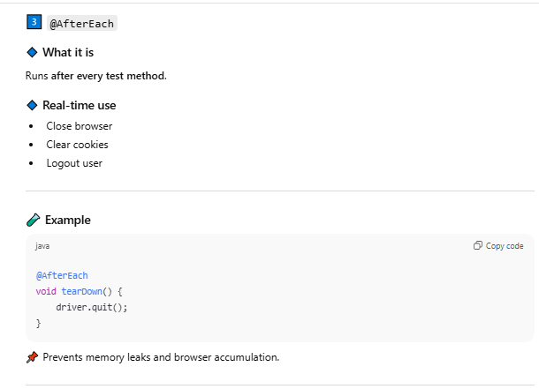

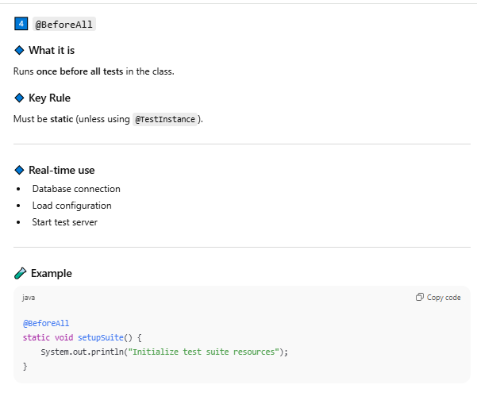

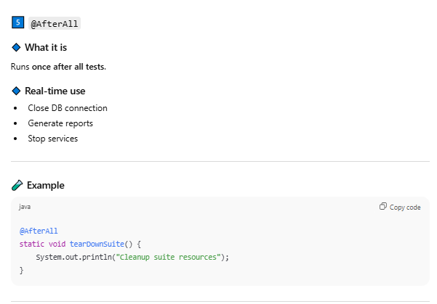

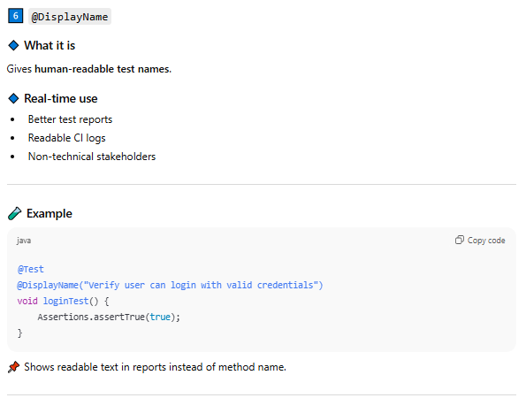

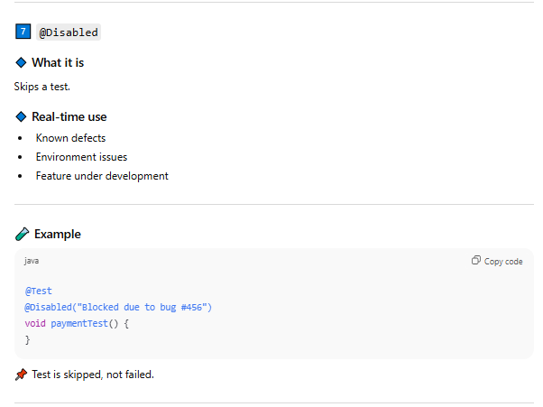

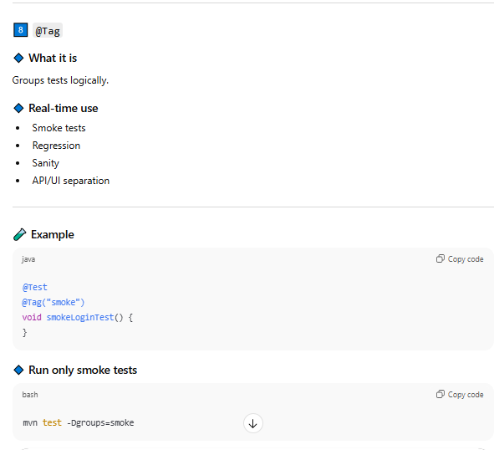

### Assertions 5

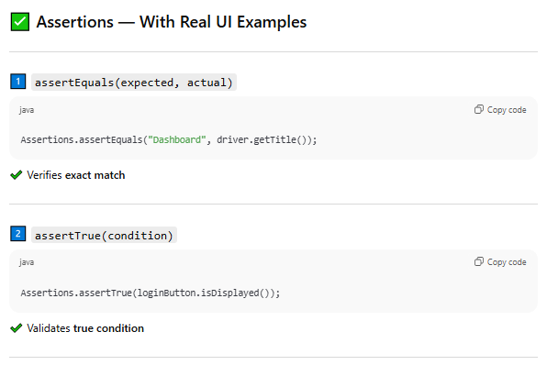

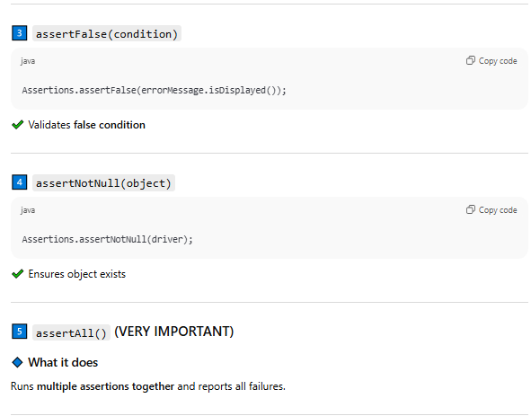

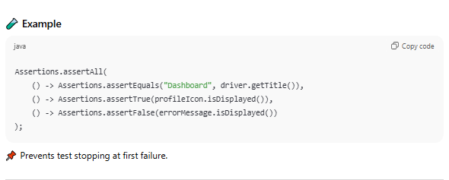

* Assertions.assertEquals(expected, actual)
* Assertions.assertTrue(boolean)
* Assertions.assertFalse(Boolean)
* Assertions.assertNotNull(onject) Ex – driver
* Assertions.assertAll(
* ()->
* ()->
* ()->
* )

### Parameterized Tests

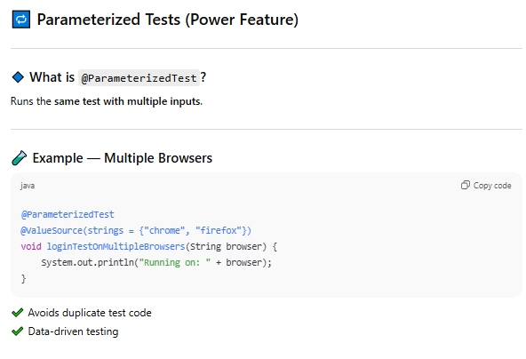

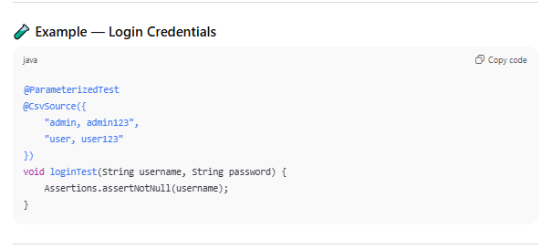

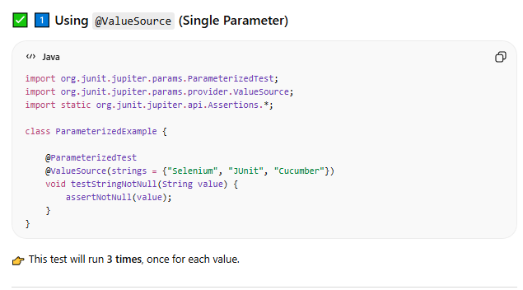

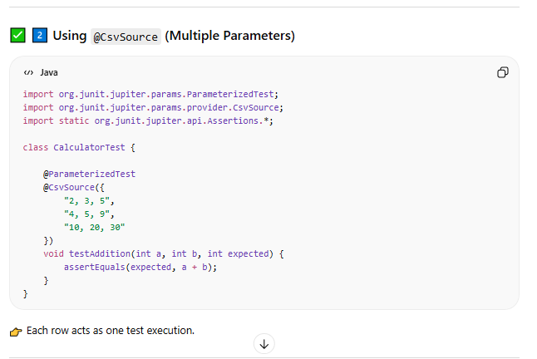

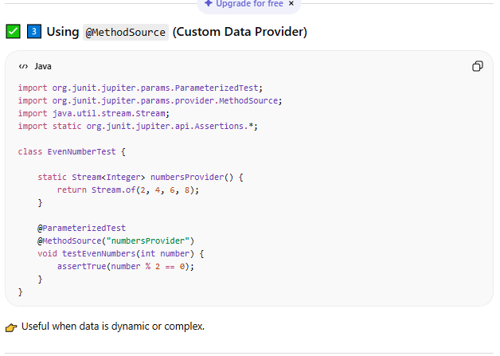

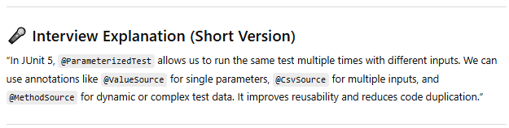

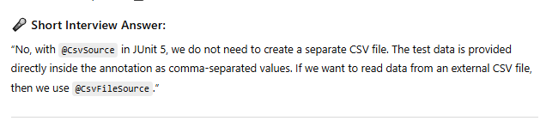

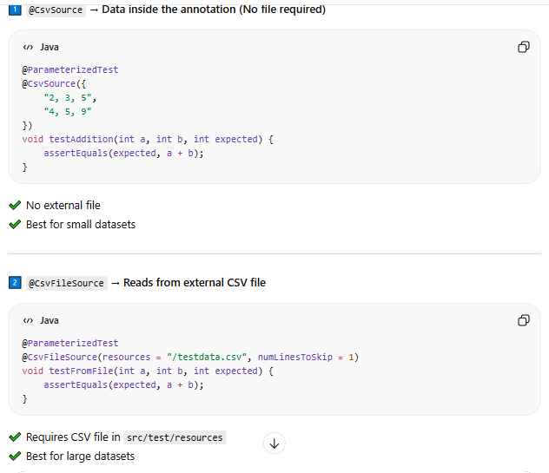

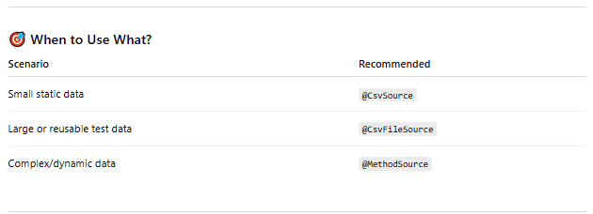

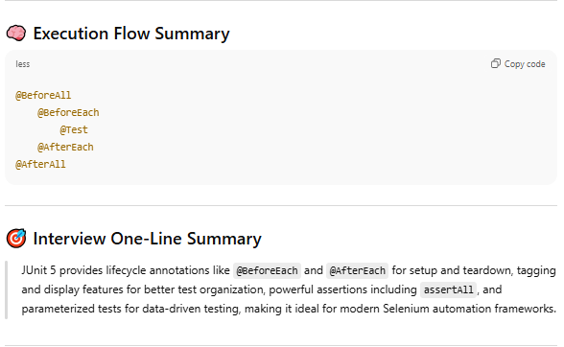

### Junit VS Cucumber useful

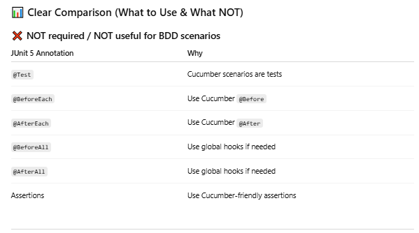

### Failed Retry

Failed case Retry handalled through Maven SureFile plugin in most of the cases

SureFireplugin is not suitable for cucumber bdd framework because as per the pom configuration “**/*Test.java” , it execute all the runner file once again.

Better approach is to use Cucumber Rerun plugin that means keep two runner class file

* RunnerTest.java -> Run all the scenarios
* RunnerFailedTest.java -> Run only the failed scenarios (keeps on running on same execution trigger, but sometime it generates messy and confusing reports)
* To avoid such problem if occurs, keep second runner file name like – RunnerFailed.java and execute explicitly only when needed.

**Main Runner file –**

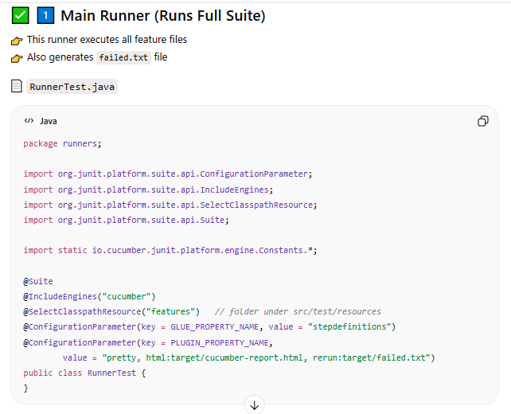

**Add Tags if required –**

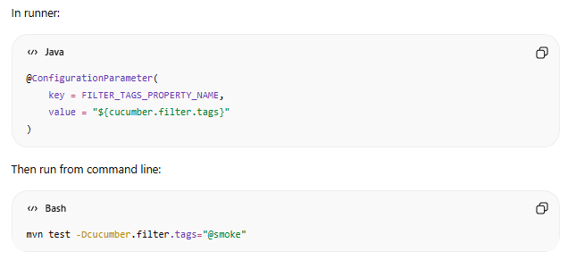

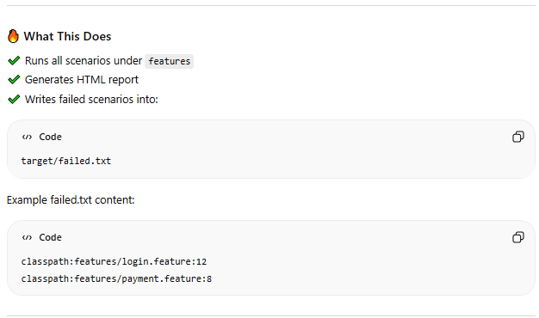

**Failed Runner File -**

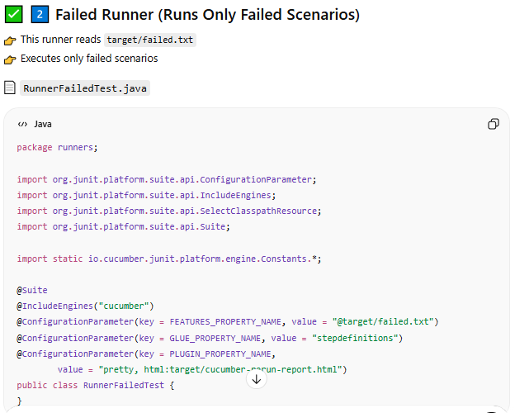

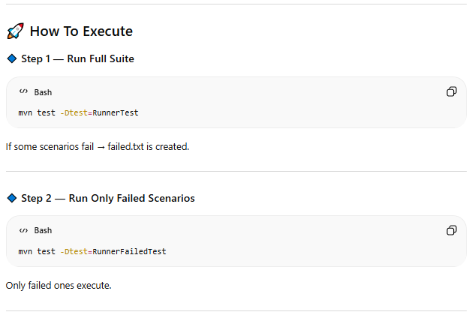

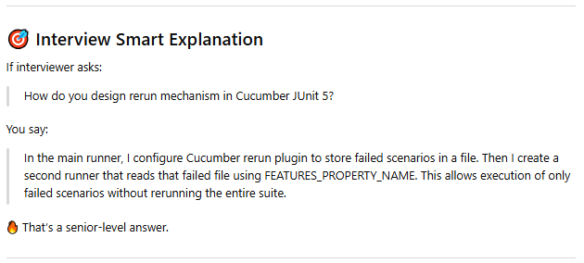

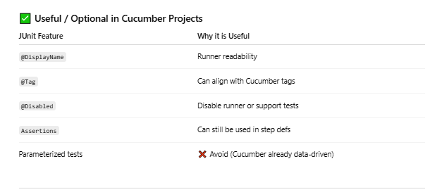

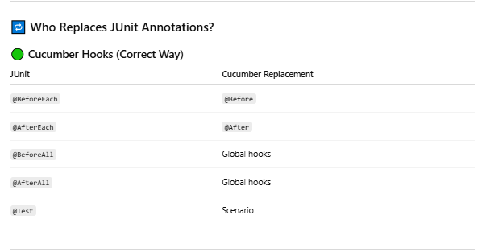

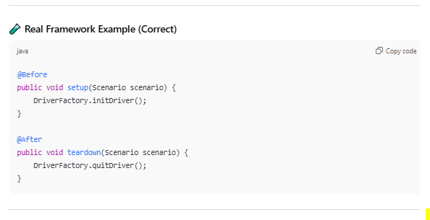

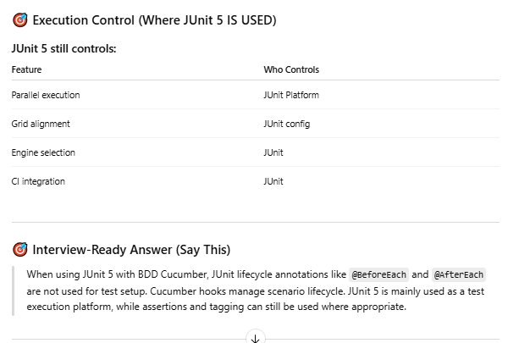

# TestNG |Framework – 1

### TestNG

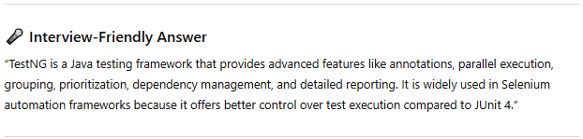

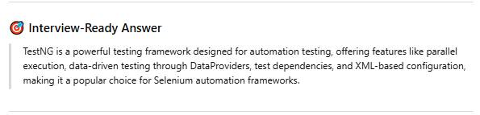

### Assertion

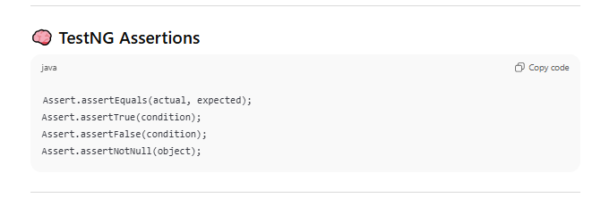

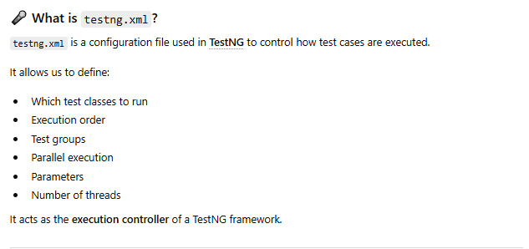

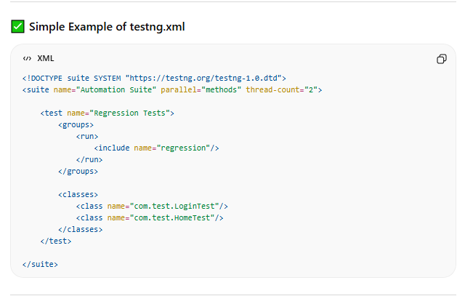

### Annotation

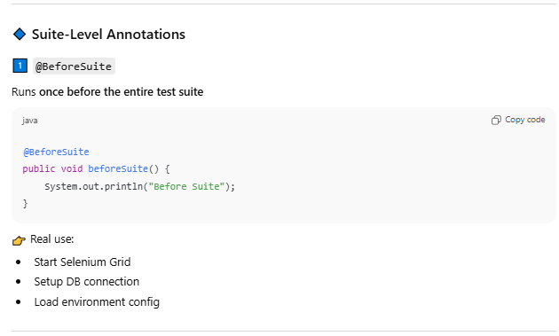

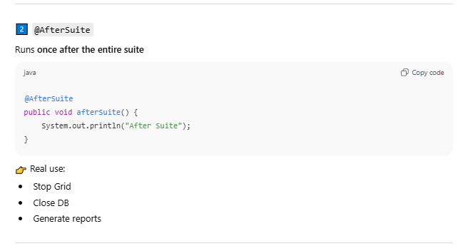

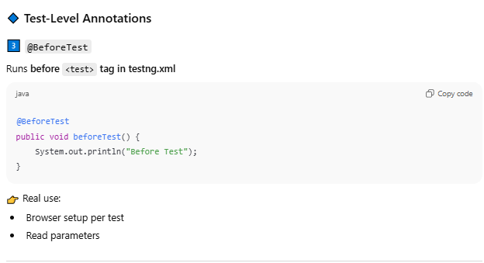

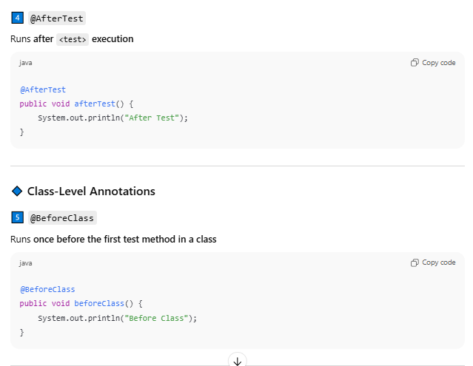

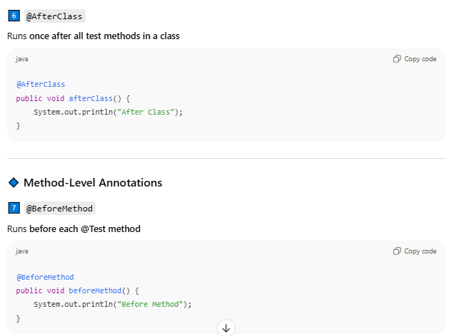

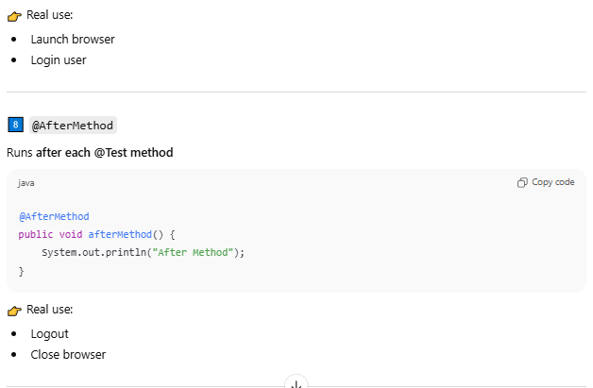

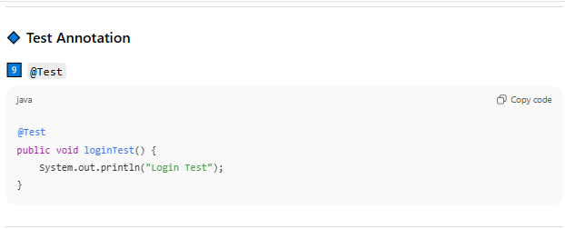

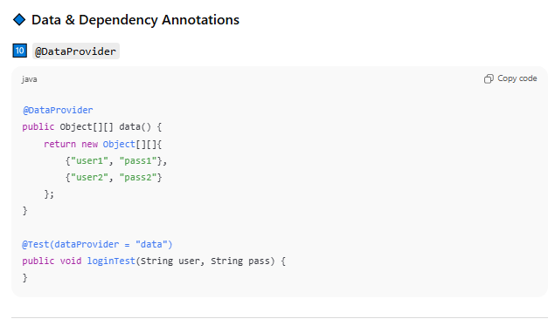

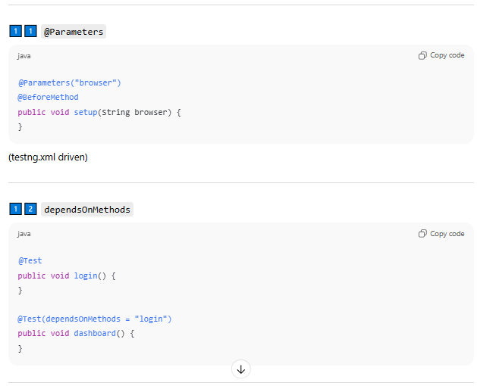

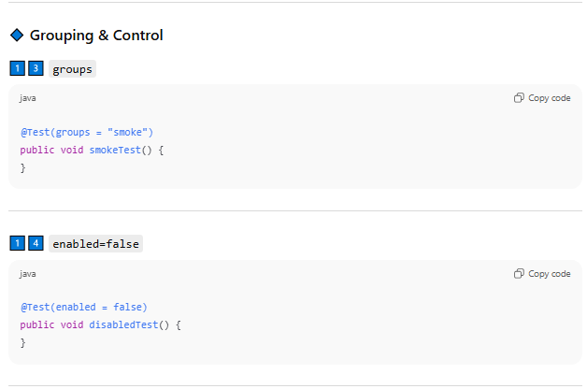

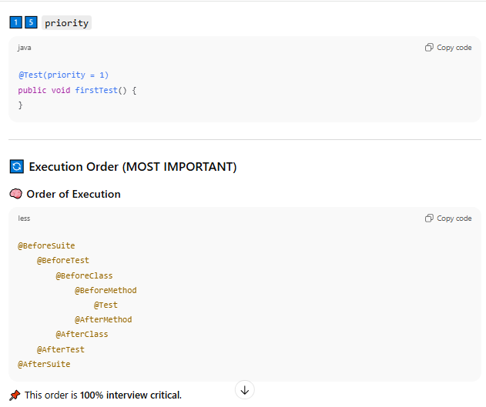

Advanced

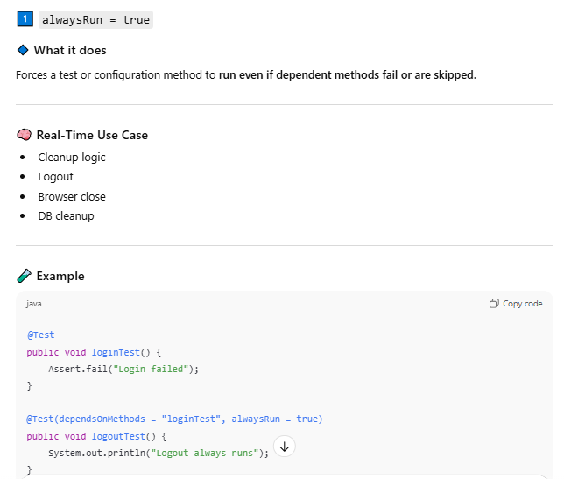

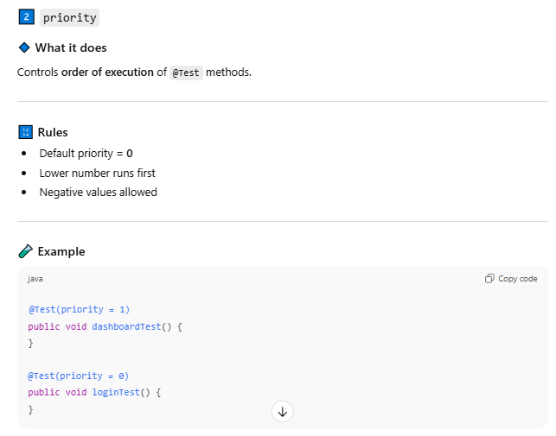

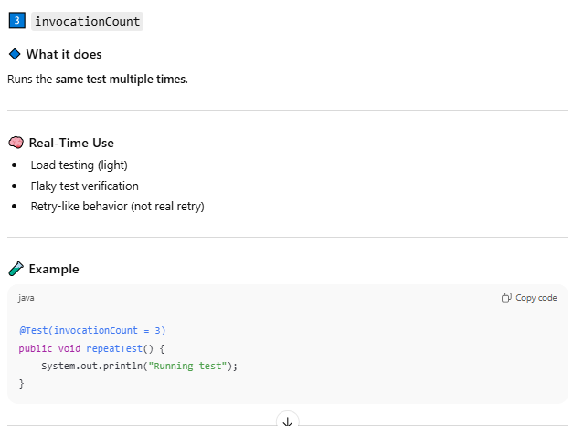

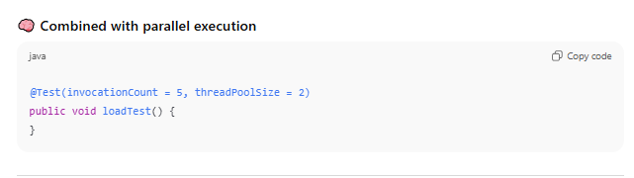

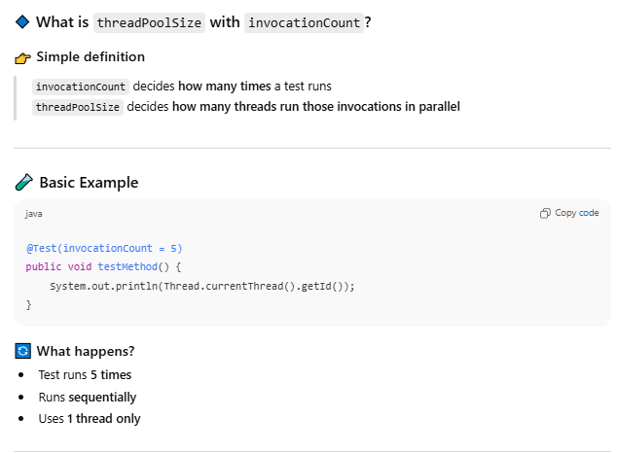

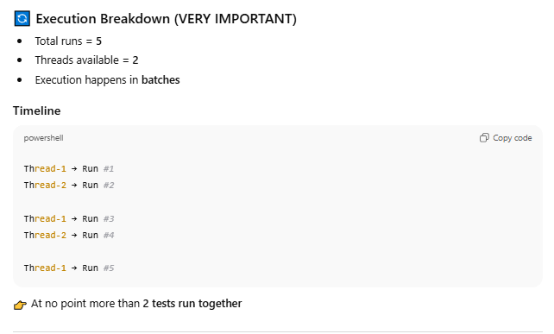

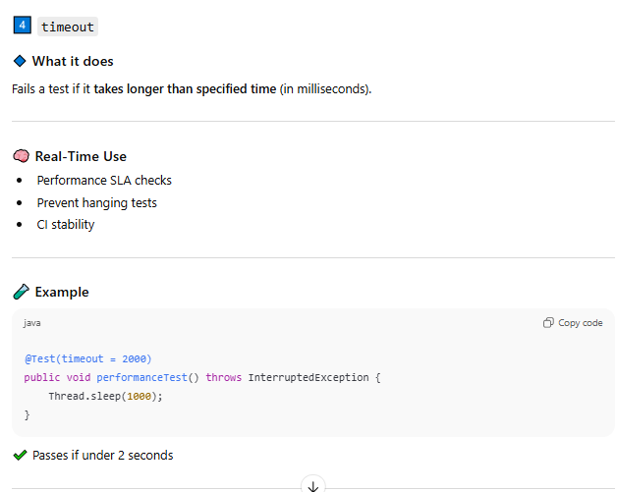

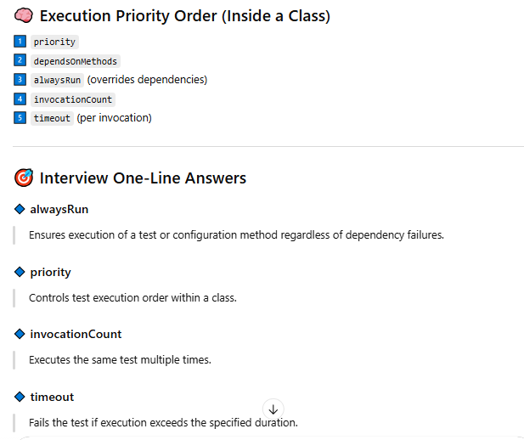

### Difference in @beforeTest and @Test

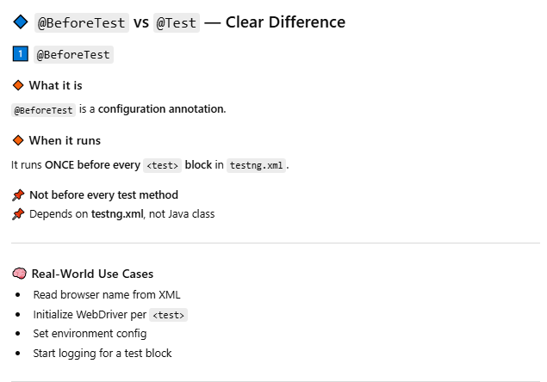

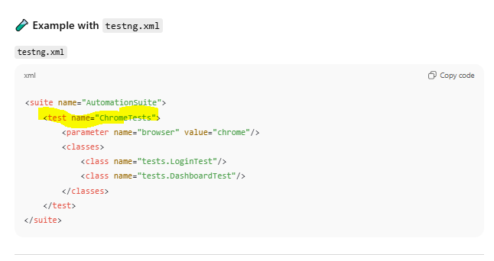

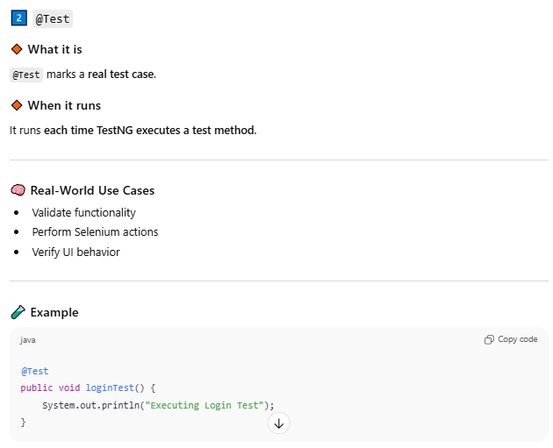

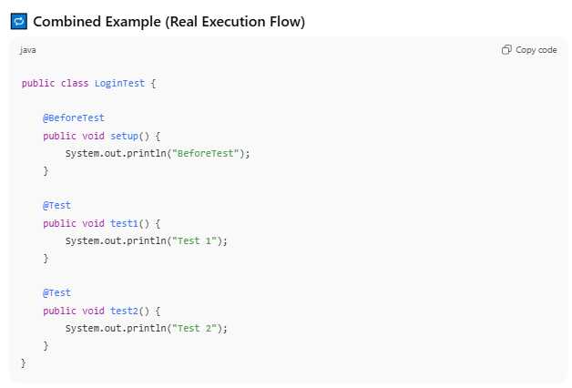

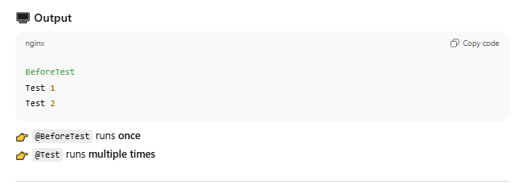

### Real Example if @BeforeTest and @Test

Q.- If I have two <Test> blocks in testing.xml file, and 5 @Test in class file how it executes

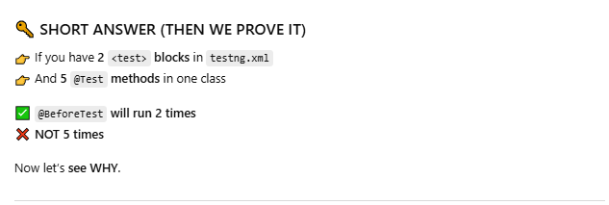

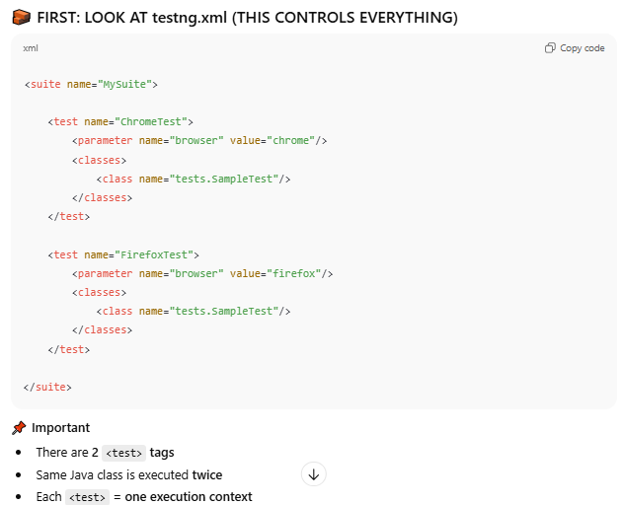

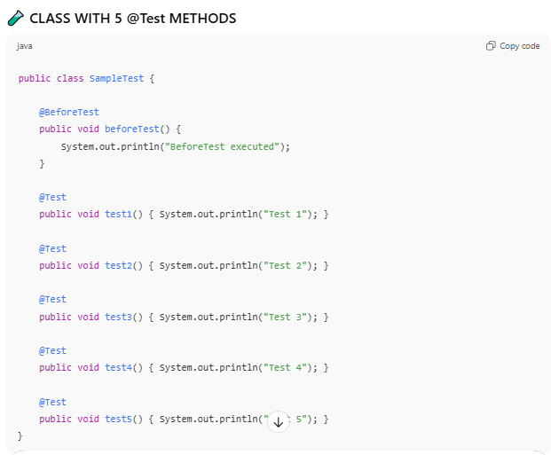

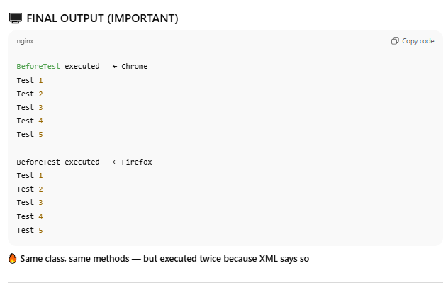

### Real Time Project Artifact

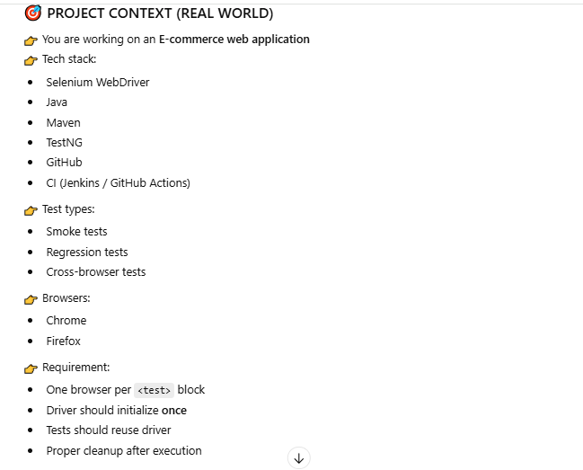

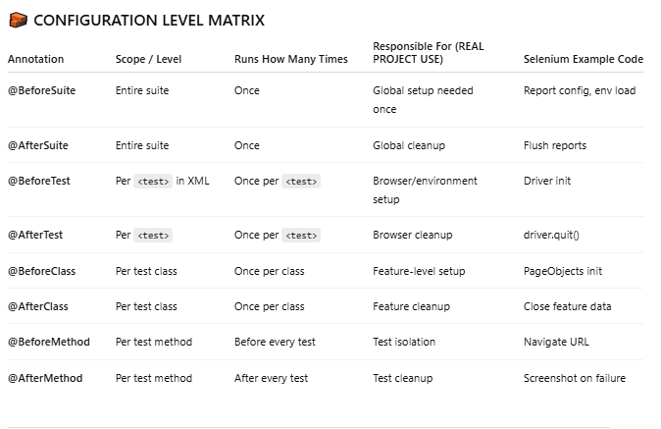

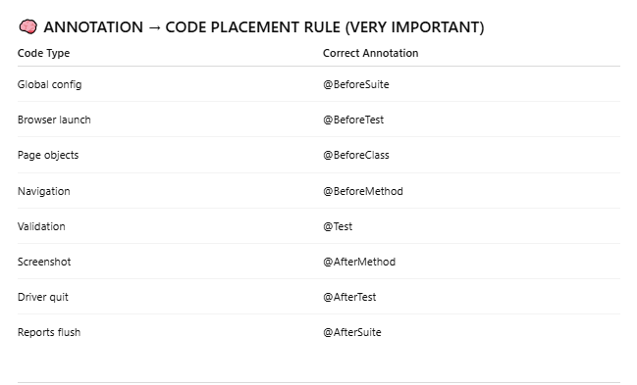

### Parallel Execution

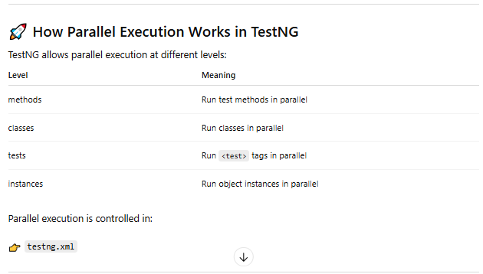

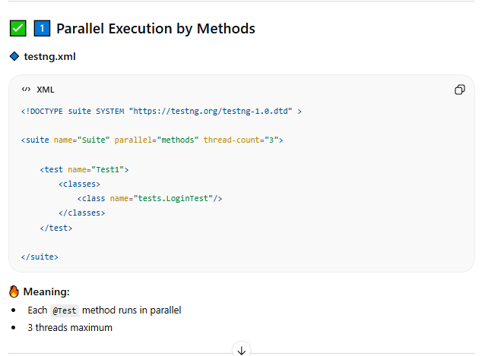

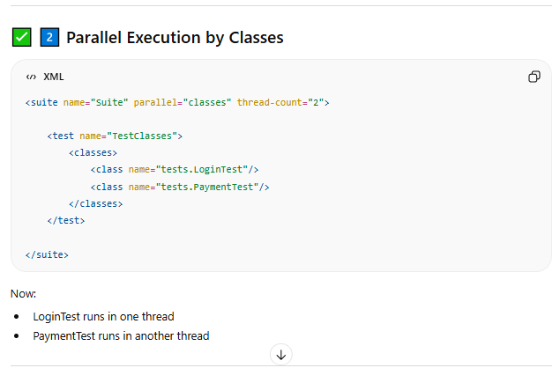

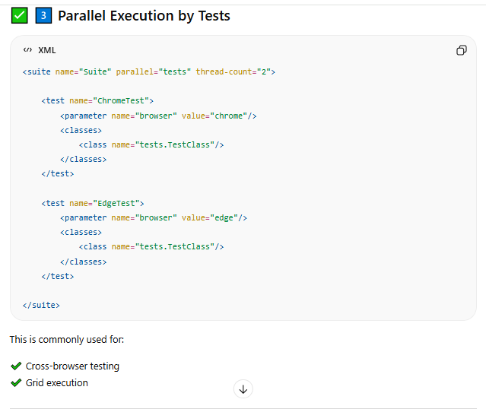

### TestNG and Junit 5 Difference

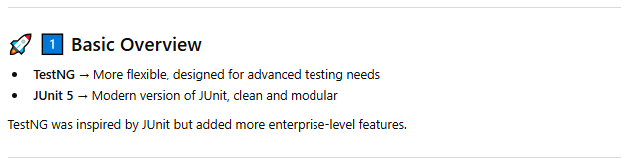

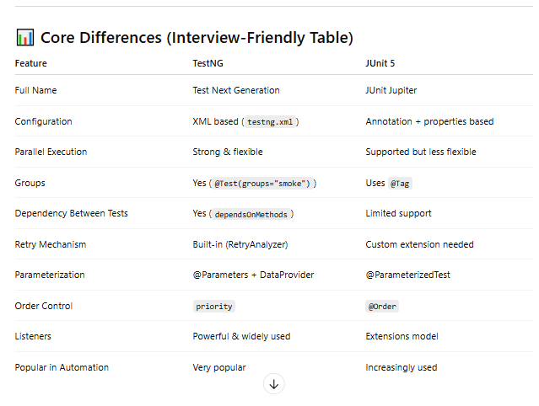

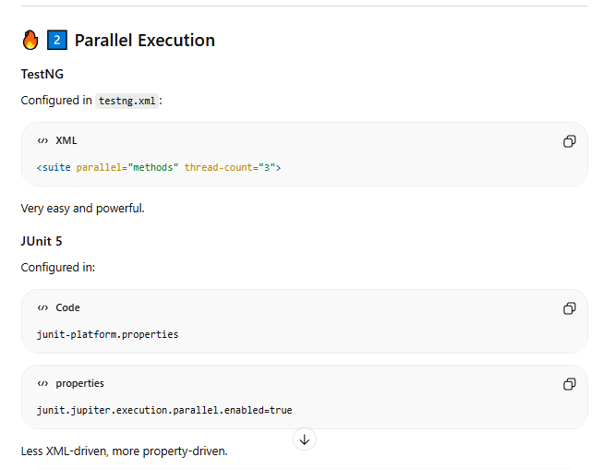

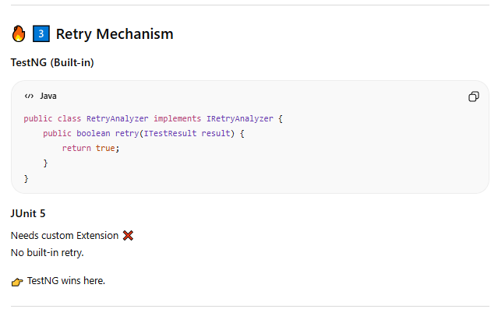

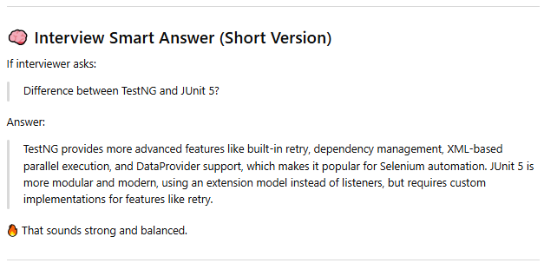

1. **What’s TestNG – Importance of TestNG:**

TestNG is an automation testing framework which stands for “Testing Next Generation". TestNG is derived from[JUnit](https://www.guru99.com/junit-tutorial.html)which uses the annotations (@).TestNG consists all the features of JUnit framework but also contains some more additional features that make TestNG more powerful

Using TestNG you can generate a proper report, and easily come to know how many test cases are passed, failed and skipped.You can execute failed test case separately

1. **Why Use TestNG with Selenium?**

As we work and know, default Selenium test does not generate a proper format for the test results. Using TestNG we can generate test results.

There are so many features of TestNG, but we will only focus on the most important ones. Following are key features of TestNG

1. **Report Generation:** Generate the report in a proper format including a number of test cases runs, passed, failed, and the number of test cases skipped.

WebDriver has no native mechanism for generating reports. TestNG can generate the report in a readable format like the one shown below.

[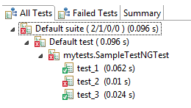](https://www.guru99.com/images/report-0057.png)

1. **Grouping and Priority:** Multiple test cases can be grouped more easily by converting them into testng.xml file. In which you can make priorities which test case should be executed first.
2. **Multiple Execution:** The same test case can be executed multiple times without loops just by using keyword called 'invocation count.'
3. **Cross Browser Execution:** Using testng, you can execute multiple test cases on multiple browsers, i.e., cross browser testing.
4. **Integration:** The testing framework can be easily integrated with tools like Maven, Jenkins, etc.
5. **Useful Annotation:** Annotations used in the testing are very easy to understand ex: @BeforeMethod, @AfterMethod, @BeforeTest, @AfterTest
6. **Simplfy Coding Standard:** TestNG simplifies the way of test scripting. There is no more need for a static main method in our tests. The sequence of actions is regulated by annotations that do not require methods to be static.
7. **Exception Handling:** Uncaught exceptions are automatically handled by TestNG without terminating the test prematurely. These exceptions are reported as failed steps in the report.

[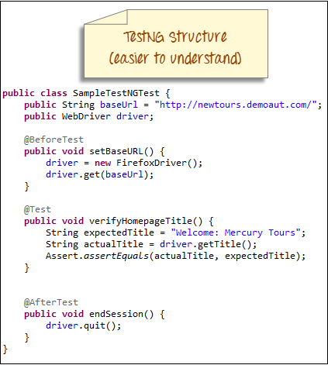](https://www.guru99.com/images/testng_structure-0058.png)[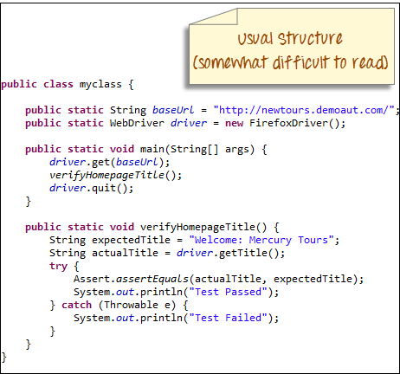](https://www.guru99.com/images/usual_structure-0059.png)

1. **Installing TestNG in Eclipse**

**Step 1)**Launch Eclipse.

1. On the menu bar, click Help.
2. Choose the "Install New Software…" option.

**Step 2)**In the Eclipse Install dialog box

1. Enter "http://dl.bintray.com/testng-team/testng-eclipse-release/" in the Work with box
2. Click the Add button.

**Step 3)**In Add repository dialog

1. Enter "TestNG" in Name Text Field
2. Click on Add button.
3. It will search for the entered software.

**Step 4)**

1. Select the "TestNG" checkbox
2. Click on the "Next" button.

**Step 5)**It will give you a review of Items to be installed. Click on Next.

**Step 6)**

1. Select the radio button "I accept the terms of the license agreement"
2. Click on Finish. It will take time depending on your Internet speed.

**Step 7)**If you encounter a Security warning, just click "Install Anyway".

**Step 8)**Wait for the installation to finish. When Eclipse prompts you for a restart, click "Restart now."

**Step 9)**After the restart, verify if TestNG was indeed successfully installed. Click Window > Show View >Other.

Then open the Java directory and see if TestNG is included. That's it to TestNG Installation

**Cross check installation – Window -> Show View -> Type TestNG into Preferences**

1. **Running Test Cases in TestNG without java compiler**

**Step 1:** Create a TestNG project. It is created in the same way as we create the java project. Click on the **File > New > Java Project**

**Step 2:** Now we will create the Java class file in a src folder. Click on the New > Class.

**Step 3:** Enter the class name. Suppose I gave the class name as test1. As we know that execution of java file starts with the main method, check the box of the main method.

In the above screen, we observe that **public static void main()** method has been included in the **test1** class file, so it means that the program will run on Java compiler.

**Step 4:** If you install TestNG framework or TestNG library, then you do not need to compile on Java compiler as TestNG itself is a java compiler that compiles the test cases. In order to achieve this, we need to install the TestNG plug-in and then add the TestNG plug-in in a project.

**Step 5:** Now we will create a simple program.

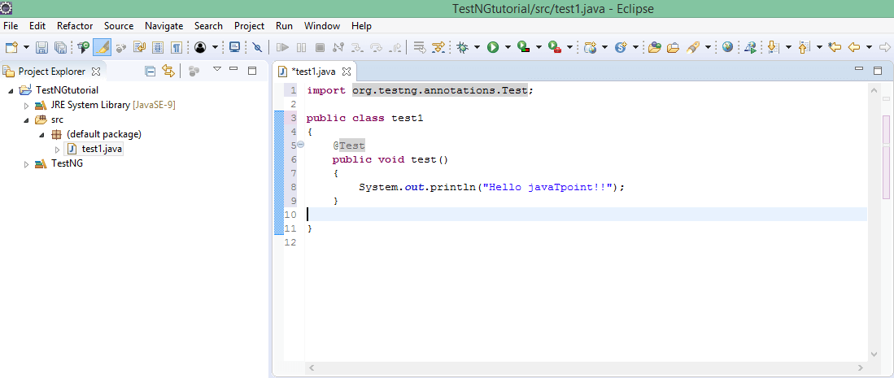In the above case, we have created a test() method and the class test1 does not contain the main() method. In this case, we use @Test notation which will run the program without any main() method.

Right Click on @Test annotation and add TestNG Library and Import TestNG annotation package.

**Step 6:** Run the program by using TestNG. Java Class file -> Right Click -> Run As -> TestNG Test

**Step 7:** Eclipse will provide two outputs – one in the Console window and the other on the TestNG Results window

**Note** : If we don’t mention any priority, testng will execute the @Test methods based on alphabetical order of their method names irrespective of their place of implementation in the code.

1. **Importance of XML file in TestNG Configuration**

In TestNG, you can define multiple test cases in a single class whereas, in Java, you can define only one test in a single class in the main() method. In Java, if you want to create one more test, then you need to create another java file and define the test in the main() method.

Instead of creating test cases in different classes, we recommend you to use TestNG framework that allows you to create multiple test cases in a single class.

You can create multiple test cases with the help of **@Test** annotation.

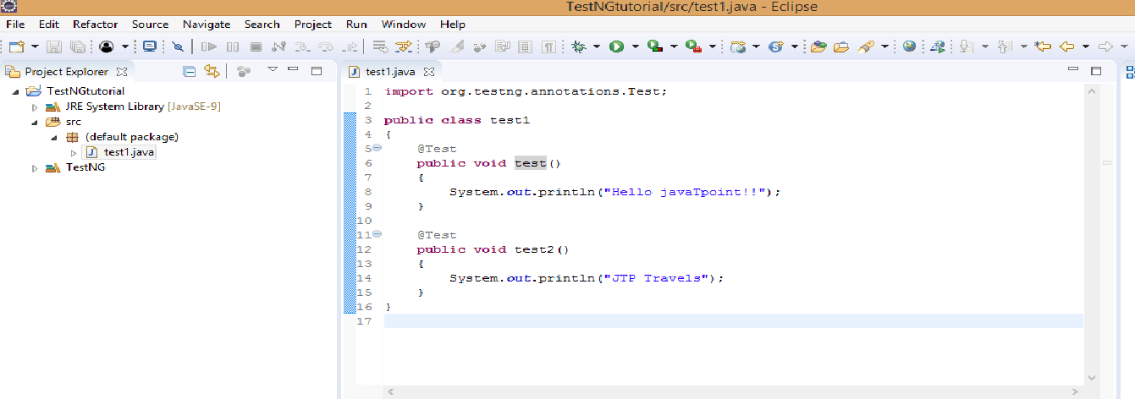

The above code consists of a class test1. The class test1 consists of two test cases, i.e., test1() and test2(). You can differentiate the test cases by considering the sequence of test cases. In the above code, the test case **test2()** is written in the second **@Test** annotation, so this test case will be considered as the second case.

1. Right click on the project. Move your cursor down, and you will see TestNG and then click on the **Convert to TestNG**.
2. The below screen shows the preview of the xml file. Click on the **Next** button.
3. Click on the **Finish** button.
4. The testing.xml file is shown below:

In the below source code of xml file, suite is at the higher hierarchy in TestNG. Inside the , you have to define the test name folder. This test name folder is the name of the folder. For example, In a loan company, there are three different types of modules such as personal loan, home loan and car loan, and each module contain its own test cases. All these test cases are defined in the test name folder.

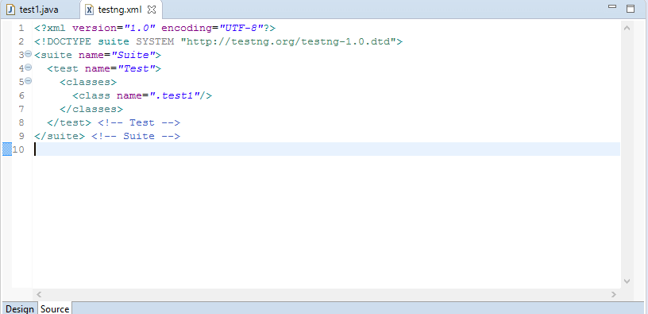

<?xml version="1.0" encoding="UTF-8"?>

<!DOCTYPE suite SYSTEM "http://testng.org/testng-1.0.dtd">

<suite name="loan_department">

  <test name="Personal_loan">

    <classes>

      <**class** name="day1.module1"/>

      <**class** name="day1.module2"/>

    </classes>

  </test>

</suite>

Test Suite -> TestFolder(Module) -> Testcases

In the above XML file, we have created the suite "**loan_department**". We have created the module "Personal loan" inside the suite and within this module, we have created the test cases defined in the classes day1.module1 and day1.module2, where day1 is the package name and module1 and module2, are the classes.

1. In this step, we will run the test cases. Now we do not need to run the java files individually. We have to run the XML file which will automatically execute all the test cases as we have configured all the class files inside the XML file that are containing test cases.
2. Right click on the **testng.xml** file and then move down to the **Run As** and then click on **the1 TestNG Suite**.
3. **Exclude/Include test cases/method**

TestNG provides the feature of enabling and disabling the test cases. We can disable a set of test cases from getting them executed. For example, consider a scenario where a serious bug occurs in a feature while running certain tests, so we need to disable those test cases from being executed. In TestNG, test cases can be disabled in two ways:

1. You can disable the test case in a @Test annotation.
2. You can disable the test case in the XML file.

**Exclude Method : -**

1. TestNG @Test enable parameter: You can disable or exclude the test cases from execution by using the enable attribute as False to the @Test.

**Module1.java**

**package** day1;

**import** org.testng.annotations.Test;

**public** **class** module1

{

    @Test(enabled=**false**)

**public** **void** test1()                                          // First test case

    {

        System.out.println("Hello javaTpoint!!");

    }

      @Test

**public** **void** test2()                                          // Second test case

    {

        System.out.println("JTP Travels");

    }}

Disable the enable attribute in the XML file.

**Module2.java**

**package** day1;

**import** org.testng.annotations.Test;

**public** **class** module2

{

 @Test

**public** **void** WebLoginCarLoan()

 {

     System.out.println("WebLoginCarLoan");

 }

 @Test

**public** **void** MobileLoginCarLoan()

 {

     System.out.println("MobileLoginCarLoan");

 }

 @Test

**public** **void** APILoginCarLoan()

 {

     System.out.println("APILoginCarLoan");

 }  }

If we want to disable the MobileLoginCarLoan test case in car loan module, then we need to add the <method> tag in xml file which has access to all the methods of a class.

<?xml version="1.0" encoding="UTF-8"?>

<!DOCTYPE suite SYSTEM "http://testng.org/testng-1.0.dtd">

<suite name="loan_department">

   <test name="Personal_loan">

   <classes>

   <**class** name="day1.module1"/>

   </classes>

   </test> <!-- Test -->

   <test name="Car_loan">

   <classes>

   <**class** name="day1.module2">

   <methods>

   <exclude name = "MobileLoginCarLoan"/>

   </methods>

   </**class**>

   </classes>

   </test>

</suite> <!-- Suite -->

**Include Method : -**

Let’s understand Include method, in a class or module there are several testcase method, for an example if there are 100 testcases method and user wants to run not all but any two sepecific at that situation making 98 exclude is a bad practice better option is to include those two only. So, In execution it will address those two only, rest 98 will be automatically excluded from execution.

**package** day1;

**import** org.testng.annotations.Test;

**public** **class** test

{

@Test

**public** **void** test1()

 {

     System.out.println("test1");

 }

 @Test

**public** **void** test2()

 {

     System.out.println("test2");

 }

 @Test

**public** **void** test3()

 {

     System.out.println("test3");

 }

 @Test

**public** **void** test4()

 {

     System.out.println("test3");

 }

}

<?xml version="1.0" encoding="UTF-8"?>

<!DOCTYPE suite SYSTEM "http://testng.org/testng-1.0.dtd">

<suite name="test_suite">

  <test name="test">

  <classes>

  <**class** name="day1.test">

  <methods>

  <include name="test3"/>

  </methods>

  </**class**>

  </classes>

  </test> <!-- Test -->

</suite> <!-- Suite -->

In the above output, we observe that only one test case is running, i.e., test3 as we have included only test3 in <include> tag in an XML file.

1. **Running test cases with Regex**

We use the regular expressions in testng.xml file with the help of include/exclude test methods from the test suite execution. Let’s assume we have created the java file. If we want to include or exclude only those test cases which are starting with a keyword "**Mobile**". To achieve this, we need to configure **testing.xml** file and after configuration, it would look like:

<?xml version="1.0" encoding="UTF-8"?>

<!DOCTYPE suite SYSTEM "http://testng.org/testng-1.0.dtd">

<suite name="test_suite">

<test name="test">

<classes>

<**class** name="com.javatpoint.test">

<methods>

<include name="Mobile.*"/>

<exclude name="Mobile.*"/>

</methods>

</**class**>

</classes>

</test> <!-- Test -->

</suite> <!-- Suite -->

1. **Running test cases in package level**

<suite name="Suite2" >

<test name="all-tests">

<packages>

<package name="io.devqa.tests.ui"/>

<package name="io.devqa.tests.api"/>

</packages>

</test>

</suite>

<suite name="Suite-3" >

<test name="all-packages">

<packages>

<package name=".*" />

</packages>

</test>

</suite>

1. **TestNG Groups**

TestNG Groups allow to perform grouping of different test methods. It is required when you want to execute the test methods of different classes.

Not only declaring the methods within a specified group, but also declaring another group within a specified group. Thus, TestNG can be asked to include a certain set of groups while excluding another set of groups.

Groups are specified in the testng.xml file with <groups> tag. Groups can be specified either in the <suite> tag or <test> tag. If the <groups> tag is specified inside the <suite> tag, then it is applied to all the <test> tags of XML file. If the <groups> tag is specified within a particular <test> folder, then it is applied to that particular <test> tag only.

Now, we create a testng.xml file where we configure the classes that we have created and add new tag <groups>. We want to execute those test cases which have a group "SmokeTest".



First case: Test cases within Groups

1. When <groups> tag is defined inside the Suite tag.

<?xml version="1.0" encoding="UTF-8"?>

<!DOCTYPE suite SYSTEM "http://testng.org/testng-1.0.dtd">

<suite name="test_suite">

<groups>

<run>

<include name="SmokeTest"/>

</run>

</groups>

<test name="Personal Loan">

<classes>

<**class** name="com.javatpoint.Personal_loan"/>

</classes>

</test> <!-- Test -->

<test name="Home Loan">

<classes>

<**class** name="com.javatpoint.Home_loan"/>

</classes>

</test> <!-- Test -->

</suite> <!-- Suite -->

1. When <groups> tag is defined inside the test tag.

<?xml version="1.0" encoding="UTF-8"?>

<!DOCTYPE suite SYSTEM "http://testng.org/testng-1.0.dtd">

<suite name="test_suite">

<test name="Loan">

<groups>

<run>

<include name="SmokeTest"/>

</run>

</groups>

 <classes>

 <**class** name="com.javatpoint.Personal_loan"/>

 <**class** name="com.javatpoint.Home_loan"/>

  <**class** name="com.javatpoint.Car_loan"/>

  </classes>

  </test> <!-- Test -->

 </suite> <!-- Suite -->

Last Case: Group in Groups – GRI/GDI RI

We can also specify a group within another group. The groups which are defined in another groups are known as Meta Groups.

<?xml version="1.0" encoding="UTF-8"?>

<!DOCTYPE suite SYSTEM "http://testng.org/testng-1.0.dtd">

<suite name="test_suite">

<test name="Groups in Groups">

<groups>

<define name="Group 1">

<include name="Smoke"/>

<include name="Regression"/>

</define>

<run>

<include name="Group 1"/>

</run>

</groups>

<classes>

<**class** name="com.javatpoint.Groups_in_Groups"/>

</classes>

</test> <!-- Test -->

</suite> <!-- Suite -->

Multiple Grouping :

package com.javatpoint;

import org.testng.annotations.Test;

public class Groups

{

@Test(groups= {"Group A"})

public void testcase1()

{

System.out.println("Test case belonging to Group A");

}

@Test(groups= {"Group A","Group B"})

public void testcase2()

{

System.out.println("Test case belonging to both Group A and Group B");

}

}

1. **Hierarchy of the TestNG Annotations:**
2. @BeforeSuite
3. @BeforeTest
4. @BeforeClass
5. @BeforeGroup
6. @BeforeMethod
7. @Test
8. @AfterMethod
9. @AfterGroup
10. @AfterClass
11. @AfterTest
12. @AfterSuite

|  |  |
| --- | --- |
| **Annotation** | **Description** |
| @BeforeSuite | The BeforeSuite annotated method will be run only once, before all the tests(methods) in this suite have executed. Use Case - Initial setup before execution like environment variables are set in a @BeforeSuite annotated method so that before executing all the test cases. |
| [@AfterSuite](https://www.javatpoint.com/testng-aftersuite-annotation) | The AfterSuite annotated method will be run only once, after all the tests(methods) in this suite have executed. Use Case - Cleaning up selenium drivers after test cases execution done. |
| [@BeforeTest](https://www.javatpoint.com/testng-beforetest-annotation) | The BeforeTest annotated method will be executed, before the execution of all the test methods available in classes corresponding to that folder. Use Case - Setup initial Preconditions like deleting some duplicate records from db that have already been inserted by same test methods within a class. |
| [@AfterTest](https://www.javatpoint.com/testng-aftertest-annotation) | The AfterTest annotated method will be executed, after the execution of all the test methods available in classes corresponding to that folder Use Case - Setup initial Postconditions like deleting some duplicate records from db that have already been inserted by same test methods within a class |
| [@BeforeClass](https://www.javatpoint.com/testng-beforeclass-annotation) | The BeforeClass annotated method will be executed before the execution of all the test methods of the current class. Use Case - To initialize some global variables in a class level |
| [@AfterClass](https://www.javatpoint.com/testng-afterclass-annotation) | The AfterClass annotated method will be executed after the execution of all the test methods of the current class. Use Case - To terminate some global variables in a class level |
| [@BeforeMethod](https://www.javatpoint.com/testng-beforemethod-annotation) | The annotated method will be executed before the execution of each test method. Use Case - Login to Application |
| [@AfterMethod](https://www.javatpoint.com/testng-aftermethod-annotation) | The annotated method will be executed after the execution of each test method. Use Case - Logout to Application |
| [@BeforeGroups](https://www.javatpoint.com/testng-beforegroups-annotation) | The BeforeGroups annotated method will be executed only once for a particular group before the execution of all test methods belonging to that group. |
| [@AfterGroups](https://www.javatpoint.com/testng-aftergroups-annotation) | The AfterGroups annotated method will be executed only once for a particular group after the execution of all test methods belonging to that group. |

1. **TestNG Anotation Attributes:**

While writing the test cases in the TestNG, you need to mention the @Test annotation before the test method.

@Test

**public** **void** testcase1()

{

   System.out.println("This is testcase1");

}

**Some of the common attributes are described below:**

In the above code, we have specified the @Test annotation before the test method, i.e., testcase1().

We can also explicitly specify the attributes in a **@Test** annotation. Test attributes are the test specific, and they are specified at the right next to the **@Test** annotation.

1. **Description :**

The "**description**" attribute provides information about the test.  @Test(description=”this test validates the login functionality”).

1. **TimeOut** :

The timeOut is a time period provided to the test case to complete its execution within specified time slot else fail. @Test(timeOut= 500). **Please note the time specified is in milliseconds.**

1. **Priority**:

When no 'priority' attribute is specified then the TestNG will run the test cases in alphabetical order. Priority determines the sequence of the execution of the test cases. The priority can hold the integer values between -5000 and 5000. If priority is not specified, then the default priority will be 0. @Test(priority=1), @Test(priority=2)

1. **DependsOnMethods:**

When the second test method wants to be dependent on the first test method, then this could be possible by the use of "**dependsOnMethods**" attribute. If the first test method fails, then the dependent method on the first test method, i.e., the second test method will not run. @Test(dependsOnmethod=”Login”).

1. **Groups**:

The 'groups' attribute is used to group the different test cases that belong to the same functionality @Test(groups=”Payment_Module”)

1. **AlwaysRun**:

this attribute when used with a test method ensures it always run irrespective of the fact even if the parameters on which the method depends fails. When the value is set to true this method will always execute. For example, @Test(alwaysRun= true).

1. **Enabled**:

The 'enabled' attribute contains the boolean value. By default, its value is true. If you want to skip some test method, then you need to explicitly specify '**false**' value. @Test(enabled= false).

1. **InvocationCount**:

This attribute works exactly like the loop. Based on the attribute set across the test method, it would execute that method those number of times. For example, @Test(invocationCount = 5), this would execute the test 5 times.

1. **InvocationTimeOut**:

this ensures the test runs the number of times specified as per the invocationCount in the defined time set by the invocationTimeOut attribute. For example, @Test(invocationCount =5,invocationTimeOut = 20 )

1. **thread-count :** This sits in tesng.xml file for parallel execution and specify number of threads can be created for parllele executions. Default is 5
2. **threadPoolSize:**

public class InvocationCnt {

@Test(threadPoolSize=3, invocationCount=5)

public void test1() throws InterruptedException {

System.out.println("Thread ID: "+Thread.currentThread().getId());

}

}

**Above method ran 5 times, but 3 threads shared the 5 times of test run…(threads 11, 12 and 13)**

**Parllel Execution:**

This can be achieved in various ways from Suit Level as well as from Test Level. Types of parallelisms are methods, tests,classes and instance (applicable all from suite level)

Test levels – classes, methods,

[<**suite**](http://testng.org/testng-1.0.dtd) name="Parallel test suite" parallel="**classes**" thread-count="2">

  <**test** name="Test 1">

   <**classes**>

   <**class** name="com.parallel.TestParallelClassOne"/>

    <**class** name="com.parallel.TestParallelClassTwo"/>

   </**classes**>

  </**test**>

</**suite**>

<suite name="Test-method Suite" parallel="**methods**" thread-count="2" >

<test name="Test-method test" group-by-instances="true">

<classes>

<class name="com.howtodoinjava.parallelism.ParallelMethodTest" />

</classes>

</test>

</suite>

<suite name = "Parallel Testing Suite">

<test name = "Parallel Tests" parallel = "**methods**">

<classes>

<class name = "ParallelTest" />

</classes>

</test>

</suite>

3. @Test(invocationCount = ?, threadPoolSize = ?)

The threadPoolSize attribute tells TestNG to create a thread pool to run the test method via multiple threads. With thread pool, it will greatly decrease the running time of the test method.

Example 3.1 – Start a thread pool, which contains 3 threads, and run the test method 3 times.

@Test(invocationCount = 3, threadPoolSize = 3)

public void testThreadPools() {

System.out.printf("Thread Id : %s%n", Thread.currentThread().getId());

}

Output – The test method run 3 times, and each received its own thread.

[ThreadUtil] Starting executor timeOut:0ms workers:3 threadPoolSize:3

Thread Id : 10

Thread Id : 12

Thread Id : 11

PASSED: testThreadPools

PASSED: testThreadPools

PASSED: testThreadPools

**TestNG with Maven Integration using SureFire Plugin**

<plugin>

<groupId>org.apache.maven.plugins</groupId>

<artifactId>maven-surefire-plugin</artifactId>

<version>2.20</version>

<configuration>

<testFailureIgnore>true</testFailureIgnore>

<suiteXmlFiles>

<suiteXmlFile>testng.xml</suiteXmlFile>

</suiteXmlFiles>

</configuration>

</plugin>

If configuration tag is not present then maven will identify each classes as testcases with thier suffics as **Test** andexecute one by one

But if configuration tag is mentioned like above then maven will check for that xml file and based upon the configuration it will triggere and control the execution

**Master Example**

**import** **static** org.testng.Assert.assertEquals;

**import** java.io.File;

**import** java.io.IOException;

**import** java.util.concurrent.TimeUnit;

**import** org.apache.commons.io.FileUtils;

**import** org.openqa.selenium.By;

**import** org.openqa.selenium.OutputType;

**import** org.openqa.selenium.TakesScreenshot;

**import** org.openqa.selenium.WebDriver;

**import** org.openqa.selenium.WebElement;

**import** org.openqa.selenium.chrome.ChromeDriver;

**import** org.testng.annotations.AfterClass;

**import** org.testng.annotations.AfterGroups;

**import** org.testng.annotations.AfterMethod;

**import** org.testng.annotations.AfterSuite;

**import** org.testng.annotations.AfterTest;

**import** org.testng.annotations.BeforeClass;

**import** org.testng.annotations.BeforeGroups;

**import** org.testng.annotations.BeforeMethod;

**import** org.testng.annotations.BeforeSuite;

**import** org.testng.annotations.BeforeTest;

**import** org.testng.annotations.Test;

**public** **class** AnnotationsTest {

**public** WebDriver driver;

**public** String url="https://www.lambdatest.com/";

@BeforeSuite

**public** **void** setUp()

{

System.*setProperty*("webdriver.chrome.driver", "C:\\Users\\navyug\\workspace\\QAPractise\\src\\ChromeDriver\\chromedriver.exe");

driver=**new** ChromeDriver();

System.***out***.println("The setup process is completed");

}

@BeforeTest

**public** **void** profileSetup()

{

driver.manage().window().maximize();

System.***out***.println("The profile setup process is completed");

}

@BeforeClass

**public** **void** appSetup()

{

driver.get(url);

System.***out***.println("The app setup process is completed");

}

@Test(priority=2)

**public** **void** checkLogin()

{

driver.get("https://accounts.lambdatest.com/login");

driver.findElement(By.*xpath*("//input[@name='email']")).sendKeys("sadhvisingh24@gmail.com");

driver.findElement(By.*xpath*("//input[@name='password']")).sendKeys("xxxxx");

driver.findElement(By.*xpath*("//*[@id='app']/section/form/div/div/button")).click();

System.***out***.println("The login process on lamdatest is completed");

}

@Test(priority=0 ,description= "this test validates the sign-up test")

**public** **void** signUp() **throws** InterruptedException

{

WebElement link= driver.findElement(By.*xpath*("//a[text()='Free Sign Up']"));

link.click();

WebElement organization=driver.findElement(By.*xpath*("//input[@name='organization_name']"));

organization.sendKeys("LambdaTest");

WebElement firstName=driver.findElement(By.*xpath*("//input[@name='name']"));

firstName.sendKeys("Test");

WebElement email=driver.findElement(By.*xpath*("//input[@name='email']"));

email.sendKeys("User622@gmail.com");

WebElement password=driver.findElement(By.*xpath*("//input[@name='password']"));

password.sendKeys("TestUser123");

WebElement phoneNumber=driver.findElement(By.*xpath*("//input[@name='phone']"));

phoneNumber.sendKeys("9412262090");

WebElement termsOfService=driver.findElement(By.*xpath*("//input[@name='terms_of_service']"));

termsOfService.click();

WebElement button=driver.findElement(By.*xpath*("//button[text()='Signup']"));

button.click();

}

@Test(priority=3, alwaysRun= **true**, dependsOnMethods="check_login", description="this test validates the URL post logging in" , groups="url_validation")

**public** **void** testCurrentUrl() **throws** InterruptedException

{

driver.findElement(By.*xpath*("//*[@id='app']/header/aside/ul/li[4]/a")).click();

String currentUrl= driver.getCurrentUrl();

assertEquals(current_url, "https://automation.lambdatest.com/timeline/?viewType=build&page=1", "url did not matched");

System.***out***.println("The url validation test is completed");

}

@Test(priority=1, description = "this test validates the logout functionality" ,timeOut= 25000)

**public** **void** logout() **throws** InterruptedException

{

Thread.*sleep*(6500);

driver.findElement(By.*xpath*("//*[@id='userName']")).click();

driver.findElement(By.*xpath*("//*[@id='navbarSupportedContent']/ul[2]/li/div/a[5]")).click();

}

@Test(enabled=**false**)

**public** **void** skipMethod()

{

System.***out***.println("this method will be skipped from the test run using the attribute enabled=false");

}

@Test(priority=6,invocationCount =5,invocationTimeOut = 20)

**public** **void** invocationcountShowCaseMethod()

{

System.***out***.println("this method will be executed by 5 times");

}

@AfterMethod()

**public** **void** screenshot() **throws** IOException

{

TakesScreenshot scr= ((TakesScreenshot)driver);

File file1= scr.getScreenshotAs(OutputType.***FILE***);

FileUtils.copyFile(file1, **new** File("C:\\Users\\navyug\\workspace\\QAPractise\\test-output\\test1.PNG"));

System.***out***.println("Screenshot of the test is taken");

}

@AfterClass

**public** **void** closeUp()

{

driver.close();

System.***out***.println("The close_up process is completed");

}

@AfterTest

**public** **void** reportReady()

{

System.***out***.println("Report is ready to be shared, with screenshots of tests");

}

@AfterSuite

**public** **void** cleanUp()

{

System.***out***.println("All close up activities completed");

}

@BeforeGroups("urlValidation")

**public** **void** setUpSecurity() {

System.***out***.println("url validation test starting");

}

@AfterGroups("urlValidation")

**public** **void** tearDownSecurity() {

System.***out***.println("url validation test finished");

}

}

**OutPut**

1. @BeforeSuite -> Setup -> The setup process is completed
2. @BeforeTest -> profileSetup -> The profile setup process is completed
3. @BeforeClass -> appSetup -> The app setup process is completed
4. @Test -> signUp() ->
5. @AfterMethod -> screenshot -> Screenshot of the test is taken
6. @Test -> logout() ->
7. @AfterMethod -> screenshot -> Screenshot of the test is taken
8. @Test -> CheckLOgin () -> The login process on lamdatest is completed
9. @AfterMethod -> screenshot -> Screenshot of the test is taken
10. @BeforeGroups -> setUpSecurity -> url validation test starting
11. @Test -> testCurrentUrl -> The url validation test is completed
12. @AfterMethod -> screenshot -> Screenshot of the test is taken
13. @AfterGroups -> tearDownSecurity -> url validation test finished
14. @Test -> invocationcountShowCaseMethod -> this method will be executed by 5 times
15. @Test -> invocationcountShowCaseMethod -> this method will be executed by 5 times
16. @Test -> invocationcountShowCaseMethod -> this method will be executed by 5 times
17. @Test -> invocationcountShowCaseMethod -> this method will be executed by 5 times
18. @Test -> invocationcountShowCaseMethod -> this method will be executed by 5 times
19. @AfterMethod -> screenshot -> Screenshot of the test is taken
20. @AfterClass -> closeUp -> The close_up process is completed
21. @AfterTest -> reportReady -> Report is ready to be shared, with screenshots of tests
22. @AfterSuite -> cleanUp -> All close up activities completed
23. **TestNG Parameters:**

TestNG Parameters are the arguments that we pass to the test methods –

Executing the test scripts with multiple set of data by taking the data from external source is known as data parameterization.

There are two ways through which we can pass the parameters to the test methods:

* TestNG Parameters
* TestNG DataProviders

Suppose we want to set the global variables such url settings, username, password or API Keys, there are some values which are constant in all the test cases, in such case we use the TestNG Parameters.

TestNG Parameters are present in the xml file. They can be applied either inside the tag or tag. If we want to apply the parameters to all the test cases, then the parameters are applied inside the tag. If the parameter is specific to a particular folder, then the parameter is applied within a tag.

We create three class files, i.e., Sum.java, Subtract.java, and Multiply.java.

**------------------------Class Sum-------------------------------**

package com.javatpoint;

import org.testng.annotations.Test;

import org.testng.annotations.Parameters;

public class Sum

{

@Test

@Parameters({"a","b"})

public void add(int c, int d)

{

int sum=c+d;

System.out.println("Sum of two numbers : "+sum);

}

}

**------------------------Class Subtract-------------------------------**

public class Subtract

{

@Test

@Parameters({"a","b"})

public void add(int c, int d)

{

int subtract=c-d;

System.out.println("Subtraction of two numbers : "+subtract);

}

}

**------------------------TestNG.XML-------------------------------**

<?xml version="1.0" encoding="UTF-8"?>

<!DOCTYPE suite SYSTEM "http://testng.org/testng-1.0.dtd">

<suite name="Suite">

<parameter name="a" value="5"/>

<parameter name="b" value="3"/>

<test name="Sum">

  <classes>

   <class name= "com.javatpoint.Sum"/>

  </classes>

  </test> <!-- Test -->

  <test name="Subtract">

  <classes>

  <class name="com.javatpoint.Subtract"/>

  </classes>

  </test>

</suite> <!-- Suite -->

**------------------------Output-------------------------------**

Sum of two Number is 8

Subtract of two number is 2

**Note** - In the above testng.xml file, we pass the parameters which are valid to all the classes.

**Second case: When parameters are specific.**

We can also define the parameters at the <test> level. Suppose we have defined variable a and b at both <suite> and <test> levels. In such cases, regular scoping rules apply. It means that any class inside <test> tag will see and use the value of parameter defined in <test> level, while the classes in the rest of the testng.xml file will see and use the value defined in <suite> level.

**------------------------TestNG.XML-------------------------------**

<?xml version="1.0" encoding="UTF-8"?>

<!DOCTYPE suite SYSTEM "http://testng.org/testng-1.0.dtd">

<suite name="Suite">

<parameter name="a" value="5"/>

<parameter name="b" value="3"/>

<test name="Sum">

<parameter name="a" value="10"/>

<parameter name="b" value="6"/>

  <classes>

   <class name= "com.javatpoint.Sum"/>

  </classes>

  </test> <!-- Test -->

  <test name="Subtract">

  <classes>

  <class name="com.javatpoint.Subtract"/>

  </classes>

  </test>

</suite> <!-- Suite -->

**------------------------Output-------------------------------**

Sum of two Number is 16

Subtract of two number is 2

1. **DataProvider:**

If you have to provide the test data, then you need to declare a method that returns the data set in the form of two-dimensional object array ***Object[][].*** Here, row represents the number of times the test method should iterate and column represents the number of parameters that we should pass as an argument to the test method. The ***DataProvider method*** can be in the same test class or one of its superclasses. It is also possible to provide DataProvider in another class but then the method has to be static.

Once you have added this method, you need to annotate it using ***@DataProvider*** to let [TestNG](https://www.edureka.co/blog/testng-annotations-in-selenium/) know that it is a DataProvider method. You can also provide a name using the name attribute of the DataProvider annotation.

If one hasn’t provided the name, by default the name of the method will be used for reference.

Now that you know what is DataProvider in TestNG, let’s move further and understand how actually it works through Parameterization.

**package** co.edureka.pages;

**import** org.testng.annotations.DataProvider;

**import** org.testng.annotations.Test;

**public** **class** DataProviderExample{

//This test method declares that its data should be supplied by the DataProvider

// "getdata" is the function name which is passing the data

// Number of columns should match the number of input parameters

@Test(dataProvider="getData")

**public** **void** setData(String username, String password)

{

System.***out***.println("your username is::"+username);

System.***out***.println("your password is::"+password);

}

@DataProvider

**public** Object[][] getData()

{

//Rows - Number of times your test has to be repeated.

//Columns - Number of parameters in test data.

Object[][] data = **new** Object[3][2];

// 1st row

data[0][0] ="user1";

data[0][1] = "abcdef";

// 2nd row

data[1][0] ="user2";

data[1][1] = "xyz";

// 3rd row

data[2][0] ="user3";

data[2][1] = "123456";

**return** data;

}

}

Invoke DataProvider from different class

By default, DataProvider resides in the same class where test method is or its base class. To put it in some other class we need to make data provider method as static and in test method we need to add an attribute **dataProviderClass** in**@Test** annotation.

@Test(dataProvider="SearchProvider",dataProviderClass=DataproviderClass.class)

public void testMethod(String author,String searchKey) throws InterruptedException{}

package parameters;

import org.testng.annotations.DataProvider;

public class DataproviderClass {

@DataProvider(name="SearchProvider")

public static Object[][] getDataFromDataprovider(){

return new Object[][] {

{ "Guru99", "India" },

{ "Krishna", "UK" },

{ "Bhupesh", "USA" }

};

}}

Key Notes –

1. **Parameterization** is require to create **Data Driven Testing**.
2. TestNG support two kinds of parameterization, using **@Parameter+TestNG.xml** and using**@DataProvider**
3. In**@Parameter+TestNG.xml**parameters can be placed in suite level and test level. If The Same parameter name is declared in both places; test level parameter will get preference over suit level parameter.
4. using @Parameter+TestNG.xml only one value can be set at a time, but @DataProvider return **an 2d array of Object**.
5. If DataProvider is present in the different class then the class where the test method resides,**DataProvider** should be **static method**.
6. There are two parameters supported by **DataProvider** are **Method** and **ITestContext.**
7. **TestNG Listeners:**

In TestNG framework, listeners keep on listening from execution status of TestNG suite, test method, and classes and so And based on a predefined/postdefined event, it performs specific actions.

For example, when you are running a test case either through selenium or appium and suddenly a test case fails. We need a screenshot of the test case that has been failed, to achieve such scenario, TestNG provides a mechanism, i.e., Listeners. When the test case failure occurs, then it is redirected to the new block written for the screenshot.

Listeners are implemented by the **ITestListener** interface. An ITestListener interface has the following methods:

1. **onTestStart():** An onTestStart() is invoked only when any test method gets started.
2. **onTestSuccess():** An onTestSuccess() method is executed on the success of a test method.
3. **onTestFailure():** An onTestFailure() method is invoked when test method fails.
4. **onTestSkipped():** An onTestSkipped() run only when any test method has been skipped.
5. **onTestFailedButWithinSuccessPercentage():** This method is invoked each time when the test method fails but within success percentage.
6. **onStart():** An onStart() method is executed on the start of any test method.
7. **onFinish():** An onFinish() is invoked when any test case finishes its execution.

**How to create the TestNG Listeners**

We can create the TestNG Listeners in two ways. First we can use the @Listeners annotation within the class and second way to use the within the suite.

**import** org.testng.Assert;

**import** org.testng.annotations.Listeners;

**import** org.testng.annotations.Test;

@Listeners(com.javatpoint.Listener.**class**)

**public** **class** Class1

{

@Test

**public** **void** sum()

{

**int** sum=0; **int** a=5;  **int** b=7;

sum=a+b;

System.out.println(sum);

}

@Test

**public** **void** testtofail()

{

System.out.println("Test case has been failed");

Assert.assertTrue(**false**);

}

}

**Listener.java**

**package** com.javatpoint;

**import** org.testng.ITestContext;

**import** org.testng.ITestListener;

**import** org.testng.ITestResult;

**public** **class** Listener **implements** ITestListener

{

@Override

**public** **void** onTestStart(ITestResult result) {

// TODO Auto-generated method stub

}

@Override

**public** **void** onTestSuccess(ITestResult result) {

// TODO Auto-generated method stub

System.out.println("Success of test cases and its details are : "+result.getName());

}

@Override

**public** **void** onTestFailure(ITestResult result) {

// TODO Auto-generated method stub

System.out.println("Failure of test cases and its details are : "+result.getName());

}

@Override

**public** **void** onTestSkipped(ITestResult result) {

// TODO Auto-generated method stub

System.out.println("Skip of test cases and its details are : "+result.getName());

}

@Override

**public** **void** onTestFailedButWithinSuccessPercentage(ITestResult result) {

// TODO Auto-generated method stub

System.out.println("Failure of test cases and its details are : "+result.getName());

}

@Override

**public** **void** onStart(ITestContext context) {

// TODO Auto-generated method stub

}

@Override

**public** **void** onFinish(ITestContext context) {

// TODO Auto-generated method stub

}

}

Use of Listener for multiple classes.

If project has multiple classes adding Listeners to each one of them could be cumbersome and error prone.In such cases, we can create a testng.xml and add listeners tag in XML.

<?xml version="1.0" encoding="UTF-8"?>

<!DOCTYPE suite SYSTEM "http://testng.org/testng-1.0.dtd">

<suite name="Suite">

<listeners>

<listener **class**-name="com.javatpoint.Listener"/>

</listeners>

<test name="Listeners_program">

<classes>

<**class** name="com.javatpoint.Testcases"></**class**>

</classes>

</test>

</suite>

Assert Vs Verify

**Hard vs Soft Asserts in Selenium**

|  |  |
| --- | --- |
| **Hard Assertions** | **Soft Assertions** |
| Test Execution will be aborted if assert condition is not met | Test execution will continue till the end of the test case even if assert condition is not met |
| Does not have to invoke any methods to capture the assertions | To view assertions result at the end of the test, tester has to invoke assertAll() |

The word **Assert** means to state a fact or belief confidently or forcefully. In Selenium, Asserts are validations or checkpoints for an application. Assertions state confidently that application behavior is working as expected. One can say that Asserts in Selenium are used to validate the test cases. They help testers understand if tests have passed or failed.

**Types of Assertions**

* Hard Assertions
* Soft Assertions (Verify Method)

**Hard Assertions**

Hard Assertions are ones in which test execution is aborted if the test does not meet the assertion condition. The test case is marked as failed. In case of an assertion error, it will throw the “***java.lang.AssertionError***” exception.

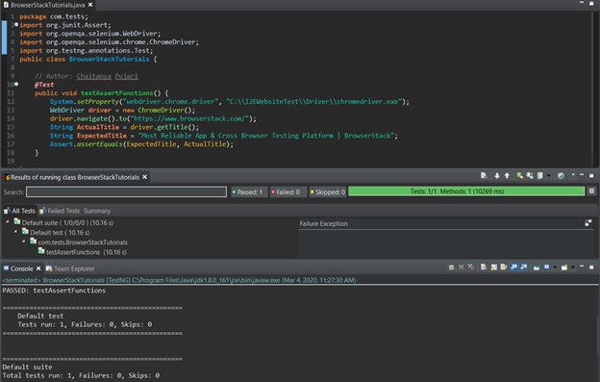

**Verify in Selenium (also known as Soft Assertion)**

In a hard assertion, when the assertion fails, it terminates or aborts the test. If the tester does not want to terminate the script they cannot use hard assertions. To overcome this, one can use soft assertions.

Let’s explore the different types of soft assertions with examples (verify).

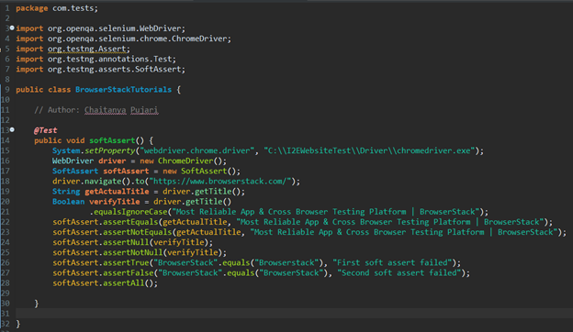

# Global Env Variable/Reusable Comp Setup |Framework – 2

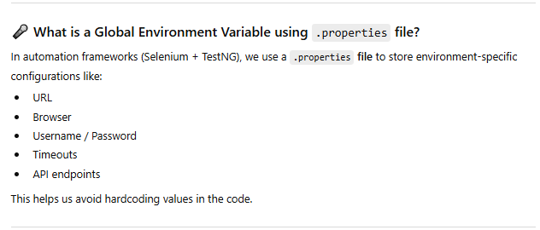

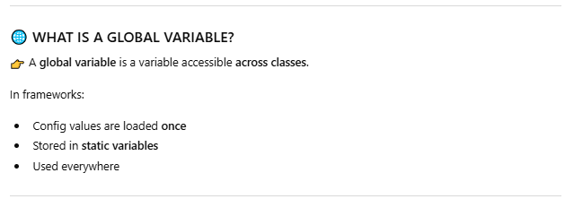

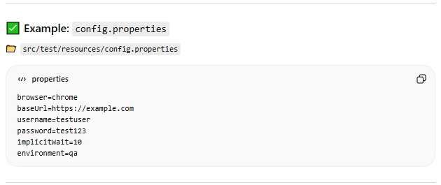

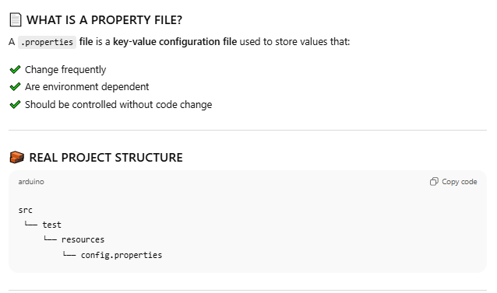

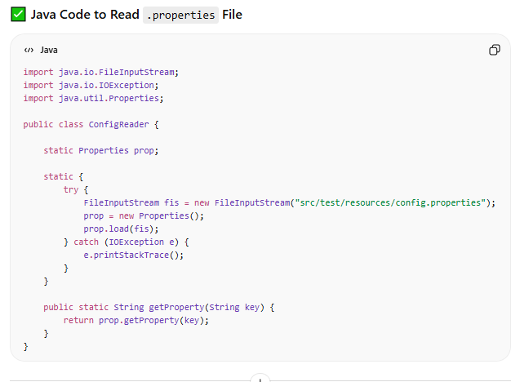

# Excel Data Driven Testing| Framework – 3

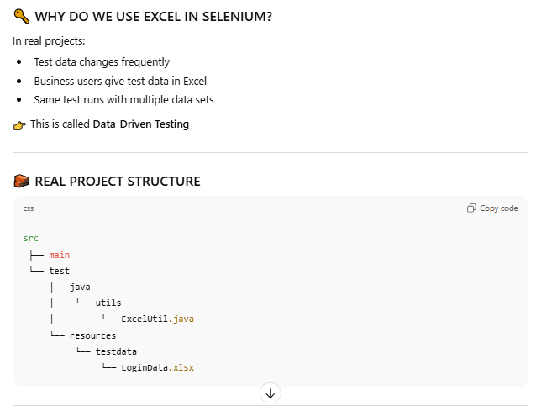

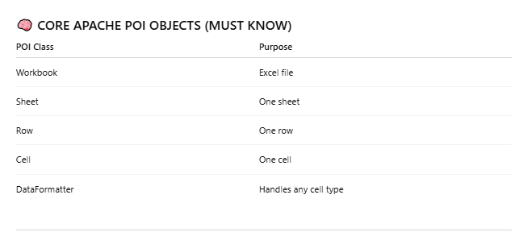



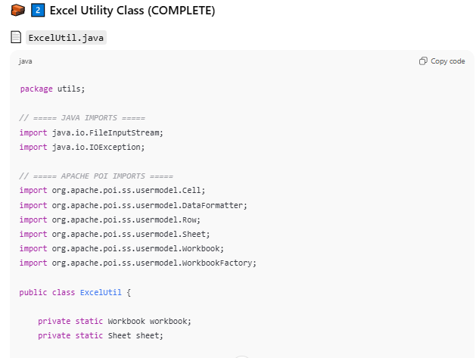

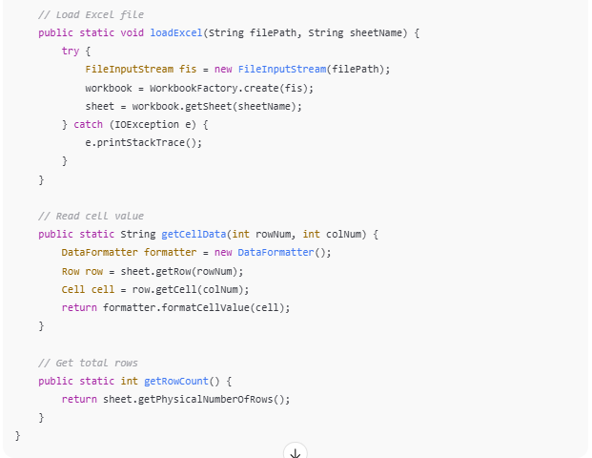

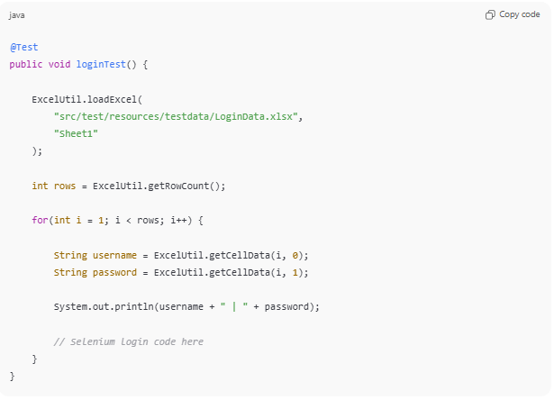

## Interveiw Specific – 1

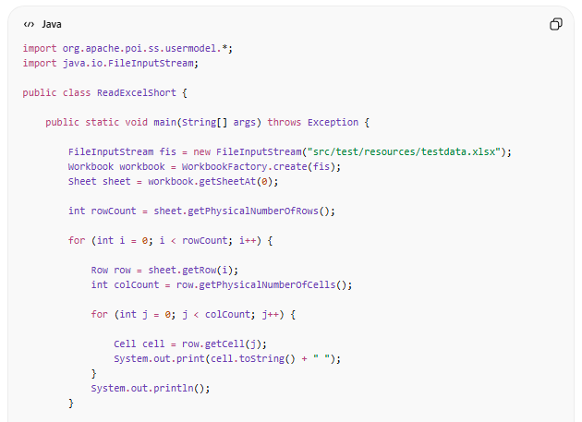

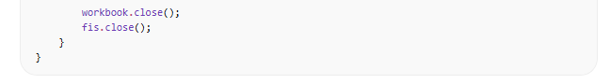

## Interview Specific – 2

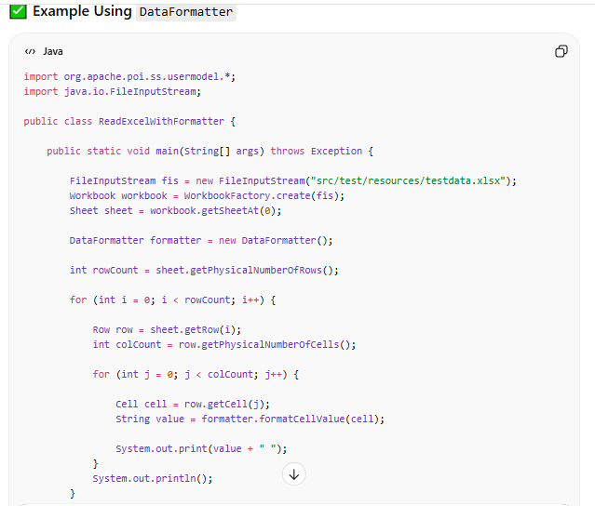

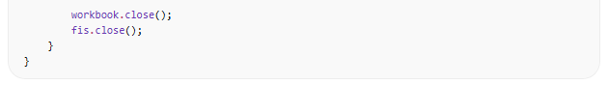

FileInputStream fis = new FileInputStream("./sample.xlsfile");

Workbook workbook = WorkbookFactory.create(fis);

Sheet sheet = workbook.getSheetAt(0);

Dataformatter formatter = new Dataformatter();

int rowCount = sheet.getPhyscialNumberofRows();

for(int r =1; r<rowCount; r++){

Row row = sheet.getRow(r);

int colCount = row.getPhyscialNumberOfCells();

for (int c=1; c<colCount; c++){

Cell cell = row.getCell(c);

String value = formatter.formateCellValue(cell);

System.out.println(value);

}

}

Note : <https://www.javatpoint.com/apache-poi-excel-workbook>

1. **Installation Apache POI –**

Add below depandency to your Maven Project

<!-- https://mvnrepository.com/artifact/org.apache.poi/poi -->

<dependencies>

<dependency>

<groupId>org.apache.poi</groupId>

<artifactId>poi</artifactId>

<version>4.1.2</version>

</dependency>

</dependencies>

1. **Apache Feature –**

* Apache POI (Poor Obfuscation Implementation File System) provides stream-based processing which is useful for large files and takes less memory.
* It is helpful to handle both XLS and XLSX formats of spreadsheets.
* This library contains HSSF implementation for Excel (97-2007) file format i.e .xls.
* The XSSF library implementation should be used for Excel .xlsx file format.
* The HSSF library and XSSF API provides mechanisms to read, write or modify excel spreadsheets.
* It also provides SXSSF that is an extension of XSSF to work with very large excel sheets.
* The SXSSF requires less memory and is suitable when working with very large spreadsheets.
* Apache POI provides excellent support for additional excel features such as working with Formulas, creating cell styles by filling colors and borders, fonts, headers and footers, data validations, images, hyperlinks etc.

1. **Excel Apach POI –**

Apache POI is an open source library provided by Apache Software Foundation to read and write Excel files.

Essential classes and Interface in Apache POI API:

There are two formats of Excel files – .xls and .xlsx format. To read .xls format POI has HSSF implementation and for .xlsx format POI has XSSF implementation.

**Workbook –** It’s an interface implement by HSSFWorkbook and XSSFWorkbook to work with xls and xlsx format workbook respectively.

**Sheet –**It’s an interface implemented by HSSFSheet and XSSFSheet to work with sheets of xls and xlsx format workbook respectively.

**Row –**It’s an interface implemented by HSSFRow and XSSFRow, which represent a ROW of a sheet of xls and xlsx format respectively.

**Cell –**It’s an interface implemented by HSSFCell and XSSFCell, which represent a CELL in a row of a sheet of xls and xlsx format respectively.

1. 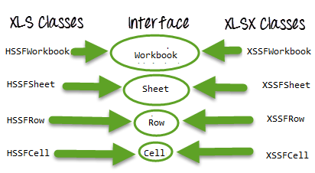Creating a workbook.
2. Opening a Workbook.
3. Creating a Sheet.
4. Saving a Workbook.
5. Saving a Workbook with a new name.
6. Closing a Workbook.
7. Getting Row number from a Sheet.
8. Getting Cell number from a Row of a Sheet.
9. Reading Data from a Cell.
10. Writing Data into a Cell.

**Below are the classes will use to read the data:**

1. **FileInputStream** – A FileInputStream is an inputstream for reading data from a File.
2. **Workbook** – XSSFWorkbook(.XLSX) and HSSFWorkbook(.XLS) classes implement this interface.
3. **XSSFSheet** - XSSFSheet (.XLSX) and HSSFSheet (.XLS) classes implement this interface.
4. **XSSFRow** - XSSFRow (.XLSX) and HSSFRow (.XLS) classes implement this interface.
5. **XSSFCell** - XSSFCell (.XLSX) and HSSFCell (.XLS) classes implement this interface.

**Below are the methods will use to read the data which are available in the above classes:**

1. **getSheet(“sheetName”)** – Get sheet with the given name
2. **getLastCellNum()** – Get the index of the last cell contained in the row Plus one as index starts from ZERO
3. **getLastRowNum()**
4. **getRow(int)** – Returns the row.
5. **getCell(int)** – Get the cell representing a given column
6. **setCellValue() –** Set the value of the cell
7. **getStringCellValue()** – Get the value of the cell as a String
8. **getNumericCellValue()** – Get the value of the cell as a number.
9. **getDateCellValue()** – Get the value of the cell as a date.
10. **getBooleanCellValue()** – Get the value of the cell as a boolean.

|  |  |
| --- | --- |
| Modifier and Type | Method and Description |
| Sheet | cloneSheet(int sheetNum) |
|  | Create an Sheet from an existing sheet in the Workbook. |
| void | [close()](https://poi.apache.org/apidocs/dev/org/apache/poi/ss/usermodel/Workbook.html#close--) |
|  | Close the underlying input resource (File or Stream), from which the Workbook was read. |
| [DataFormat](https://poi.apache.org/apidocs/dev/org/apache/poi/ss/usermodel/DataFormat.html) | [createDataFormat()](https://poi.apache.org/apidocs/dev/org/apache/poi/ss/usermodel/Workbook.html#createDataFormat--) |
|  | Returns the instance of DataFormat for this workbook. |
| [Name](https://poi.apache.org/apidocs/dev/org/apache/poi/ss/usermodel/Name.html) | [createName()](https://poi.apache.org/apidocs/dev/org/apache/poi/ss/usermodel/Workbook.html#createName--) |
|  | Creates a new (uninitialised) defined name in this workbook |
| [Sheet](https://poi.apache.org/apidocs/dev/org/apache/poi/ss/usermodel/Sheet.html) | [createSheet()](https://poi.apache.org/apidocs/dev/org/apache/poi/ss/usermodel/Workbook.html#createSheet--) |
|  | Create a Sheet for this Workbook, adds it to the sheets and returns the high level representation. |
| int | [getActiveSheetIndex()](https://poi.apache.org/apidocs/dev/org/apache/poi/ss/usermodel/Workbook.html#getActiveSheetIndex--) |
|  | Convenience method to get the active sheet. |
| [java.util.List<>](https://poi.apache.org/apidocs/dev/org/apache/poi/ss/usermodel/Name.html) | [getAllNames()](https://poi.apache.org/apidocs/dev/org/apache/poi/ss/usermodel/Workbook.html#getAllNames--) |
|  | Returns all defined names. |
| [java.util.List<>](https://poi.apache.org/apidocs/dev/org/apache/poi/ss/usermodel/PictureData.html) | [getAllPictures()](https://poi.apache.org/apidocs/dev/org/apache/poi/ss/usermodel/Workbook.html#getAllPictures--) |
|  | Gets all pictures from the Workbook. |
| int | [getNumberOfSheets()](https://poi.apache.org/apidocs/dev/org/apache/poi/ss/usermodel/Workbook.html#getNumberOfSheets--) |
|  | Get the number of spreadsheets in the workbook |
| [Sheet](https://poi.apache.org/apidocs/dev/org/apache/poi/ss/usermodel/Sheet.html) | [getSheet(java.lang.String name)](https://poi.apache.org/apidocs/dev/org/apache/poi/ss/usermodel/Workbook.html#getSheet-java.lang.String-) |
|  | Get sheet with the given name |
| [Sheet](https://poi.apache.org/apidocs/dev/org/apache/poi/ss/usermodel/Sheet.html) | [getSheetAt(int index)](https://poi.apache.org/apidocs/dev/org/apache/poi/ss/usermodel/Workbook.html#getSheetAt-int-) |
|  | Get the Sheet object at the given index. |
| int | [getSheetIndex(java.lang.String name)](https://poi.apache.org/apidocs/dev/org/apache/poi/ss/usermodel/Workbook.html#getSheetIndex-java.lang.String-) |
|  | Returns the index of the sheet by his name |
| java.lang.String | [getSheetName(int sheet)](https://poi.apache.org/apidocs/dev/org/apache/poi/ss/usermodel/Workbook.html#getSheetName-int-) |
|  | Get the sheet name |
| [SheetVisibility](https://poi.apache.org/apidocs/dev/org/apache/poi/ss/usermodel/SheetVisibility.html) | [getSheetVisibility(int sheetIx)](https://poi.apache.org/apidocs/dev/org/apache/poi/ss/usermodel/Workbook.html#getSheetVisibility-int-) |
|  | Get the visibility (visible, hidden, very hidden) of a sheet in this workbook |
| void | [removeSheetAt(int index)](https://poi.apache.org/apidocs/dev/org/apache/poi/ss/usermodel/Workbook.html#removeSheetAt-int-) |
|  | Removes sheet at the given index |
| void | [setActiveSheet(int sheetIndex)](https://poi.apache.org/apidocs/dev/org/apache/poi/ss/usermodel/Workbook.html#setActiveSheet-int-) |
|  | Convenience method to set the active sheet. |
| void | setSelectedTab(int index) |
|  | Sets the tab whose data is actually seen when the sheet is opened. |
| void | setSheetName(int sheet, java.lang.String name) |
|  | Set the sheet name. |
| [java.util.Iterator<Sheet>](https://poi.apache.org/apidocs/dev/org/apache/poi/ss/usermodel/Sheet.html) | [sheetIterator()](https://poi.apache.org/apidocs/dev/org/apache/poi/ss/usermodel/Workbook.html#sheetIterator--) |
|  | Returns an iterator of the sheets in the workbook in sheet order. |

<https://poi.apache.org/apidocs/dev/org/apache/poi/ss/usermodel/Workbook.html>

1. **Sample Excel Program :**

**import** org.apache.poi.xssf.usermodel.XSSFRow;

**import** org.apache.poi.xssf.usermodel.XSSFSheet;

**import** org.apache.poi.xssf.usermodel.XSSFWorkbook;

**import** java.io.FileInputStream;

**public** **class** ExcelRowAndColumnCount

{

**public** **static** **void** main(String args[]) **throws** Exception

{

FileInputStream fis = **new** FileInputStream("/Volumes/Krishna/TestData.xlsx");

XSSFWorkbook workbook = **new** XSSFWorkbook(fis);

XSSFSheet sheet = workbook.getSheet("Sheet");

XSSFRow row = sheet.getRow(0);

**int** colNum = row.getLastCellNum();

System.***out***.println("Total Number of Columns in the excel is : "+colNum);

**int** rowNum = sheet.getLastRowNum()+1;

System.***out***.println("Total Number of Rows in the excel is : "+rowNum);

}

}

1. **Advanced Excel Program :**

**import** org.apache.poi.xssf.usermodel.XSSFCell;

**import** org.apache.poi.xssf.usermodel.XSSFRow;

**import** org.apache.poi.xssf.usermodel.XSSFSheet;

**import** org.apache.poi.xssf.usermodel.XSSFWorkbook;

**import** java.io.FileInputStream;

**public** **class** ExcelApiTest

{

**public** FileInputStream fis = **null**;

**public** XSSFWorkbook workbook = **null**;

**public** XSSFSheet sheet = **null**;

**public** XSSFRow row = **null**;

**public** XSSFCell cell = **null**;

String xlFilePath;

**public** ExcelApiTest(String xlFilePath) **throws** Exception

{

**this**.xlFilePath = xlFilePath;

fis = **new** FileInputStream(xlFilePath);

workbook = **new** XSSFWorkbook(fis);

fis.close();

}

**public** **int** getRowCount(String sheetName)

{

sheet = workbook.getSheet(sheetName);

**int** rowCount = sheet.getLastRowNum()+1;

**return** rowCount;

}

**public** **int** getColumnCount(String sheetName)

{

sheet = workbook.getSheet(sheetName);

row = sheet.getRow(0);

**int** colCount = row.getLastCellNum();

**return** colCount;

}}

**public** **class** RowColumnCountFromExcelUsingUtilClass

{

**public** **static** **void** main(String[] args) **throws** Exception

{

ExcelApiTest eat = **new** ExcelApiTest("/Volumes/Krishna/TestData.xlsx");

**int** colCount = eat.getColumnCount("Credentials");

System.***out***.println("Total Columns in the Excel : "+colCount);

**int** rowCount = eat.getRowCount("Credentials");

System.***out***.println("Total Rows in the Excel : "+rowCount);

}

}

1. **Frequently used utility methods :**
2. **Create Excel Workbook & Worksheet:**

XSSFWorkbook workbook = **new** XSSFWorkbook();

XSSFSheet sheet = workbook.createSheet("student Details");

oFileWriter = **new** FileOutputStream(sFilename);

oExcelWorkbook.write(oFileWriter);

oFileWriter.**close**();

oExcelWorkbook.**close**();

1. **Column Count:**

FileInputStream fis = **new** FileInputStream("/Volumes/Krishna/TestData.xlsx");

XSSFWorkbook workbook = **new** XSSFWorkbook(fis);

**XSSFSheet sheet** = workbook.getSheet("Sheet");

XSSFRow row = sheet.getRow(0);

**int** colNum = row.getLastCellNum();

1. **Row Count:**

FileInputStream fis = **new** FileInputStream("/Volumes/Krishna/TestData.xlsx");

XSSFWorkbook workbook = **new** XSSFWorkbook(fis);

**XSSFSheet sheet** = workbook.getSheet("Sheet");

**int** rowNum = sheet.getLastRowNum()+1;

1. **Read All Sheet Name & Count:**

FileInputStream fis = **new** FileInputStream("/Volumes/Krishna/TestData.xlsx");

XSSFWorkbook workbook = **new** XSSFWorkbook(fis);

**int** nrSheets = workbook.**getNumberOfSheets**();

String[] names = **new** String[nrSheets];

**for** ( **int** i = 0; i < nrSheets; i++ )

{

names[i] = workbook.**getSheetName**( i );

}

**return** names;

1. **Read Coulmn’s data from specific Row:** *RowNum*

FileInputStream fis = **new** FileInputStream("/Volumes/Krishna/TestData.xlsx");

XSSFWorkbook workbook = **new** XSSFWorkbook(fis);

**XSSFSheet sheet** = workbook.getSheet("Sheet");

XSSFRow row = sheet.getRow(RowNum-1);

**int** colNum = row.getLastCellNum();

**for** ( **int** i = 0; i < colNum; i++ )

{

Cell sCell = sheet.getRow(RowNum-1).getCell(i)

**switch** (sCell.getCellTypeEnum())

{

**case** BOOLEAN:

System.out.print(sCell.getBooleanCellValue());

**break**;

**case** STRING:

System.out.print(sCell.getRichStringCellValue().getString());

**break**;

**case** NUMERIC:

**if** (DateUtil.isCellDateFormatted(cell))

{

System.out.print(cell.getDateCellValue());

}

**Else**

{

System.out.print(cell.getNumericCellValue());

}

**break**;

**case** FORMULA:

System.out.print(cell.getCellFormula());

**break**;

**case** BLANK:

System.out.print("");

**break**;

**default**:

System.out.print("");

**}**

1. **Read specific cell data:**

FileInputStream fis = **new** FileInputStream("/Volumes/Krishna/TestData.xlsx");

XSSFWorkbook workbook = **new** XSSFWorkbook(fis);

**XSSFSheet sheet** = workbook.getSheet("Sheet");

System.out.println(sheet.getRow(0).getCell(0).getStringCellValue())

1. **Read data cell by cell:**

FileInputStream fis = **new** FileInputStream("/Volumes/Krishna/TestData.xlsx");

XSSFWorkbook workbook = **new** XSSFWorkbook(fis);

**XSSFSheet sheet** = workbook.getSheet("Sheet");

**for** (**int** r = 0; r < sheet.getLastRowNum();r++)

**{**

XSSFRow row = sheet.getRow(r);

**for** (**int** c = 0; c < row.getLastCellNum();c++)

{

System.out.println(getRow(r).getCell(c).getStringCellValue())

}

}

**public** **class** POIforgfgRead {

**public** **static** **void** main(String[] args)

{

**try** {

FileInputStream file = **new** FileInputStream(**new** File("gfgcontribute.xlsx"));

// Create Workbook instance holding reference to .xlsx file

XSSFWorkbook workbook = **new** XSSFWorkbook(file);

// Get first/desired sheet from the workbook

XSSFSheet sheet = workbook.**getSheetAt**(0);

// Iterate through each rows one by one

Iterator<Row> rowIterator = sheet.iterator();

**while** (rowIterator.hasNext()) {

Row row = rowIterator.next();

// For each row, iterate through all the columns

Iterator<Cell> cellIterator = row.cellIterator();

**while** (cellIterator.hasNext()) {

Cell cell = cellIterator.next();

// Check the cell type and format accordingly

**switch** (cell.getCellType()) {

**case** Cell.CELL_TYPE_NUMERIC:

System.out.print(cell.getNumericCellValue() + "t");

**break**;

**case** Cell.CELL_TYPE_STRING:

System.out.print(cell.getStringCellValue() + "t");

**break**;

}

}

System.out.println("");

}

file.close();

}

**catch** (Exception e) {

e.printStackTrace();

}

}

}

1. **Write specific cell data:**

FileInputStream fis = **new** FileInputStream("/Volumes/Krishna/TestData.xlsx");

XSSFWorkbook workbook = **new** XSSFWorkbook(fis);

**XSSFSheet sheet** = workbook.getSheet("Sheet");

sheet.getRow(0).createCell(0).setCellValue(“Selenium”)

1. **Write data to last+1 Row:**

FileInputStream fis = **new** FileInputStream("/Volumes/Krishna/TestData.xlsx");

XSSFWorkbook workbook = **new** XSSFWorkbook(fis);

**XSSFSheet sheet** = workbook.getSheet("Sheet");

**int** rowNum = sheet.getLastRowNum()+1;

XSSFRow row = sheet.getRow(rowNum);

**for** (**int** c = 0; c < row.getLastCellNum();c++)

{

sheet.getRow(rowNum).createCell(c).setCellValue(“Selenium”))

}

FileOutputStream fout=**new** FileOutputStream(**new** File("filename.xlsx"));

**Workbook**.write(fout)

fout.**close**()

1. **Remove Workbook and Worksheet:**

FileInputStream fis = **new** FileInputStream("/Volumes/Krishna/TestData.xlsx");

XSSFWorkbook workbook = **new** XSSFWorkbook(fis);

**XSSFSheet sheet** = workbook.getSheet("Sheet");

**int** sheetIndex = workbook.[getSheetIndex](https://www.codota.com/code/java/methods/org.apache.poi.ss.usermodel.Workbook/getSheetIndex)(("Sheet");

workbook.removeSheetAt(sheetIndex);

**Note:** File I/O can remove Workbook

1. **HSS Class (XLS):**

File file = **new** File(filePath+"\\"+fileName);

//Create an object of FileInputStream class to read excel file

FileInputStream inputStream = **new** FileInputStream(file);

Workbook guru99Workbook = **null**;

//Find the file extension by splitting file name in substring and getting only extension name

String fileExtensionName = fileName.substring(fileName.indexOf("."));

//Check condition if the file is xlsx file

**if**(fileExtensionName.equals(".xlsx"))

{

guru99Workbook = **new** XSSFWorkbook(inputStream);

}

//Check condition if the file is xls file

**else** **if**(fileExtensionName.equals(".xls"))

{

guru99Workbook = **new** HSSFWorkbook(inputStream);

}

1. **Data Provider By Excel WorkBook:**

**import** org.testng.annotations.DataProvider;

**import** org.testng.annotations.Test;

**public** **class** ExcelToDataProvider {

String xlFilePath = **null**;

String sheetName = **null**;

ExcelApiTest eat = **null**;

@Test(dataProvider = "userData")

**public** **void** fillUserForm(String userName, String passWord, String dateCreated,

String noOfAttempts, String result)

{

System.***out***.println("UserName: "+ userName);

System.***out***.println("PassWord: "+ passWord);

System.***out***.println("DateCreated: "+ dateCreated);

System.***out***.println("NoOfAttempts: "+ noOfAttempts);

System.***out***.println("Result: "+ result);

System.***out***.println("*********************");

}

@DataProvider(name="userData")

**public** Object[][] userFormData() **throws** Exception

{

Object[][] data = testData("C:\TestNG\SampleData.xlsx", "Sheet1");

**return** data;

}

**public** Object[][] testData(String xlFilePath, String sheetName) **throws** Exception

{

Object[][] excelData = **null**;

eat = **new** ExcelApiTest(xlFilePath);

**int** rows = eat.getRowCount(sheetName);

**int** columns = eat.getColumnCount(sheetName);

excelData = **new** Object[rows-1][columns];

**for**(**int** i=1; i<rows; i++)

{

**for**(**int** j=0; j<columns; j++)

{

excelData[i-1][j] = eat.getCellData(sheetName, j, i);

}

}

**return** excelData;

}

}

1. **Summary | Points to Remember :**
2. Excel file can be read by Java IO operation. For that, we need to use **Apache POI Jar**.
3. There are two kinds of a workbook in Excel file, **XLSX** and**XLS** files.
4. POI has different Interfaces Workbook, Sheet, Row, Cell.
5. These interfaces are implemented by corresponding**XLS** (**HSSFWorkbook, HSSFSheet, HSSFRow, HSSFCell**) and**XLSX** (**XSSFWorkbook, XSSFSheet, XSSFRow, XSSFCell**) file manipulation classes.
6. JXL is another API for Excel manipulation.
7. JXL cannot work with XLSX format of excel.
8. Row index starts from **ZERO**
9. Column index starts from **ZERO**
10. Extension of excel file is ‘**.xlsx**’ from Excel 2007
11. If you want to read integer value then you have to use “‘”(i.e. **apostrophe**) value in front of that value.[Example : 10 → **‘**10]
12. We need to use different kind of methods to read String, Integer and Date values from the excel.

# Maven| Framework – 4

## Maven

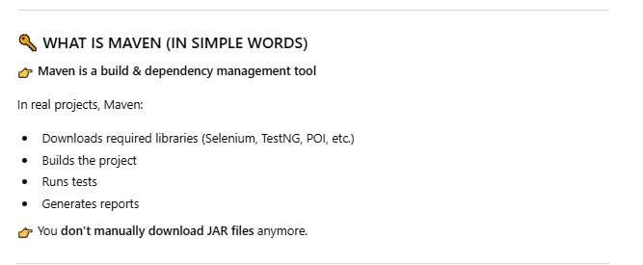

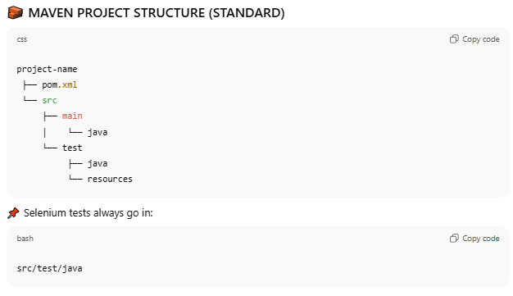

## POM

Project Object Model (POM) is XML file that includes information about the project and configuration used by Maven to construct the whole project, such as dependencies, source directory, plugin, goals, and so on.

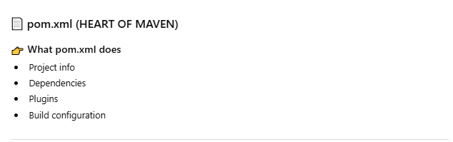

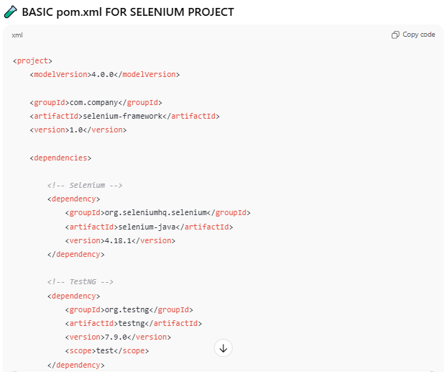

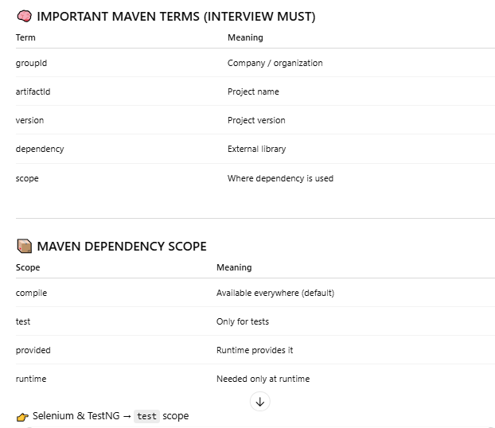

## Maven Life Cycle - CCTPI

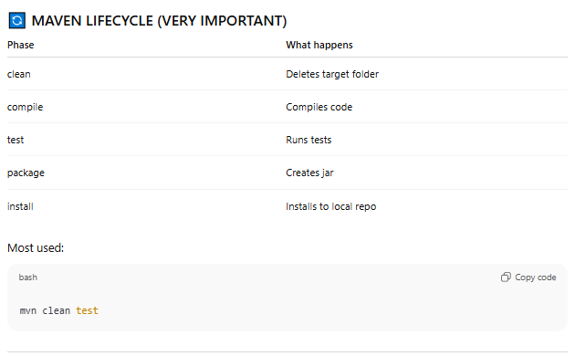

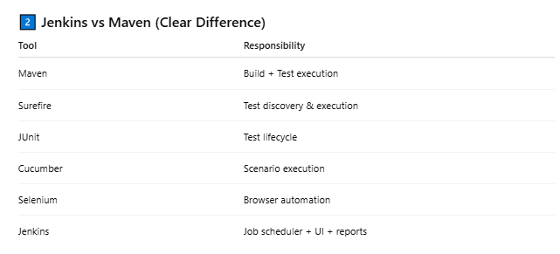

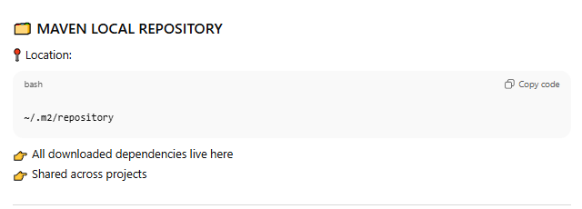

## Execution Flow

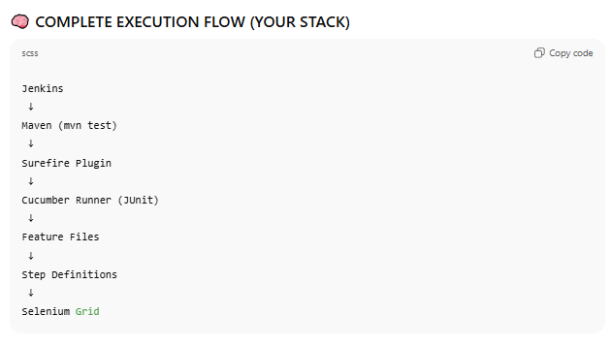

## Failed TestCase Retry

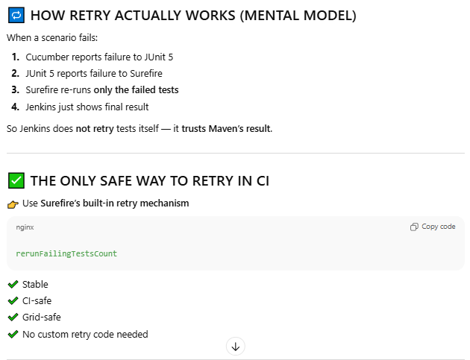

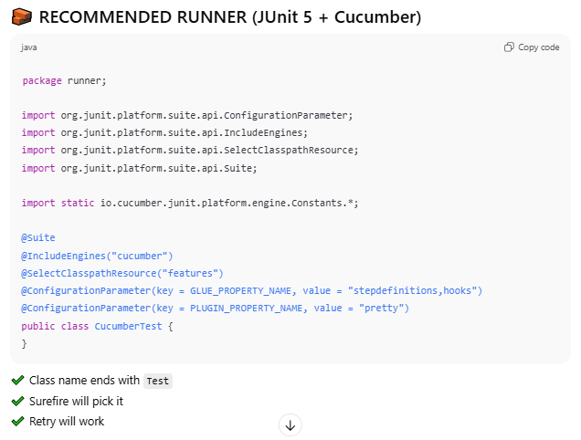

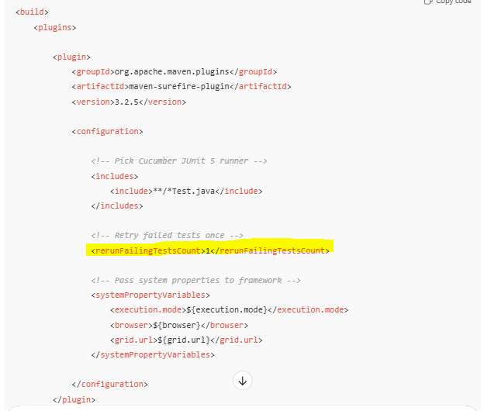

## Trigger from Jenkins

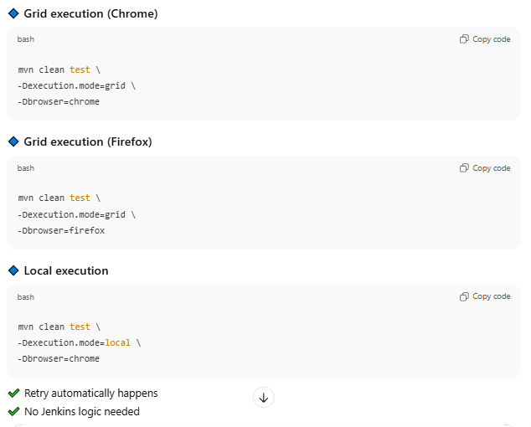

## Discussion Matrix

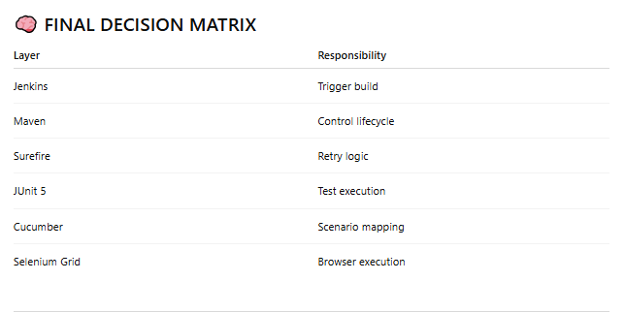

## Trigger From

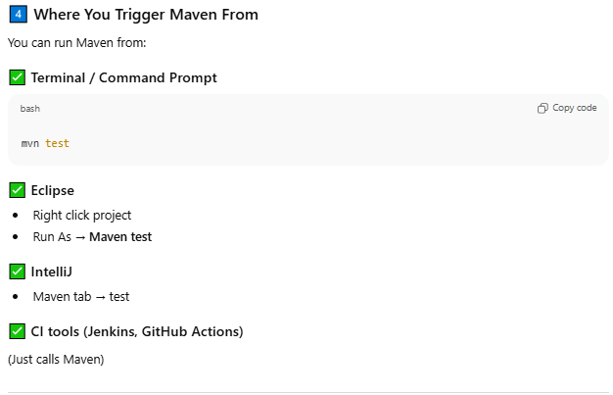

## Daily Used Command

1. Local Run -> **mvn test -Dborwser=chrome**

2. Smoke tests -> **mvn test -Dcucumber.filter.tags=@smoke**

3. Debug single scenarios -> **mvn test -Dcucumber.features=feature:line**

5. Build without tests -> **mvn clean install -D@skipTests**

6. Debug execution -> **mvn test -Dmaven.surefire.debug**

7. Single feature -> **mvn test -Dcucumber.features=path/feature.feature**

8. Multiple features -> **mvn test -Dcucumber.features=feature1,feature2**

9. Scenario by line -> **mvn test -Dcucumber.features=feature:25**

10 Exclude tags -> **mvn test -Dcucumber.filter.tags = "not @wip"**

11. Exclude complex tags -> **mvn test -Dcucumber.filter.tags = "@smoke and not @wip"**

12 Runner file -> **mvn test -Dtest=CucumberTestRunner**

13. Multiple runner file -> **mvn test -Dtest=Runner1, Runner2**

14. Env Specific -> **mvn test -Denv=QA**

15. Retry failed tests once -> **mvn test -Dsurefire.rerunFailingTestsCount=1**

16. Generate allure report -> **mvn allure:report**

17. Open report -> **mvn allure:serve**

18. Jenkis test -> **mvn clean test (Run all tests)**

19. Grid execution -> **mvn clean test -Dexecution.mode=grid -Dbrowser=chrome**

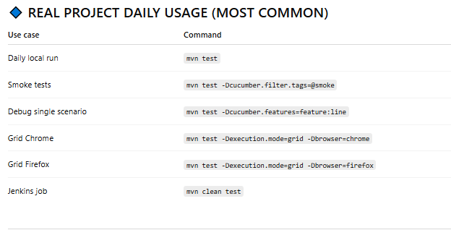

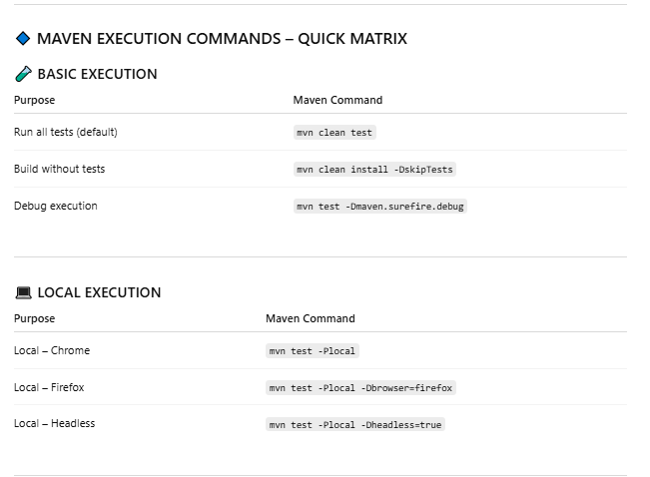

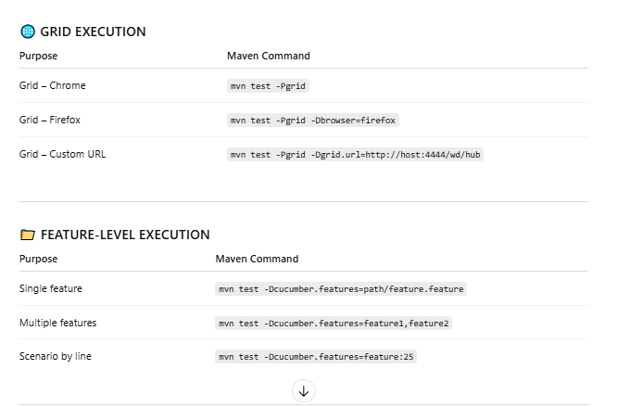

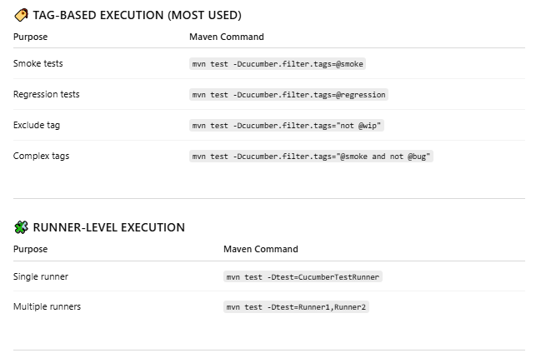

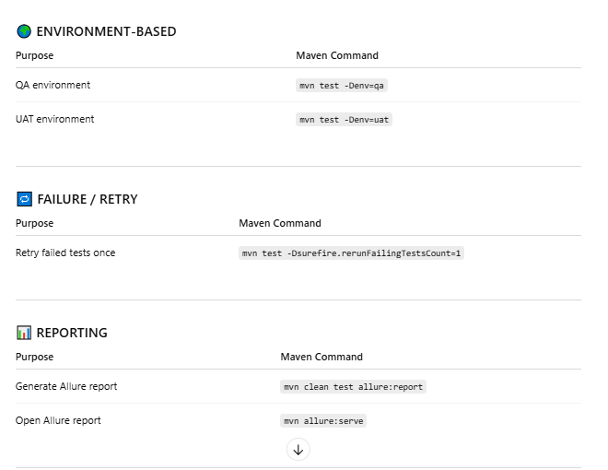

## Doubt

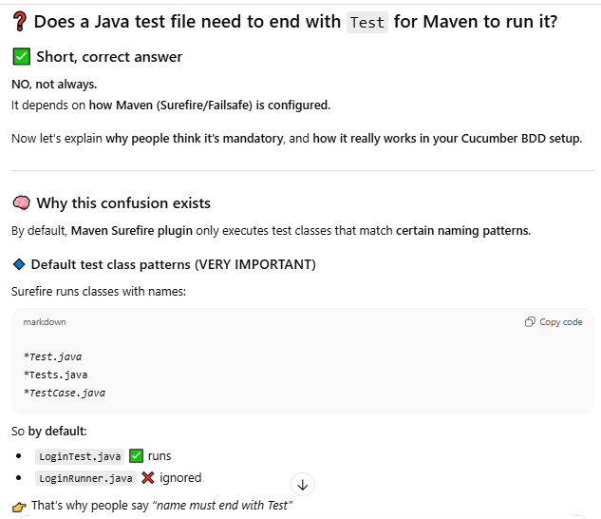

No because Maven knows only oen TestRunner file where cucumber is configured so just on TestRunnerFile with containing **Test** should be fine.

# Jenkins - Continuous Integration | Framework - 5

## Jenkins

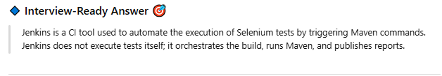

Orchestrates =faciliators

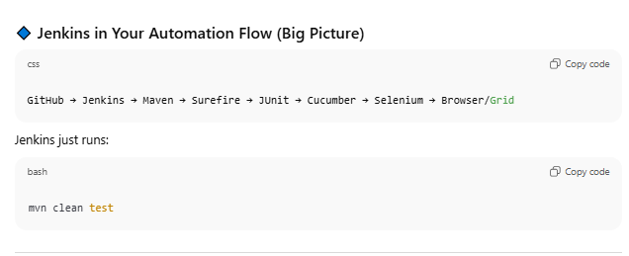

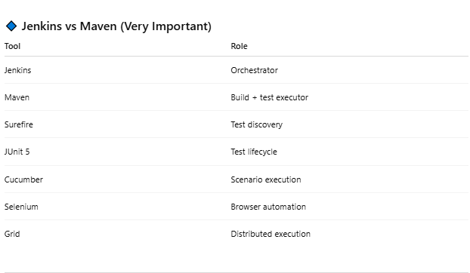

## Jenkins Setup and Pipeline

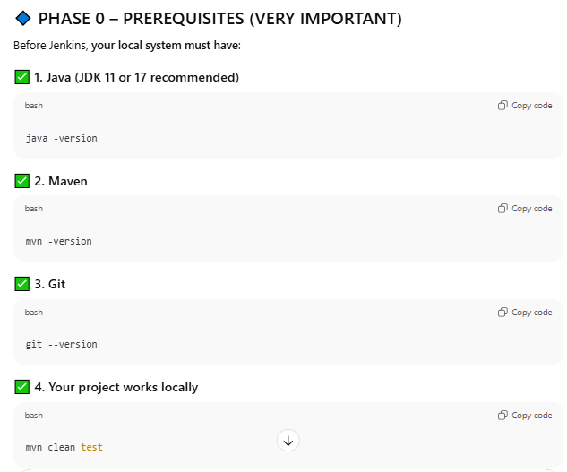

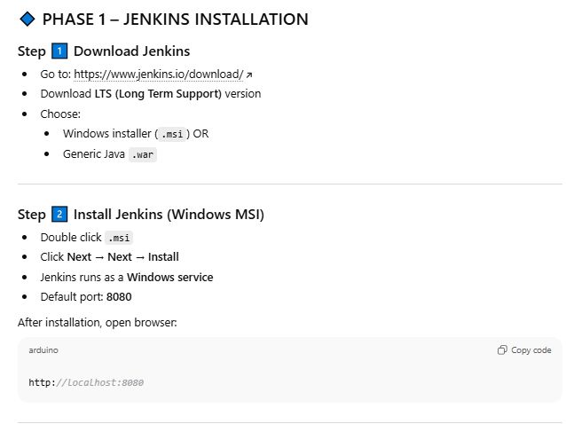

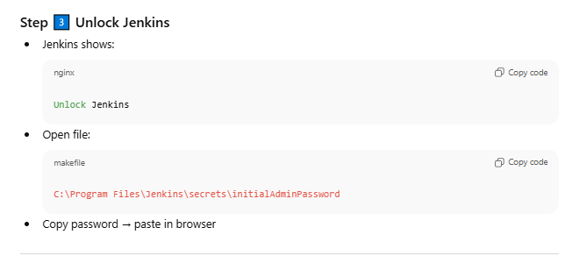

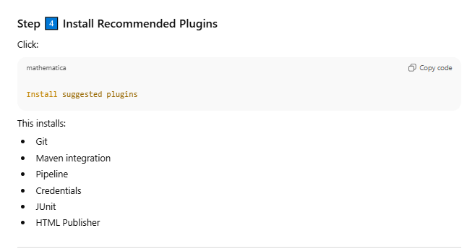

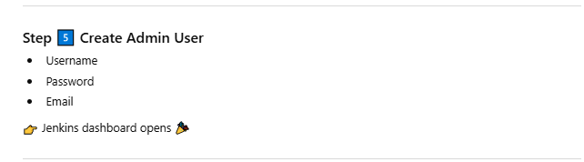

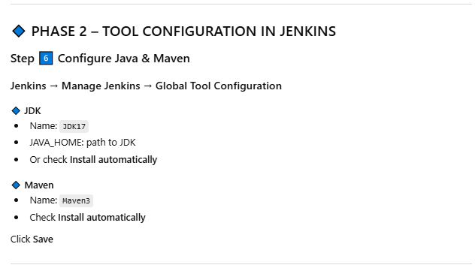

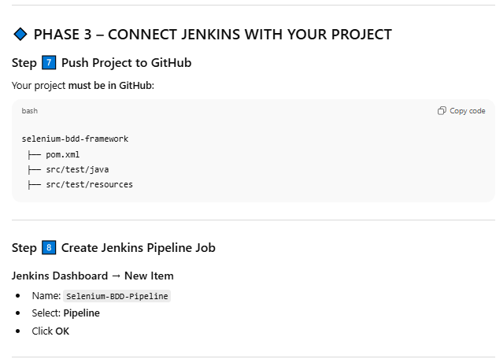

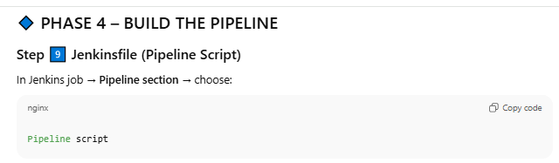

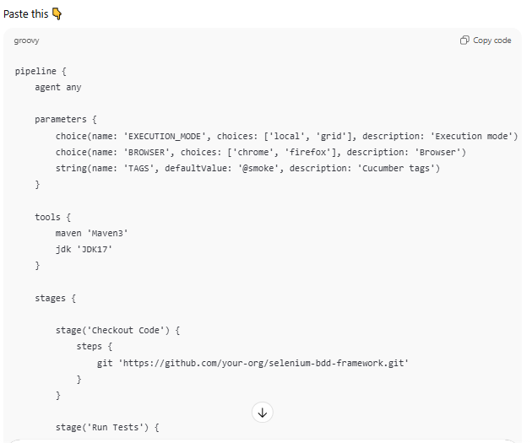

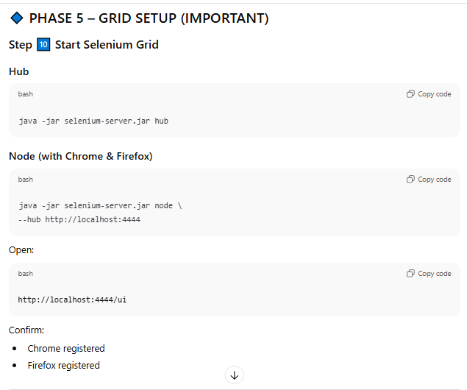

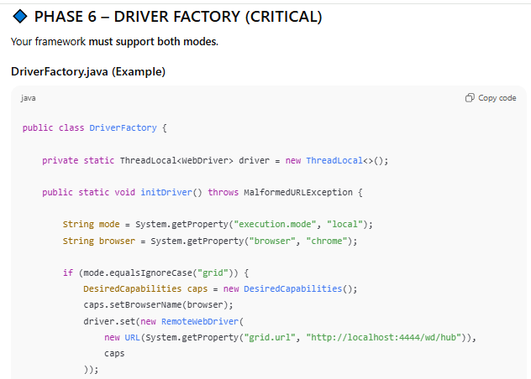

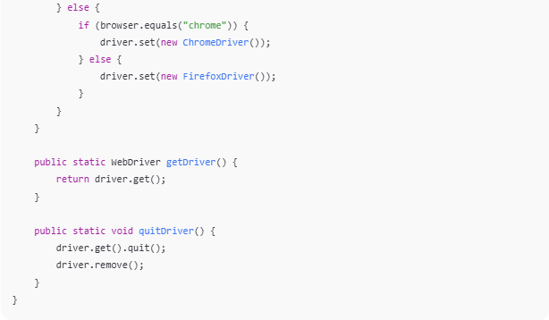

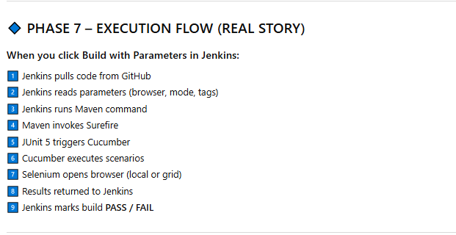

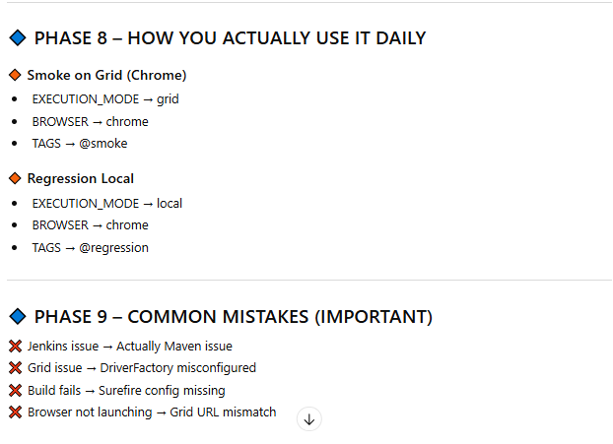

## Jenkins FailedCase Retry – No Action

Question -

If <rerunfailingTestcount>1<rerunfailingTestCount> set then no need to perform any action for the re execution right?

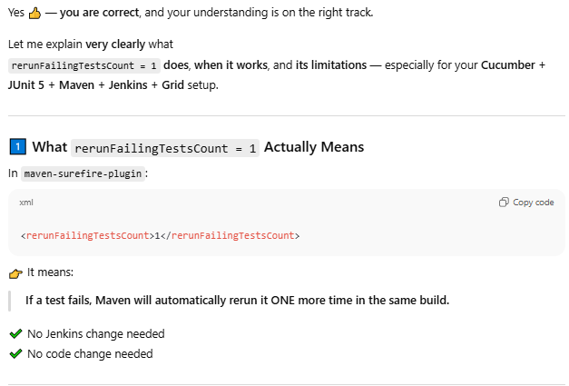

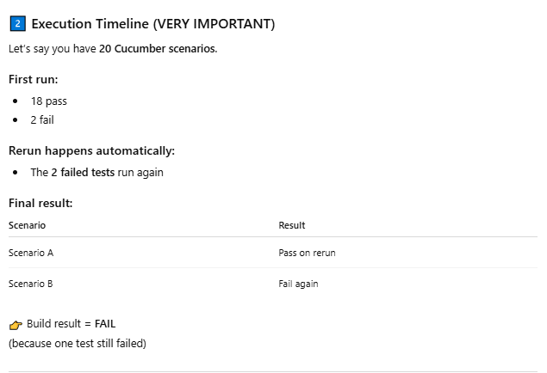

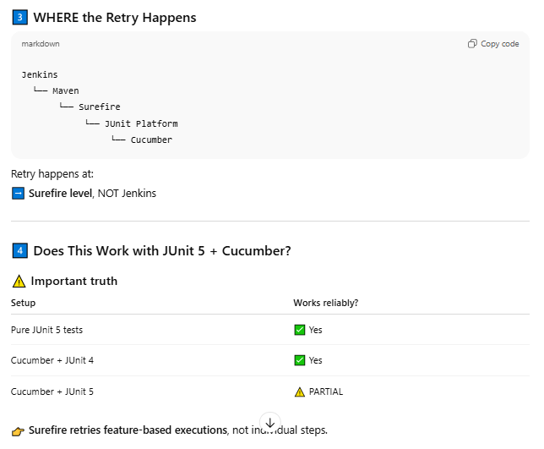

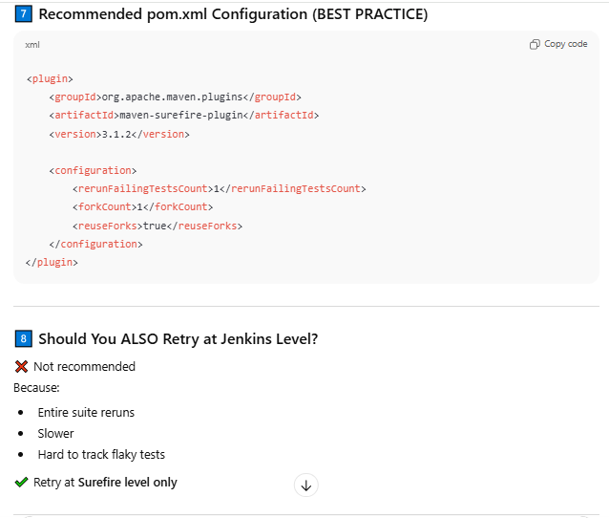

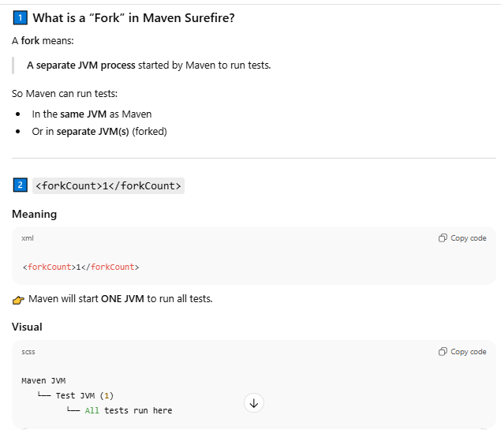

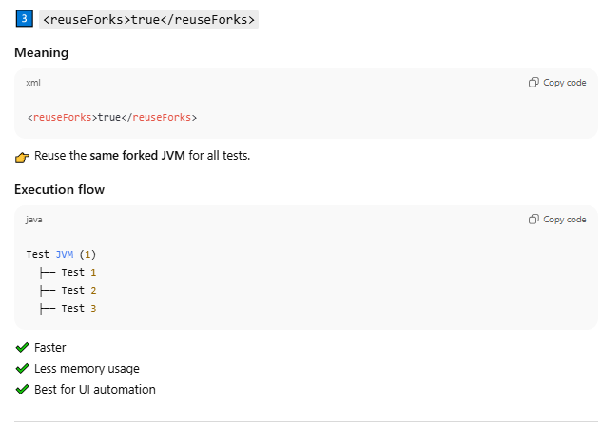

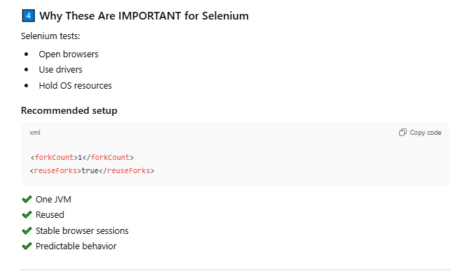

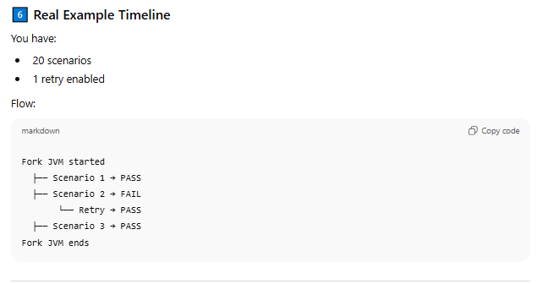

## Pipeline scheduled CRON

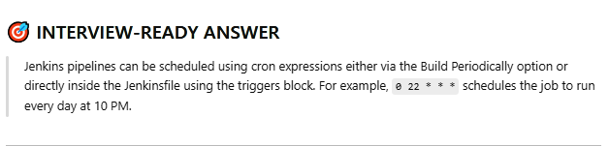

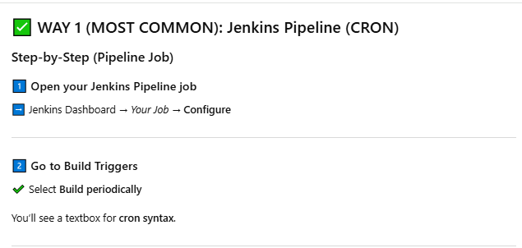

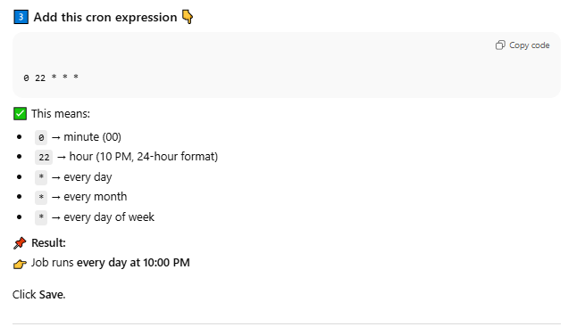

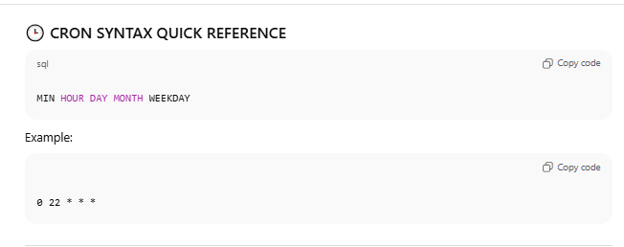

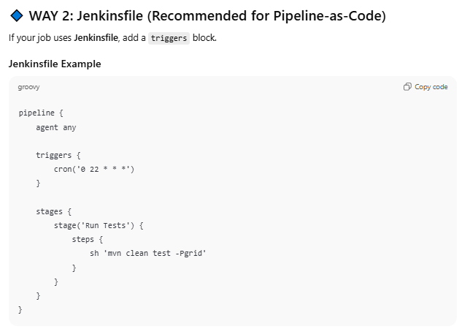

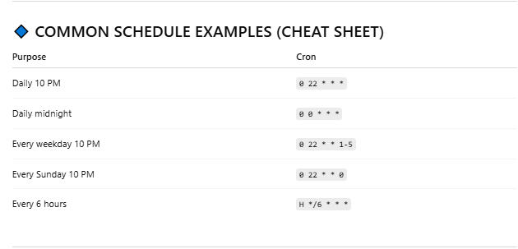

# Loging – SLF4J + Logback

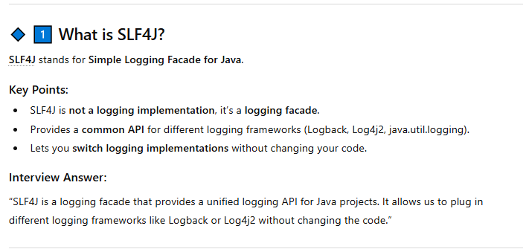

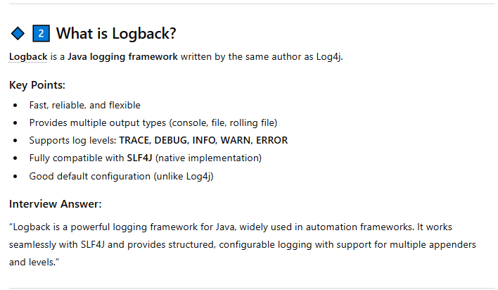

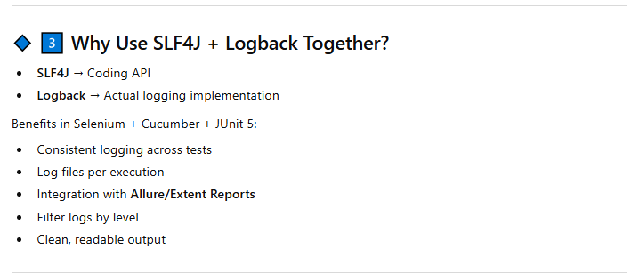

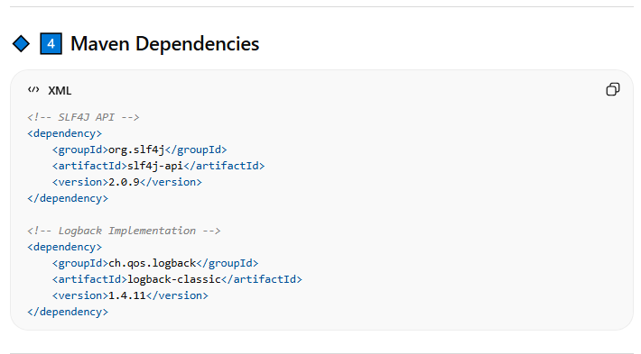

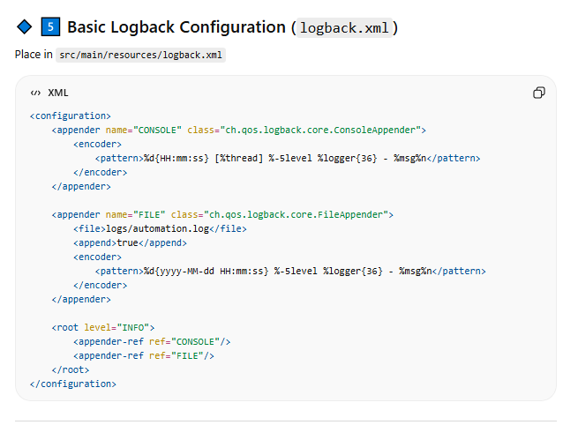

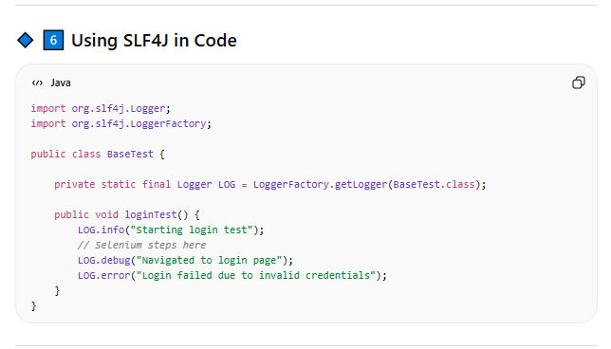

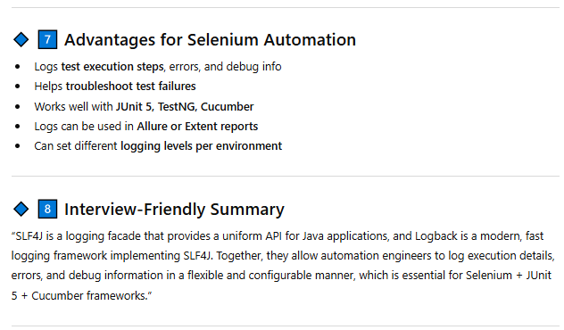

# POM – Page Object Model | Framework – 7

## ****Page Object Model****

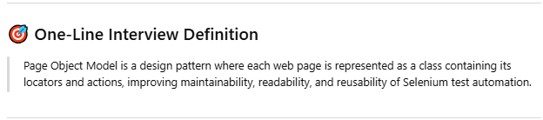

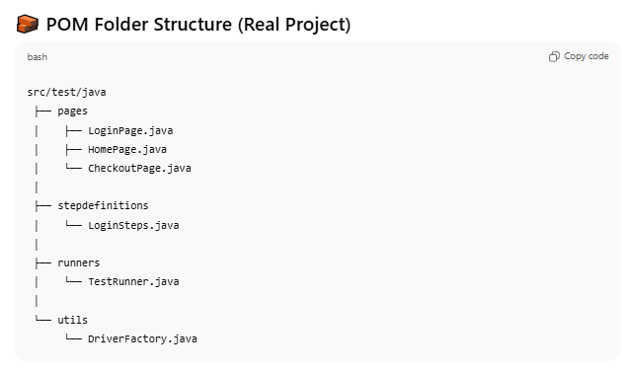

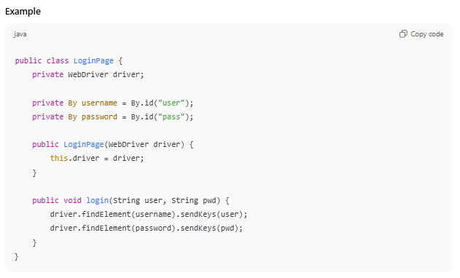

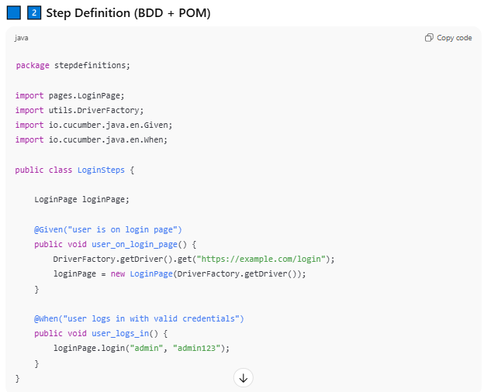

## Page Factory

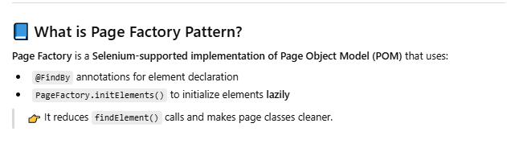

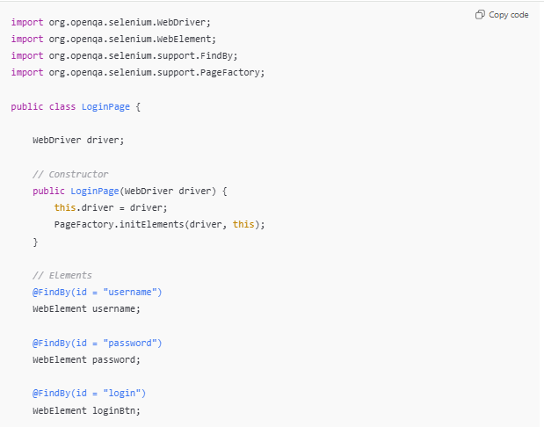

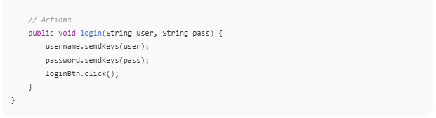

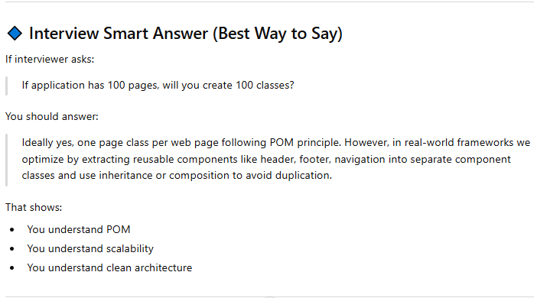

Page Object Model is a design pattern in test automation to build an**Object Repository** for web UI elements. Every web page in the application should have a corresponding page class. This Page class will find the WebElements and also may contain page methods which perform operations on those WebElements.

**Why Page Object Model?**

it is very easy to manage, reusability of code and eliminates duplication of code

[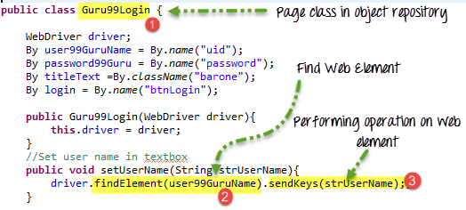](https://www.guru99.com/images/AdvanceSelenium/071514_0722_PageObjectM4.png)

The key benefit if UI changes in the future, then we can update WebElements to Page Classes in POM or Object Repository accordingly

# Cucumber

## BDD and Cucumber

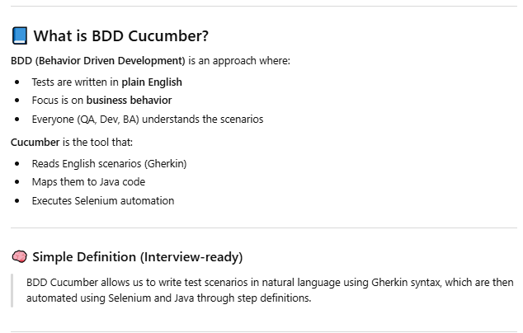

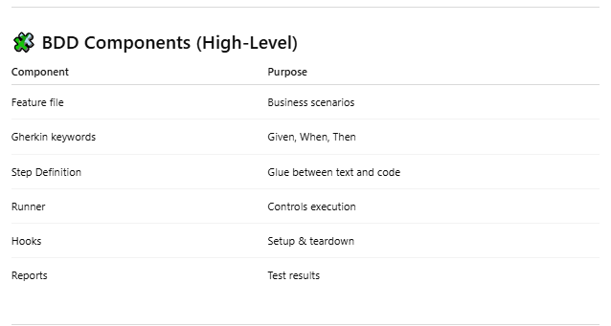

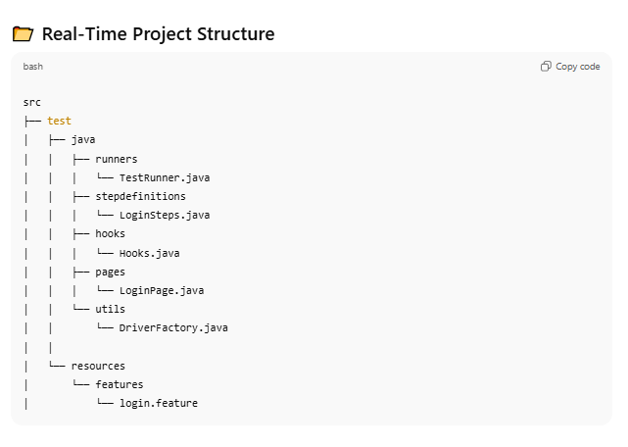

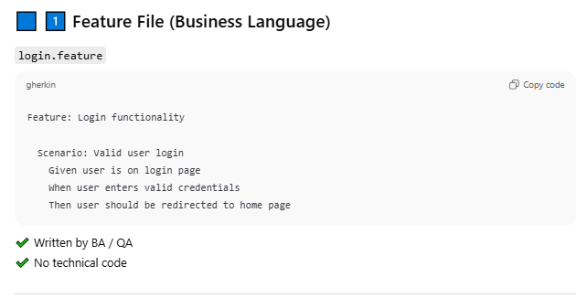

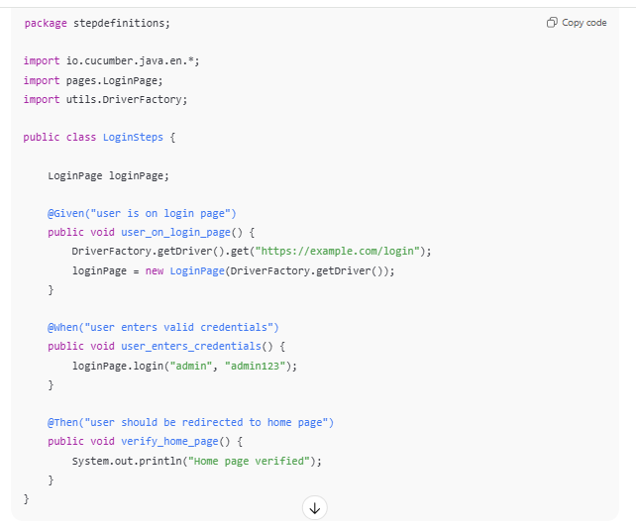

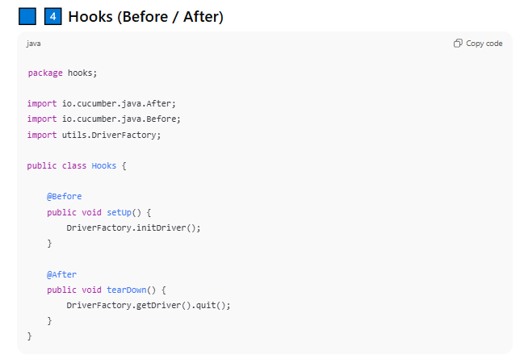

## Feature File Keywords

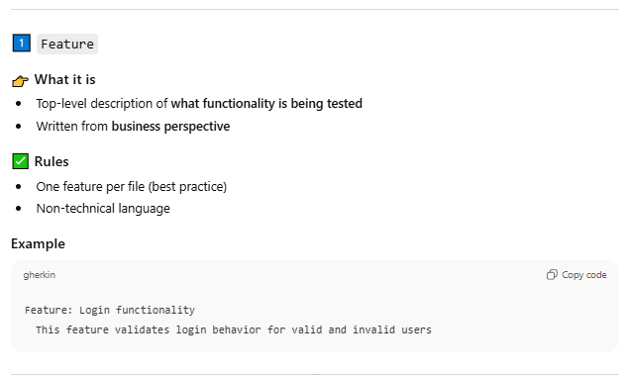

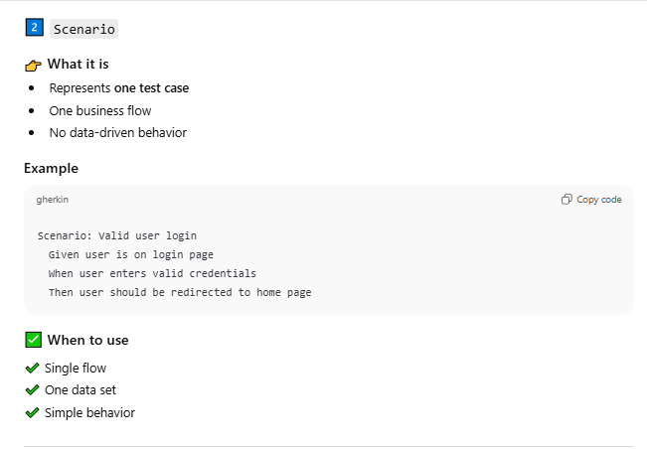

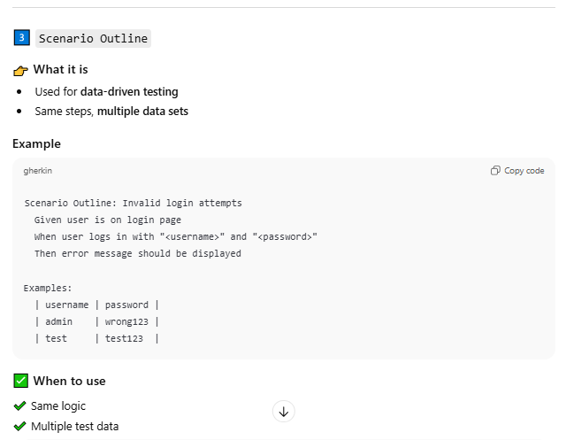

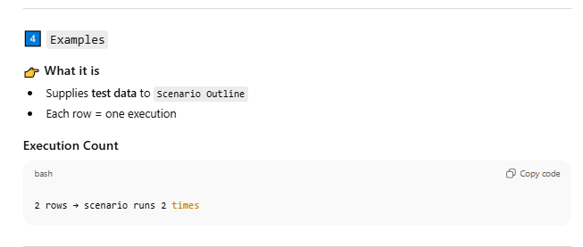

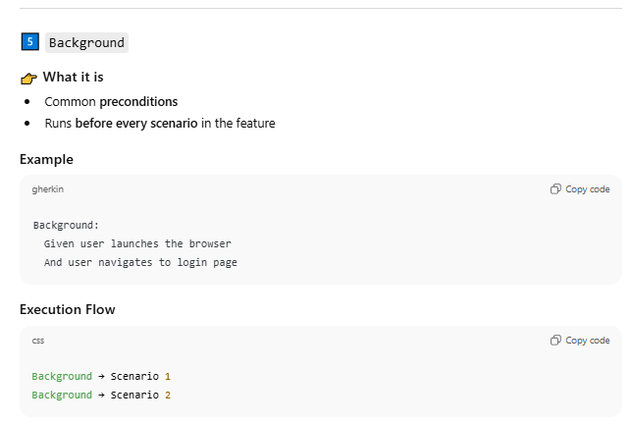

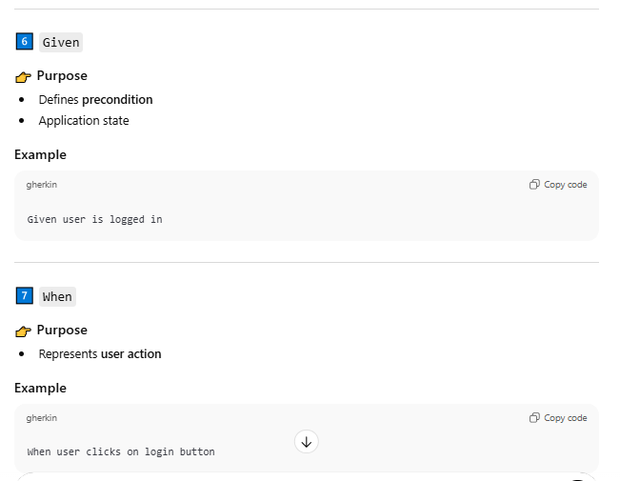

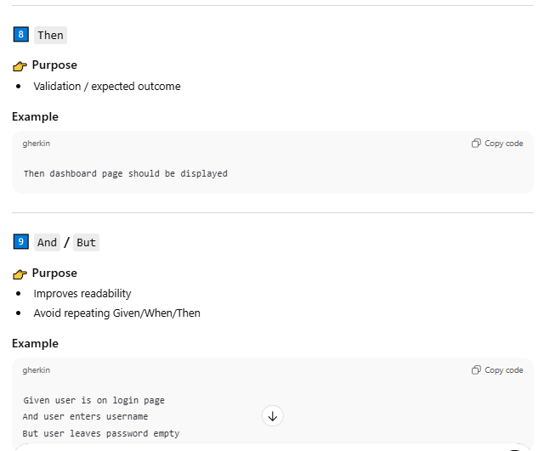

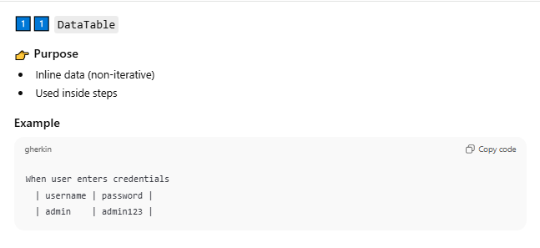

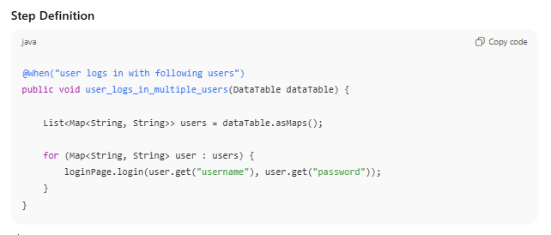

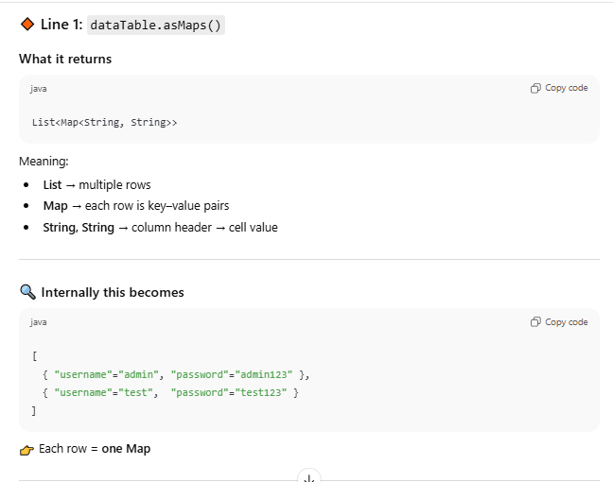

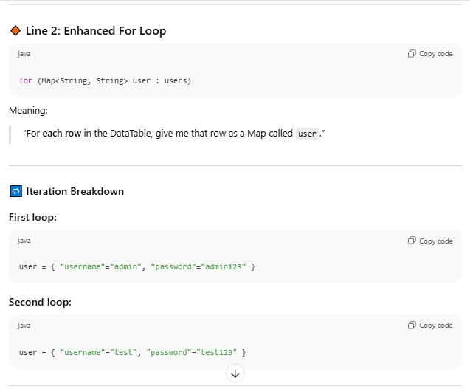

## Cucumber TestRunner Keywords – Junit 5

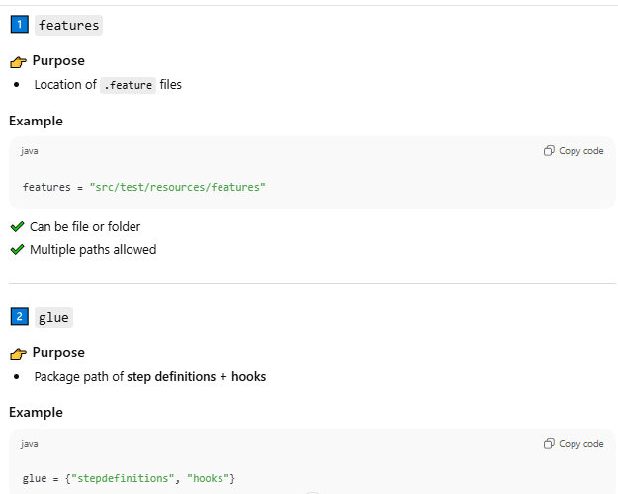

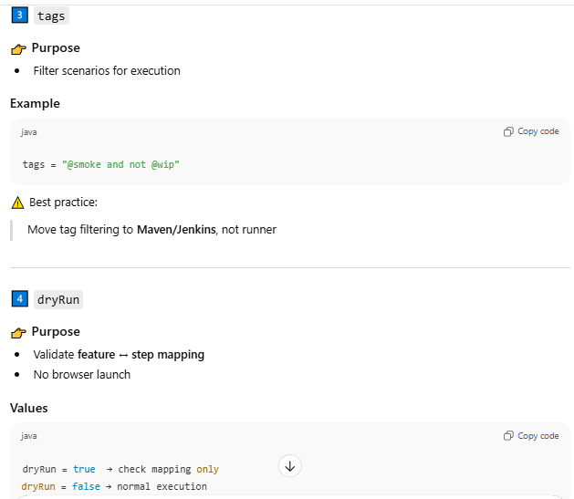

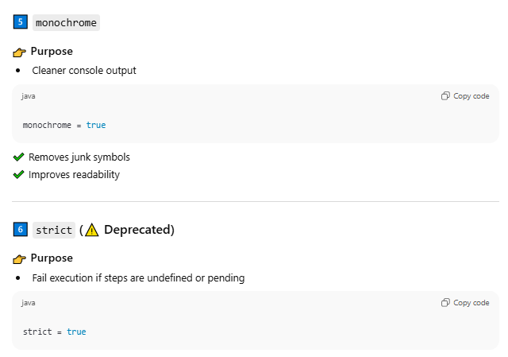

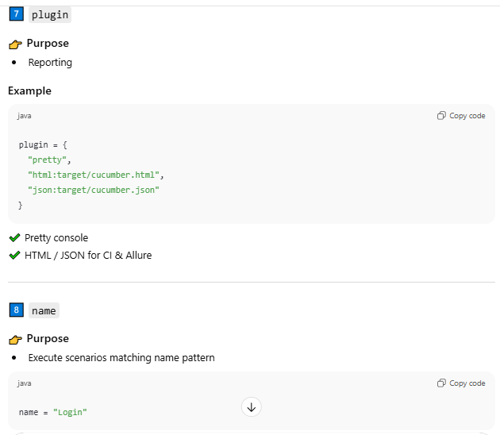

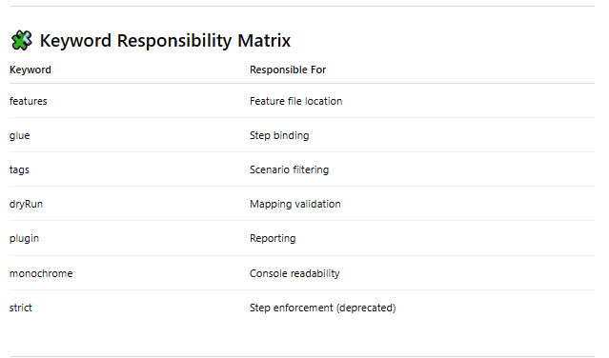

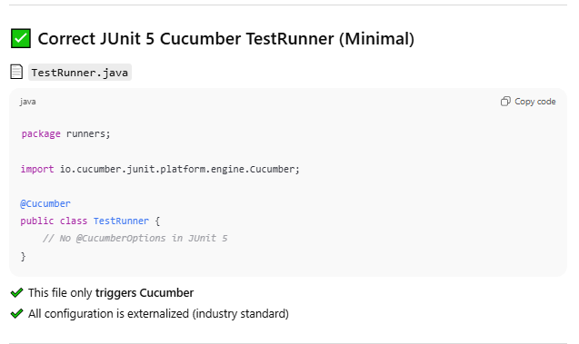

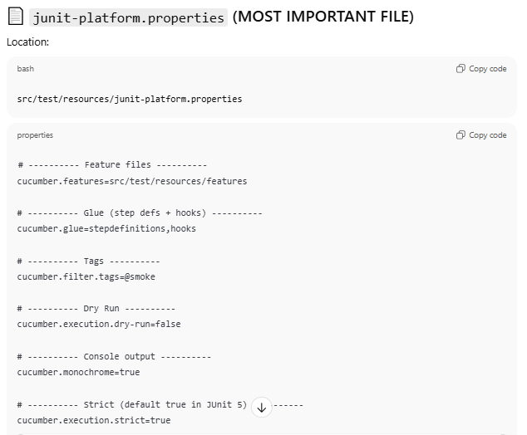

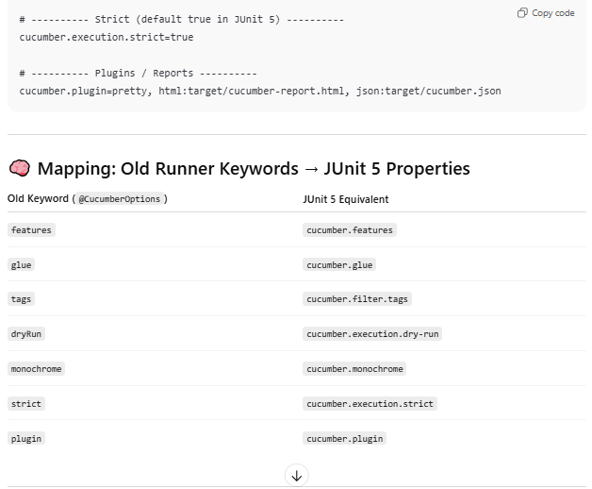

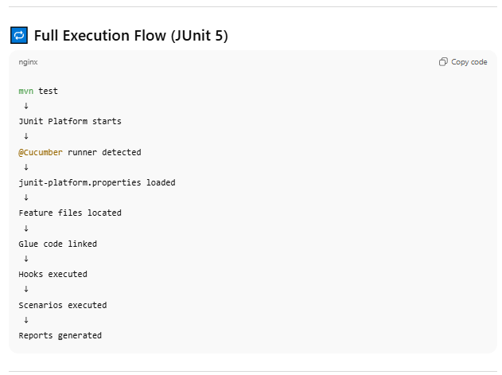

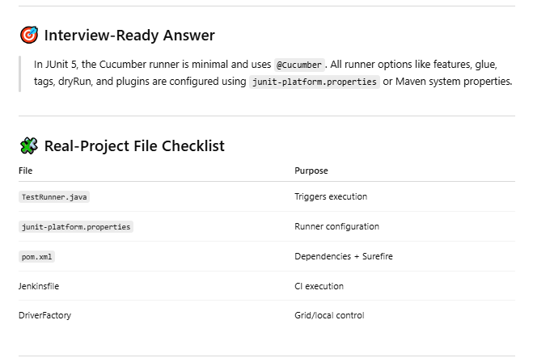

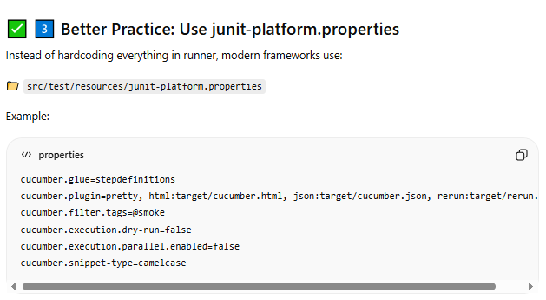

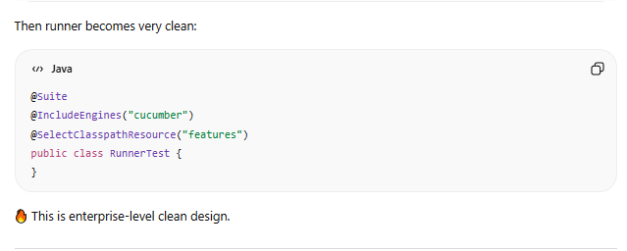

# Framework

Project

Src/test/java

cucumberOption

stepDefination

POM repository

Implementation

Resources

Utils

Feature

Driver

Report

Config

Target

POM.xml

Project

Package

## Package Information

1. **cucumberOption** : This packages contains TestRunner.java class file where cucumber options feature and glue(steps definition) components are being mapped along with other options dryRun, strict, plugin, tages etc
2. **stepDefination**: This package contains java class for each and every screen of an application in order to particularly define corresponding function for each gherkin steps
3. **POM Repository** : This package contains java class to design page object pattern in test automation to build an**Object Repository** for web UI elements. Every web page in the application should have a corresponding page class. This Page class will find the WebElements and also may contain page methods which perform operations on those WebElements.
4. **Implementation** : This package contains the corresponding web page class and the respective function implementation, actual selenium codes are lying here.
5. **Utils**: This package contains reusable utility functions that help selenium core functions in automation.
6. **Resources : This package contains miscellenous fiels related to logger, reports etc**

## Folder Information

1. Feature Folder contains all the feature files of an application to design a scenarios
2. Driver folder contains respective browser drivers
3. Report Folder contains cucumber default report as well as cucumber html graphics report
4. Config folder contains global config properties file
5. POM.XML

## Execution Control Sequence

1. Select a particular scenario and execute
2. Before tag hook will be called and create a driver class object and set it to global variable
3. Once the driver object is create and set to its global variable
4. Control goes to respective step definition function in stepDefination class
5. Here Picocontainer dependency that we have in our POM.xml comes into picture
6. So with the help of picocontainer mechanism, it starts creation of stepDefination class object and hence stepDefination respective constructor being called. This Constructor expects PageObjectManager class instance as parameter and with help of this instance will get rest other class object and use it in our function.

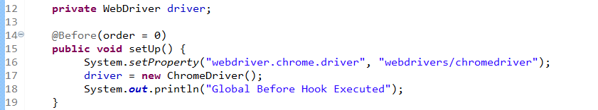

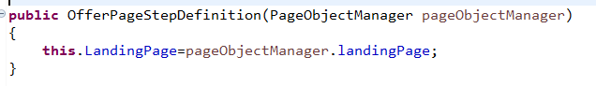

# Automation Exception

Import Packages

**import** java.util.List;

To Support and implements List of WebElements

**import** java.util.concurrent.TimeUnit;

To Support and implements time synchronization

**import** org.openqa.selenium.By;

To Support and implements find by elements

**import** org.openqa.selenium.WebDriver;

To Support and implements webdriver interface and its methods

**import** org.openqa.selenium.WebElement;

To Support and implements webelemnt and work around

**import** org.openqa.selenium.chrome.ChromeDriver;

To Support and implements ChromeDriver

**import** org.openqa.selenium.JavascriptExecutor;

To Support and implements JavascriptExecutor

**import** java.io.File;

To Support and implements I/O operations

**import** java.io.IOException;

To Support and implements IO Exceptions

**import** com.google.common.io.Files;

To Support and implements google I/O file operations

**import** org.openqa.selenium.OutputType;

To Support and implements Output Type

**import** org.openqa.selenium.TakesScreenshot;

To Support and implements TakeScreenshot operations

**import** org.openqa.selenium.Capabilities;

**import** org.openqa.selenium.chrome.ChromeOptions;

**import** org.openqa.selenium.remote.CapabilityType;

**import** org.openqa.selenium.remote.DesiredCapabilities;

**Types of Selenium exceptions Selenium exceptions root causes**

1. NoSuchElementException :

WebDriver is not able to find the existence of web element on the web page. Here, the FindElementBy method is unable to find the web element.

**Root Cause:** Elements are removed from the DOM Xpath you specified for the element may be wrong AJAX has not returned yet and you've already obtain NoSuchElementException Page is still being rendered but you've already finished your element search because of low wait time The element is not on the page at all.

1. NoSuchWindowException

Selenium WebDriver is unable to switch to the window.

**Root Cause**: Current window closed Target window is not opened yet, but you were trying to perform operation When target window has been closed but still the code tried to perform operation on the target window.

1. NoSuchFrameException WebDriver is unable to switch to the given frame.

**Root Cause:** Invalid name of the frame Switchable frame does not exist We have not given enough wait time to load the frame

1. NoAlertPresentException

Selenium WebDriver is unable to switch to the alert. Here Alert popup could be Alert Box, Confirmation Box, Prompt Box from the Javascript commands.

**Root Cause**: When user tries to access alert which is not present in the at current time When javascript alert is blocked in the browser Not giving enough time for the alert to load When alert is already closed

1. ElementNotSelectableException WebDriver is not able to select or click the web element on Application under test (AUT).

**Root Cause**: The attribute of the web element is set to disable

1. ElementNotVisibleException This type of Exception occurs when existing element in DOM has an attribute set as hidden. In this case, elements are there, but they are not visible or available to interact with the WebDriver.

**Root Cause**: HTML element’s attribute set to ‘hidden’ Trying to use sendkeys to element which is not visible

1. ElementNotSelectableException This exception is thrown when an element is present in the DOM but not able to select.

**Root Cause:** Element may be overlapped by another element.

1. InvalidSelectorException When you write wrong XPath syntax then this exception may occur.

**Root Cause:** XPath syntax is not correct

1. TimeoutException This exception occurs when we use wait commands like Implicit Wait, Explicit Wait or Fluent Wait. Once any of the waits fails after exceeding defined time then TimeoutException occurs.

**Root Cause:** WebDriver fails to perform an activity in defined time within Implicit Wait or Explicit Wait

1. WebDriverException This exception occurs when the WebDriver is performing the action right after you close the browser.

**Root Cause:** WebDriver trying to execute a statement after the browser is closed.

1. StaleElementReferenceException This exception occurs when the web element gets detached from the current DOM.

**Root Cause**: JavaScript or JS library has deleted an element and replaced it with one with the same ID or attributes.

1. ScreenshotException This will be thrown when selenium fails to take screenshot of the webpage. If ScreenshotException occurs then the screenshot captured turns black

**Root Cause:** When we try to take screenshot in headless browser(phantomjs, htmlunitdriver) without enabling the screenshot functionality

1. ScriptTimeoutException  Webdriver throws ScriptTimeoutException exception when executeAsyncScript takes more time than given time limit to return the value.

**Root Cause**: Webpage running a long running script

1. InsecureCertificateException  Navigation made the user agent to hit a certificate warning, which is caused by an invalid or expired TLS certificate.

**Root Cause:** Website is does not has valid certificate

1. UnableToSetCookieException  This exception is thrown when a driver fails to set a cookie.

**Root Cause:** You are trying to set the cookie without specifying the domain

**StaleElementReferenceException**

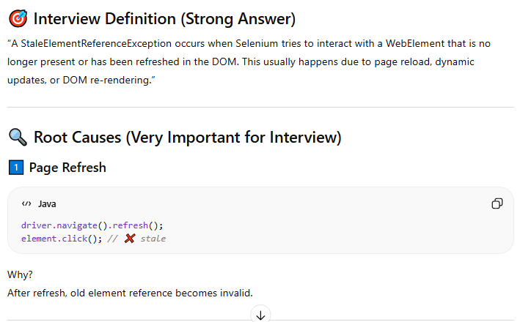

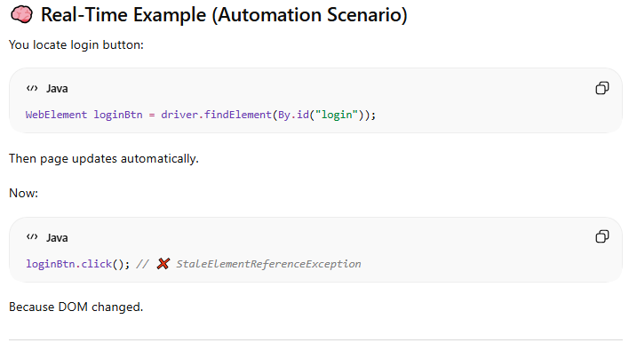

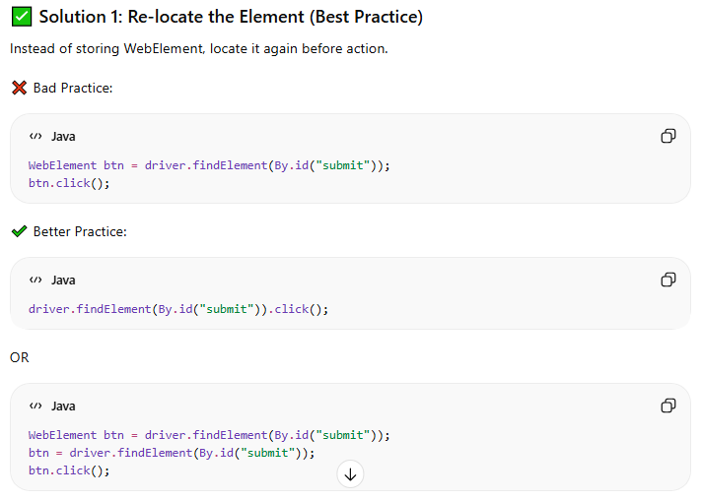

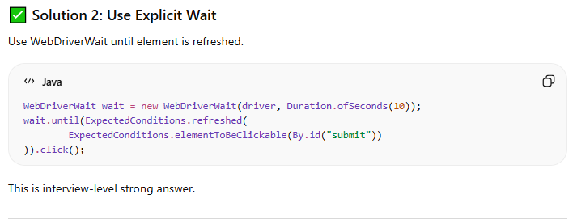

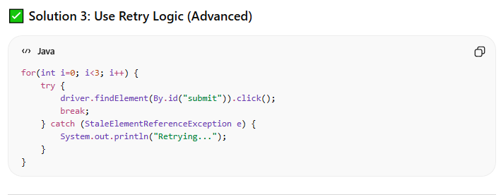

# 1–2 Minute Interview Explanation (Final Version)

“We use a **Maven-based hybrid BDD automation framework** built using **Java, Selenium WebDriver, Cucumber, Rest Assured, JUnit 5, and Allure reporting**.

At the top level, test scenarios are written in **Gherkin feature files**, which define the business flow using Given-When-Then. Test data at the scenario level is managed using **Scenario Outline and Examples**, keeping test intent and data together.

The feature files are mapped to **step definition classes**, which act as a glue layer.

For UI automation, we follow the **Page Object Model**, where each page has a dedicated class that encapsulates web elements and page actions. For API automation, we use **Rest Assured** with separate service classes, allowing UI and API tests to run independently or together in end-to-end flows.

**Cucumber Hooks** are used to manage scenario lifecycle activities such as browser setup, teardown, and capturing screenshots on failure..

Test execution is controlled using **JUnit 5 and the JUnit Platform Suite**, and execution behavior like parallelism and thread count is externalized using junit-platform.properties. Environment-specific configuration such as browser and base URL is managed through config.properties.

Finally, **Allure reporting** provides detailed execution reports with step-level visibility, screenshots, and API logs. The framework is **scalable, maintainable, and CI/CD ready**, suitable for enterprise-level UI and API automation.”

# Layered Framework Explanation — Told as a Story (Interview-Ready)

### 

### ****Layer 1: Test Specification Layer (BDD / Feature Files)****

“Everything in our framework starts at the **test specification layer**.  
This is where business requirements are captured as **Cucumber feature files** using Gherkin.  
These files describe user behavior in a business-readable format, so they answer the question what are we testing, not how we are testing it.  
At this layer, there is no automation code at all — just scenarios, steps, and tags that define the intent of the test.”

### ****Layer 2: Glue Layer (Step Definitions)****

“Once execution begins, Cucumber moves from the feature files into the **glue layer**, which consists of step definition classes.  
This layer acts as a translator between business language and technical automation.  
Each Gherkin step is mapped to a Java method, but the step definitions themselves stay very lightweight.  
They don’t contain Selenium or Rest Assured logic; instead, they simply coordinate calls to the lower automation layers.”

### ****Layer 3: UI Automation Layer (Page Object Model)****

“When a scenario involves UI interaction, control flows from the step definitions into the **UI automation layer**, which follows the Page Object Model.  
Each page in the application is represented by a dedicated class that encapsulates locators and user actions.  
This layer is responsible for how the UI behaves, while remaining completely unaware of the test scenario that triggered it.  
Because of this separation, any UI change impacts only the page classes and not the test cases.”

### ****Layer 4: API Automation Layer (Rest Assured Services)****

“For API scenarios, the execution path moves instead into the **API automation layer**.  
This layer uses Rest Assured to build requests, send them to the service, and capture responses.  
API logic is isolated in service classes, which allows API tests to run independently or be combined with UI flows in end-to-end scenarios.  
This keeps backend validation cleanly separated from test orchestration.”

### ****Layer 5: Lifecycle Management Layer (Hooks)****

“Surrounding every scenario is the **lifecycle management layer**, implemented using Cucumber Hooks.  
Before a scenario starts, hooks take care of setup activities like browser initialization or API configuration.  
After execution, hooks handle cleanup activities such as closing the browser and capturing screenshots on failure.  
This ensures consistent behavior across all tests without repeating setup logic in step definitions.”

### ****Layer 6: Utility & Support Layer****

“Throughout execution, all layers rely on a shared **utility layer**.  
This includes classes for WebDriver management, configuration reading, and common reusable helpers.  
The utility layer abstracts low-level technical details and provides standardized services to the rest of the framework, helping us avoid duplication and enforce consistency.”

### ****Layer 7: Execution & Control Layer (JUnit 5 Runner)****

“The overall execution of the framework is controlled by the **execution layer**, which is built on JUnit 5 using the JUnit Platform.  
This layer is responsible for discovering feature files, applying tag filters, and triggering Cucumber as a test engine.  
It acts as the central coordinator that ties together all layers during runtime.”

### ****Layer 8: Execution Configuration Layer (JUnit Platform Properties)****

“Closely supporting execution is the **execution configuration layer**, where we use junit-platform.properties.  
This layer externalizes execution behavior such as parallel execution and thread management.  
By keeping these settings outside the code, we can tune performance for local runs or CI pipelines without modifying the framework.”

### ****Layer 9: Environment Configuration Layer****

“At runtime, the framework reads environment-specific values from config.properties.  
This layer controls things like browser type, base URLs, and timeouts, allowing the same test suite to run across multiple environments with no code changes.”

### ****Layer 10: Reporting Layer (Allure)****

“Finally, once execution completes, results flow into the **reporting layer** powered by Allure.  
This layer captures step-level execution details, screenshots on failure, and API logs, giving both technical and non-technical stakeholders clear visibility into test outcomes.”

### ****Closing the Story (Strong Interview Finish)****

“So overall, the framework follows a **clean, layered architecture** where a test starts as a business-readable scenario, flows through well-defined automation and execution layers, and ends with rich reporting.  
This design ensures strong separation of concerns, high maintainability, and easy scalability, making the framework suitable for enterprise-level automation.”

# GIT and GITHUB

## Introduction

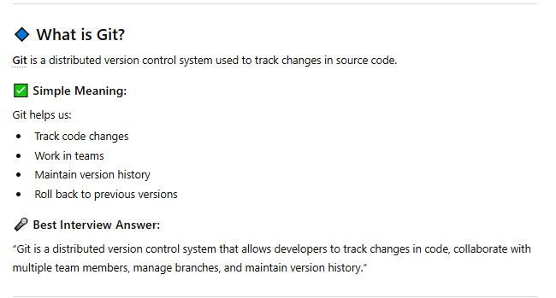

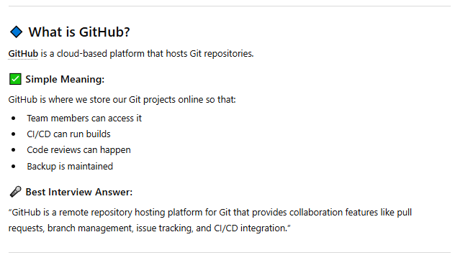

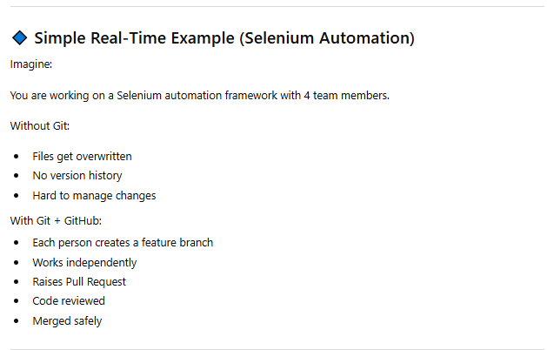

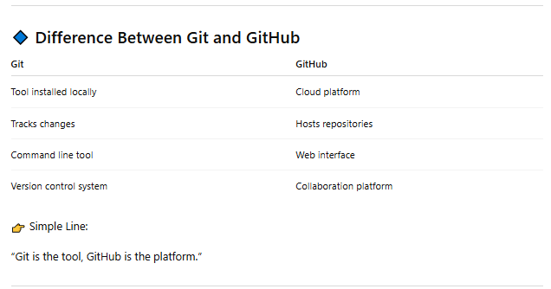

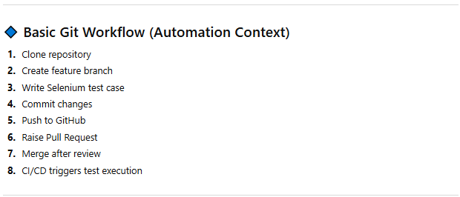

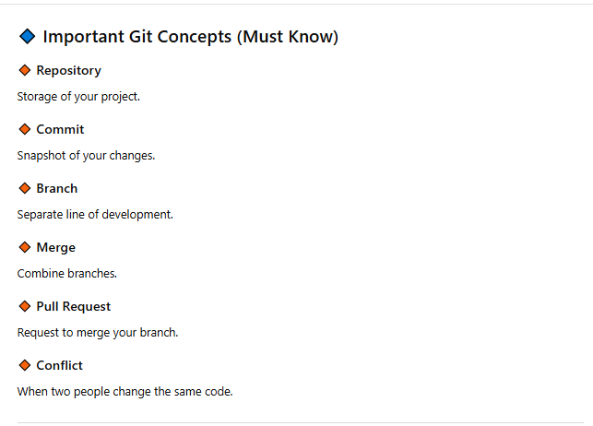

**Changes work in below fashion –**

**Changes made -> Stage -> Commit -> Push -> GITHUB [Visible changes]**

**Initialize the git if it's first time**

-------------------------------------

Open CMD inside your project directory.

git init

**Stage**

------------------------------------

git add * -> to add files for stage

git status -> to see what all files are now ready for stage

**Commit**

------------------------------------

git commit -> commit only the files ready in stage

OR

git commit -m "My first framework"

**Connect Local Project to GitHub**

-------------------------------

git remote add origin "https-gihub url"

git remote -V [Verify if it's riginated successfully]

**Push stage code to origin github**

---------------------------------

git push orgin master (default branch name as master if you dont specificed before)

## GITHUB Account creation and push the framework first time

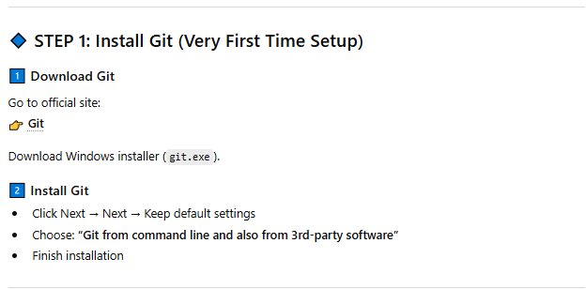

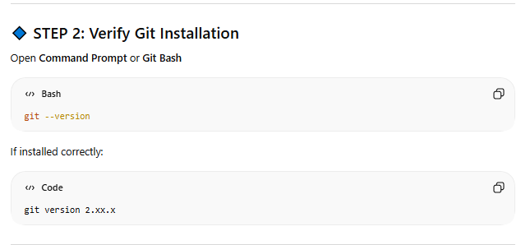

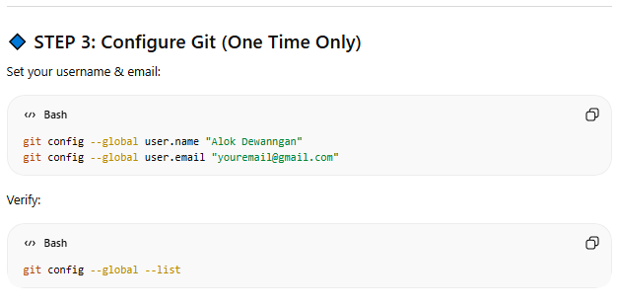

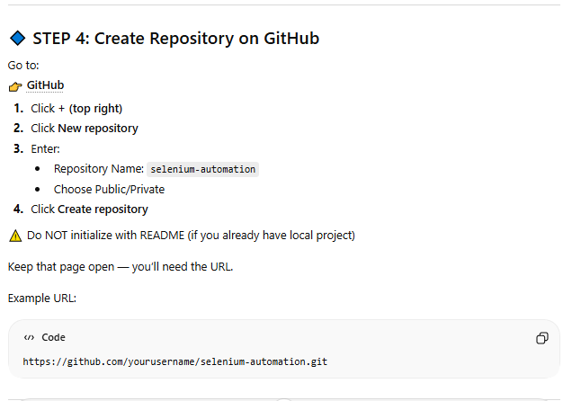

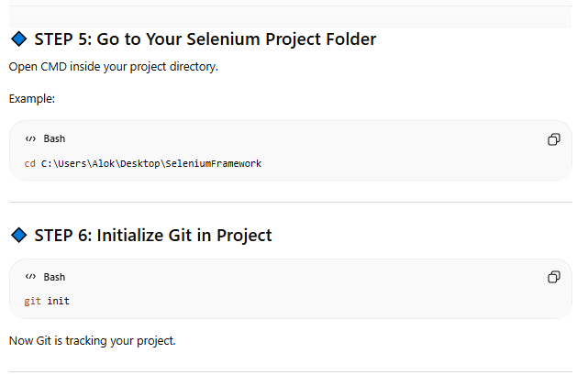

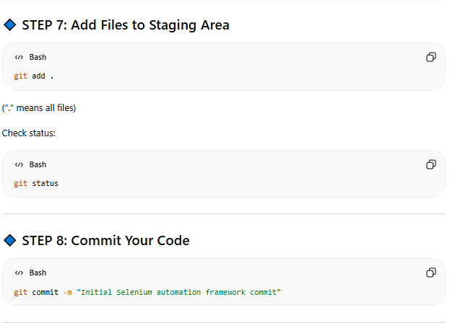

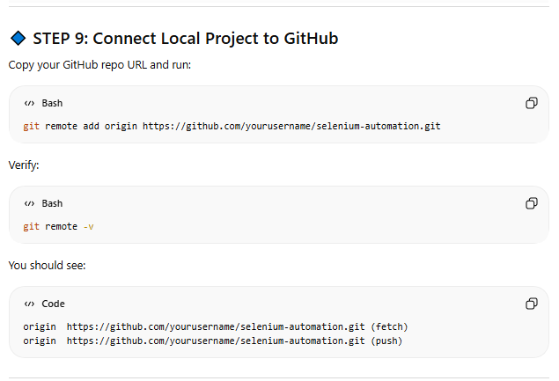

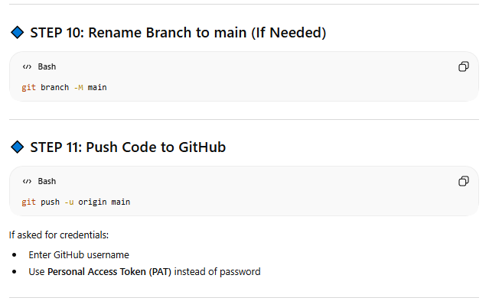

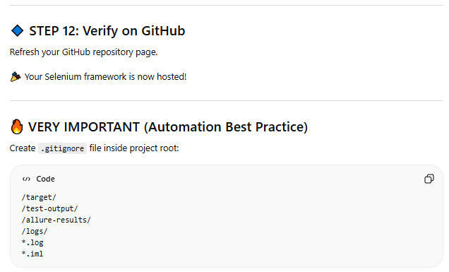

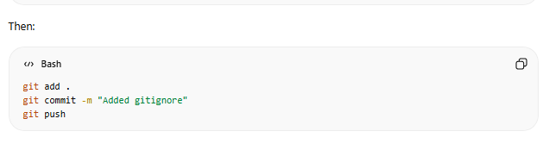

## Start working on framework

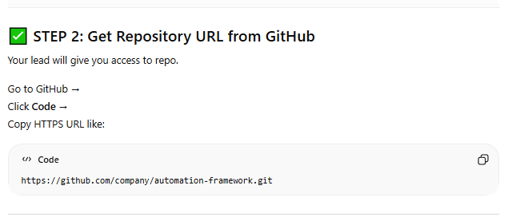

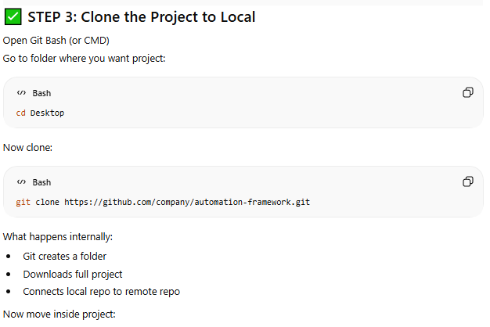

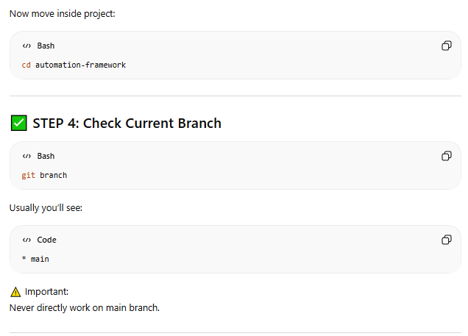

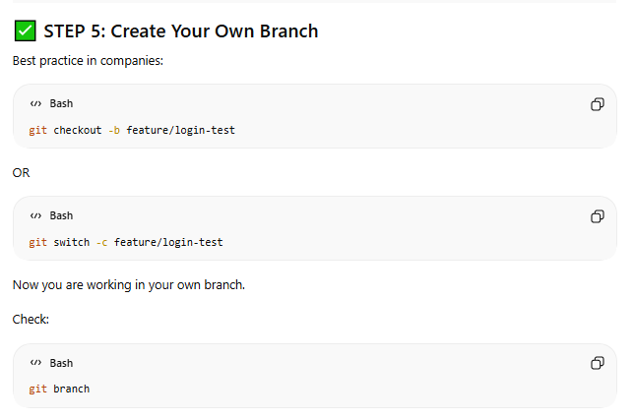

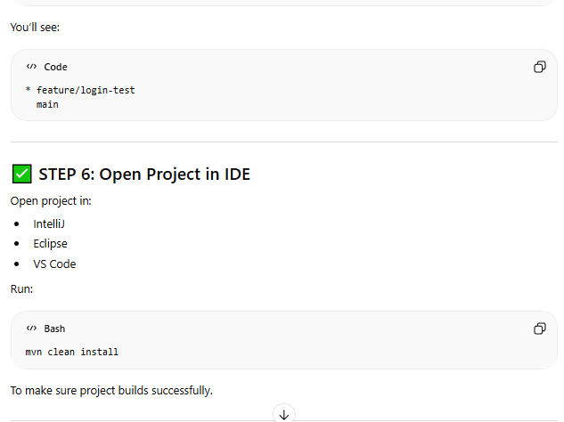

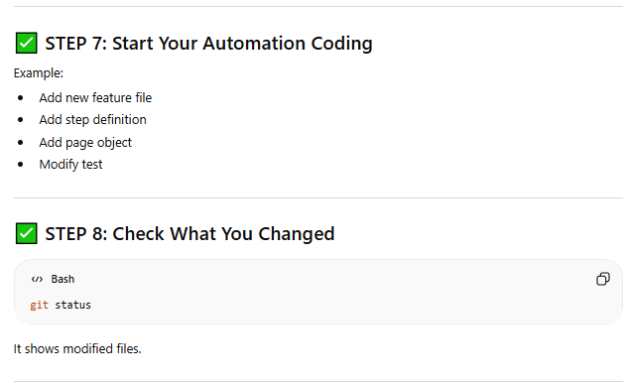

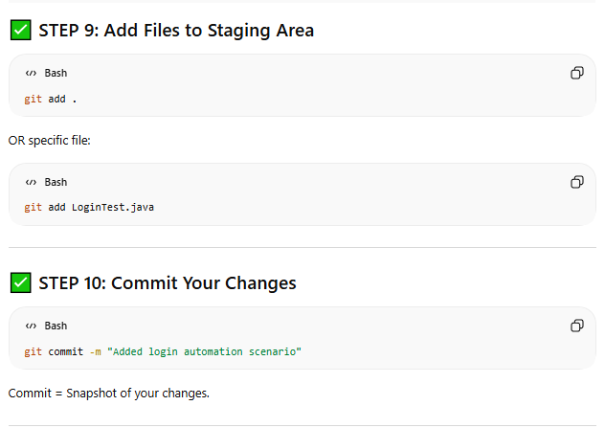

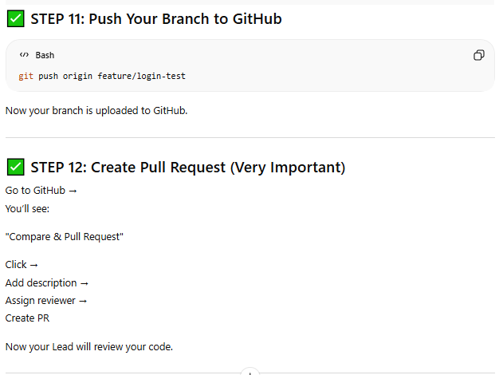

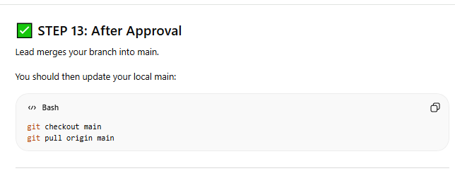

## Day to Day – Best Practice

**You can simply use below command to get latest from master branch**

git pull origin master

Or below steps are standard

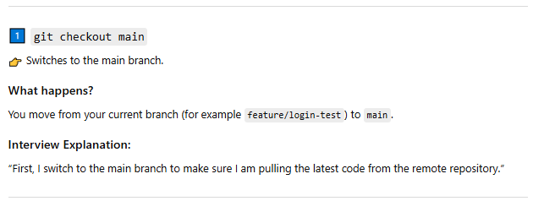

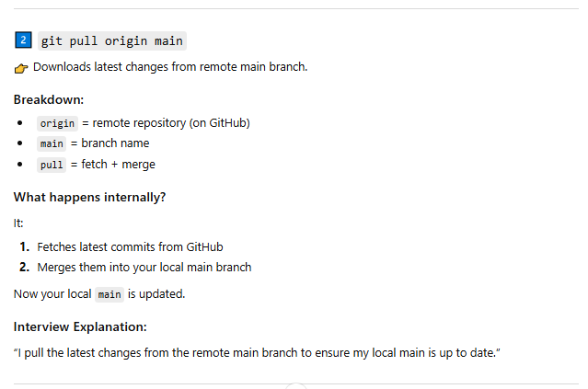

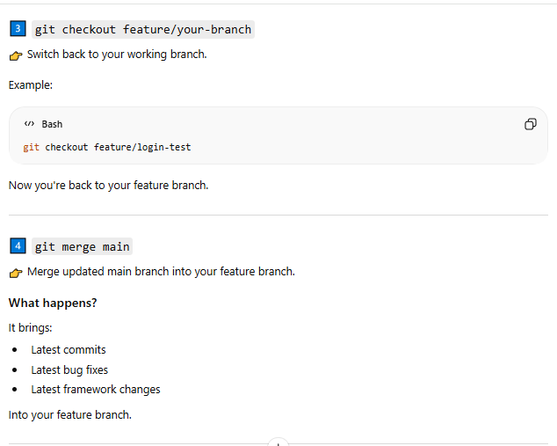

## GIT Commands

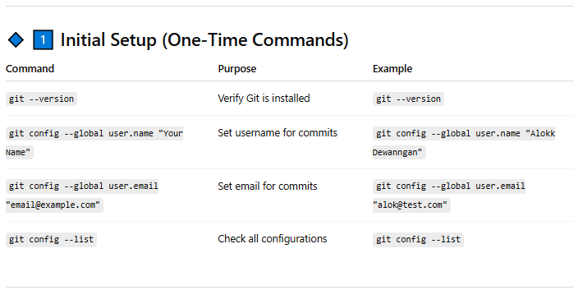

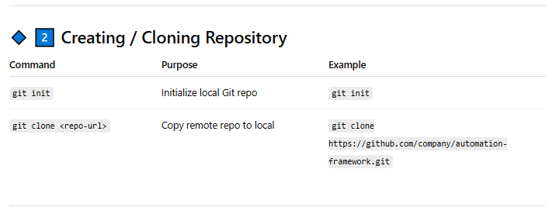

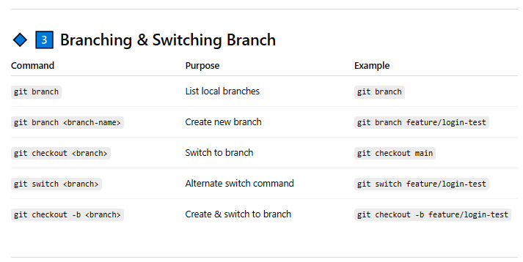

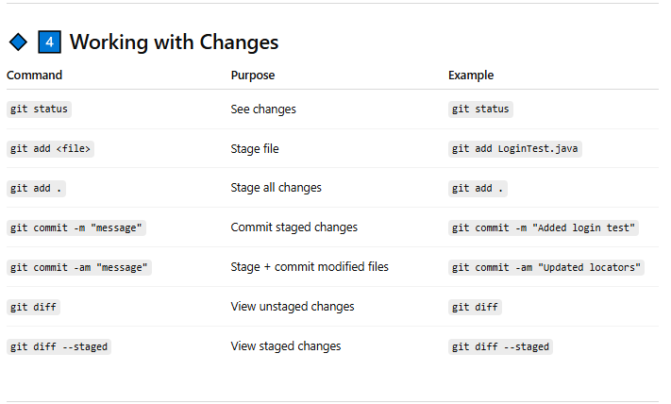

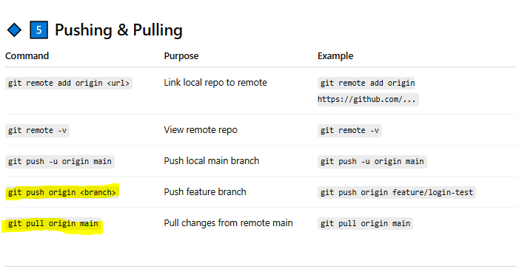

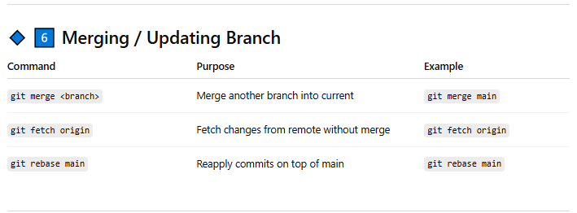

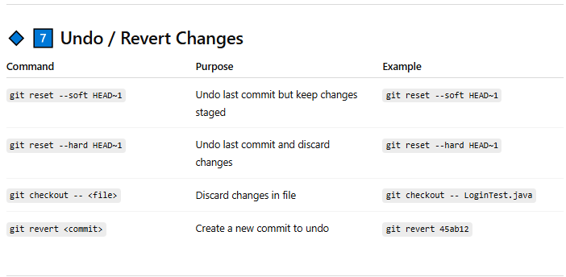

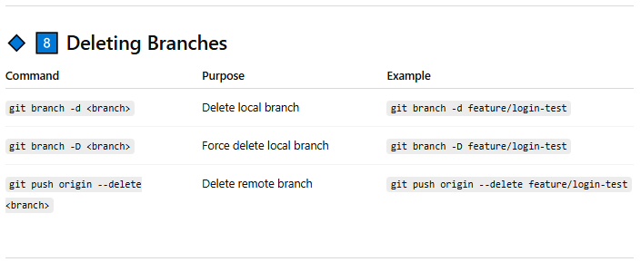

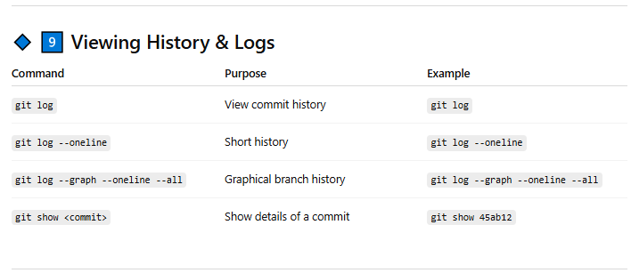

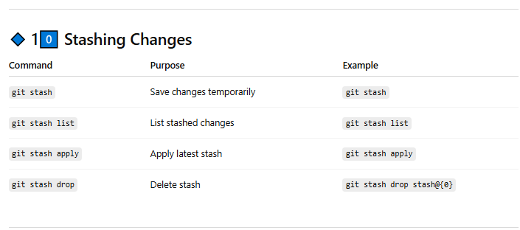

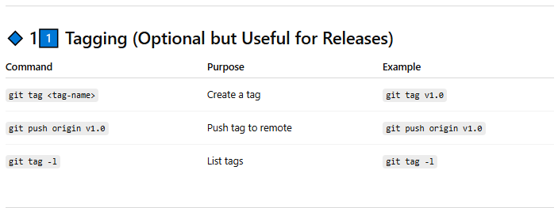

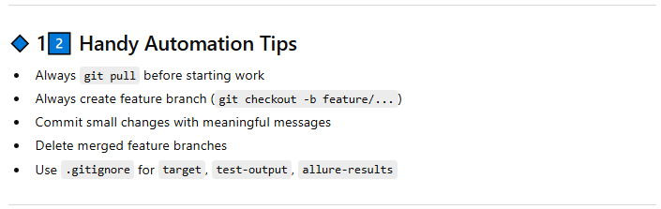

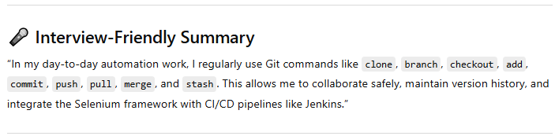

## Interview Questions

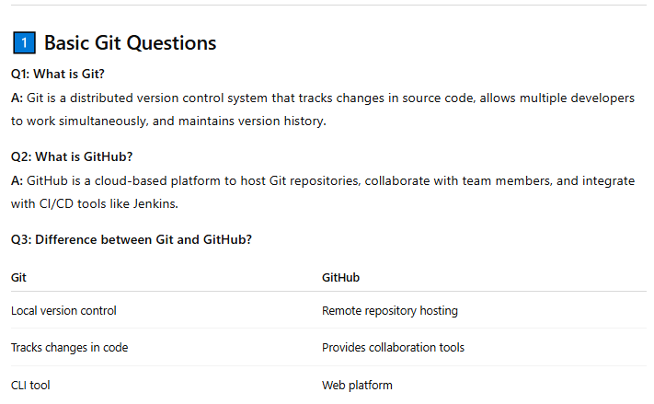

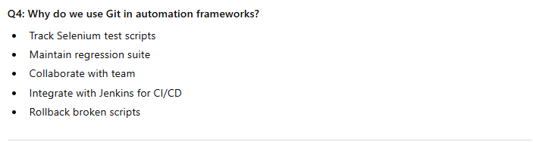

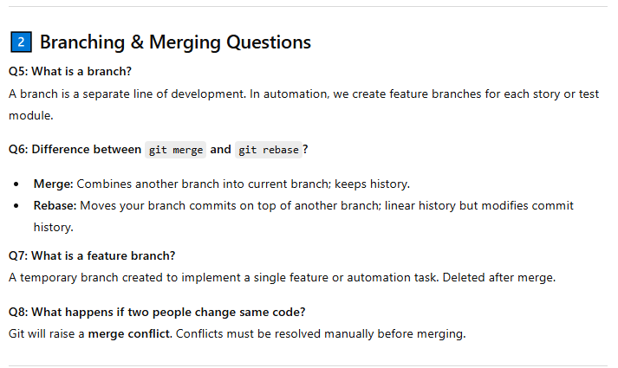

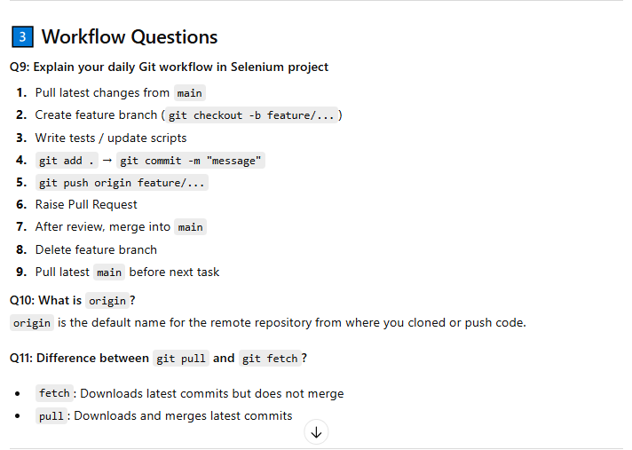

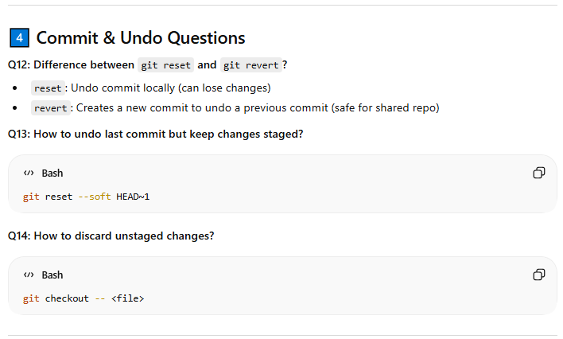

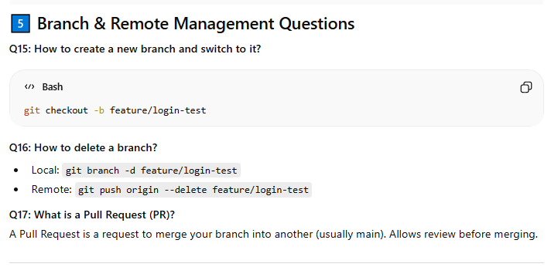

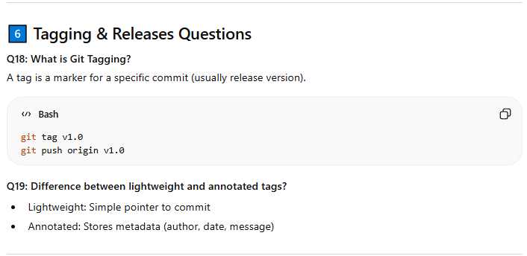

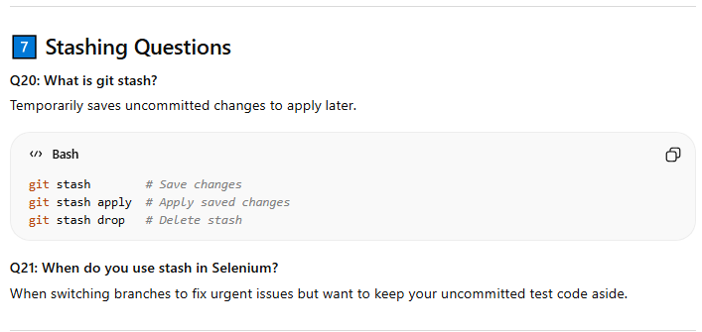

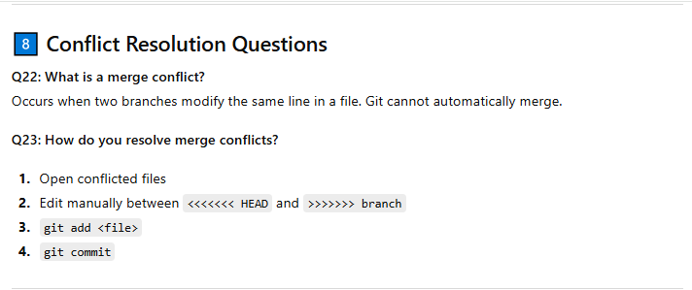

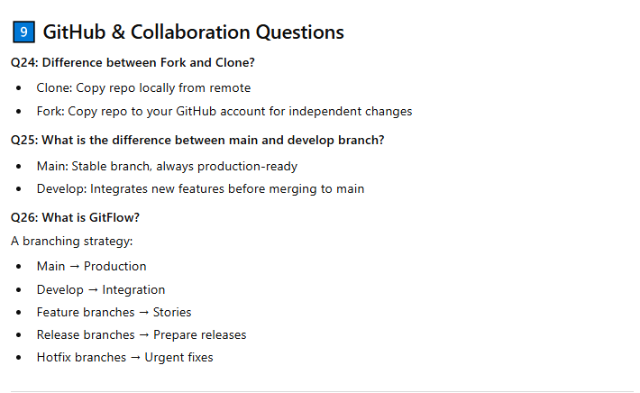

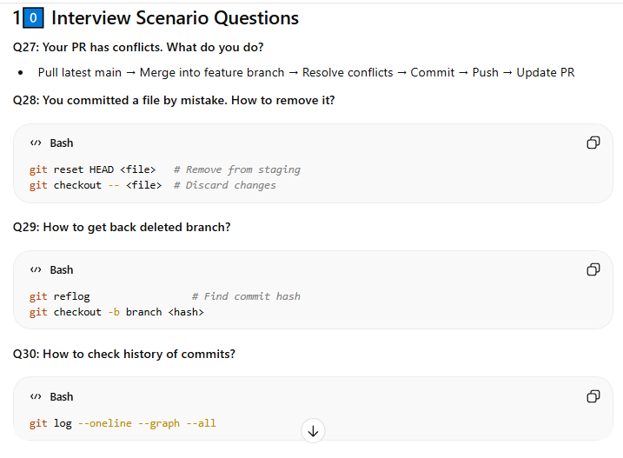

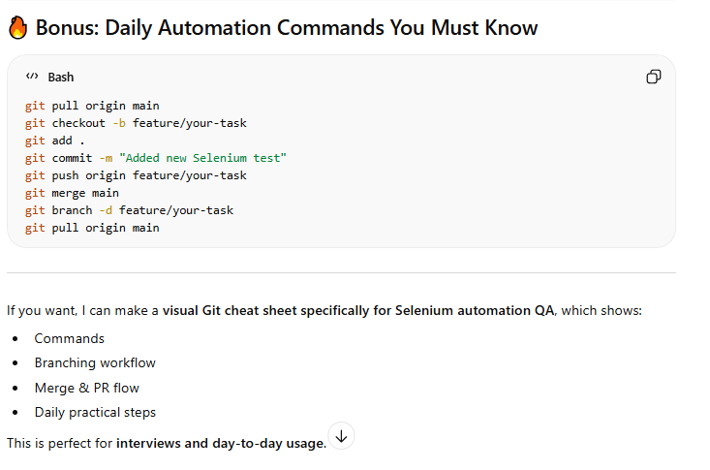

# Rest Assured API Automation

## Basics

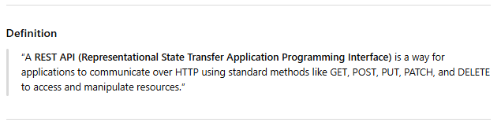

**What all challenges areincluded under API testing?**

* API Documenetaion
* Access to DB
* Authorization Overhead

**Difference between PUT and POST**

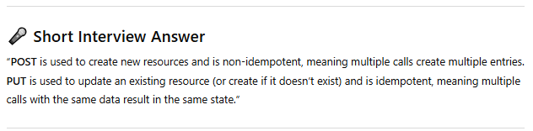

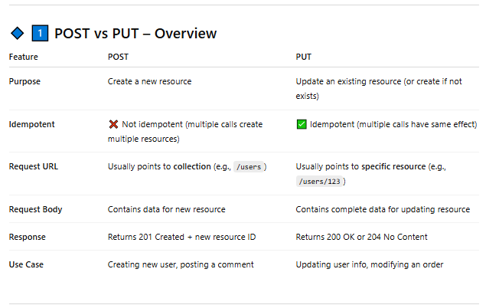

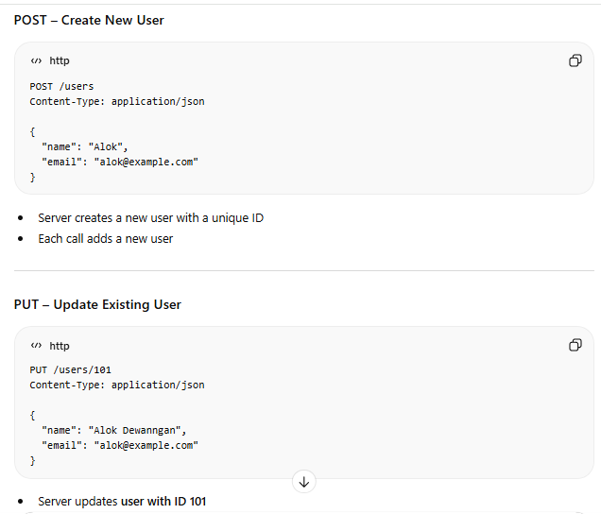

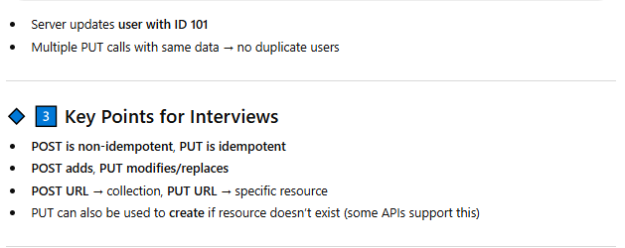

**Core componenets to send request over HTTPs**

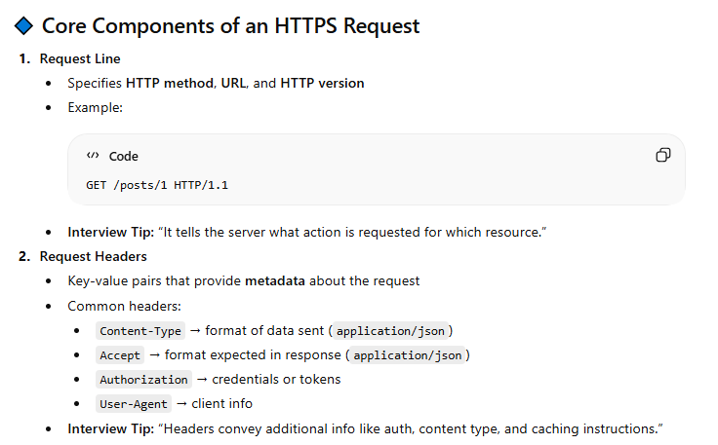

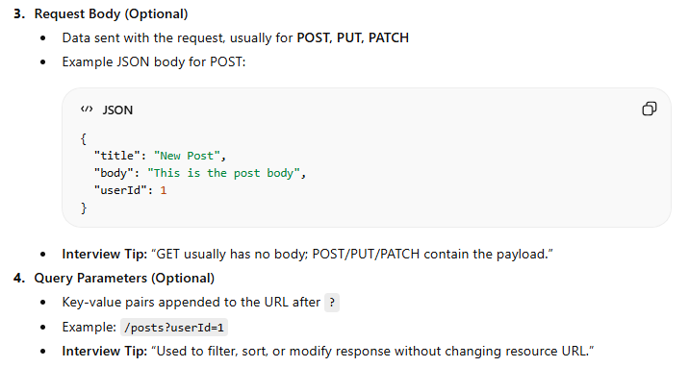

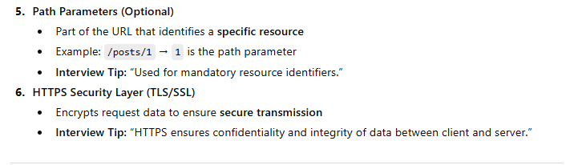

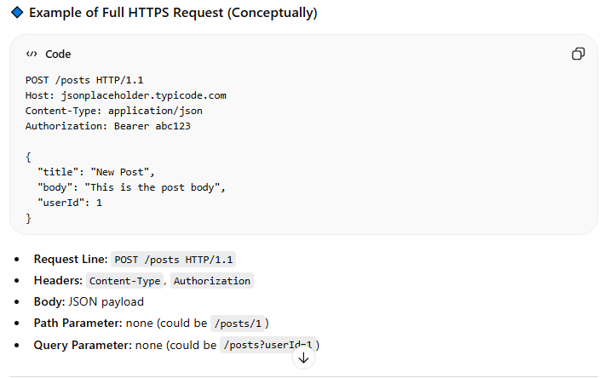

**Payload**

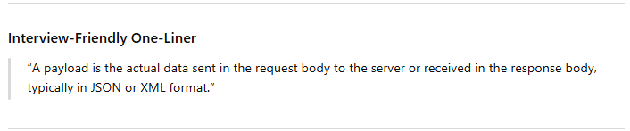

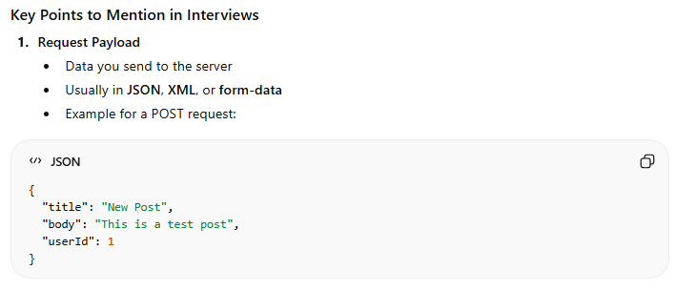

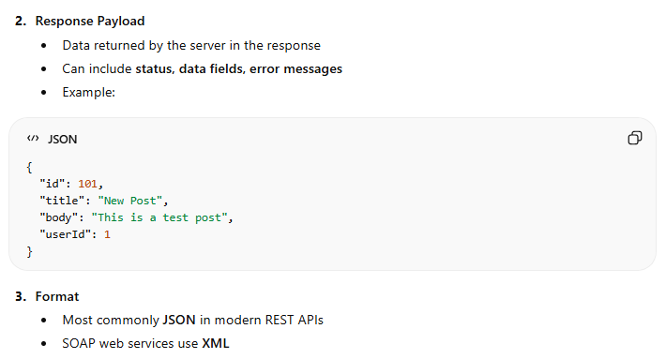

**Rest Assured**

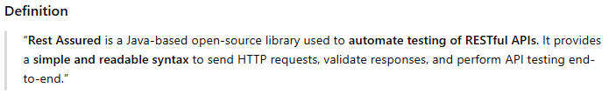

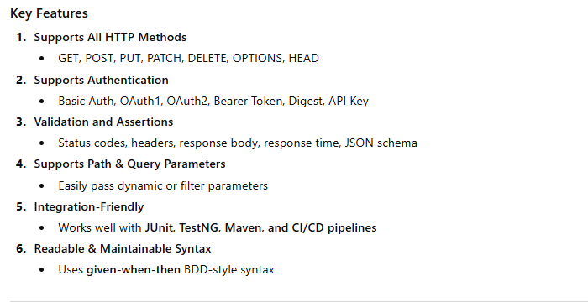

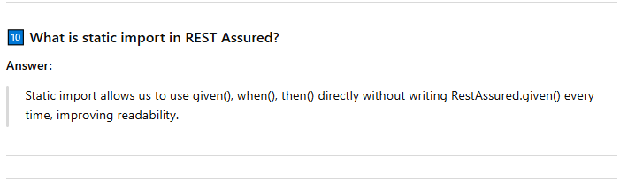

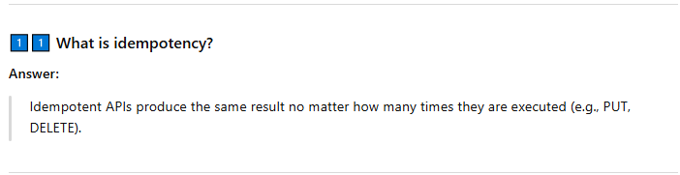

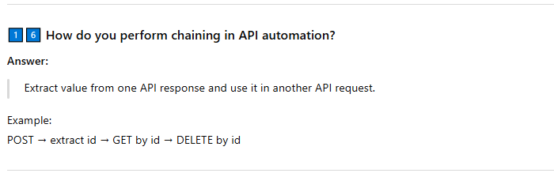

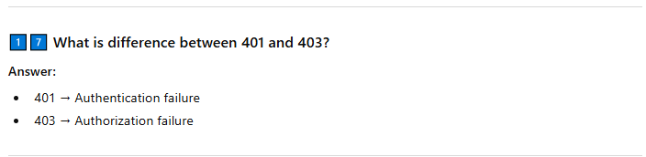

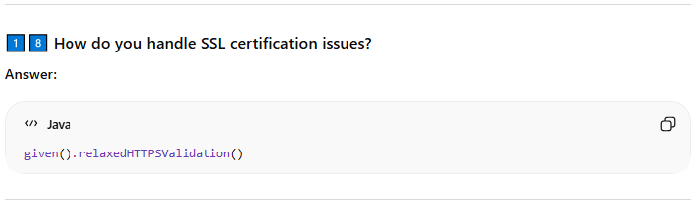

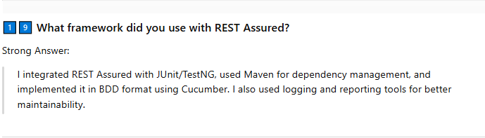

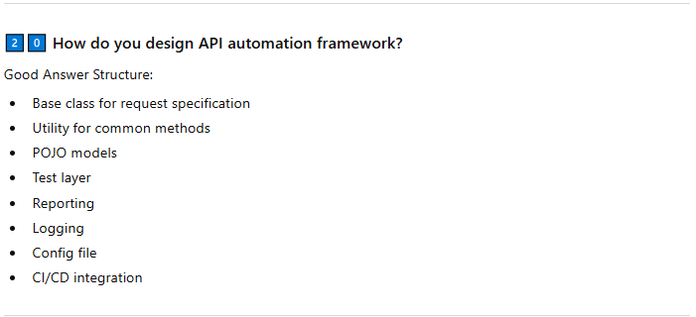

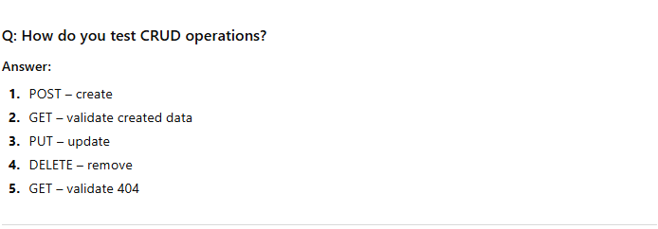

## Various HTTPS Methods

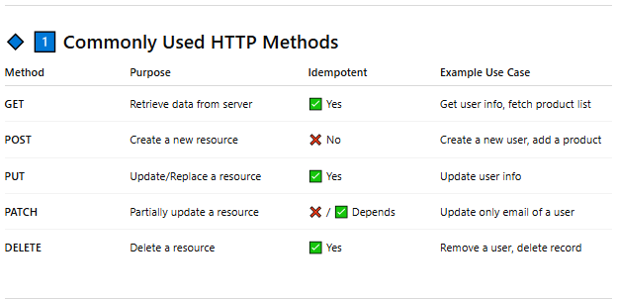

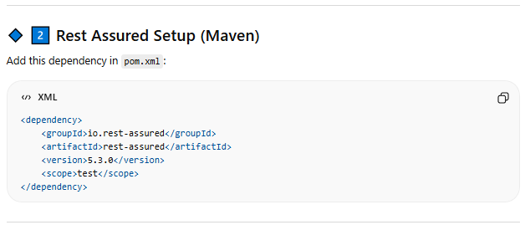

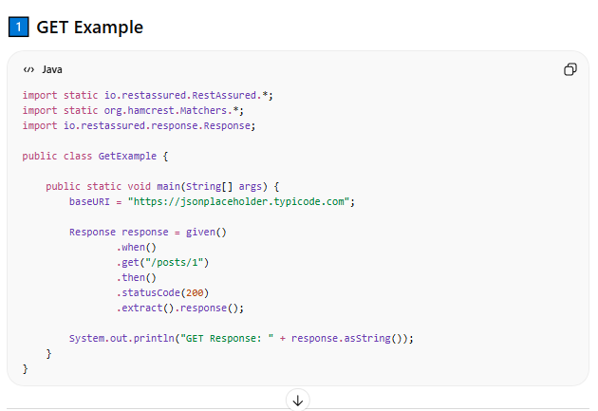

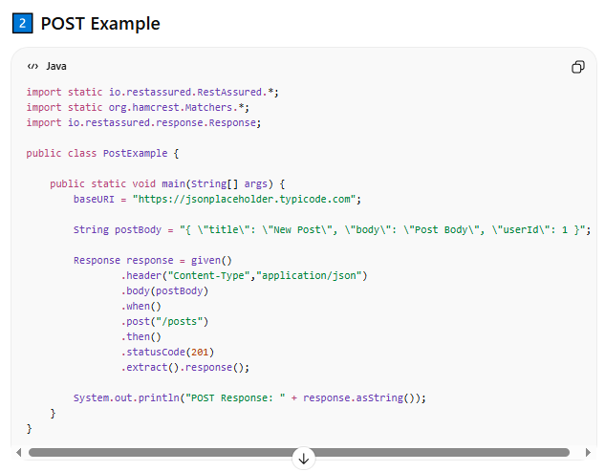

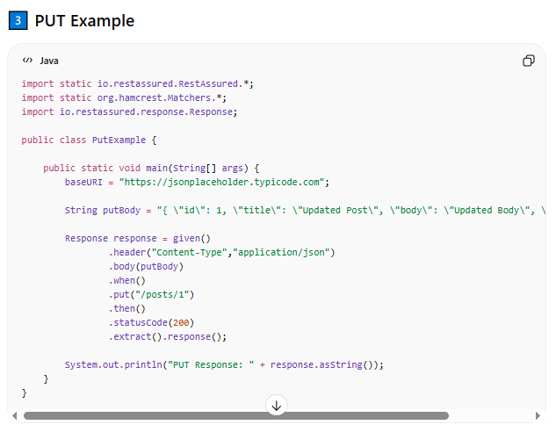

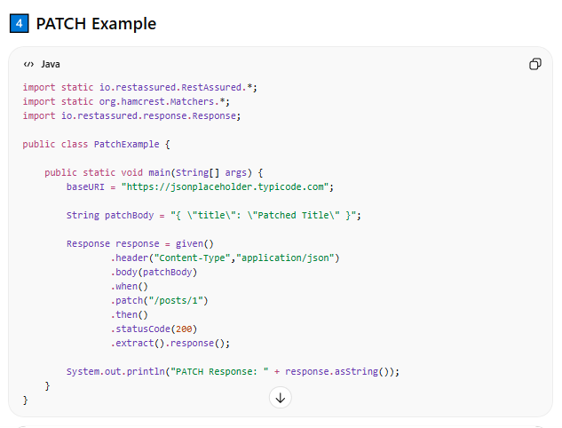

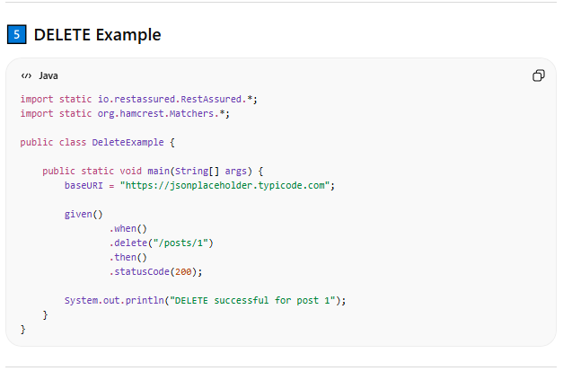

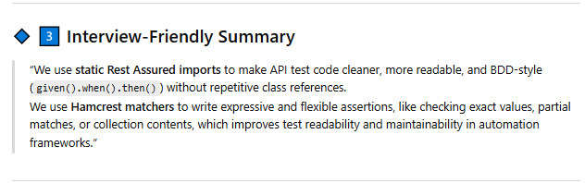

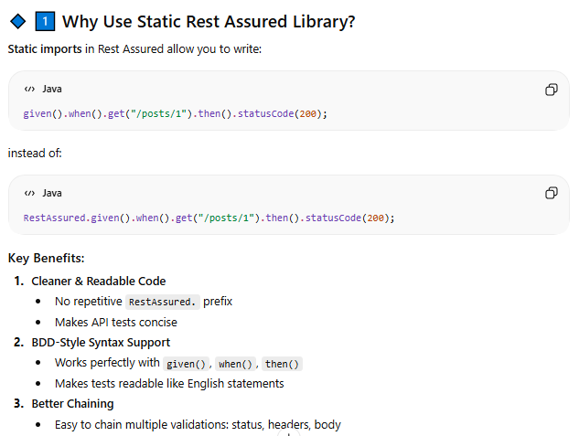

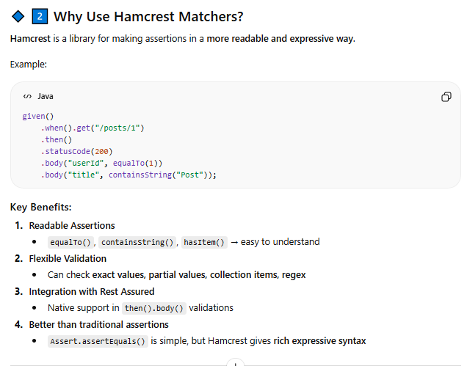

## Various type of authentication

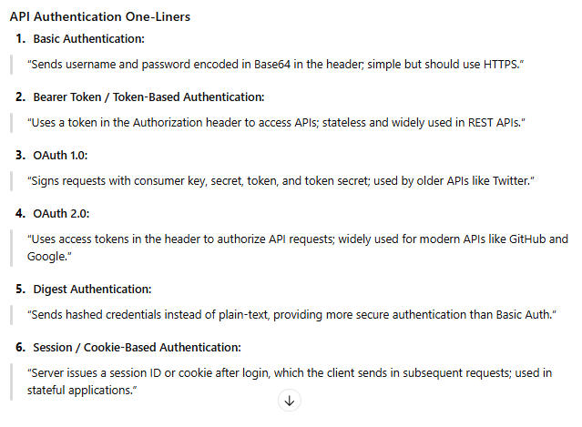

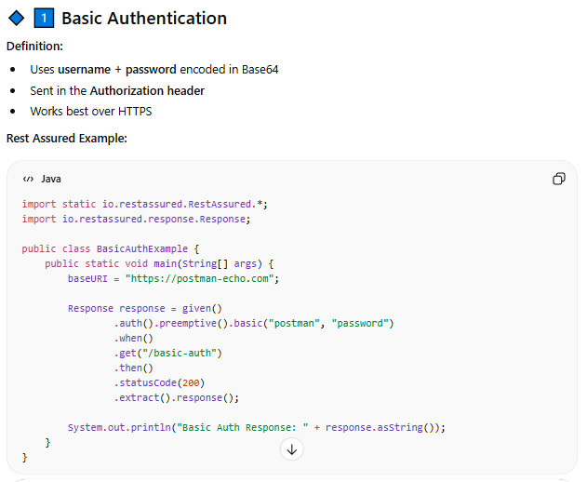

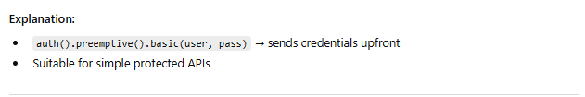

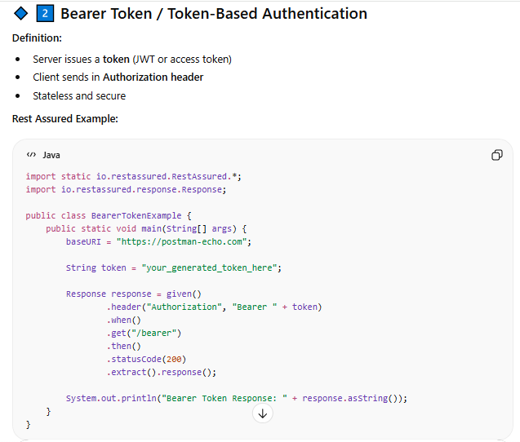

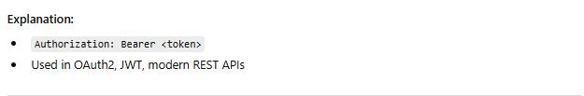

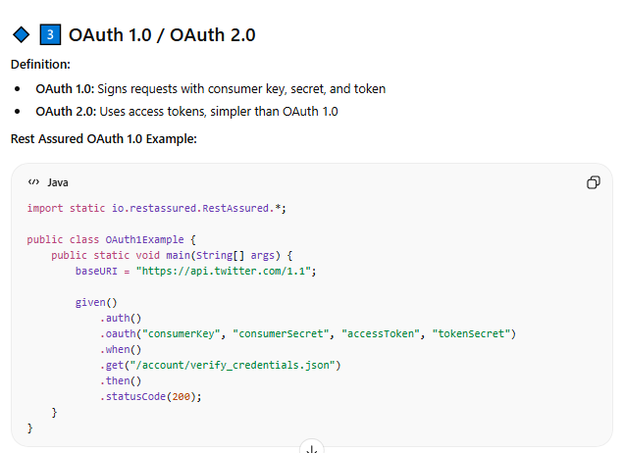

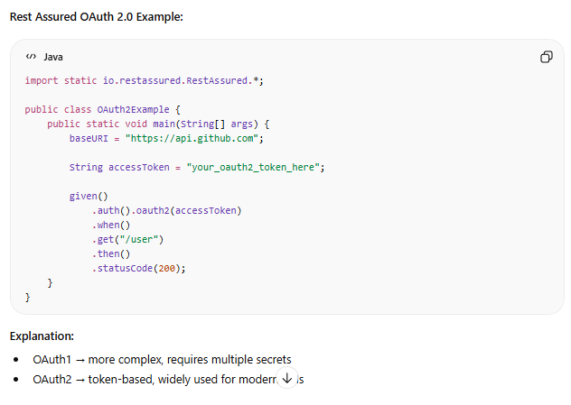

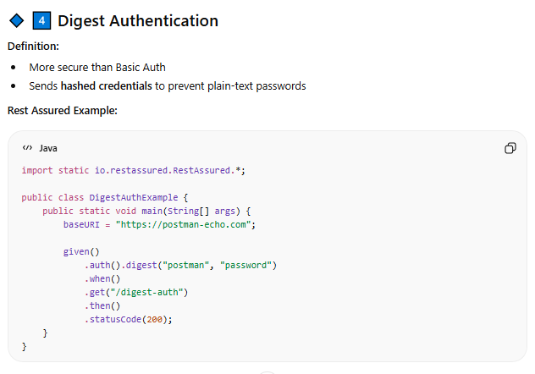

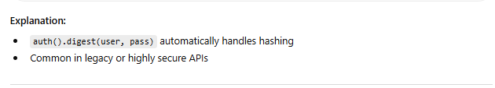

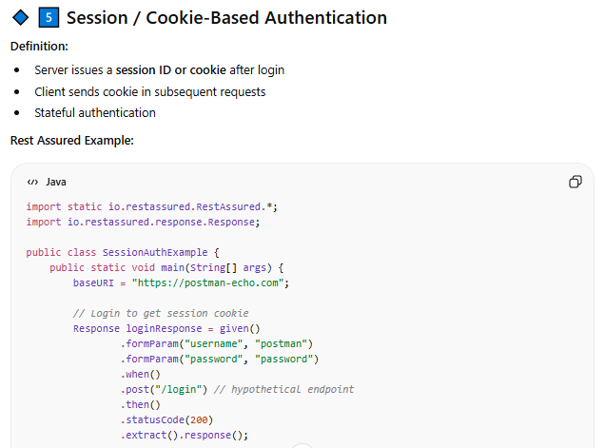

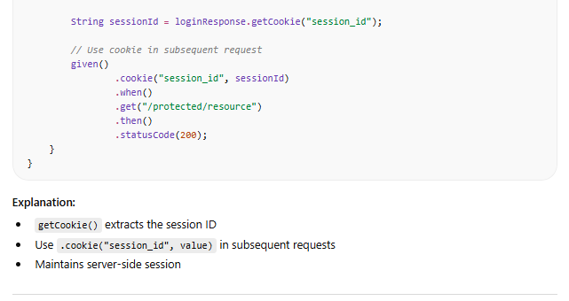

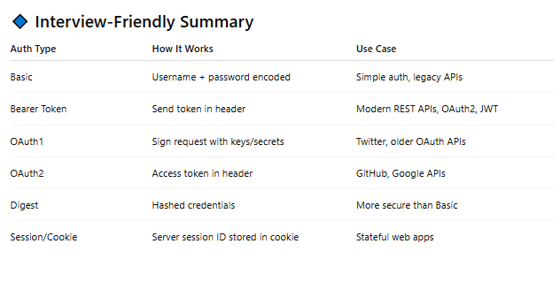

## What all need to verify in API Testing

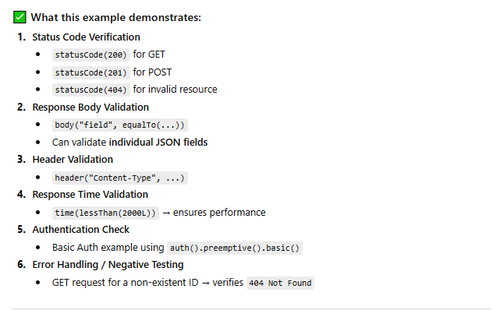

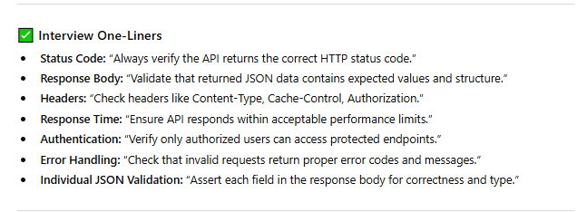

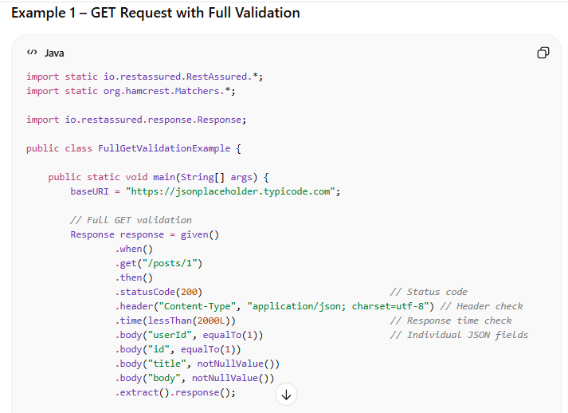

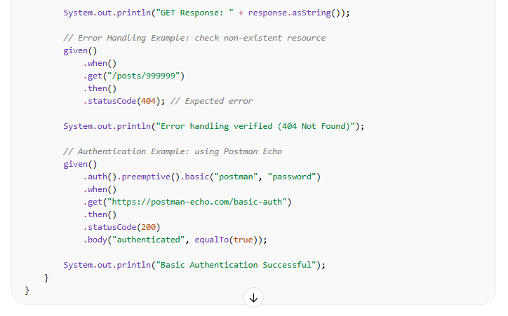

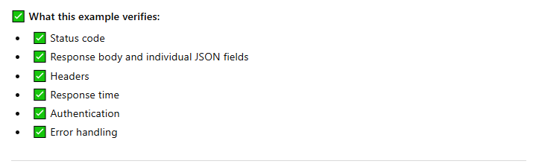

## Query and Path Parameters

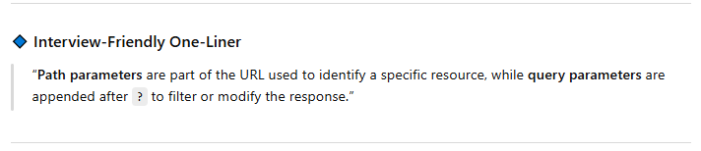

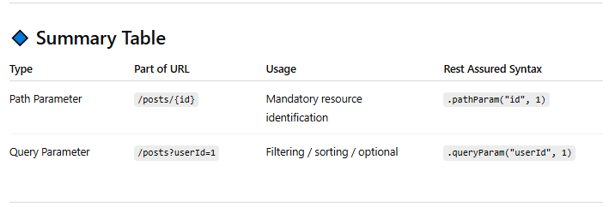

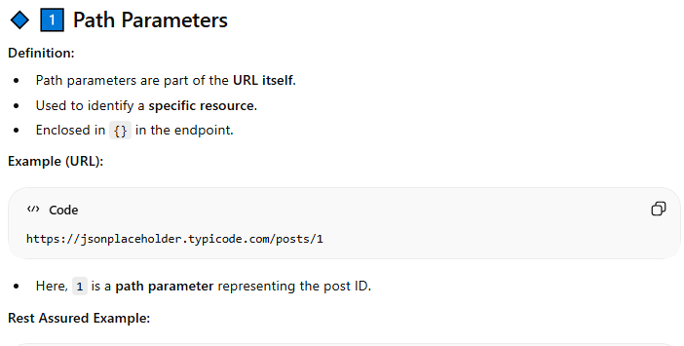

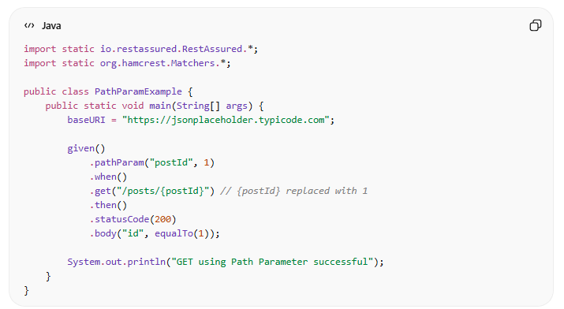

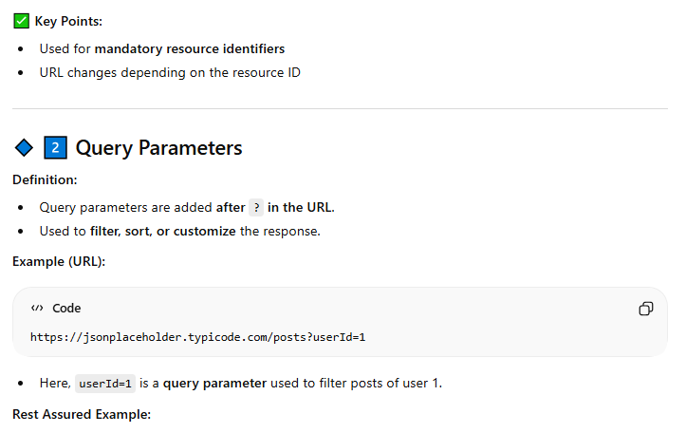

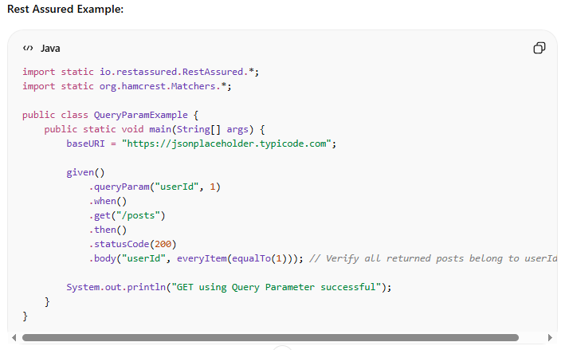

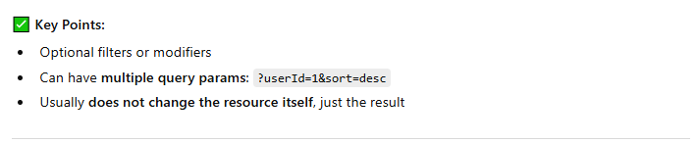

## Serialization and Deserialization

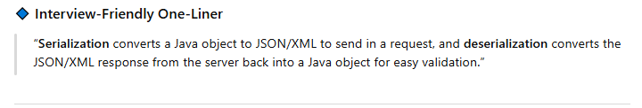

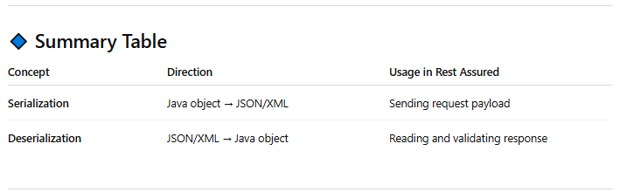

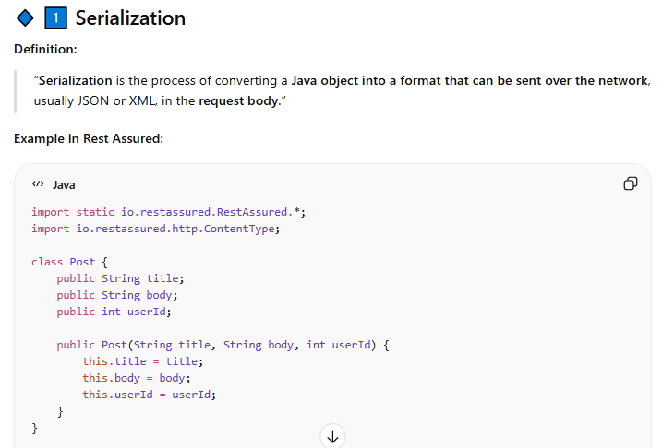

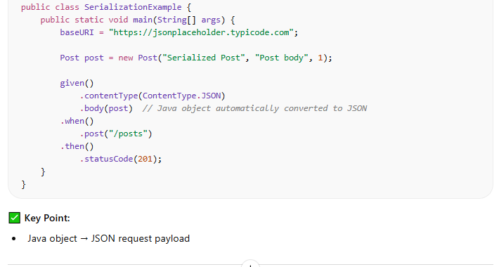

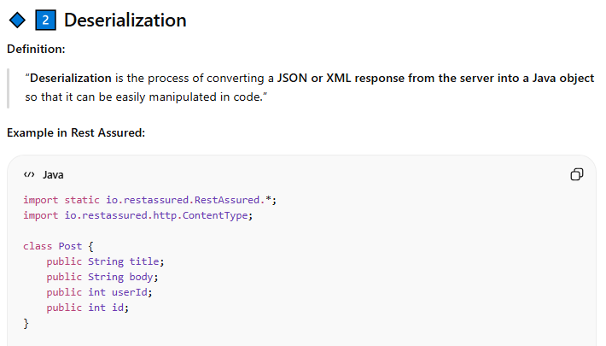

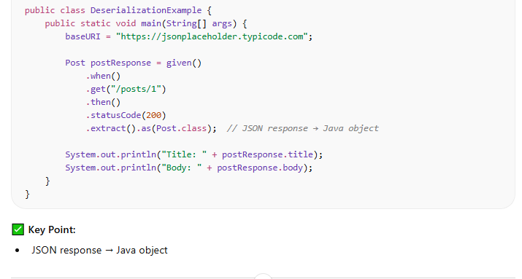

## JSON Parse Techniques

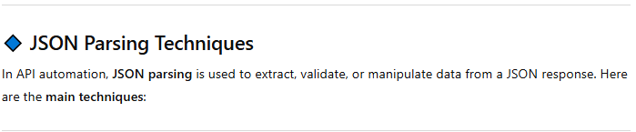

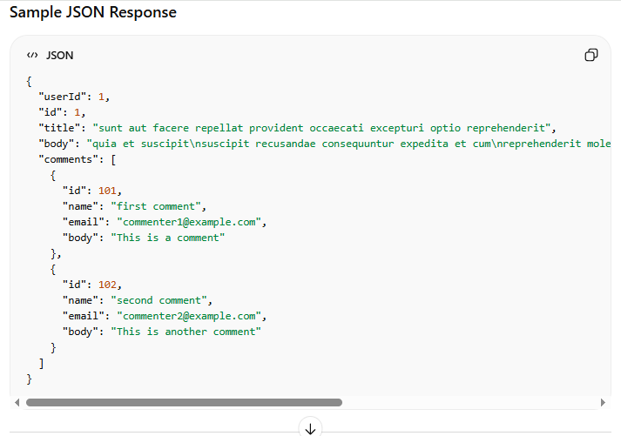

### JsonPath

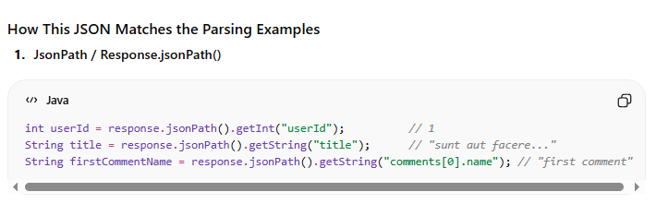

### Org.json Library

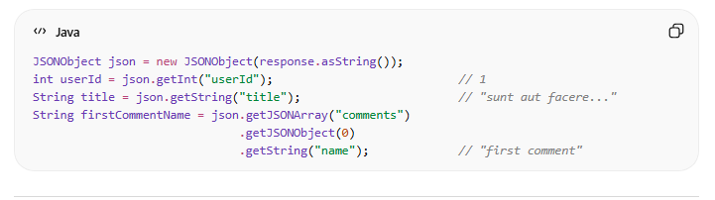

### Pojo Deserialization

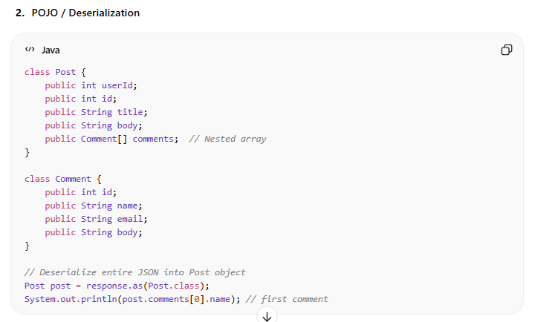

### Final Example

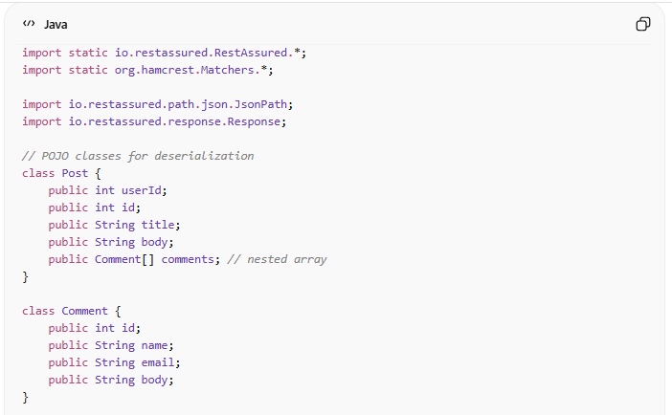

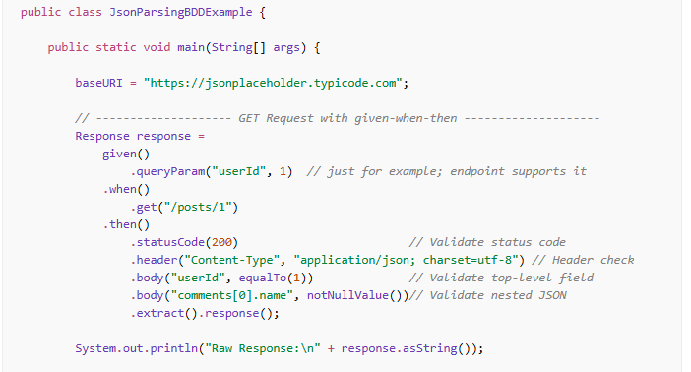

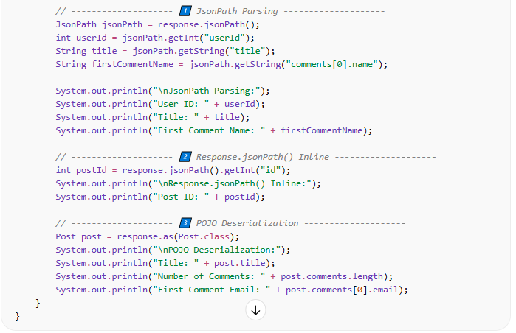

## Send file as attachemnet in Request

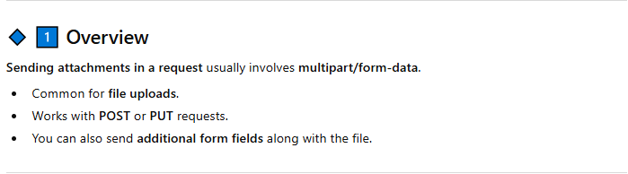

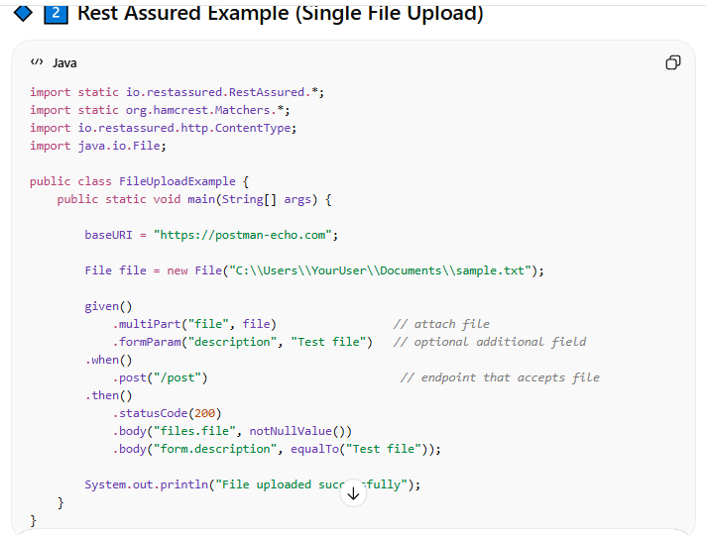

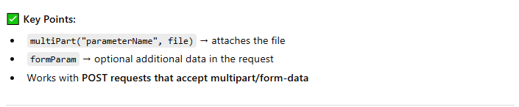

## Response Code

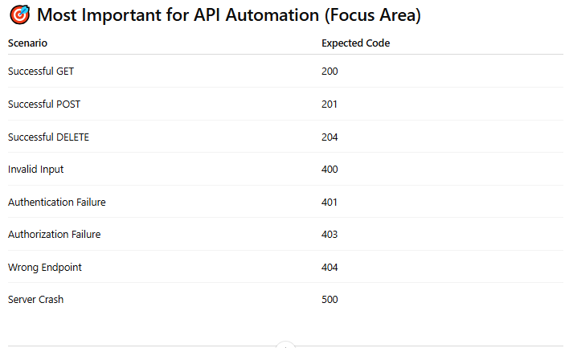

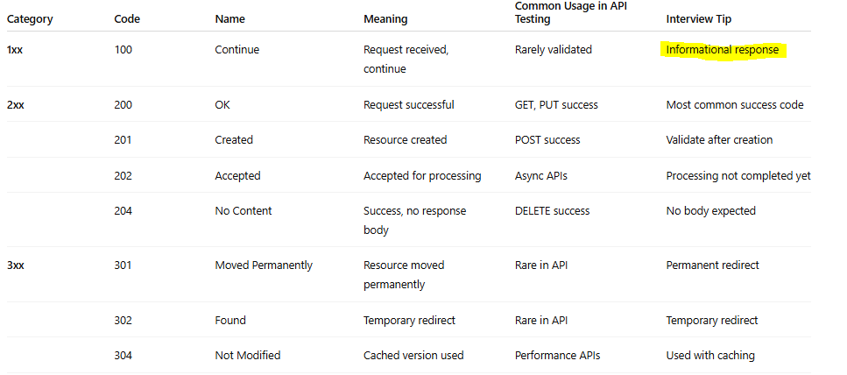

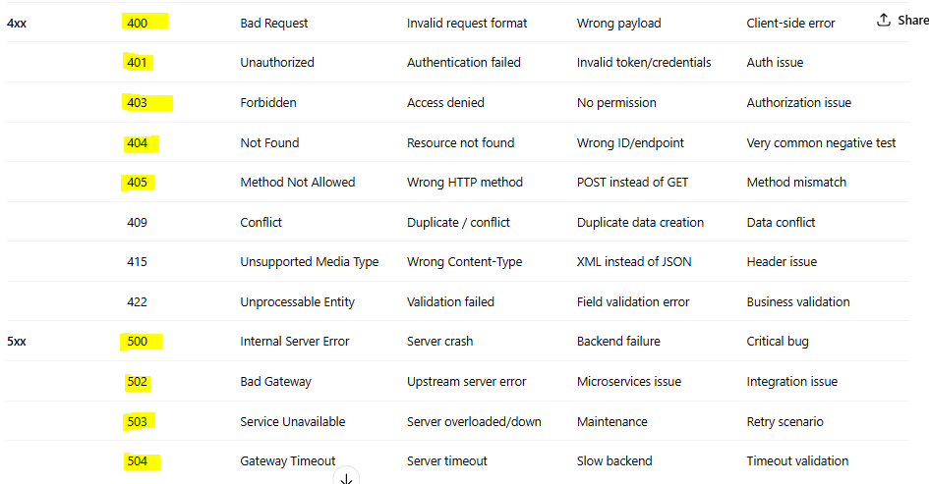

## Synchronous and Asynchronous API

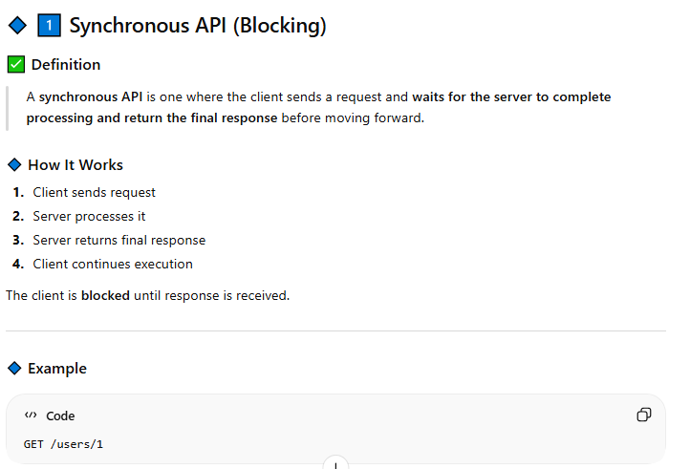

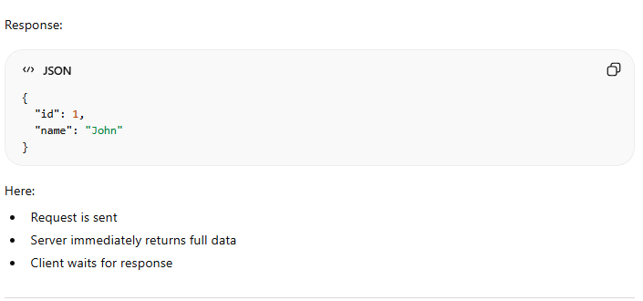

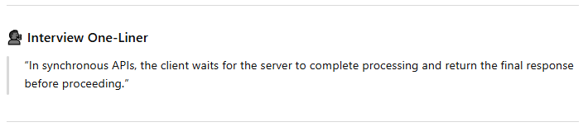

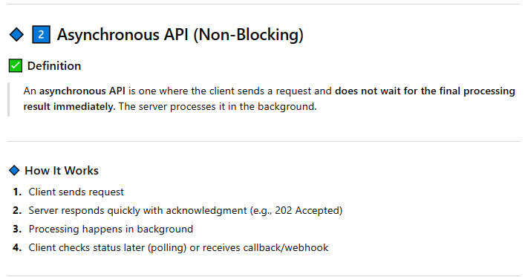

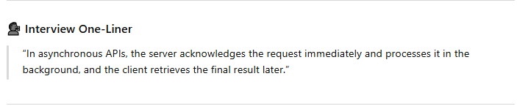

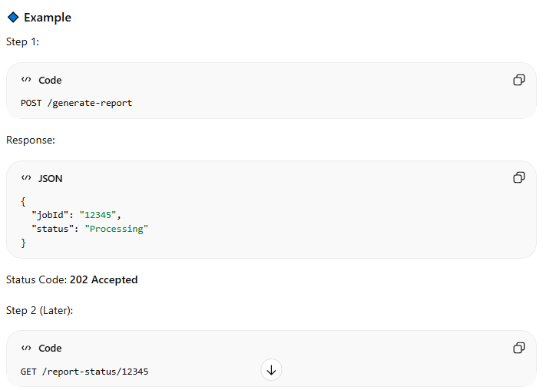

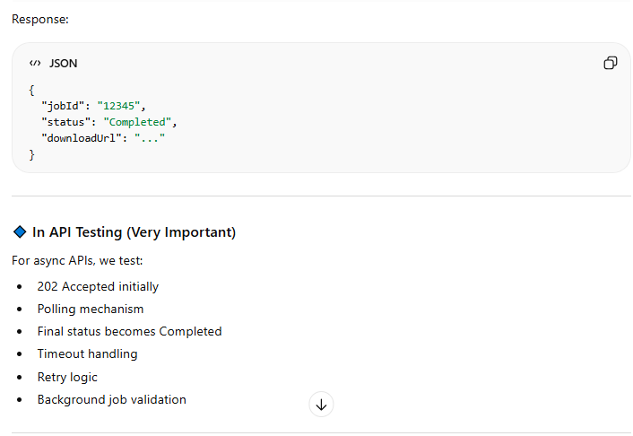

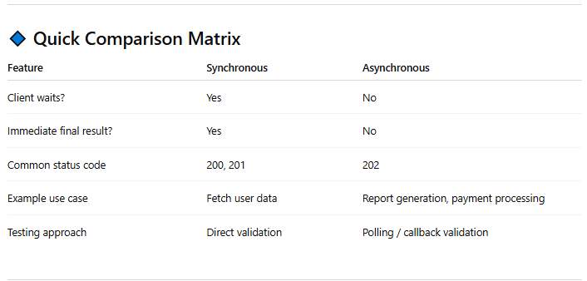

## Request and Response Specifications

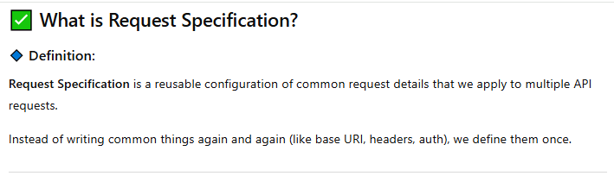

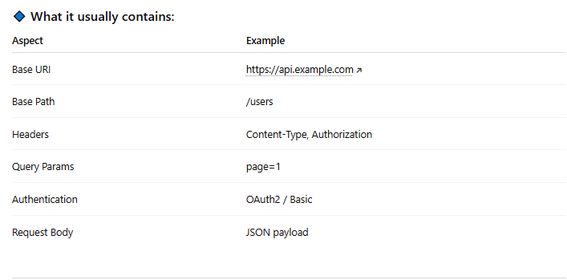

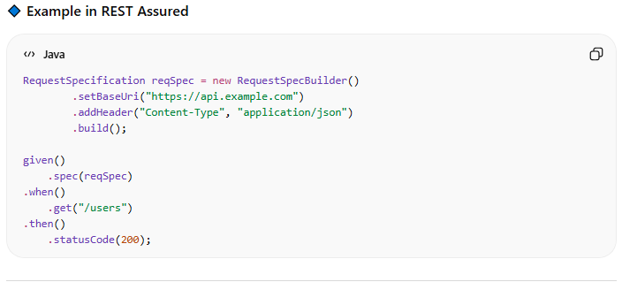

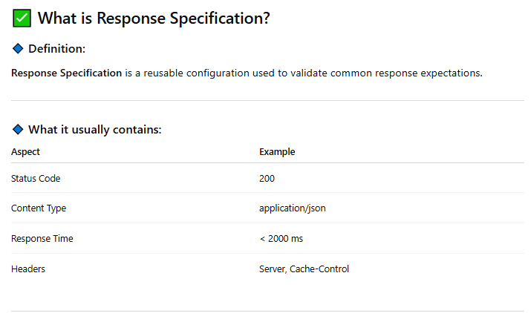

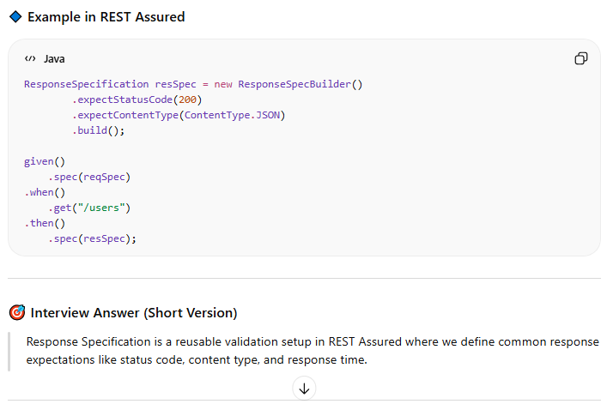

# Mockito

## Introduction

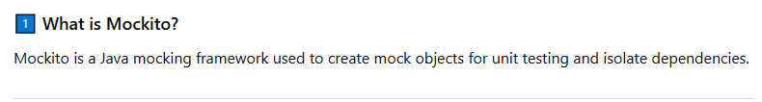

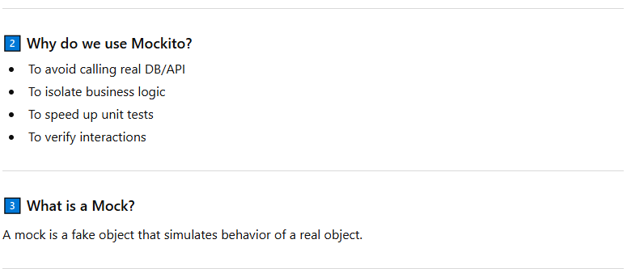

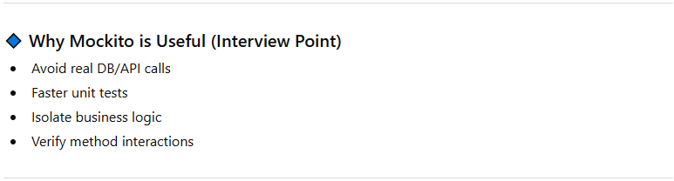

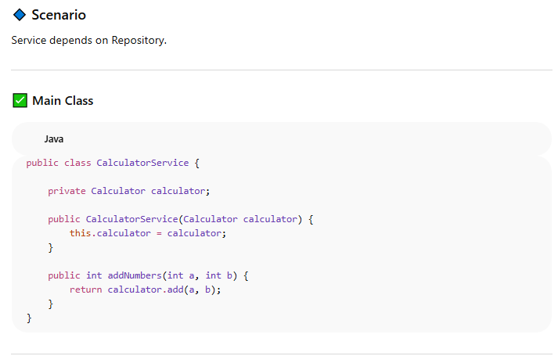

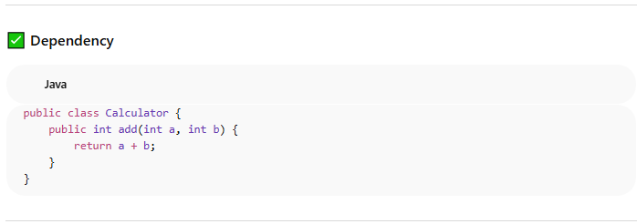

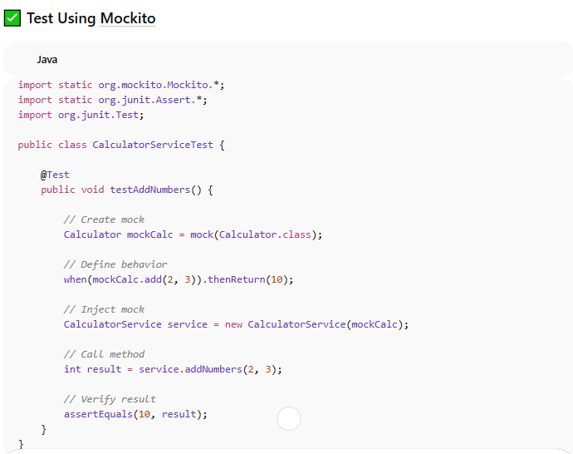

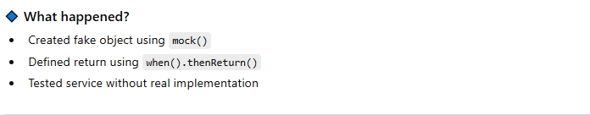

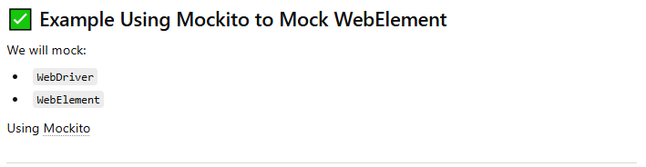

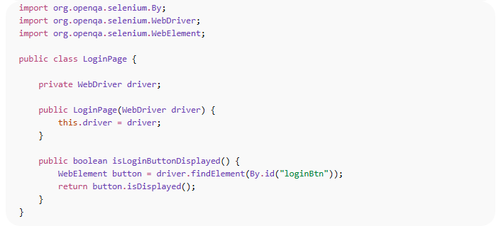

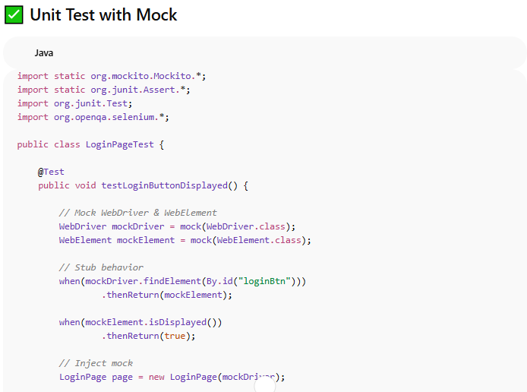

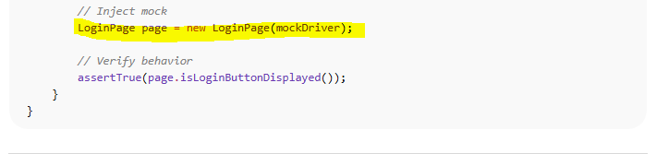

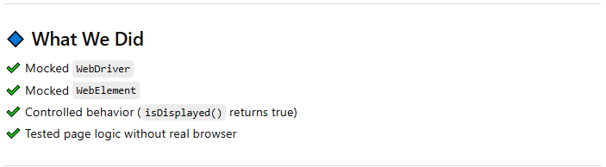

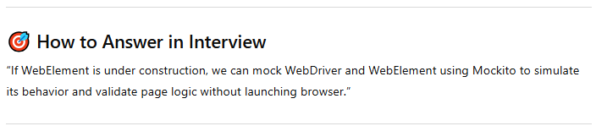

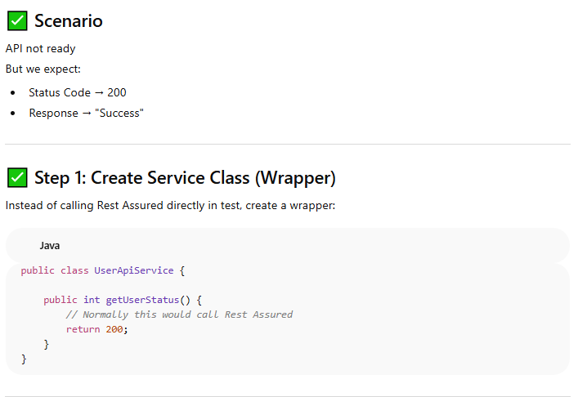

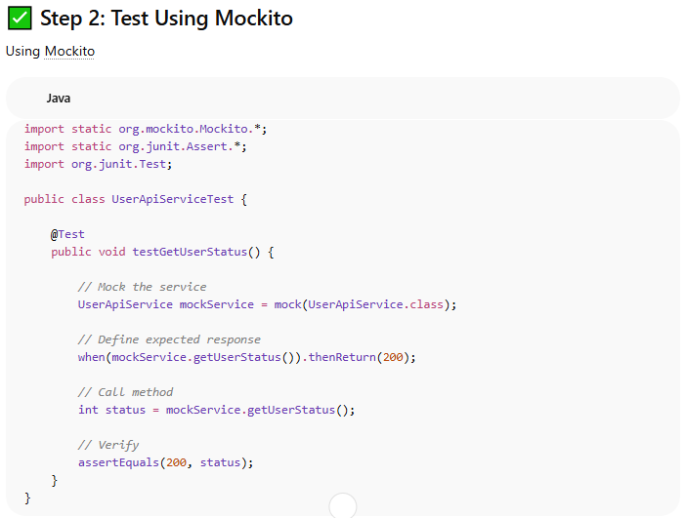

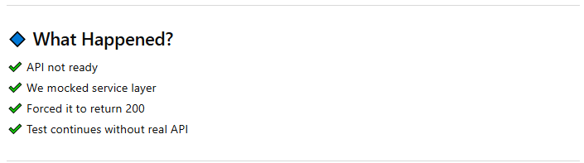

## End –To-End Scenario -WireMock

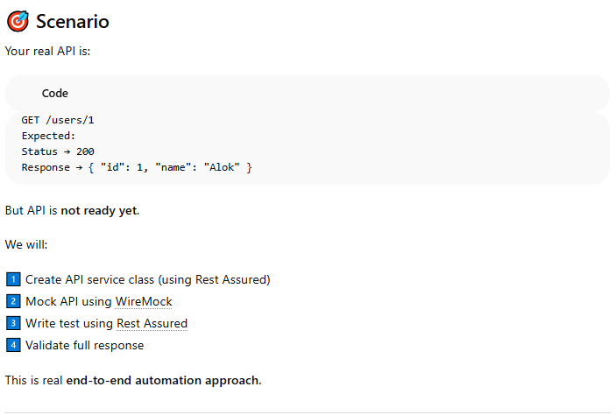

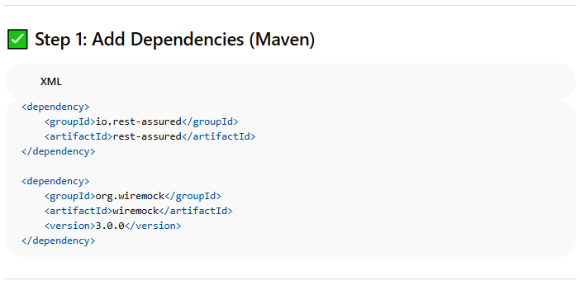

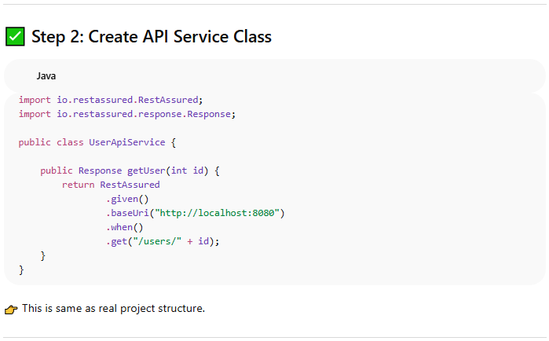

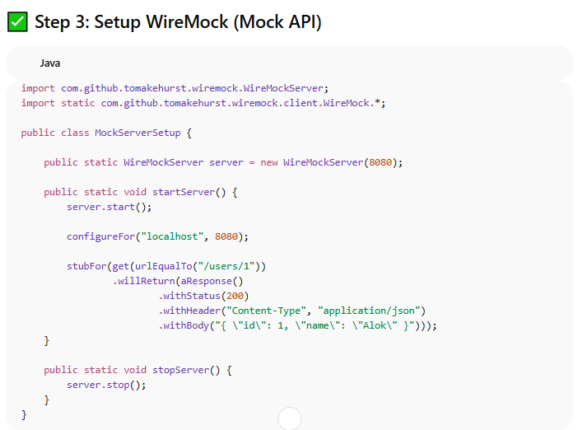

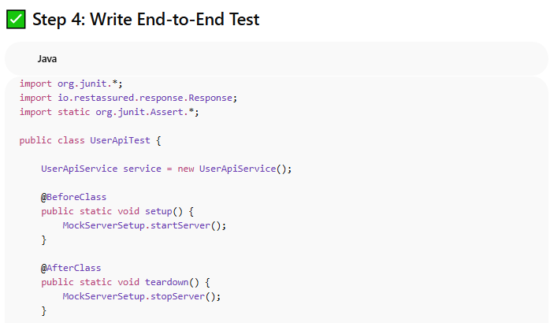

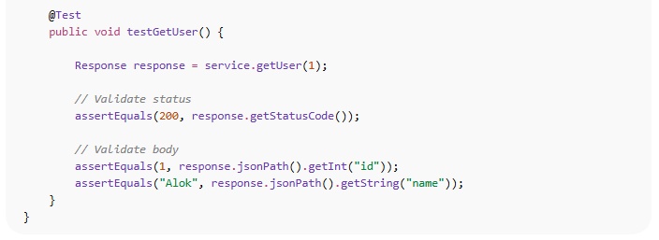

## Interview

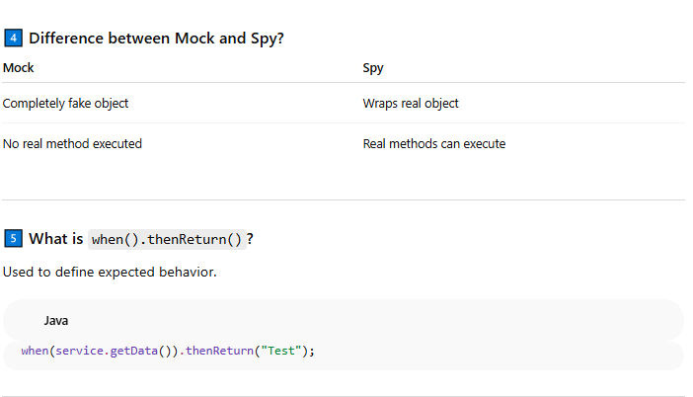

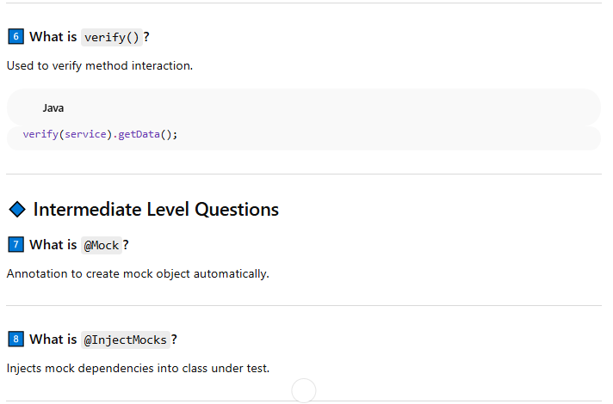

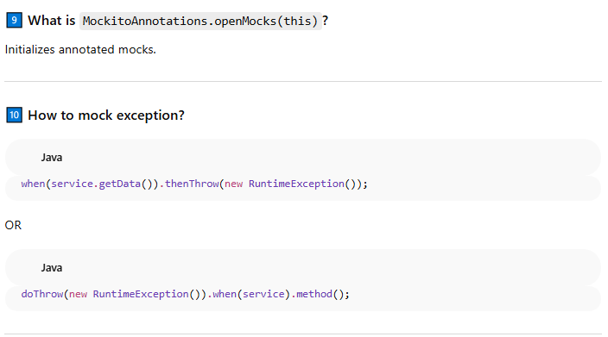

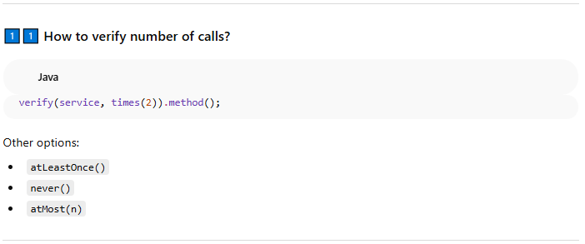

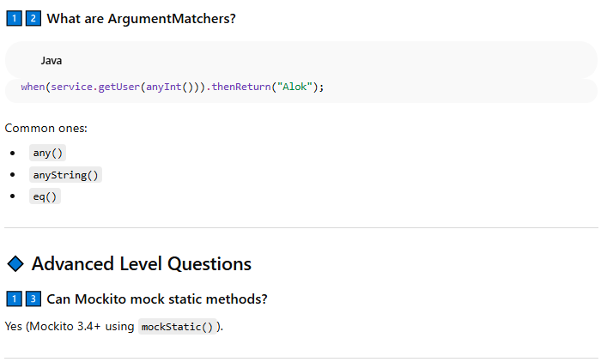

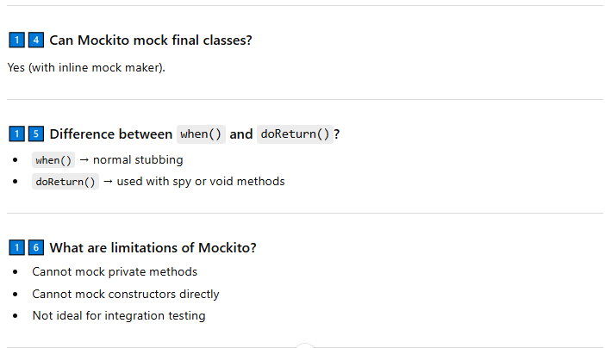

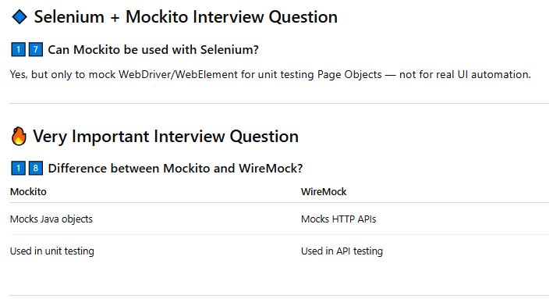

# Interview Questions

1. What makes Selenium Unique from other Automation tools?
2. Explain Web Driver Architecture.
3. Why not older Version Selenium RC 1.0?
4. What are different Versions of Selenium?
5. What are different browsers does Web driver Support?
6. In how many languages we can write Selenium code?
7. Difference between Selenium and Web driver?

“As a QA Automation Lead working in an Agile Scrum team, I actively participate in all key Agile ceremonies., my day starts with the daily stand-up where I align with developers and the product owner on story progress, risks, and acceptance criteria. I make sure testability is considered early, especially for automation.”

“After that, I review automation execution results from the CI pipeline. I analyze failures, fix critical automation issues myself, and assign remaining fixes to junior QAs with clear guidance. I’m actively hands-on with automation, especially for complex scenarios or framework-level improvements.”

“I spend time designing automation for new stories — deciding whether scenarios should be covered at API or UI level, creating Page Objects, and implementing reusable steps. I also review and refactor existing automation to reduce flakiness and improve execution stability.”

“Alongside this, I mentor my three junior QAs through code reviews, design discussions, and best-practice sharing. I work closely with developers to resolve defects quickly and ensure automation is part of the Definition of Done.”

“I end the day by tracking QA progress, reviewing coverage and quality metrics, and preparing inputs for sprint review or release readiness.”

## One-Line Interview Wrap-Up

“We estimate automation effort based on scenario count, complexity, automation type, data and environment dependencies, framework impact, and associated risks.”

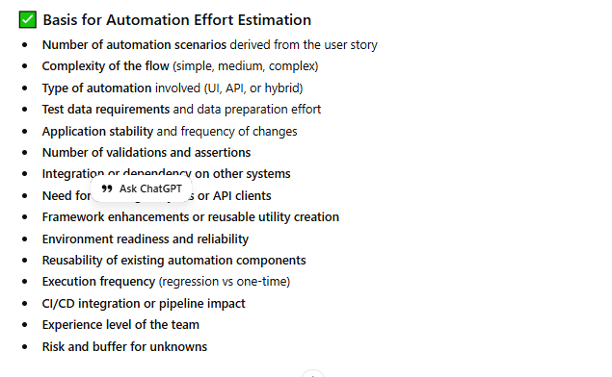

**How do you execute your automation framework across different environments (Dev, QA, Staging), and how do you manage environment-specific test data?**

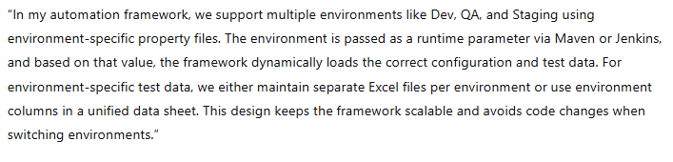

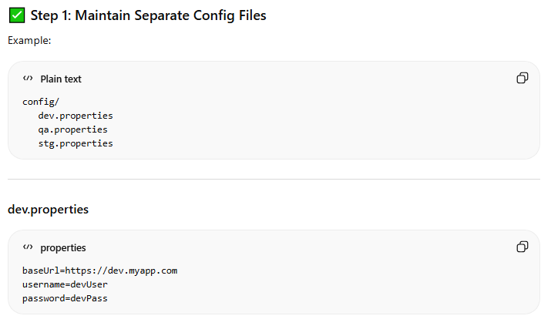

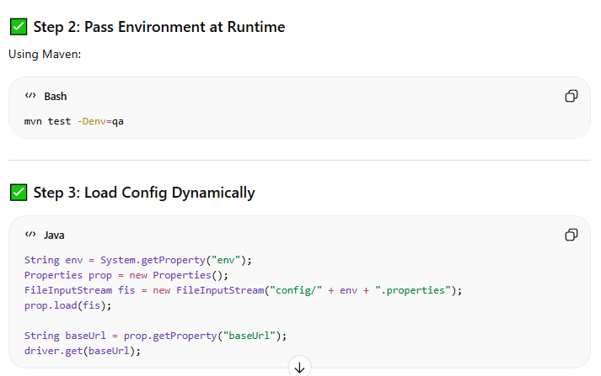

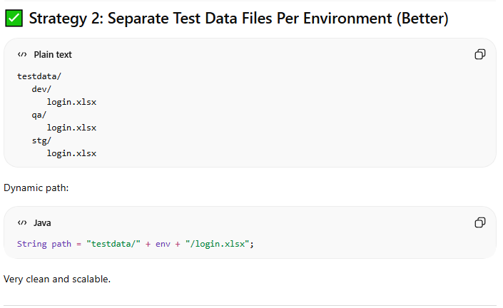

**Standard Password Validation Program**

